APPENDIX
A. Background: The 2024 Taiwan Presidential Election and Cross-Strait Politics
Since the introduction of direct presidential elections in 1996, Taiwan’s politics have centered on the issue of national identity, rooted in its colonial and civil-war history and its evolving relationship with China (Achen and Wang, 2017). The Democratic Progressive Party (DPP) has long promoted a distinct Taiwanese identity, while the Kuomintang (KMT) has emphasized Chinese cultural and historical ties. In response to the DPP’s victories in 2016 and 2020, Beijing intensified military and diplomatic pressure, escalating tensions in the Taiwan Strait.
Since 2016, China frequently sends military aircrafts to crossed the Taiwan Strait median line. Taiwan. According to China Power Project, there are 7880 violations of de facto Taiwan’s air defense identification zone (ADIZ) between 2018 and 2024 (https://chinapower.csis.org/). China held massive military drills, following the 2022 visit by US House Speaker Pelosi, when China launched missiles over the island and conducted blockades. Many analysts point to 2027 as a significant year for a potential Chinese invasion of Taiwan, as China wants its military to be ready to invade by then.
The 2024 presidential race unfolded under sustained Chinese coercion, framing the election as a referendum on Taiwan’s response to external threat. DPP candidate Lai Ching-te emphasized sovereignty, deterrence, and closer U.S. alignment, appealing to voters angered by Chinese intimidation. KMT candidate Hou Yu-ih, in contrast, advocated dialogue and stability through engagement with Beijing.
Ko Wen-je, the Taiwan People’s Party (TPP) candidate, complicated this traditional DPP–KMT divide. A former DPP ally and self-proclaimed pragmatist, Ko positions himself as an alternative to polarized blue–green politics, attracting disaffected voters. He blended criticism of the DPP’s “provocations” with warnings against Chinese aggression. His ambivalence making it unclear whether anger is directed at China or the DPP.

B. Wordings and Statistics of Independent Variables
Table B1. Wordings of Independent Variables
Question | Variable | Wording | Options | Operationalization
I2 | Voting Choice in 2024 | Which ticket did you vote for? | 01. Ko, Wen-Je and Wu, Hsin-Ying  02. Lai, Ching-Te and Hsiao, Bi-Khim  03. Hou, Yu-Ih and Jaw, Shau-Kong | Lai=1, Hou and Ko=0, otherwise = NA
I7a | Voting choice in 2020 | In the January 2020 presidential election, who did you vote? | 01. James C. Y. Soong and Yu, Hsiang  02. Daniel K. Y. Han and Simon S. C. Chang 03. Tsai, Ing-Wen and Lai, Ching-Te  89. Didn't pick up the ballot  91. Forget  92. Not eligible to vote [skip to J1a]  93. Didn't vote [skip to J1a]  94. Cast an invalid vote  95. Refuse to answer | Tsai = 1, Soong and Han = 0, otherwise = NA
M1 | International status | How has Taiwan's position in the world community changed over the past four years? | 01. Better  02. Worse  03. About the same 96. It depends  97. No opinion  98. Don’t know  95. Refuse to answer | Dummy variables, About the same vs. others, Worse vs. others
M2 | Cross-Strait relations | Generally speaking, do you believe that cross-strait relations have improved, deteriorated, or remained relatively unchanged over the past four years? | 01. Improved  02. Deteriorated  03. Remained unchanged 96. It depends  97. No opinion  98. Don’t know  95. Refuse to answer | Dummy variables, Improved and Remained unchanged vs. others, Deteriorated vs. others
M3 | Level of Anxiety about Potential Conflict | Do you worry about the possibility of military conflict between Taiwan and mainland China? | 01. Very worried  02. A little worried 03. Not too worried 04. Not worried at all 96. It depends  97. No opinion  98. Don’t know  95. Refuse to answer | Not worried at all = 1, Not too worried =2, A little worried =3, Very worried = 4
M4 | Level of Anger over China’s Coercion | Have you ever felt upset about the frequent encircling of Taiwan by China's warplanes and warships? | 01. Very upset  02. Somewhat upset  03. Not very upset  04. Not upset at all  96. It depends  97. No opinion  98. Don’t know  95. Refuse to answer | Not upset at all = 1, Not very upset =2, Somewhat upset =3, Very upset = 4
N1a | Taiwanese identity | In Taiwan, some people think they are Taiwanese. There are also some people who think that they are Chinese. Do you consider yourself as Taiwanese, Chinese or both? | 01. Taiwanese  02. Both  03. Chinese  95. Refuse to answer 98. Don’t know | Taiwanese = 1, otherwise = 0
P1c | Partisanship | Which party do you feel closest to? | 01. KMT  02. DPP  41. Taiwan People's Party | Dummy variables: DPP vs. others, KMT vs. others, TPP vs. others
J2a | Feeling about Lai | I’d like to ask you to evaluate presidential candidates using a scale ranging from 0 to 10, where 0 means you strongly dislike that candidate and 10 means that you strongly like that candidate. What would you rate Lai, Ching-Te? | 0-10  95. Refuse to answer 96. It’s hard to say  97. No opinion  98. Don’t know | 0-10
J2b | Feeling about Hou | What would you rate Hou, Yu-Ih? | 0-10  95. Refuse to answer 96. It’s hard to say  97. No opinion  98. Don’t know | 0-10
J2c | Feeling about Ko | What would you rate Ko, Wen-Je? | 0-10  95. Refuse to answer 96. It’s hard to say  97. No opinion  98. Don’t know | 0-10

Table B-2. Descriptive Statistics of Variables
Variables | N | Mean | S. D. | Min | Max
Voting for DPP in 2024 | 969 | 0.418 | 0.493 | 0 | 1
Voted for DPP in 2020 | 921 | 0.613 | 0.487 | 0 | 1
International status unchanged | 1206 | 0.382 | 0.486 | 0 | 1
International status worse | 1206 | 0.284 | 0.451 | 0 | 1
Cross-Strait relations deteriorated | 1206 | 0.557 | 0.496 | 0 | 1
Level of Anxiety about Potential Conflict | 1184 | 2.459 | 0.905 | 1 | 4
Level of Anger over China’s Coercion | 1162 | 2.652 | 0.949 | 1 | 4
Difference in Feeling between Lai and Hou | 1131 | 0.722 | 4.538 | -10 | 10
Difference in Feeling between Lai and Ko | 1134 | 0.840 | 4.769 | -10 | 10
Taiwanese identity | 1206 | 0.599 | 0.490 | 0 | 1
KMT partisanship | 1206 | 0.268 | 0.443 | 0 | 1
DPP partisanship | 1206 | 0.323 | 0.467 | 0 | 1
TPP partisanship | 1206 | 0.142 | 0.349 | 0 | 1

C. Alternative Voting Models
Table C1. Estimates of Incumbent Voting Choice Models with Partisanship
 | Lai and Hou Difference | Lai and Ko Difference
Intercept | 1.179 | 1.237
 | (1.534) | (1.885)
KMT partisanship | 0.155*** | 0.062***
 | (0.083) | (0.036)
DPP partisanship | 8.113*** | 6.160***
 | (2.858) | (2.427)
TPP partisanship | 0.097*** | 0.746
 | (0.053) | (0.412)
International status unchanged | 0.068* | 0.130
 | (0.089) | (0.194)
International status worse | 0.150 | 0.435
 | (0.231) | (0.777)
Cross-Strait relations deteriorated | 1.018 | 1.129
 | (1.188) | (1.487)
Level of Anxiety about Potential Conflict | 0.325** | 0.389+
 | (0.131) | (0.192)
Level of Anger over China’s Coercion | 2.405* | 2.095+
 | (0.881) | (0.912)
Difference in Feeling between Lai and Hou | 1.557***
 | (0.105)
Difference in Feeling between Lai and Ko |  | 1.975***
 |  | (0.169)
Taiwanese identity | 1.537 | 1.448
 | (0.520) | (0.523)
International status unchanged and Anxiety | 2.728* | 1.878
 | (1.207) | (0.973)
International status worse and Anxiety | 2.341 | 1.275
 | (1.251) | (0.744)
Cross-Strait relations deteriorated and Anxiety | 1.666 | 1.641
 | (0.673) | (0.755)
International status unchanged and Anger | 0.852 | 0.970
 | (0.366) | (0.487)
International status deteriorated and Anger | 0.685 | 0.850
 | (0.322) | (0.461)
Cross-Strait relations deteriorated and Anger | 0.575 | 0.555
 | (0.221) | (0.250)
Num.Obs. | 917 | 916
AIC | 396.0 | 336.7
BIC | 511.7 | 452.4
Log.Lik. | -173.986 | -144.348
Note: Values presented are Odds Ratios (e^{ß} ) from a logistic regression model. Standard errors are in parentheses below the OR. The reference category for “International Status” is “better”. The reference category for “Cross-Strait relations” is “Improve and the same”.
Significance: † p < 0.10; p < 0.05; p < 0.01; p < 0.001
Source: Chen (2024)
Table C2. Estimates of Incumbent Voting Choice Models for Respondents Voted for the DPP in 2020
 | Lai and Hou Difference | Lai and Ko Difference
Intercept | 1.982 | 13.949
 | (2.767) | (26.856)
International status unchanged | 0.124 | 0.043+
 | (0.171) | (0.080)
International status worse | 0.036+ | 0.070
 | (0.065) | (0.147)
Cross-Strait relations deteriorated | 0.722 | 0.200
 | (0.948) | (0.328)
Level of Anxiety about Potential Conflict | 0.357* | 0.182**
 | (0.149) | (0.115)
Level of Anger over China’s Coercion | 2.087+ | 2.004
 | (0.805) | (1.017)
Difference in Feeling between Lai and Hou | 1.538***
 | (0.105)
Difference in Feeling between Lai and Ko |  | 2.315***
 |  | (0.241)
Taiwanese identity | 2.871** | 1.925
 | (1.039) | (0.838)
International status unchanged and Anxiety | 1.555 | 2.095
 | (0.706) | (1.315)
International status worse and Anxiety | 3.031* | 1.999
 | (1.660) | (1.392)
Cross-Strait relations deteriorated and Anxiety | 1.363 | 2.808+
 | (0.575) | (1.653)
International status unchanged and Anger | 1.008 | 1.224
 | (0.469) | (0.741)
International status deteriorated and Anger | 0.708 | 0.944
 | (0.354) | (0.591)
Cross-Strait relations deteriorated and Anger | 0.763 | 0.634
 | (0.310) | (0.333)
Num.Obs. | 475 | 474
AIC | 350.3 | 238.5
BIC | 437.8 | 325.9
Log.Lik. | -154.173 | -98.247
Note: Values presented are Odds Ratios (e^{ß} ) from a logistic regression model. Standard errors are in parentheses below the OR. The reference category for “International Status” is “better”. The reference category for “Cross-Strait relations” is “Improve and the same”.
Significance: † p < 0.10; p < 0.05; p < 0.01; p < 0.001
Source: Chen (2024)

Table C3. Multinomial Logit Estimates (Odds Ratios) of Voting Choice Models

 | KMT vs DPP | TPP vs DPP
Intercept | 0.565 | 3.290
 | (2.016) | (1.351)
Voted for DPP in 2020 | 0.009*** | 0.047***
 | (0.479) | (0.484)
International status unchanged | 7.926 | 8.222+
 | (1.630) | (1.188)
International status worse | 58.619* | 152.270**
 | (1.881) | (1.573)
Cross-Strait relations deteriorated | 2.297 | 2.583
 | (1.294) | (1.112)
Level of Anxiety about Potential Conflict | 2.982* | 3.458**
 | (0.544) | (0.384)
Level of Anger over China’s Coercion | 0.404+ | 0.410*
 | (0.540) | (0.349)
Taiwanese identity | 0.225*** | 0.246***
 | (0.353) | (0.321)
International status unchanged and Anxiety | 0.677 | 0.495+
 | (0.549) | (0.406)
International status deteriorated and Anxiety | 0.362+ | 0.225**
 | (0.601) | (0.495)
Cross-Strait relations deteriorated and Anxiety | 0.824 | 0.662
 | (0.457) | (0.377)
International status unchanged and Anger | 1.316 | 1.232
 | (0.560) | (0.405)
International status deteriorated and Anger | 1.744 | 1.389
 | (0.589) | (0.467)
Cross-Strait relations deteriorated and Anger | 1.112 | 1.262
 | (0.453) | (0.364)
Residual Deviance: 796.4342
AIC: 880.4342
Note: Values presented are Odds Ratios (e^{ß} ) from a logistic regression model. Standard errors are in parentheses below the OR. The reference category for “International Status” is “better”. The reference category for “Cross-Strait relations” is “Improve and the same”.
Significance: † p < 0.10; p < 0.05; p < 0.01; p < 0.001
Source: Chen (2024)

Table C4. Multinomial Logit Estimates (Odds Ratios) of Voting Choice Models with Difference in Feeling Thermometer between Lai and Hou

 | KMT vs DPP | TPP vs DPP
Intercept | 0.394 | 2.676
 | (2.249) | (1.485)
Voted for DPP in 2020 | 0.035*** | 0.098***
 | (0.529) | (0.507)
International status unchanged | 16.940 | 19.010*
 | (1.884) | (1.358)
International status worse | 20.814 | 69.013*
 | (2.093) | (1.728)
Cross-Strait relations deteriorated | 1.168 | 1.123
 | (1.584) | (1.268)
Level of Anxiety about Potential Conflict | 2.884+ | 3.120**
 | (0.605) | (0.422)
Level of Anger over China’s Coercion | 0.504 | 0.486+
 | (0.627) | (0.387)
Feeling between Lai and Hou | 0.509*** | 0.689***
 | (0.078) | (0.065)
Taiwanese identity | 0.354** | 0.329**
 | (0.401) | (0.348)
International status unchanged and Anxiety | 0.622 | 0.476+
 | (0.621) | (0.450)
International status deteriorated and Anxiety | 0.440 | 0.287*
 | (0.681) | (0.538)
Cross-Strait relations deteriorated and Anxiety | 0.747 | 0.686
 | (0.532) | (0.417)
International status unchanged and Anger | 0.959 | 0.897
 | (0.654) | (0.456)
International status deteriorated and Anger | 1.572 | 1.222
 | (0.652) | (0.487)
Cross-Strait relations deteriorated and Anger | 1.228 | 1.453
 | (0.533) | (0.401)
Residual Deviance: 680.0634
AIC: 768.0634
Note: Values presented are Odds Ratios (e^{ß} ) from a logistic regression model. Standard errors are in parentheses below the OR. The reference category for “International Status” is “better”. The reference category for “Cross-Strait relations” is “Improve and the same”.
Significance: † p < 0.10; p < 0.05; p < 0.01; p < 0.001
Source: Chen (2024)

Table C5. Multinomial Logit Estimates (Odds Ratios) of Voting Choice Models with Difference in Feeling Thermometer between Lai and Ko
 | KMT vs DPP | TPP vs DPP
Intercept | 0.050 | 0.093
 | (2.410) | (2.078)
Voted for DPP in 2020 | 0.023*** | 0.208**
 | (0.546) | (0.601)
International status unchanged | 112.582* | 132.694*
 | (2.092) | (1.907)
International status worse | 42.296+ | 32.219+
 | (2.208) | (2.050)
Cross-Strait relations deteriorated | 4.117 | 6.036
 | (1.677) | (1.610)
Level of Anxiety about Potential Conflict | 5.007* | 6.910**
 | (0.686) | (0.654)
Level of Anger over China’s Coercion | 0.604 | 0.634
 | (0.622) | (0.526)
Feeling between Lai and Ko | 0.532*** | 0.364***
 | (0.096) | (0.101)
Taiwanese identity | 0.358* | 0.421*
 | (0.422) | (0.427)
International status unchanged and Anxiety | 0.521 | 0.274*
 | (0.683) | (0.647)
International status deteriorated and Anxiety | 0.640 | 0.348
 | (0.736) | (0.698)
Cross-Strait relations deteriorated and Anxiety | 0.409 | 0.293*
 | (0.584) | (0.587)
International status unchanged and Anger | 0.576 | 0.608
 | (0.681) | (0.610)
International status deteriorated and Anger | 0.889 | 1.063
 | (0.693) | (0.637)
Cross-Strait relations deteriorated and Anger | 1.538 | 1.637
 | (0.553) | (0.527)
Residual Deviance: 542.3849
AIC: 630.3849
Note: Values presented are Odds Ratios (e^{ß} ) from a logistic regression model. Standard errors are in parentheses below the OR. The reference category for “International Status” is “better”. The reference category for “Cross-Strait relations” is “Improve and the same”.
Significance: † p < 0.10; p < 0.05; p < 0.01; p < 0.001
Source: Chen (2024)

Table C6. Estimates of Incumbent Voting Choice Models from Weighted Data
 | Baseline Model | Lai and Hou Difference | Lai and Ko Difference
Intercept | 1.198 | 1.298* | 1.264*
 | (0.166) | (0.169) | (0.144)
International status unchanged | 0.846 | 0.804+ | 0.869
 | (0.104) | (0.091) | (0.085)
International status deteriorated | 0.690** | 0.727** | 0.877
 | (0.084) | (0.085) | (0.094)
Cross-Strait relations deteriorated | 0.984 | 0.998 | 1.080
 | (0.095) | (0.093) | (0.091)
Level of Anxiety about Potential Conflict | 0.907*** | 0.925** | 0.956+
 | (0.025) | (0.025) | (0.023)
Level of Anger over China’s Coercion | 1.095*** | 1.058* | 1.052*
 | (0.029) | (0.027) | (0.023)
Feeling between Lai and Hou |  | 1.031***
 |  | (0.004)
Feeling between Lai and Ko |  |  | 1.048***
 |  |  | (0.003)
Taiwanese identity | 1.164*** | 1.125*** | 1.099**
 | (0.039) | (0.037) | (0.034)
International status unchanged and Anxiety | 1.016 | 1.011 | 0.998
 | (0.036) | (0.034) | (0.031)
International status worse and Anxiety | 1.121** | 1.101** | 1.062+
 | (0.041) | (0.040) | (0.034)
Cross-Strait relations deteriorated and Anxiety | 0.998 | 1.002 | 0.986
 | (0.032) | (0.031) | (0.027)
International status unchanged and Anger | 0.997 | 1.033 | 1.029
 | (0.034) | (0.034) | (0.030)
International status worse and Anger | 0.936+ | 0.960 | 0.946+
 | (0.037) | (0.037) | (0.031)
Cross-Strait relations deteriorated and Anger | 0.983 | 0.983 | 0.970
 | (0.027) | (0.026) | (0.023)
Num.Obs. | 793 | 784 | 783
AIC | 472.2 | 400.7 | 261.6
BIC | 7447.7 | 8171.8 | 9825.6
Log.Lik. | -3650.416 | -4009.239 | -4836.191
Note: Values presented are Odds Ratios (e^{ß} ) from a logistic regression model. Standard errors are in parentheses below the OR. The reference category for “International Status” is “better”. The reference category for “Cross-Strait relations” is “Improve and the same”.
Significance: † p < 0.10; p < 0.05; p < 0.01; p < 0.001
Source: Chen (2024)
D. Plots of Interaction between Emotion and Retrospective Evaluation of Taiwan’s International Status with Difference in Feeling Thermometer between Lai and Hou or Ko

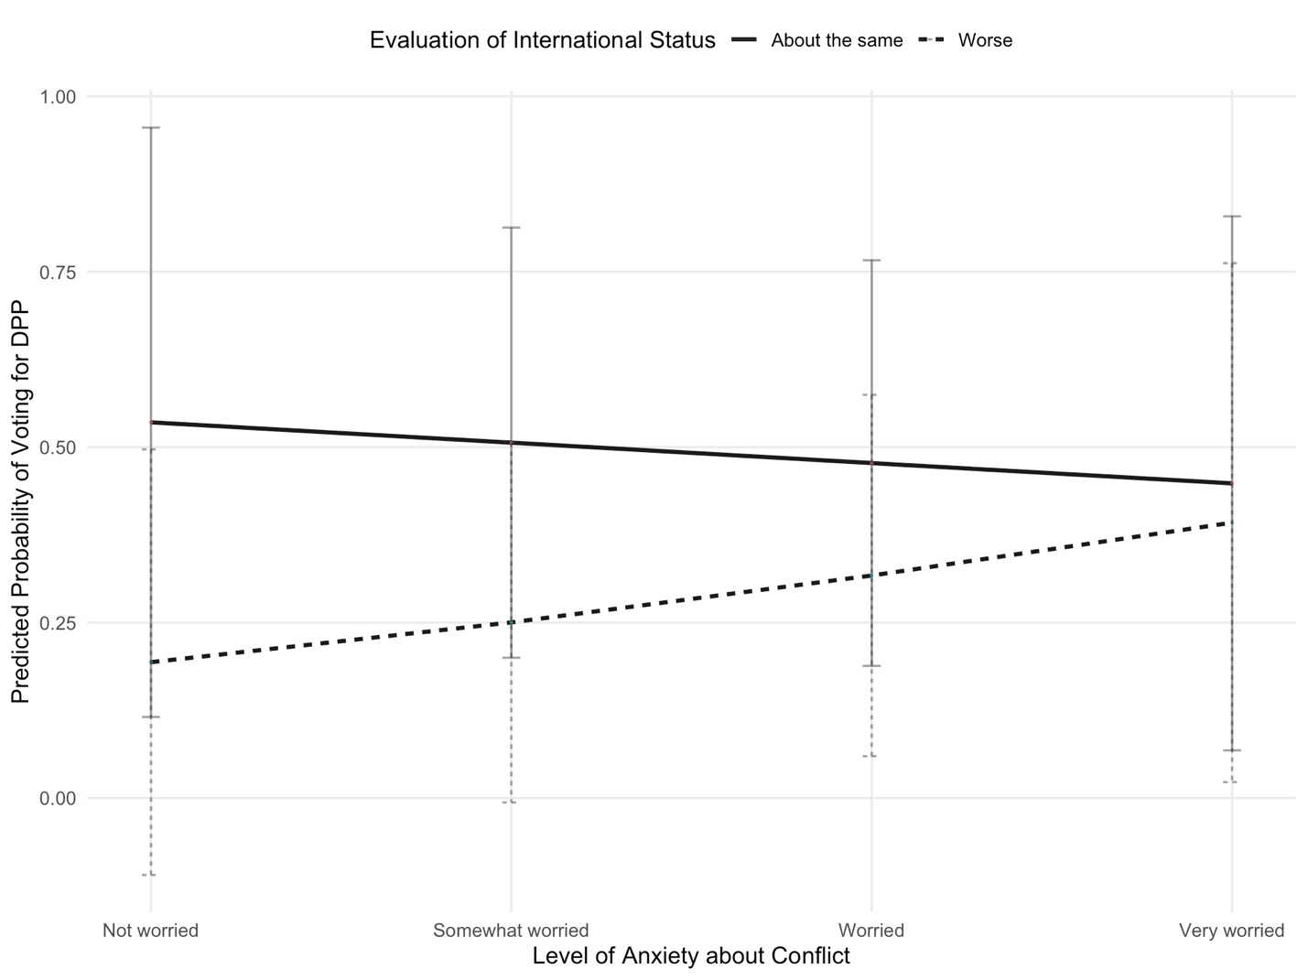
Figure D1. Interaction of Anxiety and Retrospective Evaluation of Taiwan’s International Status with Difference in Feeling Thermometer between Lai and Hou
Source: Chen (2024)

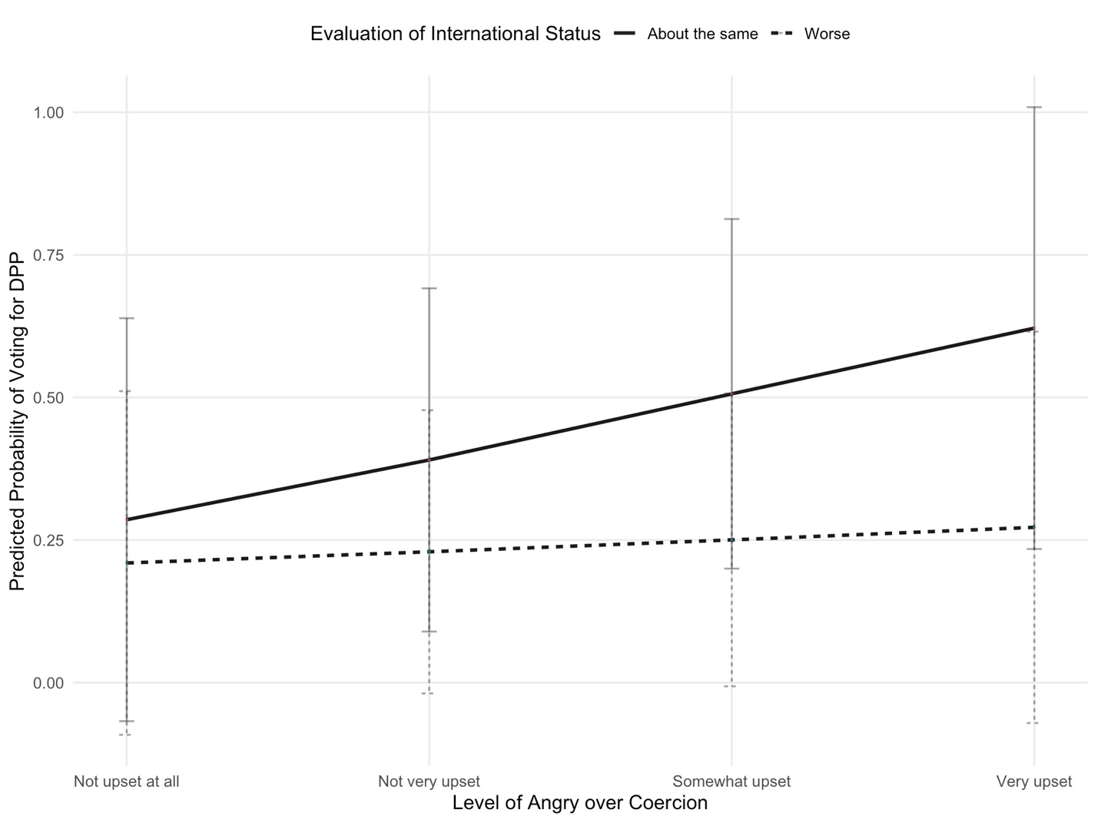

Figure D2. Interaction of Anger and Retrospective Evaluation of Taiwan’s International Status with Difference in Feeling Thermometer between Lai and Hou
Source: Chen (2024)

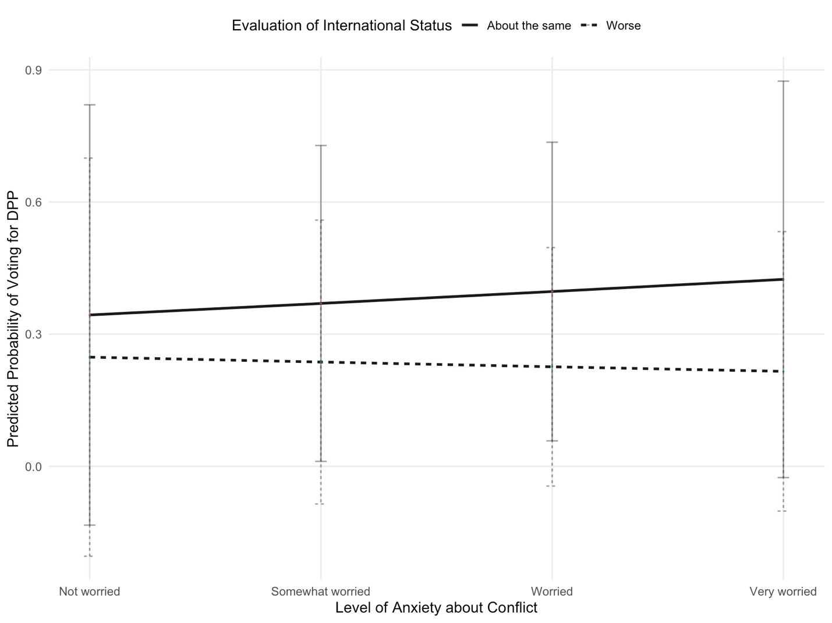

Figure D3. Interaction of Anxiety and Retrospective Evaluation of Taiwan’s International Status with Difference in Feeling Thermometer between Lai and Ko
Source: Chen (2024)

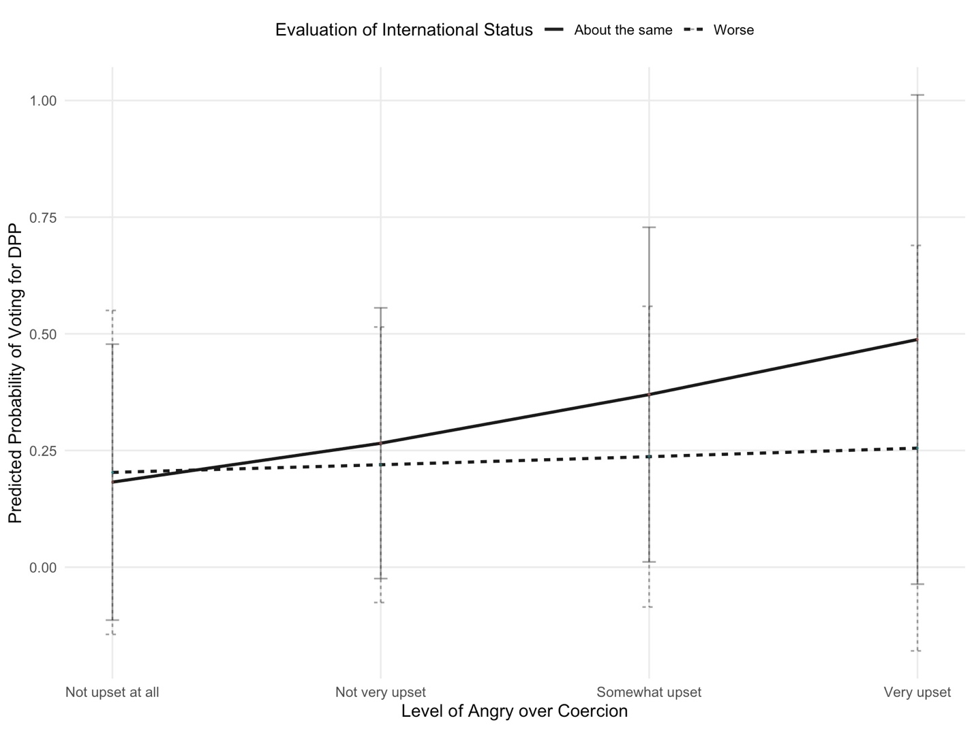

Figure D4. Interaction of Anger and Retrospective Evaluation of Taiwan’s International Status with Difference in Feeling Thermometer between Lai and Ko
Source: Chen (2024)

