Appendix VI. Preliminary Analysis of Normality
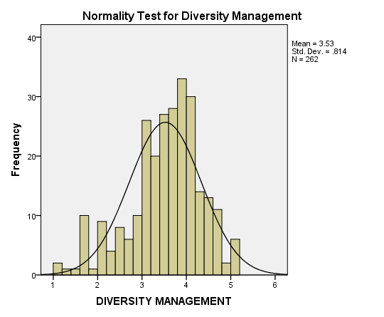
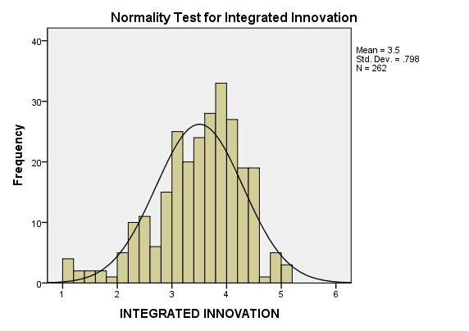
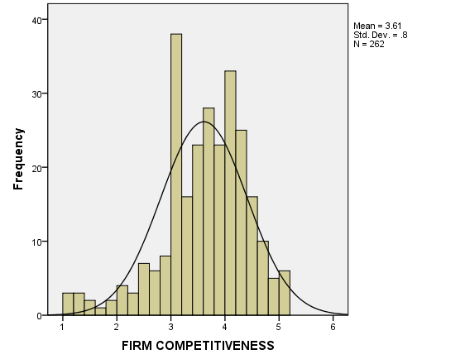
Appendix VII: Relationship between IV and DV, and Relationship among IV by Scatter Plot and Correlation.
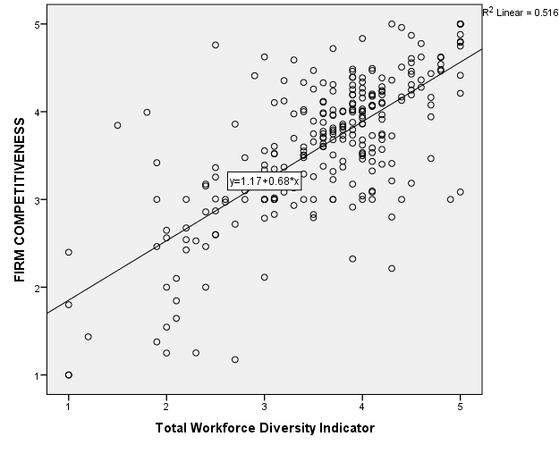

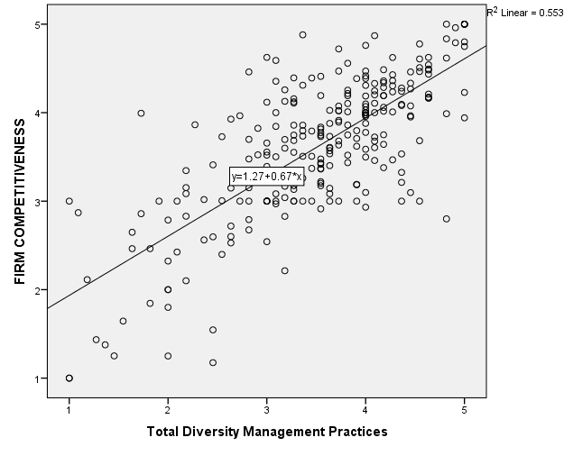

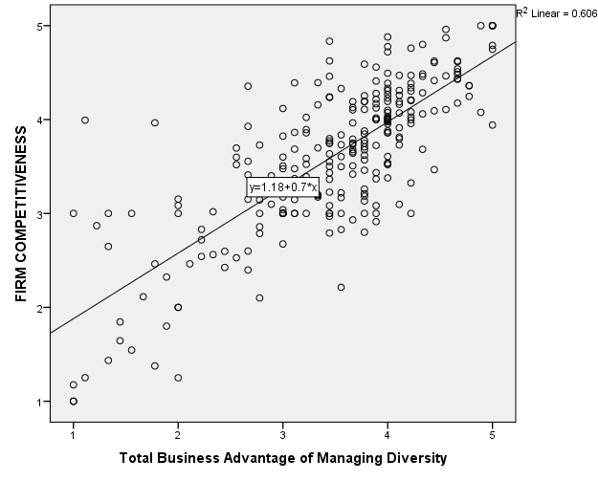
Correlations among indenpendet variables
 |  | Workforce Diversity Indicator | Diversity Management Practices | Business Advantage of Managing Diversity
Workforce Diversity Indicator | Pearson Correlation | 1 | .755** | .749**
Workforce Diversity Indicator | Sig. (2-tailed) |  | .000 | .000
Workforce Diversity Indicator | N | 262 | 262 | 262
Diversity Management Practices | Pearson Correlation | .755** | 1 | .880**
Diversity Management Practices | Sig. (2-tailed) | .000 |  | .000
Diversity Management Practices | N | 262 | 262 | 262
Business Advantage of Managing Diversity | Pearson Correlation | .749** | .880** | 1
Business Advantage of Managing Diversity | Sig. (2-tailed) | .000 | .000
Business Advantage of Managing Diversity | N | 262 | 262 | 262
**. Correlation is significant at the 0.01 level (2-tailed).
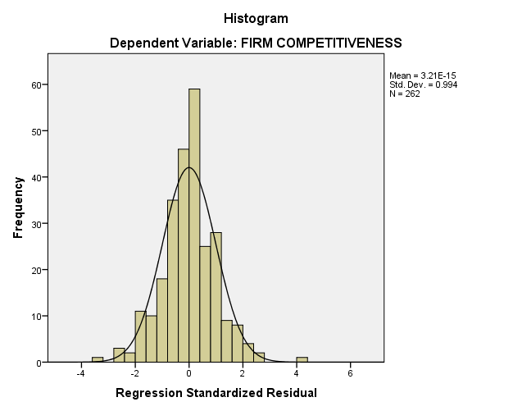
Appendix VIII: Outliers, Normality, Linearity, Homoscedasticity, Independence of Residuals

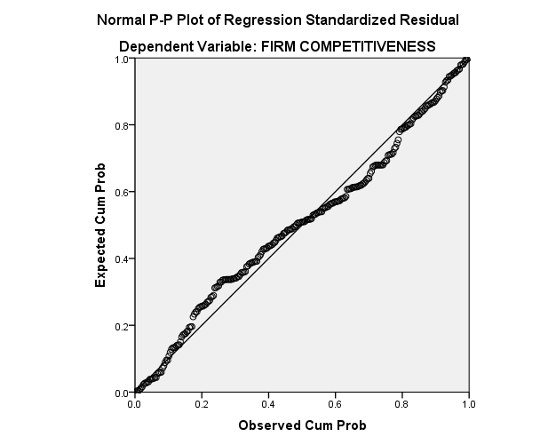
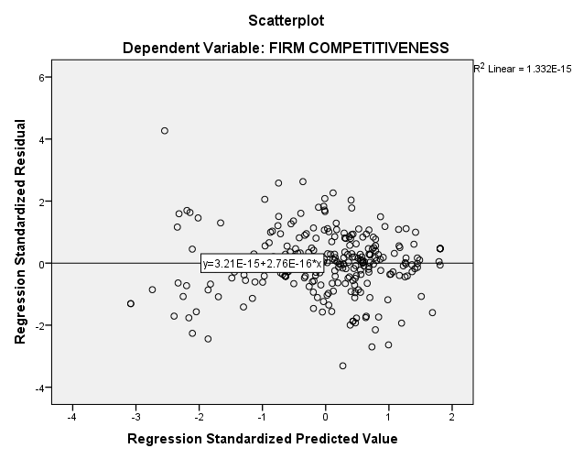
Appendix IX: The Scatterplot for Pre-liminary Analysis of Mediation
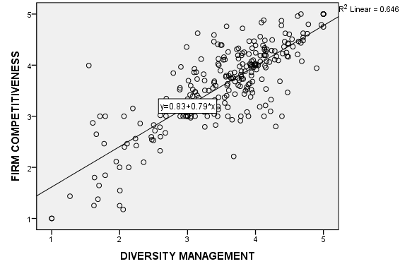
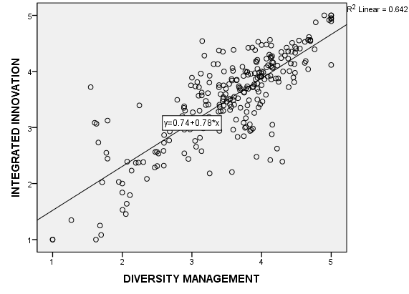
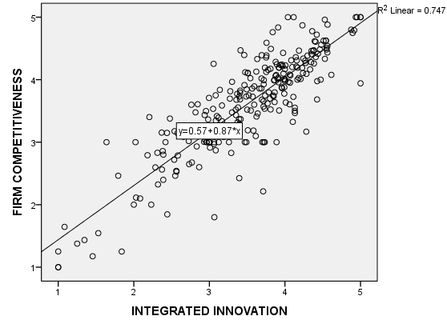
Appendix X: Normality test of TWO-WAY ANOVA
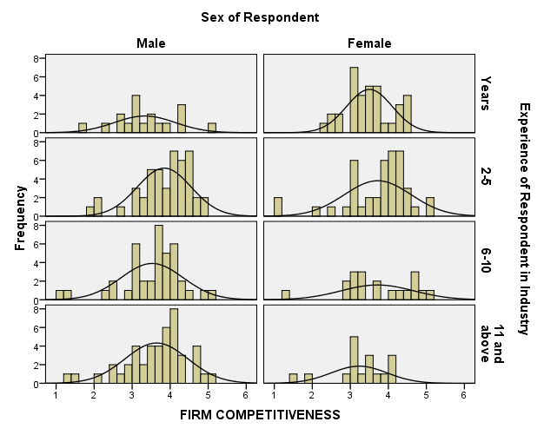

Appendix XI: Assessment of normality for Effects
Variable | min | max | skew | c.r. | kurtosis | c.r.
TExperience | 2.000 | 3.333 | -.702 | -4.637 | -.722 | -2.386
TEducation | 2.333 | 3.667 | -.455 | -3.008 | -1.083 | -3.580
TAge | 2.600 | 4.000 | -.010 | -.065 | -.749 | -2.475
TGender | 2.000 | 3.667 | .287 | 1.895 | -1.125 | -3.717
TBS | 1.000 | 5.000 | -.908 | -5.999 | .806 | 2.663
TFP | 1.000 | 5.000 | -.956 | -6.316 | 1.290 | 4.261
TTD | 1.000 | 5.000 | -.620 | -4.099 | .676 | 2.233
TMS | 1.000 | 5.000 | -.483 | -3.193 | .315 | 1.041
TPP | 1.000 | 5.000 | -.820 | -5.419 | .490 | 1.619
PRI1 | 1.000 | 5.000 | -.773 | -5.108 | .239 | .788
PRI2 | 1.000 | 5.000 | -.793 | -5.242 | .234 | .772
PRI3 | 1.000 | 5.000 | -.587 | -3.880 | -.203 | -.671
PRI4 | 1.000 | 5.000 | -.600 | -3.968 | -.142 | -.470
PRI5 | 1.000 | 5.000 | -.762 | -5.038 | .143 | .472
PRI6 | 1.000 | 5.000 | -.786 | -5.196 | .362 | 1.195
PRI7 | 1.000 | 5.000 | -.703 | -4.646 | .118 | .389
PRI8 | 1.000 | 5.000 | -.646 | -4.268 | .053 | .177
PI1 | 1.000 | 5.000 | -.739 | -4.884 | -.022 | -.074
PI2 | 1.000 | 5.000 | -.600 | -3.962 | -.383 | -1.265
PI3 | 1.000 | 5.000 | -.599 | -3.959 | -.341 | -1.128
PI4 | 1.000 | 5.000 | -.437 | -2.885 | -.678 | -2.241
PI5 | 1.000 | 5.000 | -.928 | -6.136 | .362 | 1.195
PI6 | 1.000 | 5.000 | -.859 | -5.676 | .232 | .766
PI7 | 1.000 | 5.000 | -.613 | -4.053 | -.332 | -1.096
PI8 | 1.000 | 5.000 | -.621 | -4.104 | -.205 | -.677
PI9 | 1.000 | 5.000 | -.388 | -2.566 | -.535 | -1.767
Multivariate |  |  |  |  | 209.075 | 44.345

