Supporting Information for
Jet-Induced Rainfall Seasonality and C₄ Expansion over East Asia

Jiawei Da^{1,2*}†, Chijun Sun³, Lily Serach¹, Timothy Gallagher⁴, Huayu Lu⁵, Katharine Huntington⁶, Ran Feng⁷, Hanzhi Zhang⁵, Hanlin Wang⁸, Shunchuan Ji⁹, Zachary Sharp¹⁰, Junfeng Ji², Daniel Breecker¹

Jiawei Da
Email: jiawei@psu.edu

This PDF file includes:

Figures S1 to S6

Figures

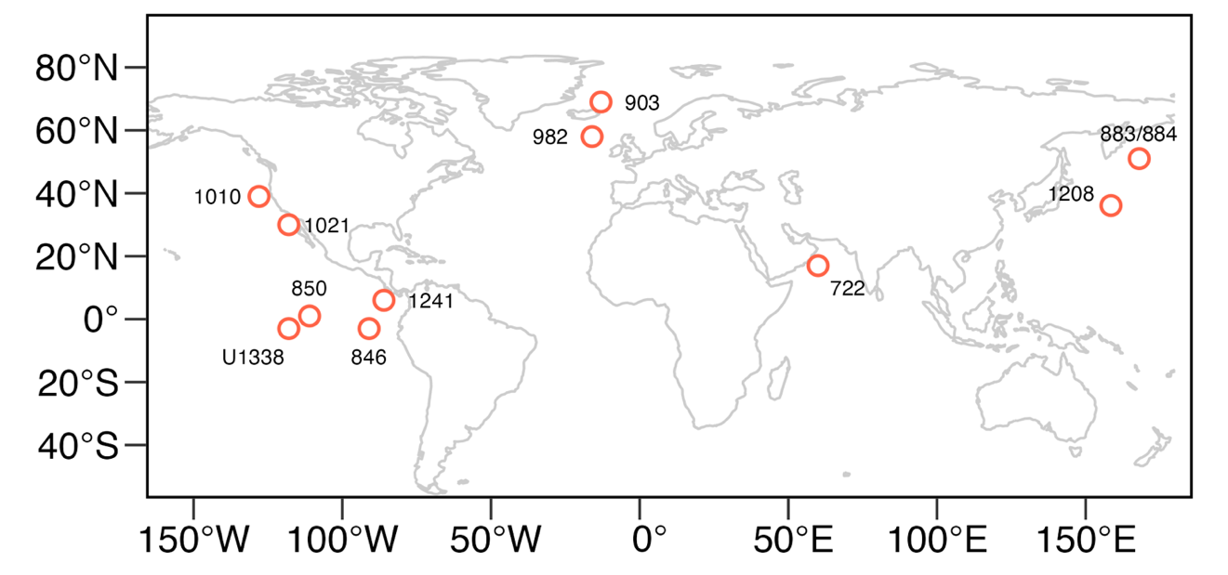

Fig. S1. The locations of Ocean Drilling Program (ODP) sites used in this study (1). The red circles and blue boxes show sites for the Miocene-Pliocene and the Pleistocene sea surface temperature records, respectively.

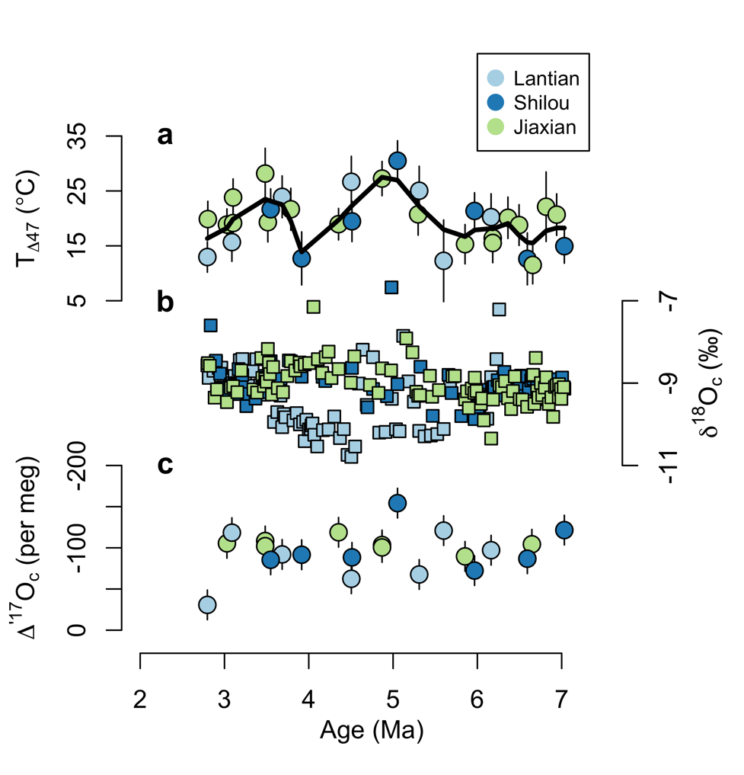

Fig. S2. Measurements from calcite nodules. (a) Clumped isotope temperature (T_{Δ47}). (b) The stable oxygen isotopic compositions (δ¹⁸O_{c}). (b) The Δ′¹⁷O values (Δ′¹⁷O_{c}). Error bars denote standard errors from replicate analyses. Note the reversed scale for Δ′¹⁷O_{c}. The black lines in panels a are the LOESS lines (span = 0.3).

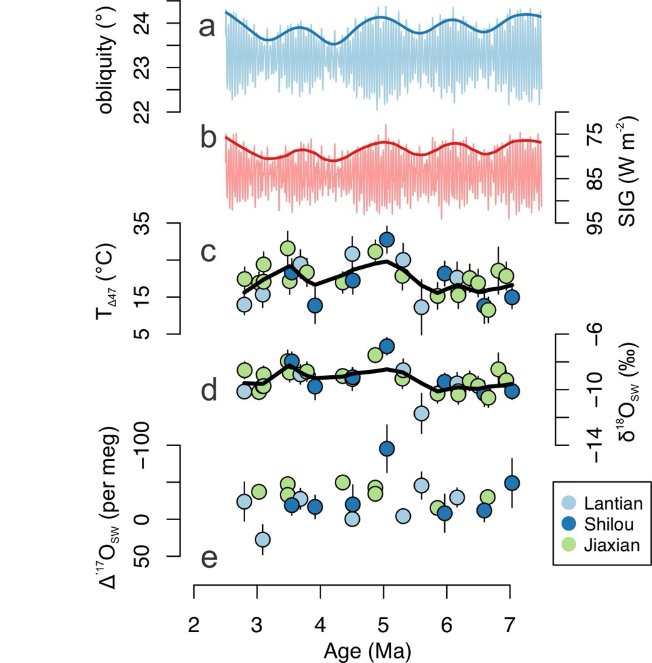

Fig. S3. Comparison of nodule-derived records with obliquity signal. (a) Obliquity signal in La2004 astronomical solution along with its filtered ∼1.2-Myr amplitude modulation. (b) 25° - 65°N summer insolation gradient (SIG) with its filtered ∼1.2-Myr amplitude modulation. (c) Clumped isotope temperature (T_{Δ47}). Error bars denote standard errors from replicate analyses. (d) Reconstructed δ¹⁸O of soil waters (δ¹⁸O_{sw}) using paired δ¹⁸O_{c}-T_{Δ47} measurements. Error bars are propagated from uncertainties in δ¹⁸O_{c} and T_{Δ47} using Monte Carlo random sampling. (e) The Δ′¹⁷O of soil waters (Δ′¹⁷O_{sw}) calculated from paired T_{Δ47}-Δ′¹⁷O_{c} measurements. Note the reversed scale for SIG and Δ′¹⁷O_{sw}. The black lines in panels c-d are the LOESS lines (span = 0.3).

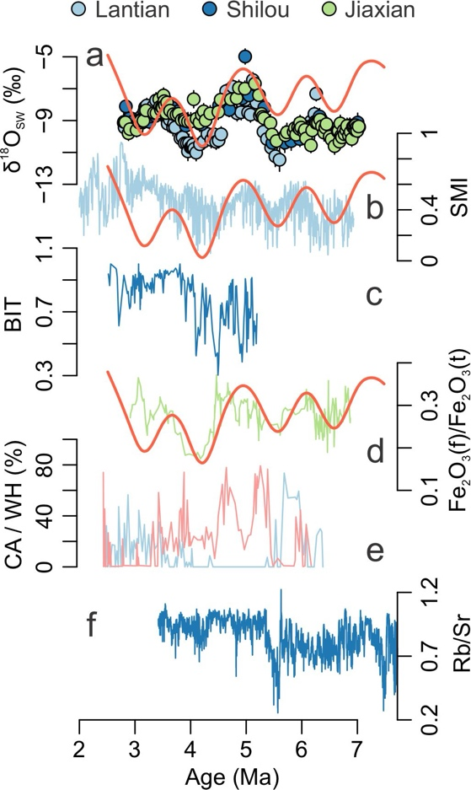

Fig. S4. Proxy-derived records from the CLP. (a) δ¹⁸O_{sw} from this study. (b) Summer monsoon index based on soil magnetic susceptibility and carbonate content from Lingtai section¹⁴. (c) The brGDGT-based aridity indicators (BIT) from Shilou section (2). (d) The ratio of free iron to total iron content from Pianguan section (3). (e) Relative abundance of mollusk assemblages (red: warm-humid, blue: cold-dry) (4). (f) Bulk soil Rb/Sr ratio from Shilou section (5). Higher values in panels b-d and f were interpreted to indicate stronger monsoon and/or wetter climate. Red curves in panels a, b, and d show the ~1.2 Ma obliquity amplitude modulation.

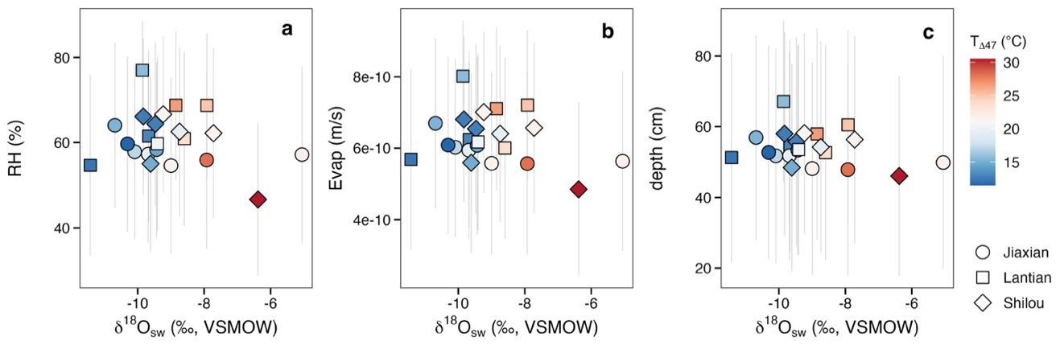

Fig. S5. Posteriors from Bayesian inversion of the steady state model. To quantitatively estimate environmental parameters that affect the oxygen isotope compositions of soil water (δ¹⁸O_{sw} and Δ′¹⁷O_{sw}), we employed Bayesian inversion to a steady-state isotope model (6, 7), which accounts for liquid and vapor transport within a 1-D soil column under isothermal condition. Here, the prior range of input parameters, including air humidity (RH), the δ¹⁸O of rainfall, carbonate formation depth, and evaporation rate were set to uniform distributions of 10-90%, -25 - -5‰, 0-100 cm, and 10⁻¹⁰ - 10⁻⁹ m/s, respectively, based on modern observations. Panels a-c are posterior estimates of RH and evaporation rate, and carbonate formation depth plotted against the reconstructed δ¹⁸O_{sw}, respectively. Different sections and T_{Δ47} are shape- and color-coded, respectively. Error bars represent 1σ error resulting from 16th and 84th percentiles of the posterior distributions.

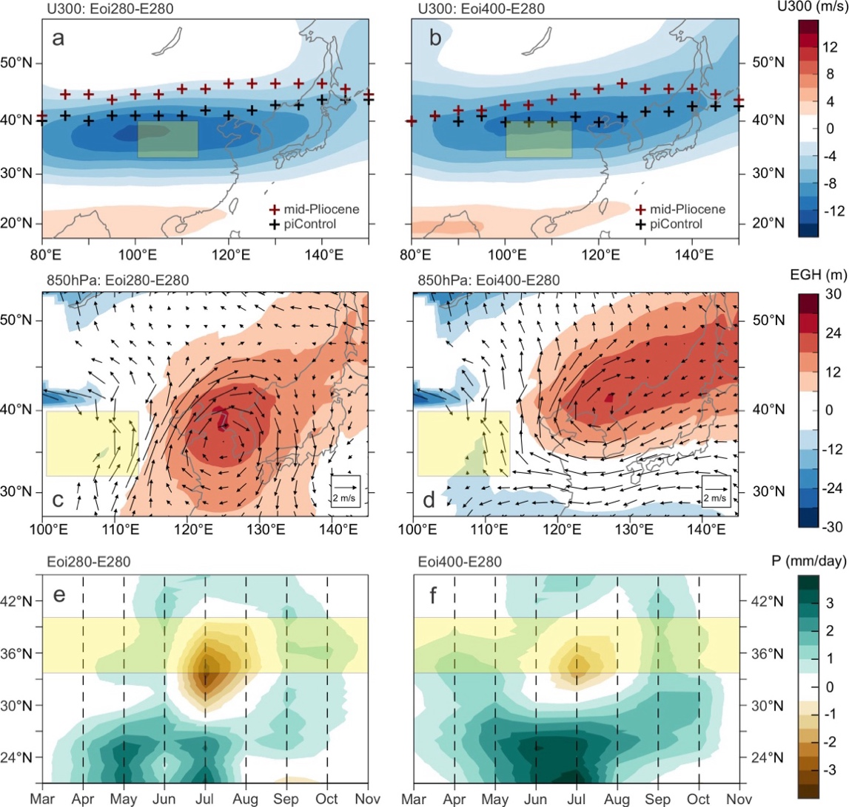

Fig. S6. The westerly jet, western Pacific subtropical high, and East Asian monthly rainfall from model simulations. (a-b) Differences in zonal winds at 300 hPa in July. The markers denote the axis of the westerly jet defined as the latitude with the maximum zonal wind speed over 10-50°N. (c-d) Differences in the eddy geopotential height (EGH, shading) and horizontal wind (vectors) at 850 hPa in July. (e-f) Monthly precipitation anomaly over 105-120°E. The left panels show the differences between Pliocene 280 ppm (Eoi280) and pre-industrial (E280) experiments, whereas the right panels show the differences between Pliocene 400 ppm (Eoi400) and E280 experiments. Yellow boxes highlight the CLP region.

SI References

1. T. D. Herbert, et al., Late Miocene global cooling and the rise of modern ecosystems. Nature Geoscience 9 (2016).
2. Y. Zheng, et al., Severe Drought Conditions in Northern East Asia During the Early Pliocene Caused by Weakened Pacific Meridional Temperature Gradient. Geophysical Research Letters 49, e2022GL098813 (2022).
3. S. Yang, et al., A strengthened East Asian Summer Monsoon during Pliocene warmth: Evidence from ‘red clay’ sediments at Pianguan, northern China. Journal of Asian Earth Sciences 155, 124–133 (2018).
4. F. Li, D.-D. Rousseau, N. Wu, Q. Hao, Y. Pei, Late Neogene evolution of the East Asian monsoon revealed by terrestrial mollusk record in Western Chinese Loess Plateau: From winter to summer dominated sub-regime. Earth and Planetary Science Letters 274, 439–447 (2008).
5. H. Ao, et al., Global warming-induced Asian hydrological climate transition across the Miocene–Pliocene boundary. Nature Communications 12, 6935 (2021).
6. C. J. Barnes, G. B. Allison, The distribution of deuterium and 18O in dry soils: 1. Theory. Journal of Hydrology 60, 141–156 (1983).
7. J. R. Kelson, et al., Triple oxygen isotope compositions of globally distributed soil carbonates record widespread evaporation of soil waters. Geochimica et Cosmochimica Acta (2023). https://doi.org/10.1016/j.gca.2023.06.034.

