Supplementary figures
Genomic and molecular characterisation of a KPC-producing Klebsiella pneumoniae clinical isolate resistant to meropenem-vaborbactam, imipenem-relebactam, and ceftazidime-avibactam
Yu Wan, Joshua L. C. Wong, Julia Sanchez-Garrido, Wen Wen Low, Jane F. Turton, Fabio Morecchiato, Ilaria Baccani, Kirsty Dodgson, Gian Maria Rossolini, Neil Woodford, Gad Frankel, Elita Jauneikaite, Danièle Meunier, and Katie L. Hopkins
December 2025

Table of contents
Supplementary Figure 1 …………………………………………………………………………… 1
Supplementary Figure 2 …………………………………………………………………………… 2
Supplementary Figure 3 …………………………………………………………………………… 3
Supplementary Figure 4 …………………………………………………………………………… 4
Supplementary Figure 5 …………………………………………………………………………… 4
Supplementary Figure 6 …………………………………………………………………………… 5
Supplementary Figure 7 …………………………………………………………………………… 6
Supplementary Figure 8 …………………………………………………………………………… 7
Supplementary Figure 9 …………………………………………………………………………… 8
References ….……………………………………………………………………………………… 9

Supplementary Figure 1. Alignment of plasmids pKpMVR1_1 and pKpMVS2_1 against pKpMVS1_1 using nucleotide BLAST as implemented in Proksee. Plasmids pKpMVR1_1 and pKpMVS1_1 belonged to replicon type IncFII(pKP91)/repB(R1701), and pKpMVS2_1 belonged to IncFII(pKP91)/IncR. The innermost ring represents the number of genetic variants per kbp (calculated using VCFtools v0.1.17) [1] in pKpMVR2_1 compared with pKpMVS1_1. The two middle rings display genes, insertion sequences, and transposons identified in the reference sequence pKpMVS1_1, with arrows indicating orientations of these genetic features (Supplementary Table 1, Additional File 3). Genes without names are not labelled. The two outer rings show regions of pKpMVR_1 and pKpMVS2_1 aligned to pKpMVS1, respectively. This figure was created using Proksee [2]. "Δ" in gene labels represents a truncated or interrupted feature, and each asterisk represents a variant of an insertion sequence or transposon. Abbreviations: CDS, coding sequence; IS, insertion sequence.
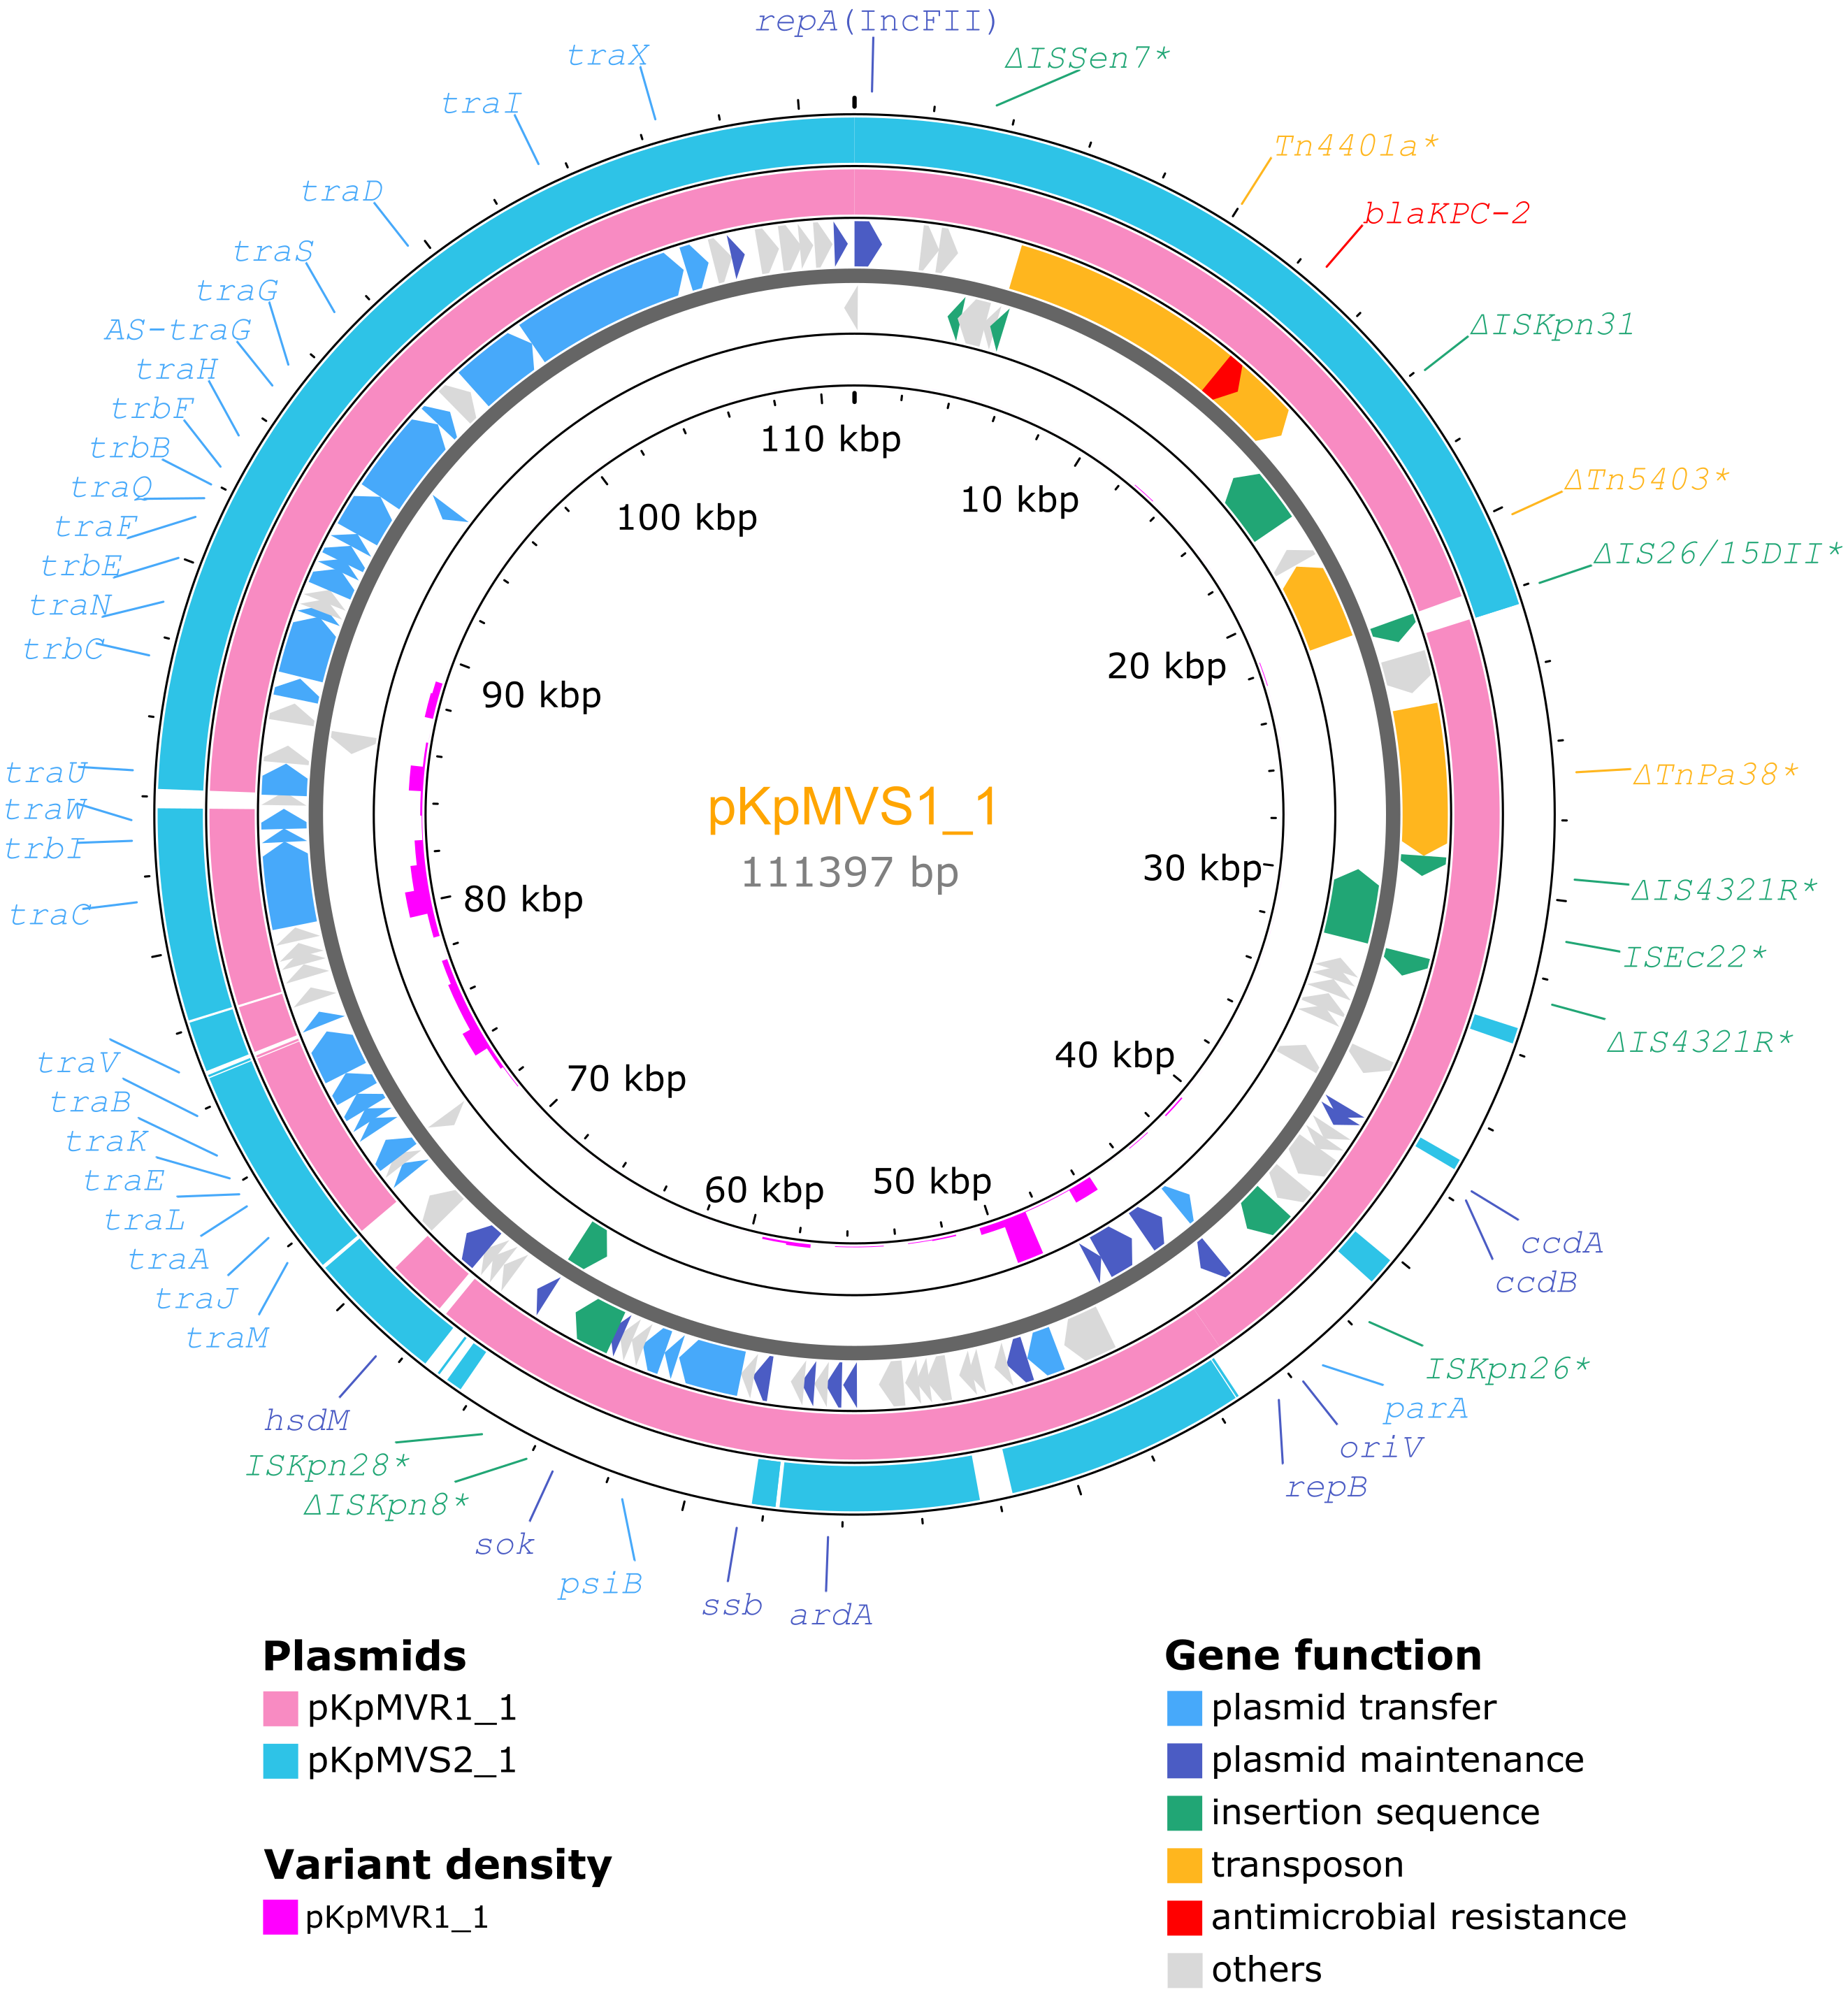
Supplementary Figure 2. A BRIG diagram comparing chromosomes of KpMVR1 and KpMVS2 with that of KpMVS1. Parameters for BLASTn sequence alignment: “-task megablast -ungapped -qcov_hsp_perc 0.8”. Four large deletions (>4 kbp) in the chromosome of KpMVR1 when compared to that of KpMVS1 (Table 3) are denoted by digits in filled circles. Genetic structures of these deleted regions are illustrated in Figure 1 and Supplementary Figures 3–5.
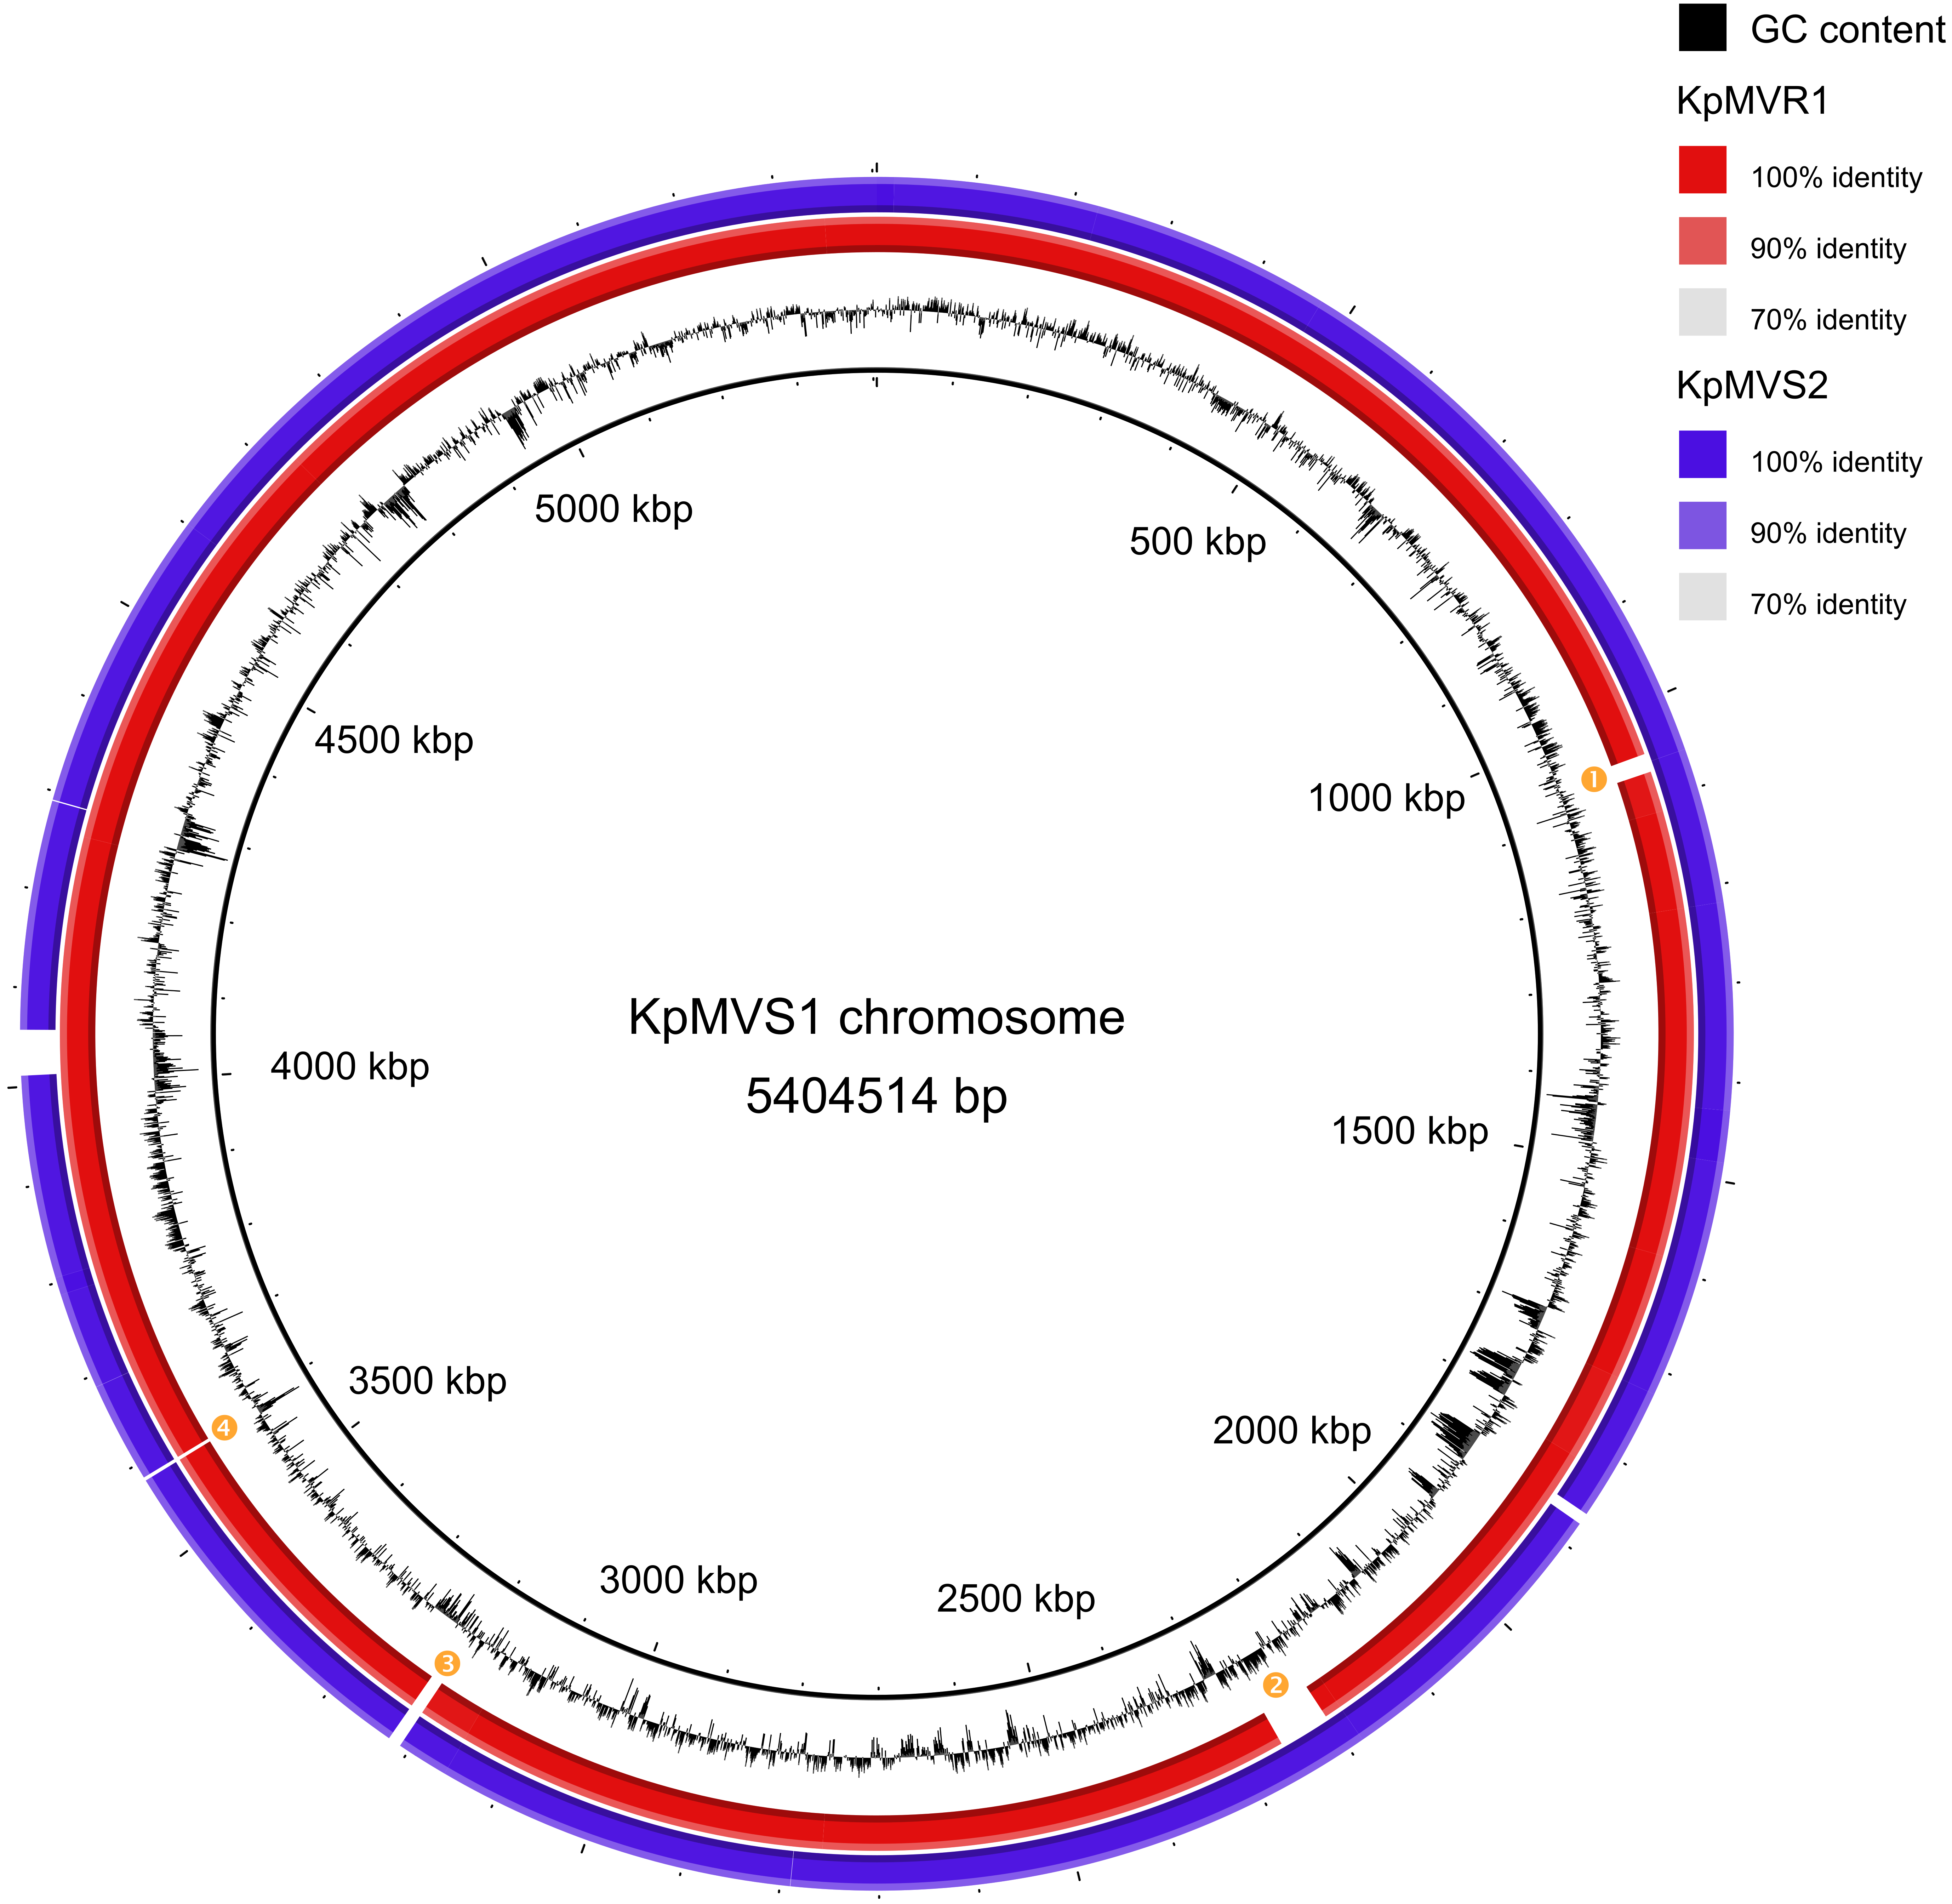

Supplementary Figure 3. Genetic structure of a 19.7-kbp region in KpMVS1 that was deleted in KpMVR1 (Table 4). Labels “start” and “end” indicate boundaries of the deleted region. Genes without known names are not labelled. “IS1X2*” denotes a variant of the IS1-family insertion sequence IS1X2 (98% nucleotide identity and 100% query coverage). “CRISPR” indicates an array of clustered regularly interspaced short palindromic repeats. See Supplementary Table 4, Addition File 3 for detailed annotations of this region.
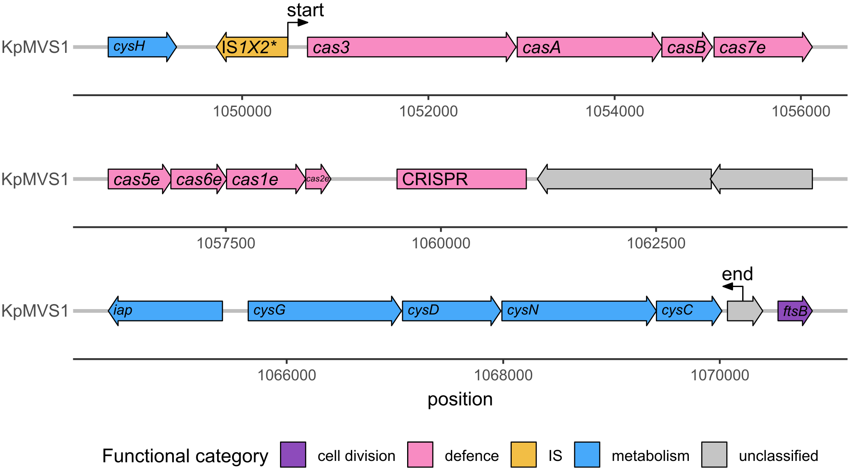

Supplementary Figure 4. Genetic structure of a 33.5-kbp region in KpMVS1 that was deleted in KpMVR1 (Table 4). Labels “start” and “end” indicate boundaries of the deleted region. Genes without known names are not labelled. See Supplementary Table 5, Additional File 3 for detailed annotations of this region.
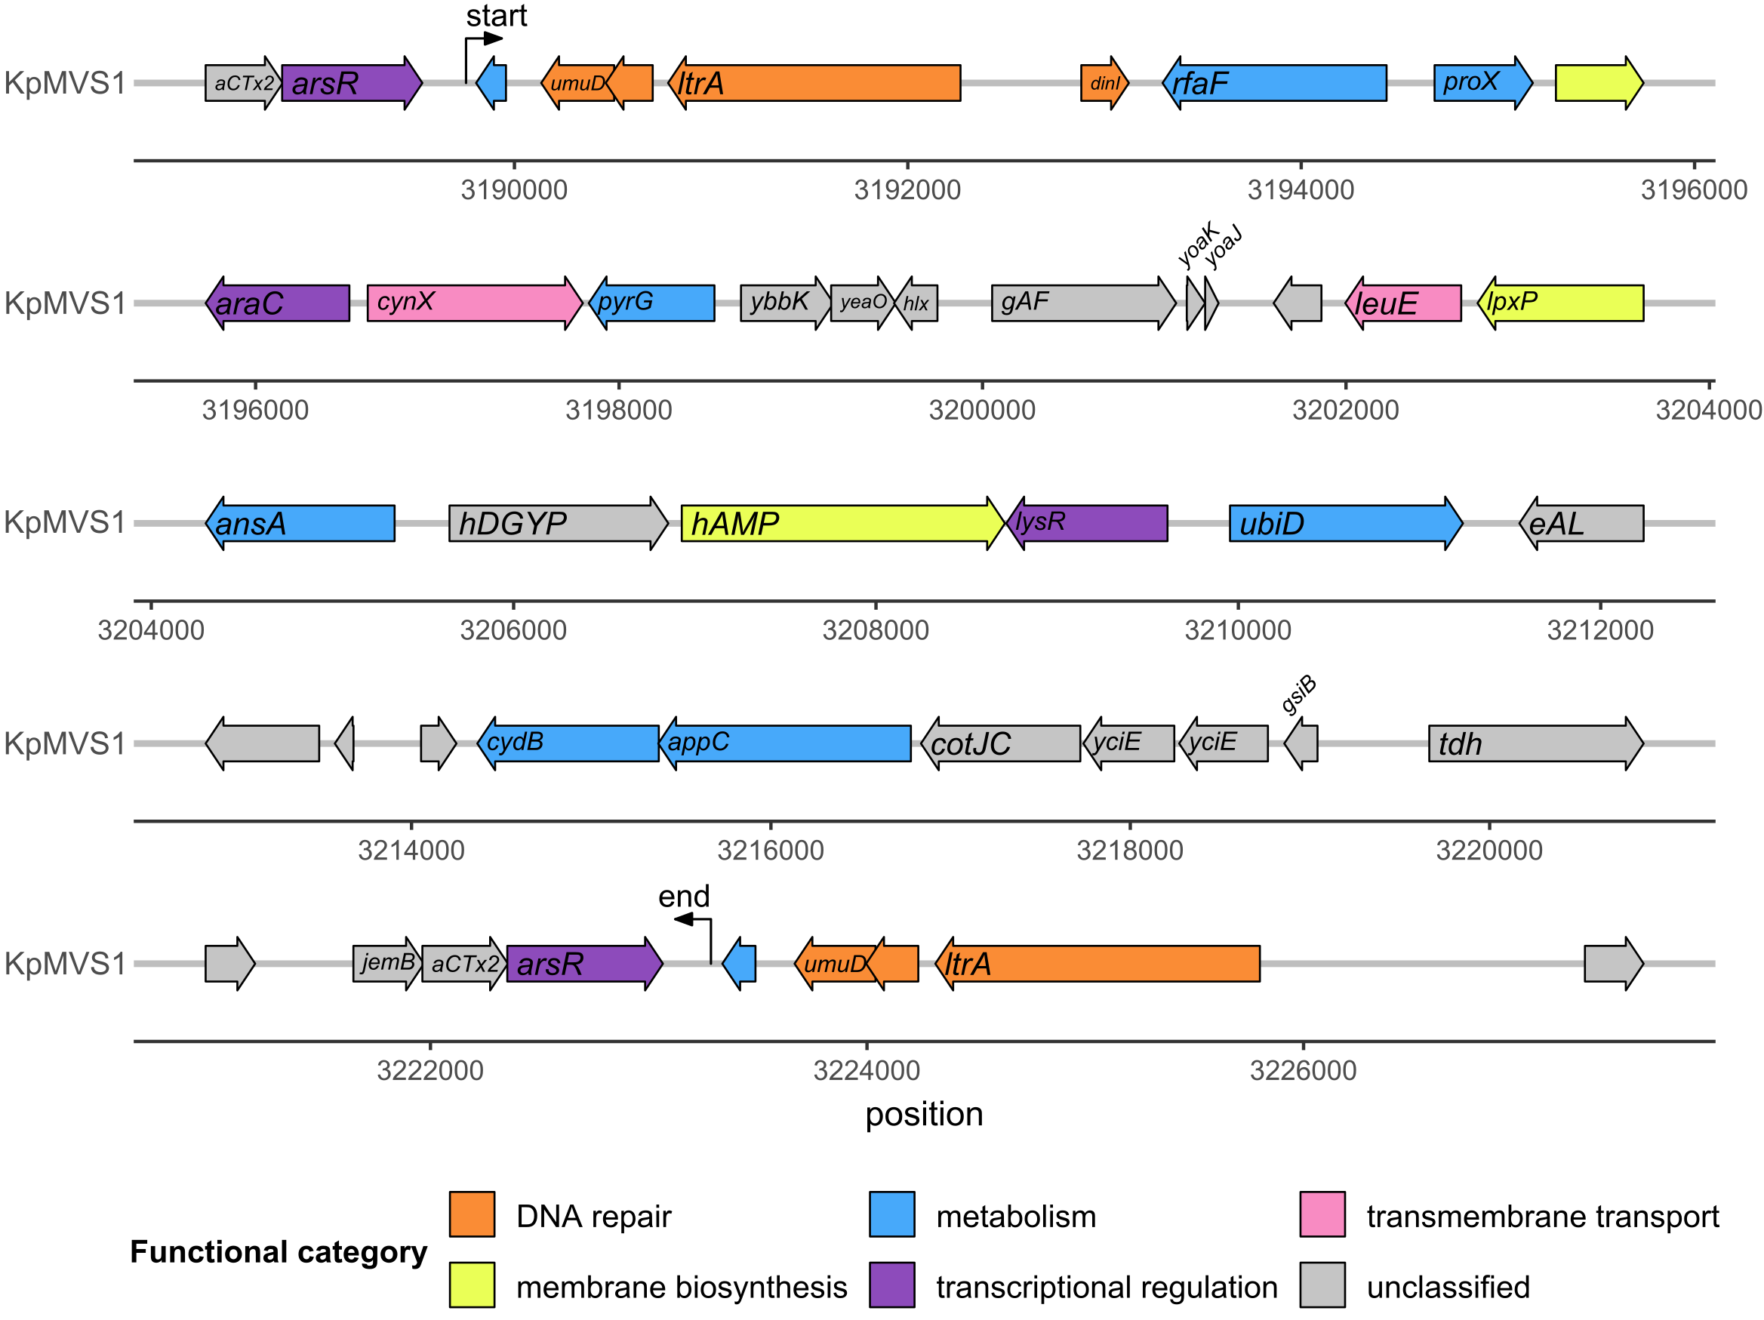

Supplementary Figure 5. Genetic structure of a 4.9-kbp region in KpMVS1 that was deleted in KpMVR1 (Table 4). Labels “start” and “end” indicate boundaries of the deleted region. Genes without known names are not labelled. “IS3H*” denotes a variant of the IS3-family insertion sequence IS3H (79% nucleotide identity and 100% query coverage). There were nine copies of this variant in the KpMVS1 chromosome and eight copies in the KpMVR1 chromosome, which is consistent with the content of the 4.9-kbp deletion (Supplementary Table 6, Additional File 3).
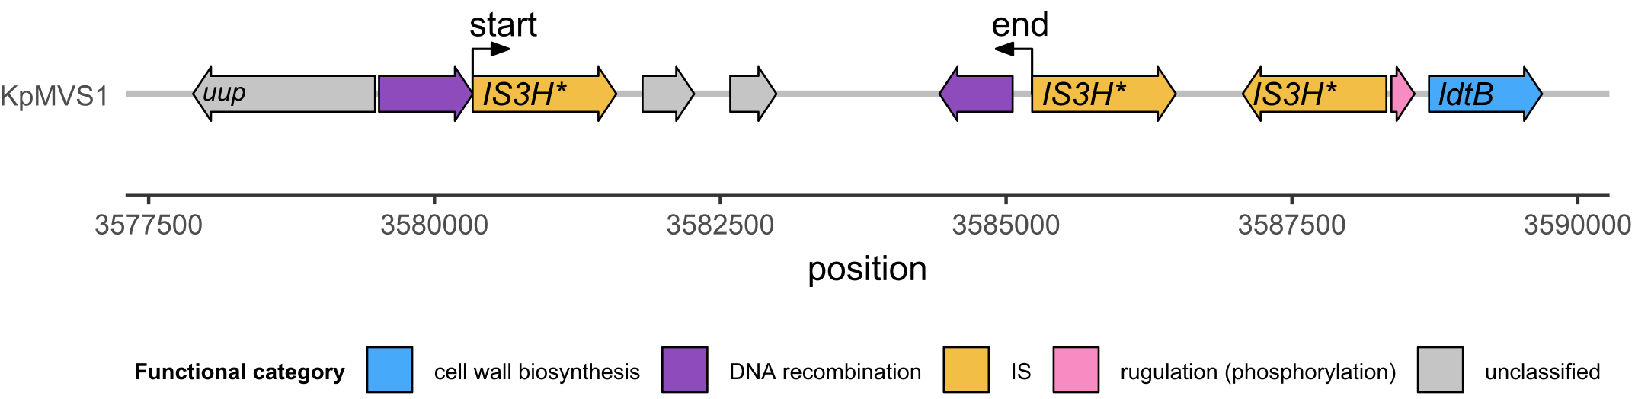
Supplementary Figure 6. Prediction of signal peptides and the cleavage site (CS) in OmpK36 using the slow model mode of SignalP v6.0. The “N”, “H”, and “C” regions in each protein sequence denote the N-terminal region (Sec/SPI n), centre hydrophobic region (Sec/SPI h), and C-terminal region (Sec/SPI c) of the signal peptide, respectively, whereas “O” denotes the non-signal peptide region (OTHER). The CS is indicated by the red vertical dashed line. The probability of each amino acid to be part of each peptide region is indicated by a coloured solid curve throughout the protein sequence. (a) Predictions for the wild-type OmpK36 in KpMVS1. (b) Predictions for the frameshifted OmpK36 variant in KpMVR1.
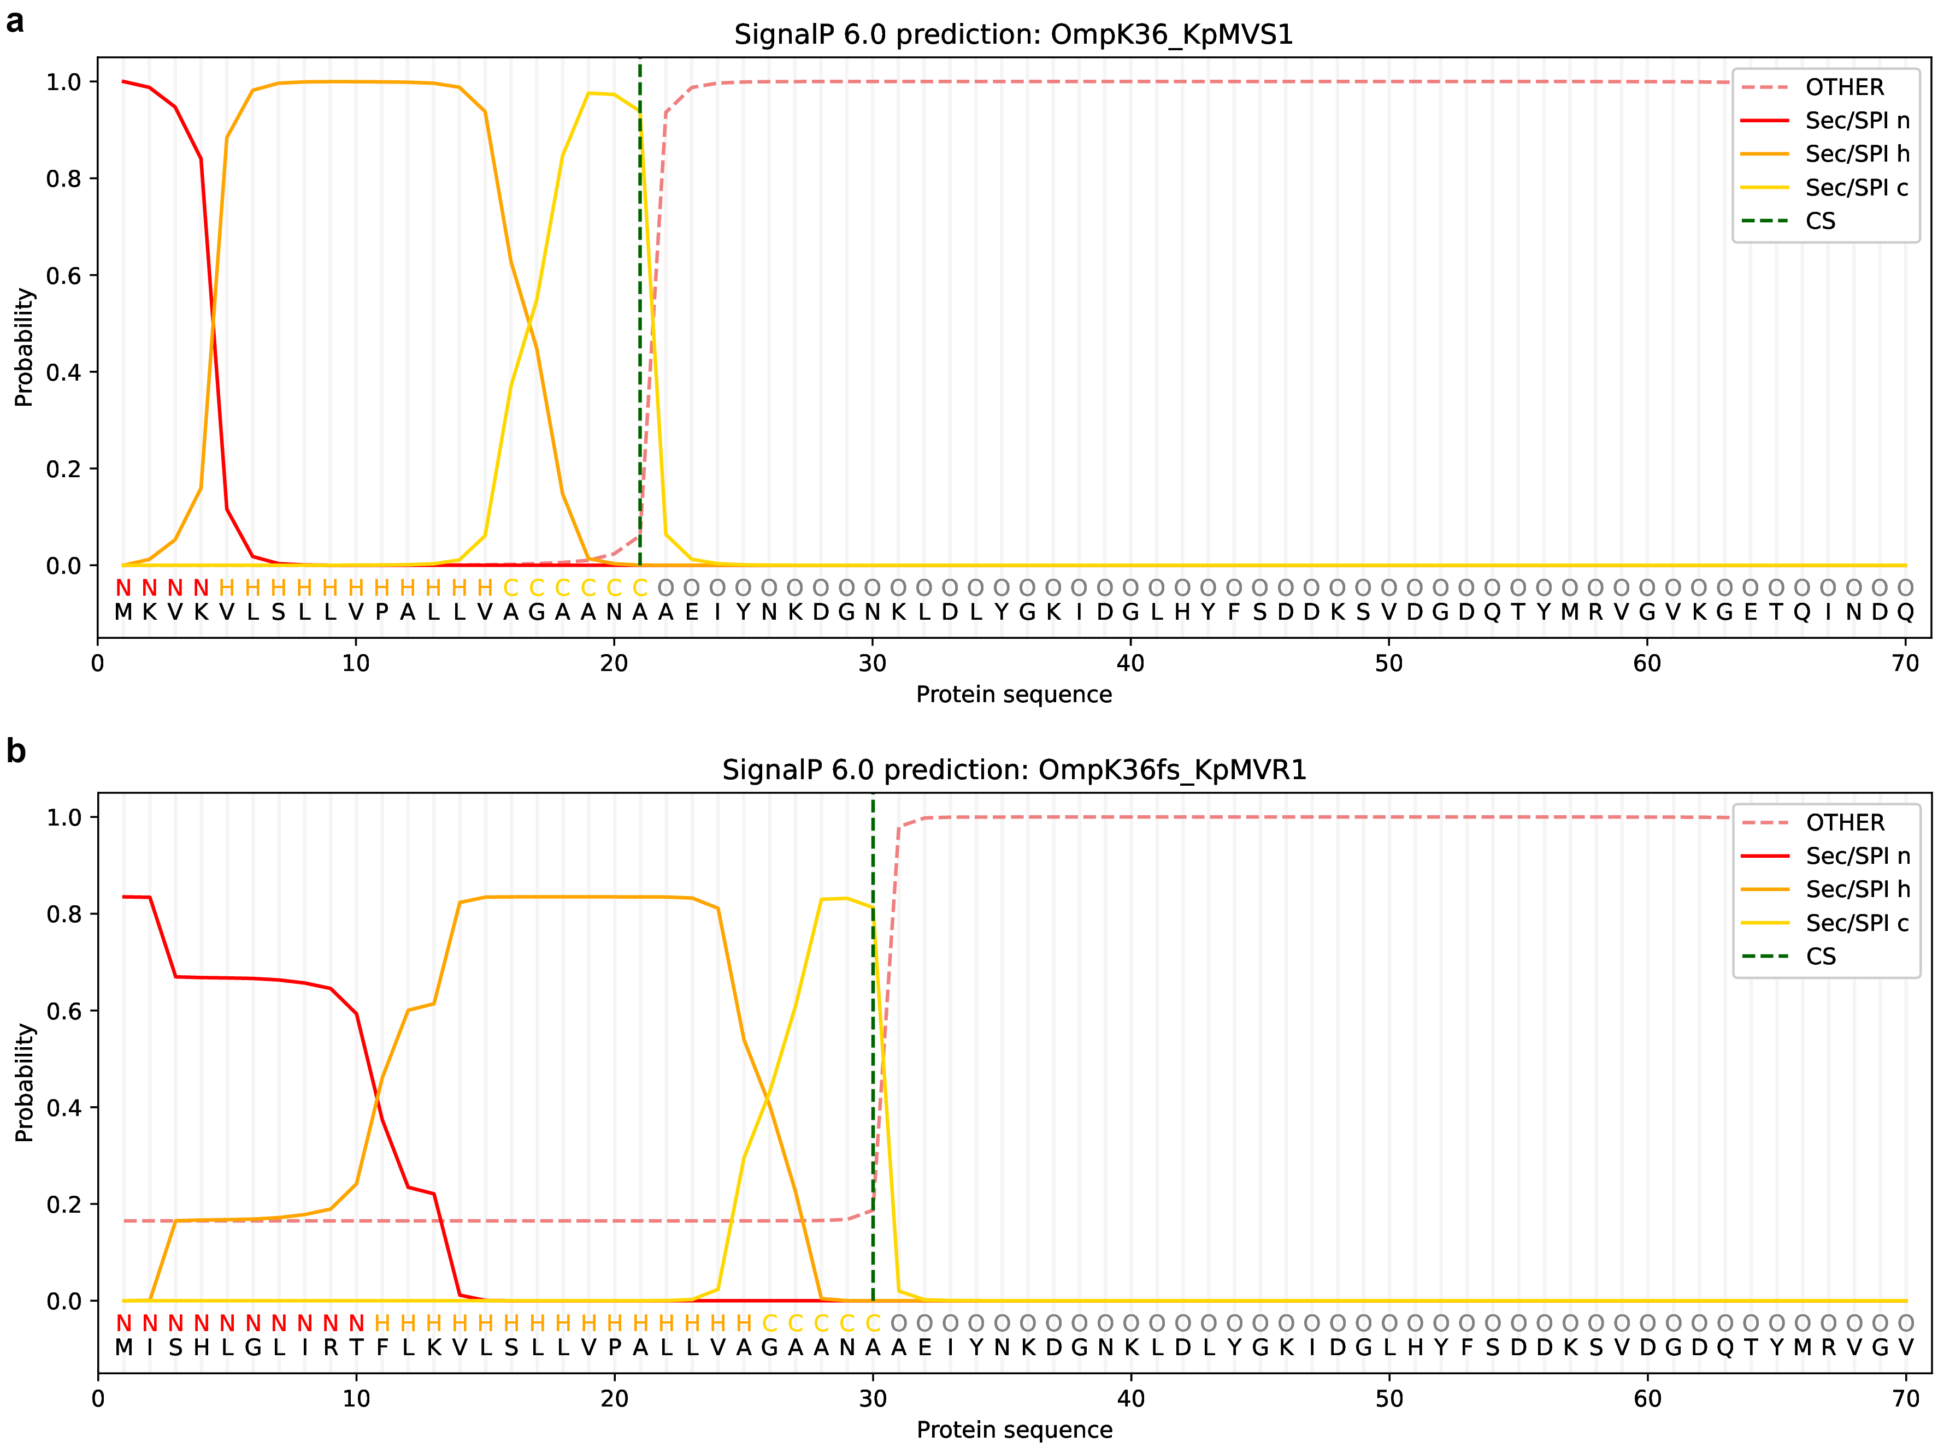

Supplementary Figure 7. Midpoint-rooted neighbour-joining phylogenetic tree of 10 TraN amino acid sequences, where TraN_{pKpMVR1_1} was identical to Tra_{pKpMVS2_1}. The sequences are named after source plasmids. The structural groups (TraNα, TraNβ, TraNγ, and TraNδ) [3] of TraN are indicated by shaded boxes and labelled. The scale bar represents the number of amino acid substitutions per residue.
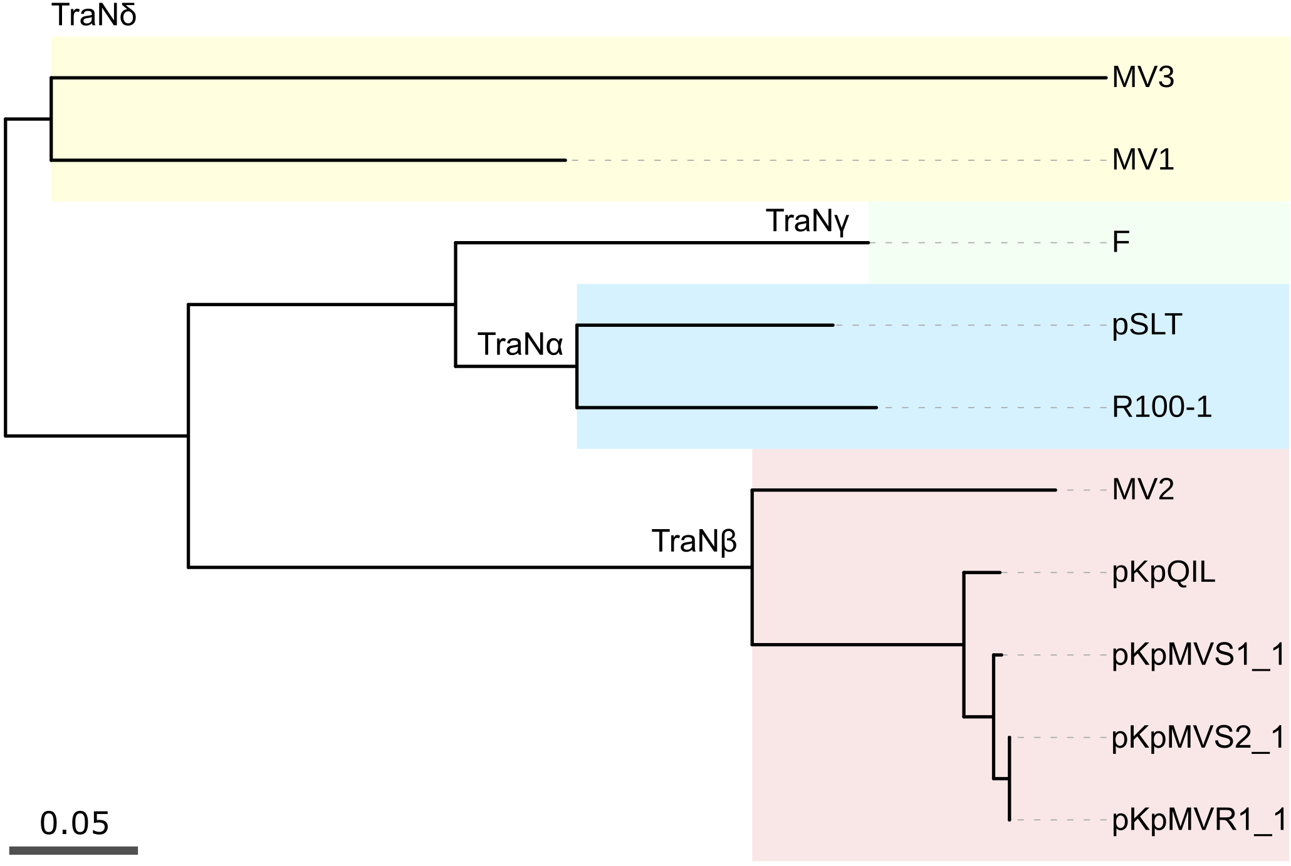
Supplementary Figure 8. Comparison of predicted TraN structures for plasmids pKpQIL, pKpMVS1_1, and pKpMVR1_1. Amino acid chains are represented by ribbons. (a) Predicted 3D structures with residues coloured by scores from the predicted local distance difference test (pLDDT). The pLDDT was performed by AlphaFold3 to evaluate the per-residue local confidence of the predicted 3D structure. (b) Pairwise structural comparison through the super-imposition analysis. Dashed boxes indicate the tip/sensor domains of TraN [3].
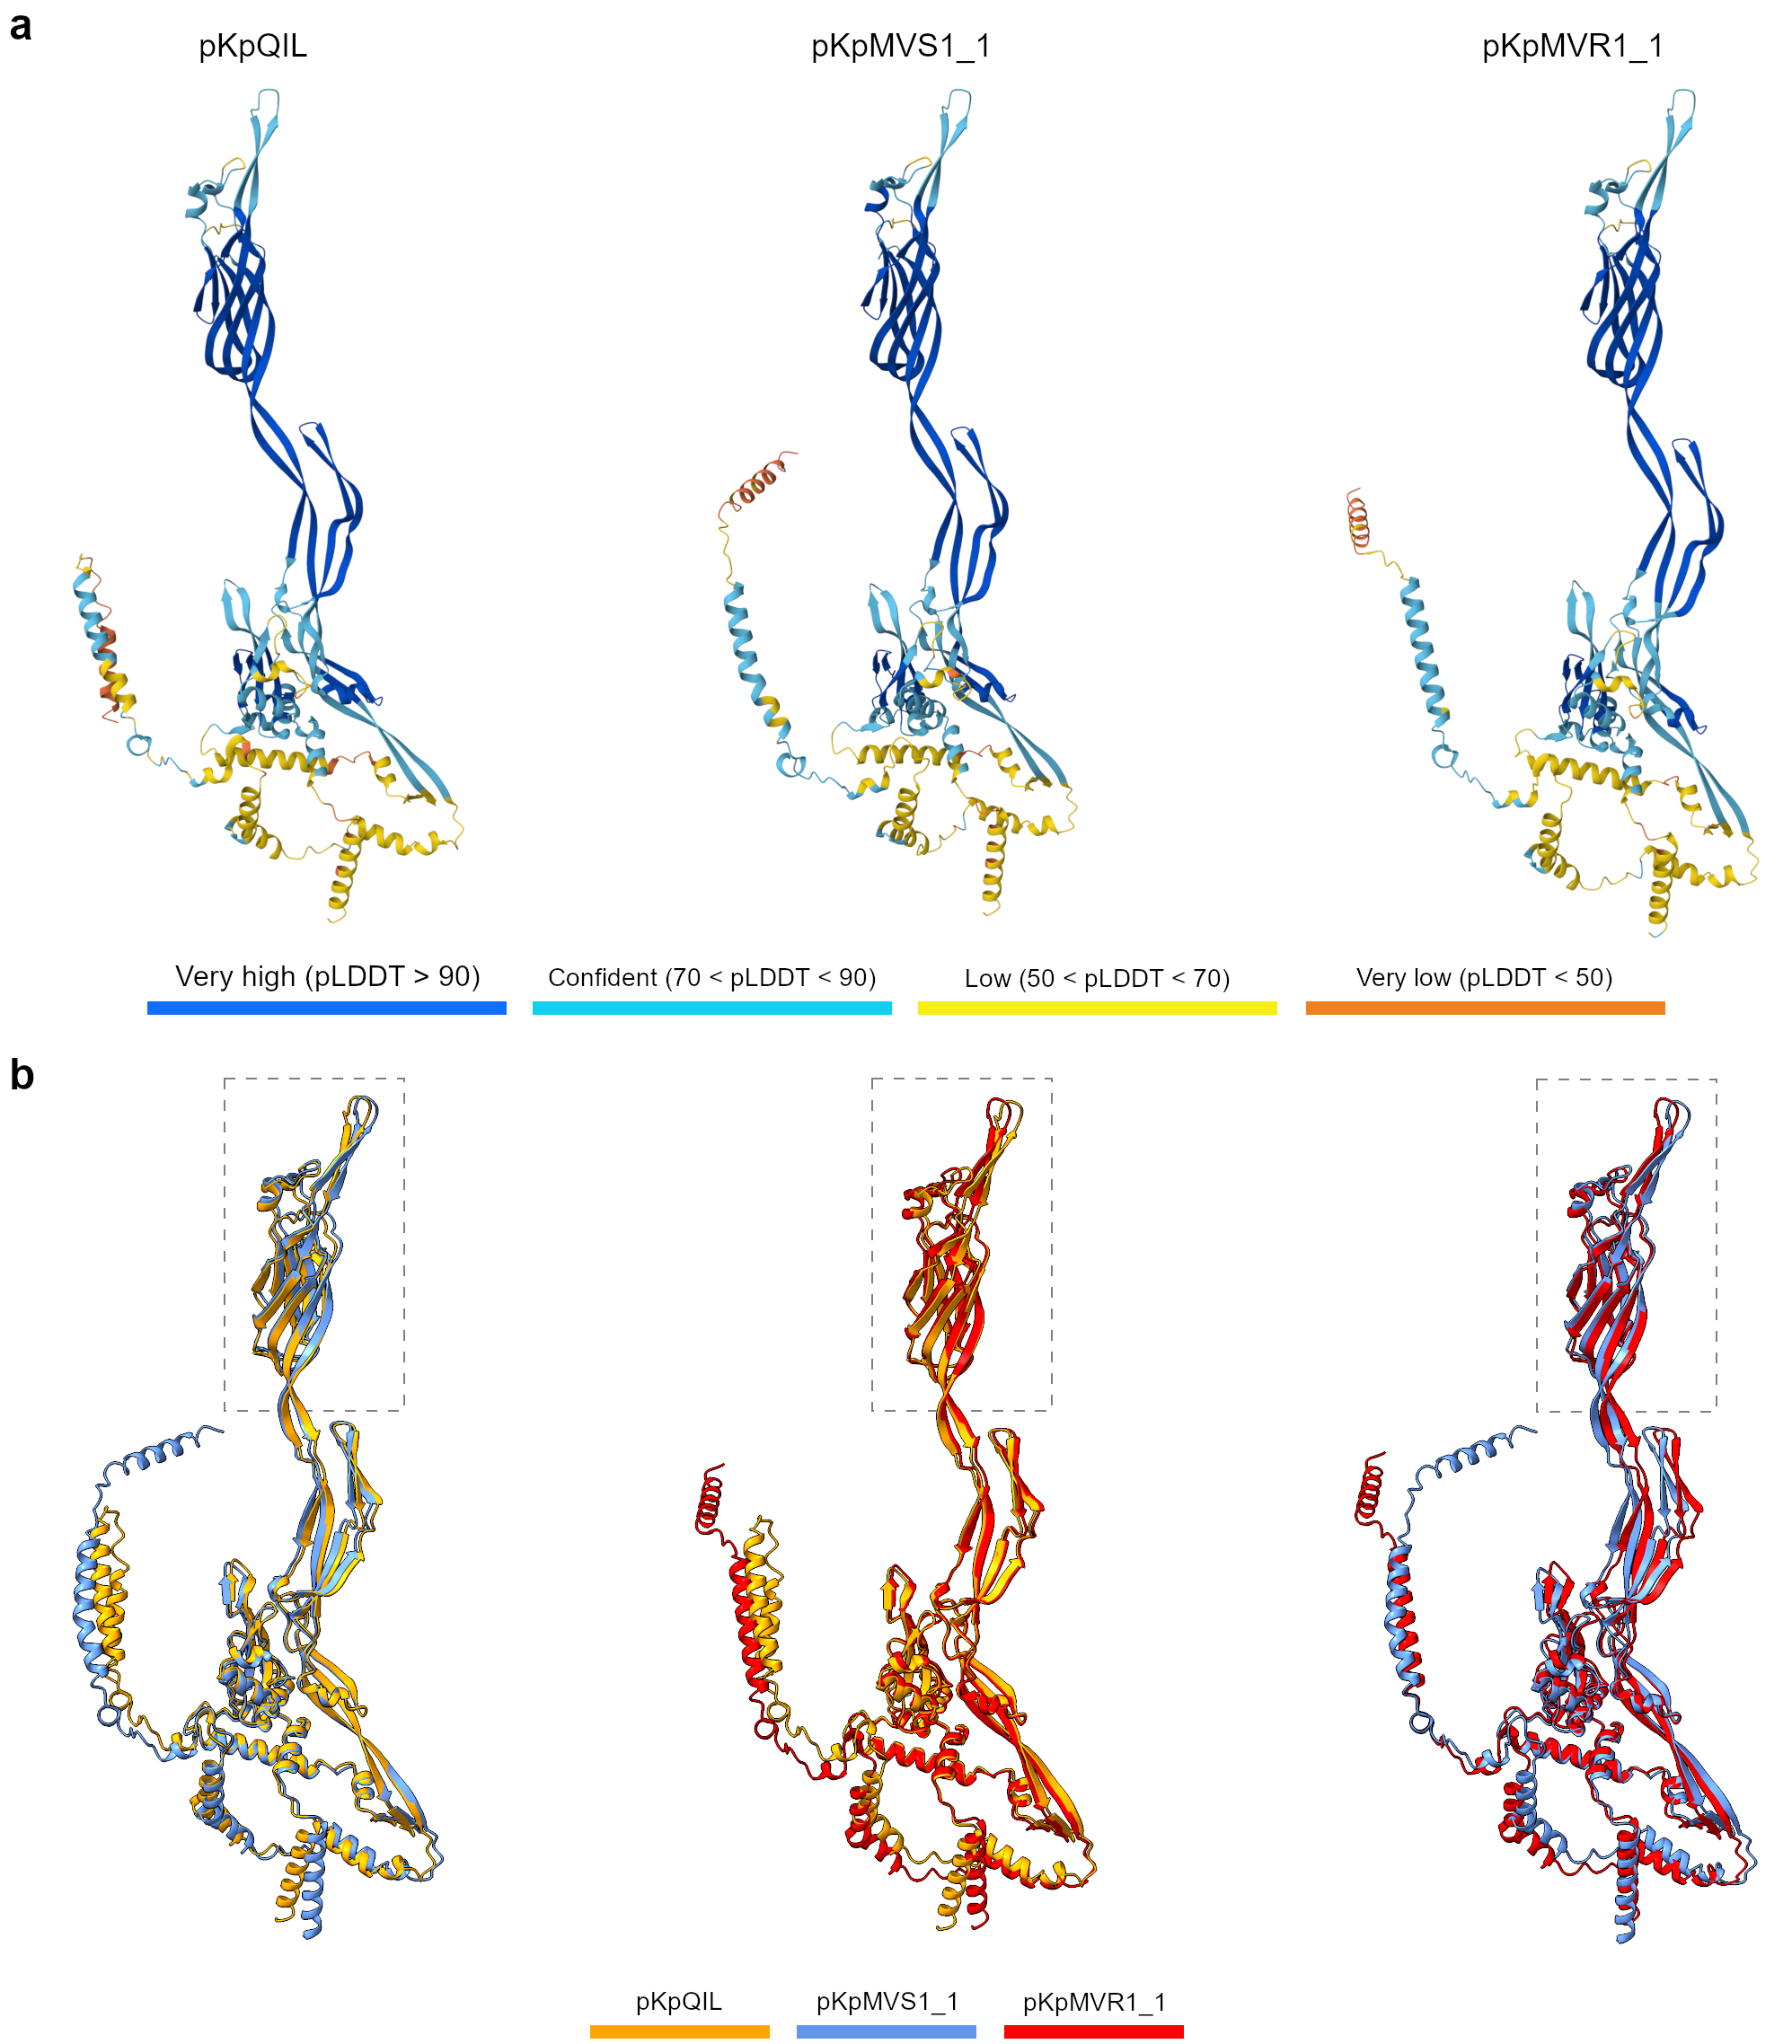

Supplementary Figure 9. Locations of amino acid variation in the tip/sensor domains of TraN from plasmids pKpQIL, pKpMVS1_1, and pKpMVR1_1, with amino acid chains represented by ribbons in the superimposition view. The variable sites are highlighted in yellow, blue, and magenta. In comparison with Supplementary Figure 8b, proteins are arbitrarily rotated around the vertical axis to expose all variable sites.
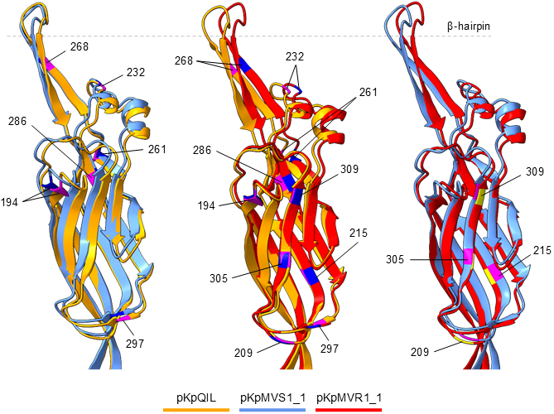

References
1. Danecek P, Auton A, Abecasis G, Albers CA, Banks E, DePristo MA, et al. The variant call format and VCFtools. Bioinformatics. 2011;27:2156–8. https://doi.org/10.1093/bioinformatics/btr330.
2. Grant JR, Enns E, Marinier E, Mandal A, Herman EK, Chen C, et al. Proksee: in-depth characterization and visualization of bacterial genomes. Nucleic Acids Research. 2023;51:W484–92. https://doi.org/10.1093/nar/gkad326.
3. Frankel G, David S, Low WW, Seddon C, Wong JLC, Beis K. Plasmids pick a bacterial partner before committing to conjugation. Nucleic Acids Research. 2023;51:8925–33. https://doi.org/10.1093/nar/gkad678.

