Supplementary information

Efficient PFAS detection in water associated with ice rinks: On-line SPE and LC-QTOF mass spectrometry for targeted and suspect screening in a single run

Yanan Liª, Roxana Sühringª*

ª Department of Chemistry and Biology, Toronto Metropolitan University, Toronto Ontario, M5B 2K3, Canada

*Corresponding author:
E-mail address: roxana.suehring@torontomu.ca (Roxana Sühring)

Table of contents
Table S1. Chemical details of the 24 targeted PFAS 3
Table S2. Quantifier and qualifier ions of 24 targeted PFAS by on-line SPE LC-QTOF 7
Table S3. Recovery of isotope-labelled PFAS passing PES filter 8
Table S4. Modified L₁₆(4⁶) array of MS ionisation parameters for optimisation 8
Table S5. Rapid suspect screening results of PFAS for ice rink water samples 11

Fig. S1. Results of 28 targeted PFAS from the optimisation of six MS parameters 9
Fig. S2. Results of 28 targeted PFAS from the optimisation of five MS parameters . 10

Table S1. Chemical details of the 24 targeted PFAS
Full names | Acronym | CAS | Chemical structure | Log P | pKa
Perfluoropentanoic acid | PFPeA | 2706-90-3 | 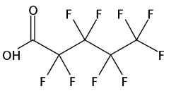 | 3.414ª | 0.400±0.10ª  2.27¹
Perfluoro(4-methoxybutanoic) acid | PFMBA | 863090-89-5 | 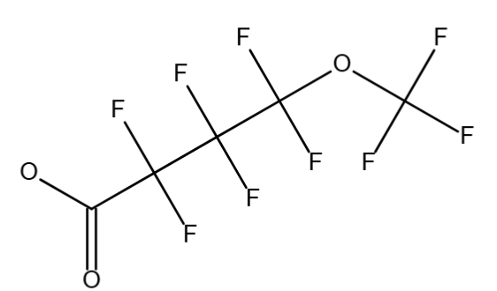 | 4.021ª | 0.507±0.10ª
Perfluorobutanesulfonic acid | PFBS | 375-73-5 | 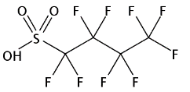 | 1.946ª | –3.574±0.50ª  0.14²  −5.5–0.14³
Perfluoro(2-ethoxyethane) sulfonic acid | PFEESA | 113507-82-7 | 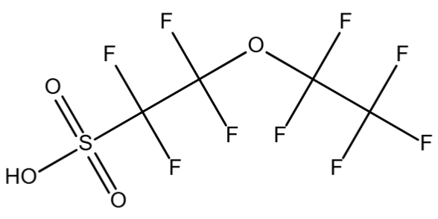 | 2.595ª | –3.250±0.50ª
Perfluoro-3,6-dioxaheptanoic acid | 3,6-OPFHpA | 151772-58-6 | 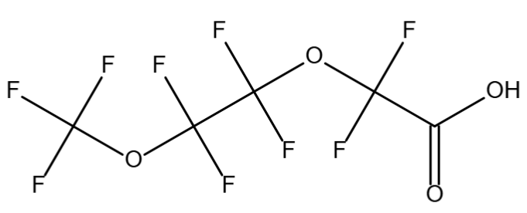 | 5.141ª | 0.198±0.10ª
4:2 Fluorotelomer sulfonic acid | 4:2 FTS | 757124-72-4 | 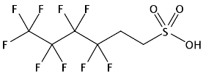 | 1.166ª | 1.249±0.50ª
Perfluorohexanoic acid | PFHxA | 307-24-4 | 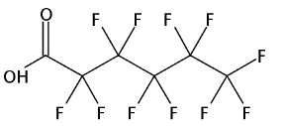 | 3.906 ª | 0.417±0.10ª  2.17¹  −0.16²  −0.16–0.9³  0.43–0.64⁴
Perfluoro-1-pentanesulfonic acid; | PFPeS | 2706-91-4 | 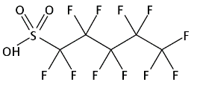 | 2.429ª | –3.561±0.50ª
2,3,3,3-Tetra-2-(1,1,2,2,3,3,3-heptafluoropropoxy)propanoic acid | HFPO-DA | 13252-13-6 | 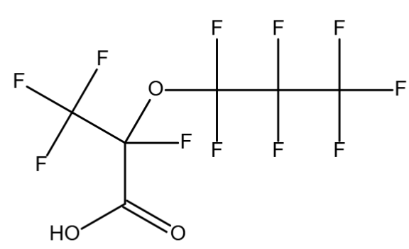 | 5.099ª | –1.356±0.10ª  2.84⁵
Perfluoroheptanoic acid | PFHpA | 375-85-9 | 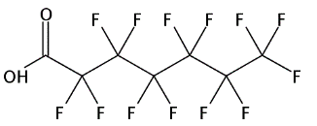 | 4.870ª | 0.470±0.10ª  2.26¹  −0.19–−0.15³  0.74–0.92⁴
Perfluorohexanesulfonic acid | PFHxS | 355-46-4 | 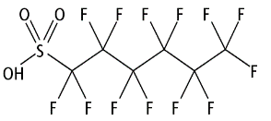 | 2.976ª | –3.339±0.50ª  0.14²  –5.5–0.14³
Dodecafluoro-3H-4,8-dioxanonanoic acid | DONA | 919005-14-4 | 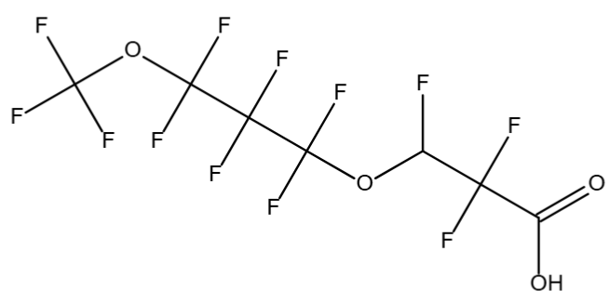 | 5.782ª | 0.567±0.10ª
Perfluoro-1-(perfluoroethyl)cyclohexanesulfonic acid | PFECHS | 646-83-3 | 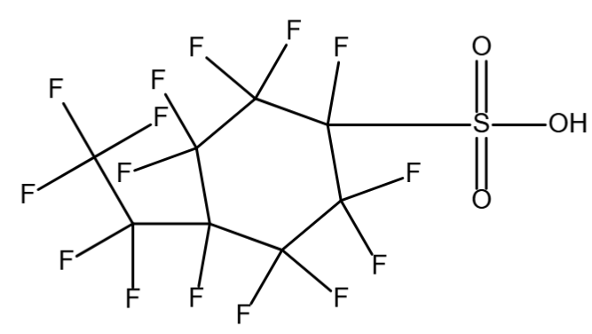 | 3.457ª | –3.565±0.70ª
6:2 Fluorotelomer sulfonic acid | 6:2 FTS | 27619-97-2 | 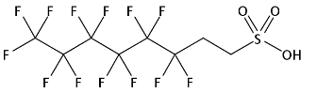 | 2.501ª | 1.305±0.50ª
Perfluorooctanoic acid | PFOA | 335-67-1 | 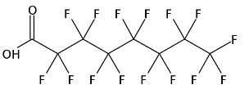 | 5.576ª | 0.504±0.10ª  2.8⁶  2.5⁷  1.31–2.8⁸  <1–3.8⁹  −3.32¹⁰
Perfluoro-1-heptanesulfonic acid | PFHpS | 375-92-8 | 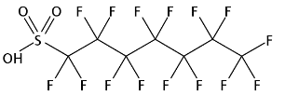 | 3.617ª | −3.290±0.50ª
Perfluorohexanesulfonamide | FHxSA-I | 41997-13-1 | 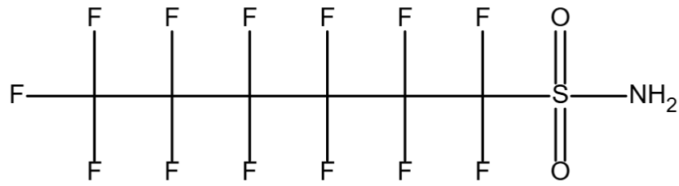 | 3.676ª | 6.939±0.60ª
Perfluorooctanesulfonic acid | PFOS | 1763-23-1 | 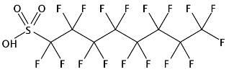 | 4.175ª | −3.272±0.50ª  −3.27²  −4.20¹⁰  −5.5–0.14³
Perfluorononanoic acid | PFNA | 375-95-1 | 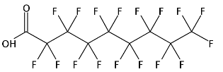 | 6.598ª | 0.516±0.10ª  2.58¹  −0.21–0.17³
9-Chlorohexadecafluoro-3-Oxanone-1-Sulfonic Acid | 9Cl-PF3ONS | 756426-58-1 | 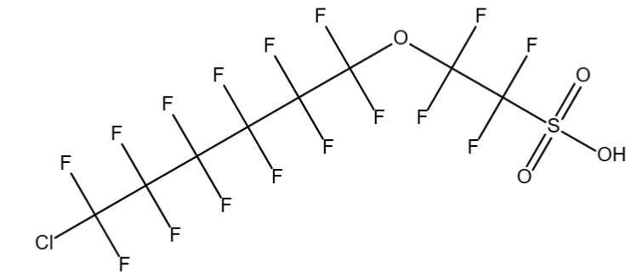 | 5.706ª | −3.172±0.50ª
Perfluorononanesulfonic acid | PFNS | 68259-12-1 | 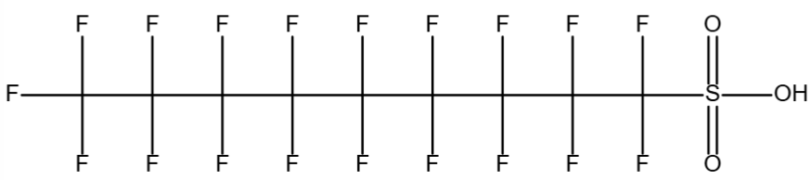 | 4.854ª | −3.265±0.50ª
8:2 Fluorotelomer sulfonic acid | 8:2 FTS | 39108-34-4 | 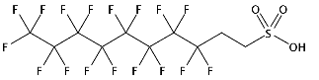 | 3.658ª | 1.316±0.50ª
Perfluorodecanoic acid | PFDA | 335-76-2 | 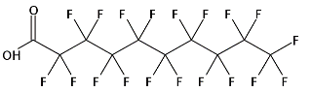 | 7.389ª | 0.520±0.10ª  2.61¹  −0.42–2.6³
Perfluoroundecanoic acid | PFUnDA | 2058-94-8 | 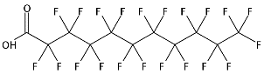 | 7.995ª | 0.522±0.10ª  3.13¹  −0.39–2.7³
ª | Predicated values were extracted from SciFinder database and calculated using Advanced Chemistry Development (ACD/Labs) Software (© 1994-2025 ACD/Labs)

Table S2. Quantifier and qualifier ions of 24 targeted PFAS by on-line SPE LC-QTOF
Acronym | Formula | Quantifier ion | Qualifier ion | Isotope labelled internal standard
PFPeA | C₅HF₉O₂ | 262.9778 | 263.9811 | ¹³C₅-PFPeA
PFMBA | C₅HF₉O₃ | 278.9704 | 280.9839 | ¹³C₃-PFBS
PFBS | C₄HF₉O₃S | 298.9448 | 299.9476 | ¹³C₅-PFPeA
PFEESA | C₄HF₉O₄S | 314.9400 | 315.9428 | ¹³C₃-PFBS
3,6-OPFHpA | C₅HF₉O₄ | 294.9667 | 295.9700 | ¹³C₅-PFHxA
4:2 FTS | C₆H₅F₉O₃S | 326.9750 | 327.9779 | ¹³C₂-4:2FTS
PFHxA | C₆HF₁₁O₂ | 312.9753 | 313.9785 | ¹³C₅-PFHxA
PFPeS | C₅HF₁₁O₃S | 348.9419 | 349.9445 | ¹³C₃-PFHxS
HFPO-DA | C₆HF₁₁O₃ | 284.9797 | 285.9831 | ¹³C₃-HFPO-DA
PFHpA | C₇HF₁₃O₂ | 362.9725 | 363.9757 | ¹³C₄-PFHpA
PFHxS | C₆HF₁₃O₃S | 398.9404 | 399.9433 | ¹³C₃-PFHxS
DONA | C₇H₂F₁₂O₄ | 376.9723 | 377.9755 | ¹³C₄-PFHpA
PFECHS | C₈HF₁₅O₃S | 460.9364 | 461.9392 | ¹³C₃-PFHxS
6:2 FTS | C₈H₅F₁₃O₃S | 426.9698 | 427.9730 | ¹³C₂-6:2FTS
PFOA | C₈HF₁₅O₂ | 412.9684 | 413.9714 | ¹³C₈-PFOA
PFHpS | C₇HF₁₅O₃S | 448.9355 | 449.9382 | ¹³C₃-PFHxS
FHxSA-I | C₆H₂F₁₃NO₂S | 397.9527 | 398.9570 | ¹³C₈-PFOA
PFOS | C₈HF₁₇O₃S | 498.9328 | 499.9359 | ¹³C₈-PFOS
PFNA | C₉HF₁₇O₂ | 462.9651 | 463.9684 | ¹³C₉-PFNA
9Cl-PF3ONS | C₈ClF₁₆O₄S | 530.8966 | 532.8935 | ¹³C₈-PFOS
PFNS | C₉HF₁₉O₃S | 548.9306 | 549.9336 | ¹³C₃-PFHxS
8:2 FTS | C₁₀H₅F₁₇O₃S | 526.9646 | 527.9680 | ¹³C₂-8:2FTS
PFDA | C₁₀HF₁₉O₂ | 512.9653 | 513.9684 | ¹³C₆-PFDA
PFUnDA | C₁₁HF₂₁O₂ | 562.9571 | 563.9604 | ¹³C₇-PFUnDA

Table S3. Recovery of isotope-labelled PFAS passing PES filter
PFAS | Peak area of PES filtered  (n = 4) |  |  | Peak area of unfiltered  (n = 4) |  | Mean recovery (%)
PFAS | Mean | RSD%ª | Mean |  | RSD% | Mean recovery (%)
¹³C₅-PFPeA | 5692636.5 | 14% | 6328132.5 |  | 4% | 90%
¹³C₃-PFBS | 7672025.0 | 8% | 7775087.3 |  | 6% | 99%
¹³C₅-PFHxA | 6161302.0 | 8% | 6138953.3 |  | 4% | 100%
¹³C₃-HFPO-DA | 2237683.3 | 9% | 2393161.0 |  | 5% | 94%
¹³C₄-PFHpA | 5171868.0 | 9% | 5614932.5 |  | 6% | 92%
¹³C₃-PFHxS | 6201562.5 | 10% | 6003007.3 |  | 6% | 103%
¹³C₈-PFOA | 4151644.5 | 15% | 4568418.8 |  | 6% | 91%
¹³C₈-PFOS | 3005866.3 | 18% | 3724659.8 |  | 4% | 81%
¹³C₉-PFNA | 865045.0 | 7% | 785689.8 |  | 5% | 110%
¹³C₆-PFDA | 1988354.3 | 8% | 2250570.5 |  | 4% | 88%
¹³C₇-PFUndA | 1531756.8 | 13% | 1338739.0 |  | 7% | 114%
¹³C₂-PFDoA | 506757.5 | 23% | 528589.5 |  | 16% | 96%
ª | RSD = relative standard deviation

Table S4. Modified L₁₆(4⁶) array of MS ionisation parameters for optimisation
Experiments number | Capillary voltage  (V) | Drying gas temperature  (°C) | Drying gas flow rate (L min⁻¹) | Sheath gas temperature  (°C) | Nozzle voltage  (V) | Nebulizer pressure  (psi)
Exp 1 | 2000 | 175 | 4 | 250 | 0 | 25
Exp 2 | 2500 | 215 | 7 | 275 | 700 | 35
Exp 3 | 3000 | 165 | 10 | 325 | 1500 | 45
Exp 4 | 3500 | 300 | 13 | 350 | 2000 | 55
Exp 5 | 2000 | 215 | 10 | 325 | 2000 | 35
Exp 6 | 2500 | 265 | 13 | 350 | 0 | 45
Exp 7 | 3000 | 300 | 4 | 250 | 700 | 55
Exp 8 | 3500 | 175 | 7 | 275 | 1500 | 25
Exp 9 | 2000 | 265 | 7 | 325 | 1500 | 55
Exp 10 | 2500 | 300 | 10 | 350 | 2000 | 25
Exp 11 | 3000 | 175 | 13 | 250 | 700 | 35
Exp 12 | 3500 | 215 | 4 | 275 | 1500 | 45
Exp 13 | 2000 | 300 | 13 | 350 | 0 | 25
Exp 14 | 2500 | 175 | 4 | 250 | 700 | 35
Exp 15 | 3000 | 215 | 7 | 275 | 1500 | 45
Exp 16 | 3500 | 265 | 10 | 325 | 2000 | 55

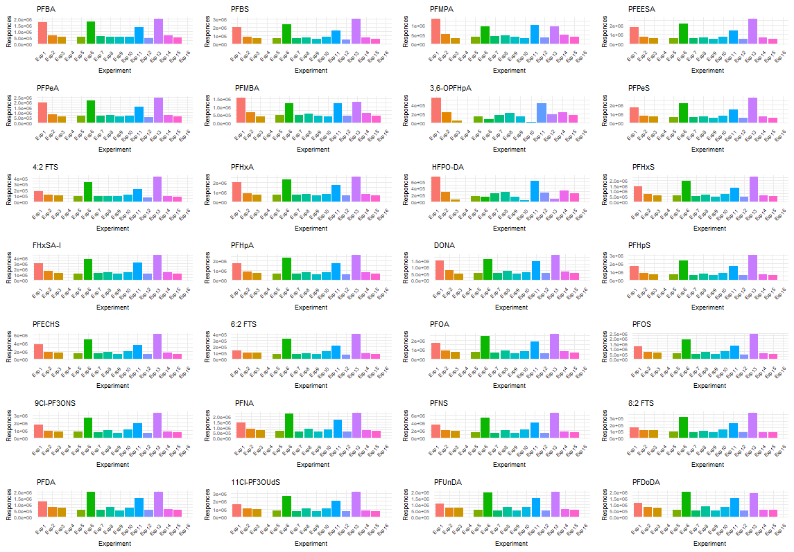
Fig. S1. Results of 28 targeted PFAS from the optimisation of six MS parameters
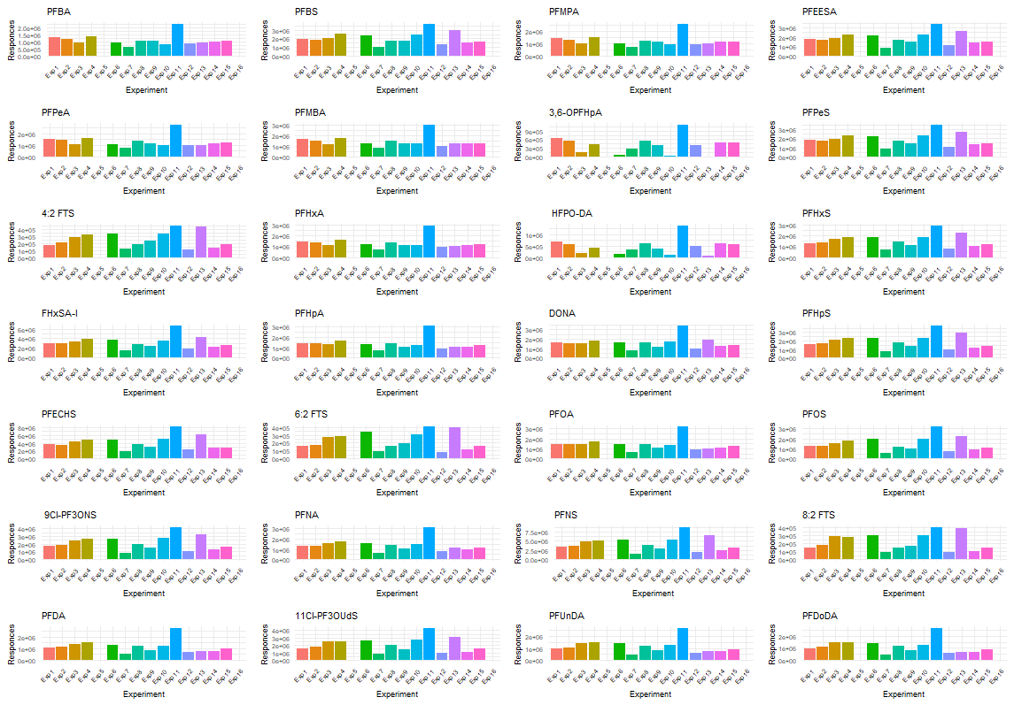
Fig. S2. Results of 28 targeted PFAS from the optimisation of five MS parameters .

Table S5. Rapid suspect screening results of PFAS for ice rink water samples
Ice rink water types | PFAS detectionª
Source water  (n = 9) | 2-(Perfluooctyl)ethanthiol)*, 3H-Perfluoro-2,2,4,4-tetrahydroxypentane*, Octafluoroadipamide*, 2,2,2-Trifluoroethyl perfluorobutanesulfonate*, PFHxA, PFHpA, N-Methylperfluorooctane sulfonamidoacetic acid*
Reverse osmosis treated water  (n = 6) | ND^{b}
Melt ice water  (n = 5) | PFOA, PFHxA, 1-Pentafluoroethylethanol*
ª | The PFAS outside of the target list used in the quantitative analysis were indicated by asterisk (*)
^{b} | ND = No detection

References
1. R. Čabala, K. Nesměrák and T. Vlasáková, Dissociation constants of perfluoroalkanoic acids, Monatshefte für Chemie - Chemical Monthly, 2017, 148, 1679-1684.
2. A. Maimaiti, S. Deng, P. Meng, W. Wang, B. Wang, J. Huang, Y. Wang and G. Yu, Competitive adsorption of perfluoroalkyl substances on anion exchange resins in simulated AFFF-impacted groundwater, Chemical Engineering Journal, 2018, 348, 494-502.
3. H. Chen, Y. Yao, Z. Zhao, Y. Wang, Q. Wang, C. Ren, B. Wang, H. Sun, A. C. Alder and K. Kannan, Multimedia Distribution and Transfer of Per- and Polyfluoroalkyl Substances (PFASs) Surrounding Two Fluorochemical Manufacturing Facilities in Fuxin, China, Environmental Science & Technology, 2018, 52, 8263-8271.
4. B. Yang, Y. Han, G. Yu, Q. Zhuo, S. Deng, J. Wu and P. Zhang, Efficient removal of perfluoroalkyl acids (PFAAs) from aqueous solution by electrocoagulation using iron electrode, Chemical Engineering Journal, 2016, 303, 384-390.
5. S. A. Gannon, W. J. Fasano, M. P. Mawn, D. L. Nabb, R. C. Buck, L. W. Buxton, G. W. Jepson and S. R. Frame, Absorption, distribution, metabolism, excretion, and kinetics of 2,3,3,3-tetrafluoro-2-(heptafluoropropoxy)propanoic acid ammonium salt following a single dose in rat, mouse, and cynomolgus monkey, Toxicology, 2016, 340, 1-9.
6. A. Prior, R. C. Moldovan, J. Crommen, A. C. Servais, M. Fillet, G. J. de Jong and G. W. Somsen, Enantioselective capillary electrophoresis-mass spectrometry of amino acids in cerebrospinal fluid using a chiral derivatizing agent and volatile surfactant, Analytica Chimica Acta, 2016, 940, 150-158.
7. A. H. Karoyo and L. D. Wilson, Investigation of the Adsorption Processes of Fluorocarbon and Hydrocarbon Anions at the Solid–Solution Interface of Macromolecular Imprinted Polymer Materials, The Journal of Physical Chemistry C, 2016, 120, 6553-6568.
8. Y. Gong, L. Wang, J. Liu, J. Tang and D. Zhao, Removal of aqueous perfluorooctanoic acid (PFOA) using starch-stabilized magnetite nanoparticles, Science of The Total Environment, 2016, 562, 191-200.
9. M. Guo, Y. Lyu, T. Xu, B. Yao, W. Song, M. Li, X. Yang, T. Cheng and X. Li, Particle size distribution and respiratory deposition estimates of airborne perfluoroalkyl acids during the haze period in the megacity of Shanghai, Environmental Pollution, 2018, 234, 9-19.
10. O. Svahn and E. Björklund, Increased electrospray ionization intensities and expanded chromatographic possibilities for emerging contaminants using mobile phases of different pH, Journal of Chromatography B, 2016, 1033-1034, 128-137.

