PRESSnet: A Novel Framework for Patient Stratification and Biomarker Discovery using Knowledge Graphs

Cohen-Setton J, Shikhare S, Kagiampakis I, Salazar D, Gonçalves M, Jayabalan S, Coker E, Bikiel D, Sidders B, Jacob E, Bulusu K

Supplementary Information

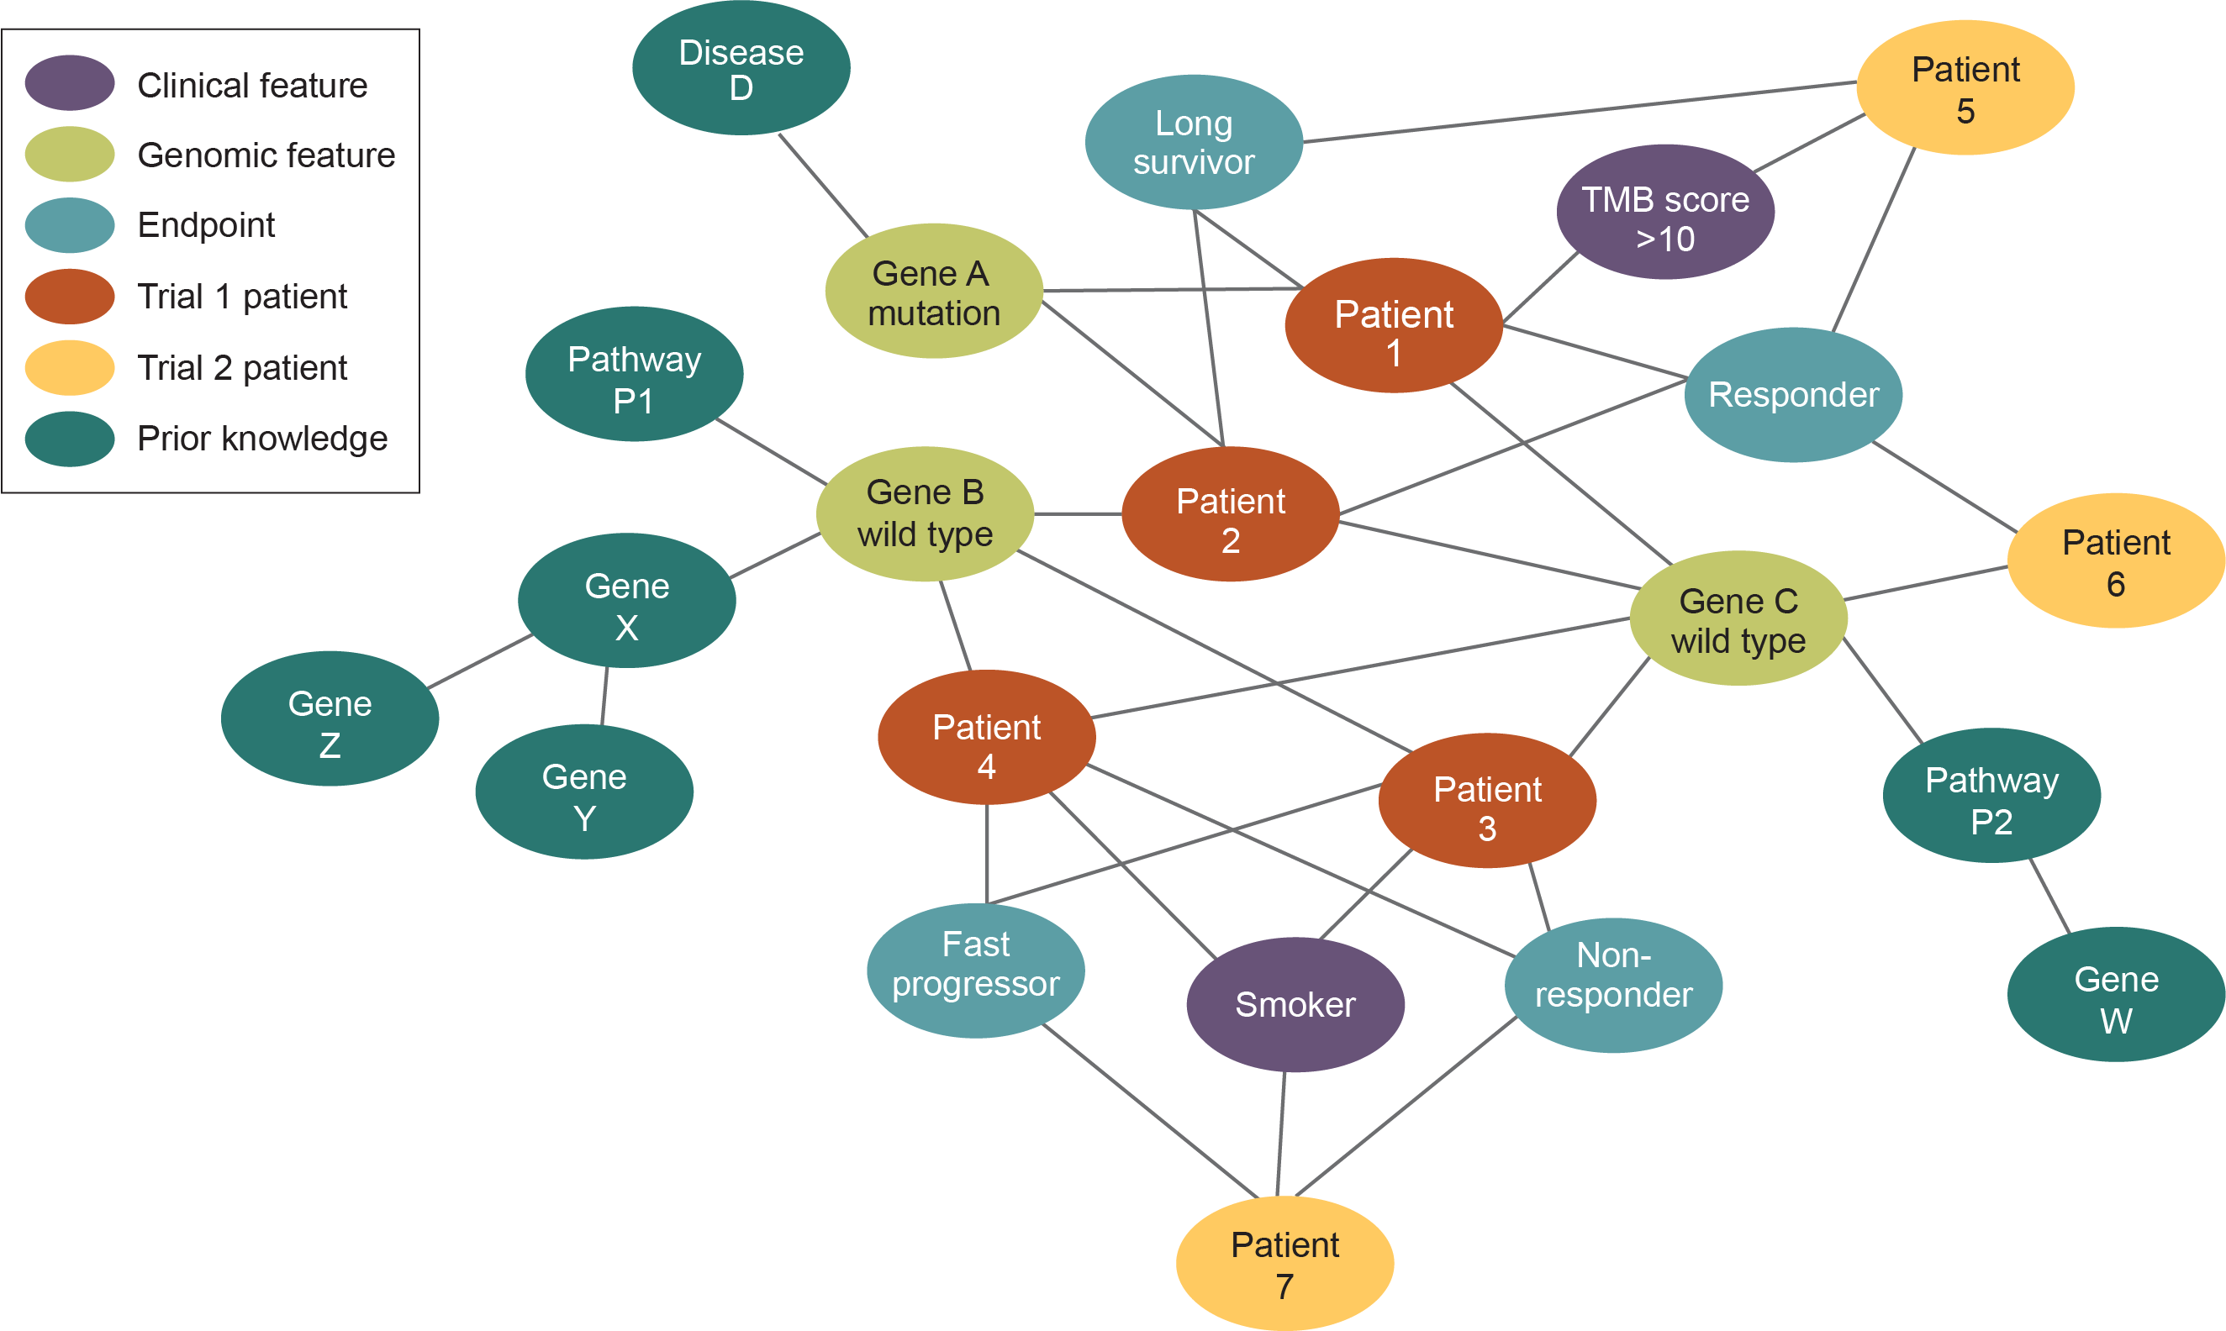

Supplementary Fig. 1 | Patient knowledge graphs (KGs) can easily scale to integrate multiple patient data sets and prior knowledge capturing the context behind features. KGs are flexible and scalable, allowing us to expand from patients in one trial (orange) to a KG integrating multiple trials (yellow) via shared features. We can also integrate prior knowledge (e.g. gene-gene interaction data, pathway data, etc.) as graph data (dark green) to combine with our trial data.

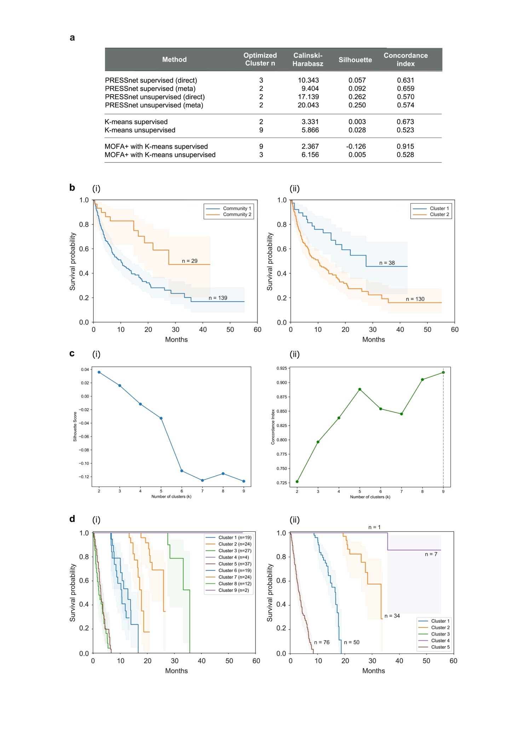

Supplementary Fig. 2 | Comparison of stratification hypotheses produced by PRESSnet and a benchmark feature clustering method. To evaluate the quality of patient stratification, PRESSnet’s approach of applying community detection to graphs of patient data was compared to K-means clustering applied to lung adenocarcinoma (LUAD) Memorial Sloan Kettering (MSK) immuno-oncology (IO) raw patient data and latent factor representations of patients produced by MOFA+. Optimal cluster n was determined using Calinski-Harabasz (CH) score for unsupervised analysis and concordance index for supervised analysis, where scoring was applied to the original raw data. a. Metrics for PRESSnet’s communities vs. those of K-means clustering for the two benchmark methods. PRESSnet strongly outperformed benchmark methods for cluster separability (C-H score, silhouette score) and survival differentiation in unsupervised analysis, and offered practical cluster counts for subtyping. b. Kaplan-Meier (KM) survival curves of clusters generated by (i) PRESSnet’s unsupervised community detection (with Louvain detection) and (ii) K-means clustering. c, Metrics for K-Means clustering applied to MOFA+ latent factors derived from supervised data, demonstrating the imbalance between (i) cluster separation quality and (ii) survival relevance across the range of cluster n values. d. Examples of KM curves for patients separated by K-Means clustering applied to MOFA+ latent factors. In (i) survival separation alone, measured by c-index, is prioritised, and in (ii) a more balanced approach is taken that tries to balance practicality, survival relevance and cluster separation. Unlike supervised PRESSnet, this approach generates stratifications for which survival data dominates the patient separation criteria, as indicated by the shapes of the curves.
Supplementary Fig. 3 | Example of a composite biomarker found in the LUSC MSK patient cohort treated with anti–programmed cell death ligand 1 (PD-L1). Both albumin and neutrophil-lymphocyte ratio are known prognostic markers in IO-treated NSCLC.^{1,2} Log rank P (signature positive vs. overall population) = 1.86e-04; hazard ratio (HR) (95% confidence interval [CI]) = 0.05 (0.01–0.41).

Supplementary Fig. 4 | Survival curves for MSK LUAD anti-PD-1–treated test patients classified as ‘high risk’ or ‘low risk’ according to PRESSnet’s PageRank-based method. PRESSnet’s Personalised PageRank-based method generated weights for ‘test set’ patients (who had no survival data included in the graph as encoded nodes). These were then converted into binary risk scores using K-means clustering with n = 2 clusters. An example of resulting survival trajectories for patients with each risk score can be seen here. Log rank P (high vs. low risk) = 1.05e-04; HR (95% CI) = 3.39 (1.76–6.52).

Supplementary Fig. 5 | Visualisation of MSK IO 2022 patient embeddings, with and without prior knowledge nodes connected to genomic feature nodes. We incorporated prior knowledge with the genomic features from the anti-PD-1–treated MSK 2022 patients. These results were obtained using the Walklet algorithm for supervised and unsupervised embedding generation for a, all patients (n = 240) and b, LUSC patients (n = 27). The resultant patient embeddings underwent downstream classification using an XGBoost Classifier to predict the binarised overall response (BOR) status, categorised as progressive disease = 0 and stable disease, partial response, and complete response = 1. The performance metrics evaluate BOR predictions across five iterations while maintaining the same training mask and model parameters (Supplementary Table 4). Shown here is a UMAP plot of patient embeddings coloured by BOR status.

Supplementary Fig. 6 | PRESSnet’s PageRank weights for prior knowledge nodes integrated with the LUAD anti-PD-1–treated patient KG. a, Plot of PageRank weights from applying PRESSnet to LUAD anti–PD-1 patient data. These are sorted by weight and colored by whether the PageRank weights passed permutation testing. This revealed two ‘tails’ of enriched biological processes or pathways. b, Node labels for the prior knowledge nodes in the ‘positive’ tail of the weights distribution, thereby associated by the model with positive survival outcomes, with associated permutation testing P-value significances. c, Node labels for the prior knowledge nodes in the ‘negative’ tail of the weights distribution. d, Labels for the top five prior knowledge nodes that passed permutation testing in each direction.
Supplementary Fig. 7 | Overview of the AML datasets used in modelling. a, Counts for features across data sets before and after preparation for our modelling. We filtered the initial feature set by using biology-guided feature selection and identifying overlapping features between data sets (see Methods: Dataset Preparation). b, Survival curves for patients across the two data sets, indicating similar survival trajectories in the patient populations. AML, acute myeloid leukemia; TCGA, The Cancer Genome Atlas.

Supplementary Fig. 8 | Survival curves for a biomarker signature that becomes significant in a combined data set analysis due to increased patient n. In contrast to the literature on established AML biomarkers, to our knowledge there are no substantive existing reports linking expression of these genes to prognosis in AML, suggesting an avenue for further research. Survival statistics: a, TCGA: log-rank P (signature positive vs. overall population) = 0.0724, HR (95% CI, signature positive) = 1.64 (1.1–2.45). b, Beat AML: log-rank P (signature positive vs. overall population) = 0.0919, HR (95% CI, signature positive) = 1.29 (1.02–1.61). c, Merged data set: log-rank P (signature positive vs. overall population) = 0.0174, HR (95% CI, signature positive) = 1.36 (1.12–1.66).

Supplementary Fig. 9 | Generating survival risk scores or classifications in unseen patients using PRESSnet’s PageRank-based techniques. a, Survival information for training set patients is used to generate weights for features (e.g., is_smoker) corresponding to their association with positive or negative survival outcome. Unseen patients are connected to nodes for the features they exhibit, and those feature nodes then propagate values to these unseen patients as represented in b. This generates PageRank weights for these test patients that can be used to predict survival outcome (see Results: Benchmarks for statistically significant biomarker discovery and patient stratification).
Supplementary Fig. 10 | Incorporating ensemble-style meta-analysis and robustness assessments into the PRESSnet PageRank workflow. a, For bootstrapping, PRESSnet resamples nodes or edges in the graph, and for permutation testing, nodes are shuffled in the graph. In PageRank analysis, model weights generated from the altered graphs as seen here can be used to generate aggregated results or assess the sensitivity of the data. b, The user can choose to forgo either or both of these assessments and produce results directly from the original graph. Results produced by bootstrapped graphs can be used in a meta-analysis; results of the meta-analysis can form the final output or be fed into the robustness assessment to identify highly sensitive nodes. Either way, the overall workflow outputs a final set of features from which single and composite biomarkers can be generated. These are finally tested across subsampled patient populations to ensure stability (see Methods: In-built meta-analysis and robustness assessment).

Supplementary Table 1. Breakdown of MSK data set³ and modalities used
n_features | MSK 2022
Mutations | 403
Copy number | 2
Clinical | 30
n_patients | Anti–PD-1 |  | Anti–PD-1 + anti-CTLA4
LUAD | 168 |  | 8
LUSC | 27 |  | 0
Other | 33 |  | 4

LUAD, lung adenocarcinoma; LUSC, squamous-cell lung cancer; MSK, Memorial Sloan Kettering

Supplementary Table 2. Most frequently significant (log rank test P < 0.05) biomarkers across MSK LUAD anti-PD-1–treated test patient sets from generalisability testingª
Feature 1 | Feature 2 | N test sets significant in
Low TMB percentile within tumour | STK11 driver mutation | 7
Low albumin | STK11 mutation | 7
Low TMB percentile across tumours | STK11 driver mutation | 7
Low TMB score | STK11 driver mutation | 7
Low mutation count | STK11 driver mutation | 7
Low PD-L1 score | High neutrophil:lymphocyte ratio | 7
Low mutation count | STK11 mutation | 6
Low TMB score | STK11 mutation | 6
Low TMB percentile within tumour | STK11 mutation | 6
Low TMB percentile across tumours | STK11 mutation | 6

ªAll are composite biomarkers. These are dominated by STK11 mutation features, which were also significant as univariate biomarkers in 4 of 10 test sets, and tumour mutation burden features, which interestingly by themselves were not significant in more than one test set.

Supplementary Table 3. Performance of PRESSnet-derived features in downstream survival analysis using Cox modelling
Test set input typeª | c-index | Mean HR (95% CI) | P
PageRank weights  PageRank weights, binarised | 0.652  0.600 | 4.11 (1.93–8.76)  2.67 (1.39–5.15) | 0.00175  0.0207
MLP classifier prediction score  MLP classifier prediction, binarised | 0.630  0.570 | 5.66 (1.73–20.8)  2.78 (1.20–6.80) | 0.0211  0.0584

ªInputs are patient categories or scores for test set patients, derived from PRESSnet or a benchmark deep neural network classifier. PRESSnet outperformed the deep neural network model for mean concordance index and statistical significance of hazard ratio metrics.
c-index, concordance index.

Supplementary Table 4. Performance of models for fivefold downstream BOR classification using PRESSnet-derived embeddings, with and without prior knowledgeª for all anti-PD1-treated patients from the MSK dataset (n=240).
Run type | MSK IO alone | MSK IO + bioprocesses | MSK IO + bioprocesses + gene-gene edges
Supervised | Acc = 0.75  F1 = 0.702  AUC = 0.753 | Acc = 0.767  F1 = 0.737  AUC = 0.776 | Acc = 0.742  F1 = 0.703  AUC = 0.741
Unsupervised | Acc = 0.575  F1 = 0.495  AUC = 0.569 | Acc = 0.583  F1 = 0.544  AUC = 0.581 | Acc = 0.583  F1 = 0.477  AUC = 0.583

ªWe observed the inclusion of biological process / pathway prior knowledge improved the predictive power of embeddings across both supervised (endpoint nodes included in the graph) and unsupervised settings, but that adding gene-gene relationship information on top did not yield noticeable further improvement.
Acc, accuracy; AUC, area under the curve; OS, overall survival.

Supplementary Table 5. Performance of models for fivefold downstream BOR classification using PRESSnet-derived embeddings, with and without prior knowledgeª for LUSC anti-PD1-treated patients from the MSK dataset (n=27).
Run type | MSK IO alone | MSK IO + bioprocesses | MSK IO + bioprocesses + gene-gene edges
Supervised | Acc = 0.333  AUC = 0.330  F1 = 0.351 | Acc = 0.633  AUC = 0.677  F1 = 0.648 | Acc = 0.633  AUC = 0.633  F1 = 0.505
Unsupervised | Acc = 0.467  AUC = 0.430  F1 = 0.433 | Acc = 0.333  AUC = 0.300  F1 = 0.194 | Acc = 0.667  AUC = 0.683  F1 = 0.627

ªIn this small dataset, we observed that prior knowledge improved the predictive power of embeddings across both supervised and unsupervised settings, with the inclusion of both pathway and gene-gene prior knowledge yielding a noticeable performance improvement in the unsupervised setting.
Acc, accuracy; AUC, area under the curve; OS, overall survival.

References

1 Argelaguet, R., Arnol, D., Bredikhin, D. et al. MOFA+: a statistical framework for comprehensive integration of multi-modal single-cell data. Genome Biol 21, 111 (2020).
2 Stares, M. et al. Hypoalbuminaemia as a prognostic biomarker of first-line treatment resistance in metastatic non-small cell lung cancer. Front Nutr 8, 734735 (2021).
3 Yu, Y., Qian, L. & Cui, J. Value of neutrophil-to-lymphocyte ratio for predicting lung cancer prognosis: a meta-analysis of 7,219 patients. Mol Clin Oncol 7, 498-506 (2017).
4 Vanguri, R. S. et al. Multimodal integration of radiology, pathology and genomics for prediction of response to PD-(L)1 blockade in patients with non-small cell lung cancer. Nat Cancer 3, 1151-1164 (2022).

