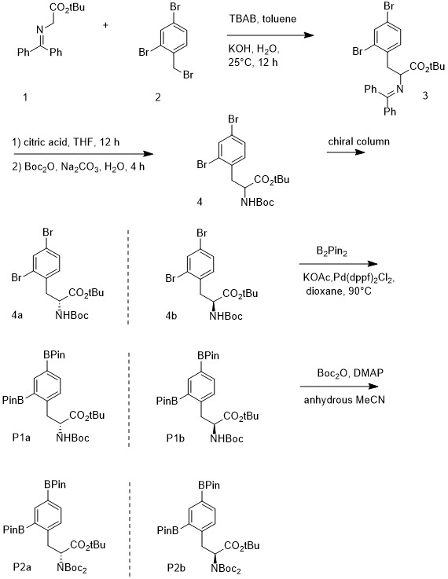
Scheme 1. F-BPA Precursor Synthetic Scheme.

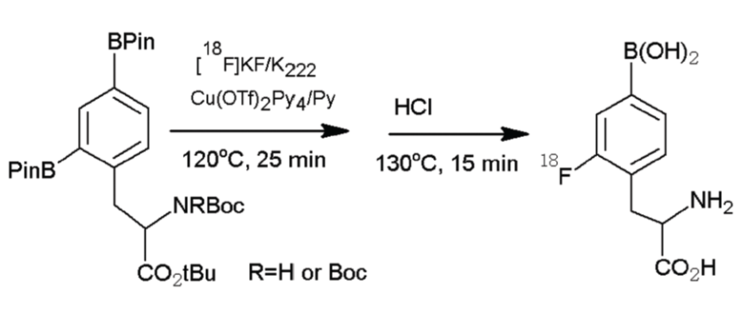
Scheme 2. Radiolabeling scheme.

