Supplementary Information for

Inelastic phonon transport across atomically sharp metal/semiconductor interfaces

Houfu Song^{1,*}, Fang Liu^{2,3,*}, Song Hu^{4,*}, Qinshu Li^{1,*}, Susu Yang², Lu Zhao¹, Hailing Jiang², Jinlin Wang², Tao Wang⁵, Yee Kan Koh⁶, Feiyu Kang^{1,7}, Junqiao Wu^{8,9}, Xiaokun Gu^{4,†}, Bo Sun^{1,7,†} and Xinqiang Wang^{2,3,†}

¹Tsinghua-Berkeley Shenzhen Institute, Tsinghua University, Shenzhen 518055, China.
²State Key Laboratory for Mesoscopic Physics and Frontiers Science Center for Nano-optoelectronics, School of Physics, Peking University, Beijing 100871, China.
³Collaborative Innovation Center of Quantum Matter, Beijing 100871, China.
⁴Institute of Engineering Thermophysics, School of Mechanical Engineering, Shanghai Jiao Tong University, Shanghai 200240, China.
⁵Electron Microscopy Laboratory, School of Physics, Peking University, Beijing 100871, China.
⁶Department of Mechanical Engineering and Center of Advanced 2D Materials, National University of Singapore, 117576 Singapore.
⁷Tsinghua Shenzhen International Graduate School and Guangdong Provincial Key Laboratory of Thermal Management Engineering & Materials, Shenzhen 518055, China.
⁸Department of Materials Science and Engineering, University of California, Berkeley, CA 94720, USA.
⁹Materials Sciences Division, Lawrence Berkeley National Laboratory, Berkeley, CA 94720, USA.

*These authors contributed equally.
†To whom correspondence should be addressed: sun.bo@sz.tsinghua.edu.cn, wangshi@pku.edu.cn, xiaokun.gu@sjtu.edu.cn

I. MBE growth of Al (111) film on Si (111) substrate
The high-energy electron diffraction (RHEED) is used to monitor the growth process of an 80-nm-thick Al film on Si substrate. As depicted in Fig. S1a, the Si surface has a typical (7×7) reconstructed diffraction patterns after thermal treatment at 900 ℃ for 30 minutes, indicating that there is no oxide layer on its surface. As the epitaxy starts at 100 °C, the stripe patterns of the Al film immediately appeared and remained unchanged. This phenomenon is mainly due to the formation of a sharp epitaxial interface between Al and Si. The X-ray diffraction (XRD) spectrum in Fig. S1b shows a sharp peak at 38.4° from Al(111) plane and another sharp peak from Si(111) plane at 28.4°, and the full width at half maximum (FWHM) value of the ω-rocking curves for the Al(111) plane is 0.13°, which further confirms the high crystallinity of the epitaxial Al film^{1,2}. Then, the surface morphology of the Al film is characterized by atomic force microscopy (AFM). It is found that the Al film grown at 100 ℃ (Al/Si Sample 1) has a continuous flat surface with a small root mean square (RMS) roughness of 0.26 nm, as depicted in Fig. S1c. When the epitaxial temperature rises to 300 ℃, the surface morphology of the Al film was deteriorated significantly (Fig. S1d), and the RMS roughness of the Al film (Al/Si Sample 2) increases to 17.1 nm.
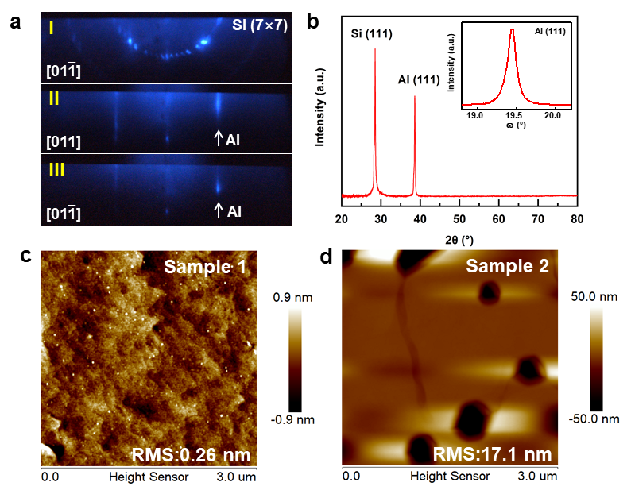
Figure S1 (a) In-situ RHEED patterns of the Si (111) substrate just before Al (111) growth (I), after 1-minute growth (Ⅱ) and after 20-minutes growth (III) at 100 ℃ with the incident electron beam parallel to the [01-1] direction of the Si substrate. (b) XRD 2θ-ω scan and ω-scan spectrum of the epitaxial Al film on Si. (c) AFM image with a 3×3 µm² scanned area of Al/Si Sample 1. (d) AFM image with a 3×3 µm² scanned area of Al/Si Sample 2.

II. Characterization of interface structure of Al/Si Sample 2
The high-angle annular dark-field scanning transmission electron microscopy (HAADF-STEM) was performed to demonstrate the interface structure of Al/Si Sample 2, as shown in Fig. S2a. We found that there is an around 2-nm-thick intermediate layer with nearly disordered lattice arrangement between the epilayer and the substrate. Energy-dispersive x-ray spectroscopy (EDX) further reveals this intermediate layer is composed of Si and Al atoms (in Fig. S2c and Fig. S2d), where Si atoms are enriched on the side close to the substrate and Al atoms are enriched on the side close to the epilayer shown as the result of EDX line scan analysis (in Fig. S2b). This indicates that the intermediate layer is most likely originated from the intermixing of Al and Si atoms at a higher growth temperature, resulting in a relatively rough interface³. Note that EDX measurements only give a quantitative analysis due to limited spatial resolution.
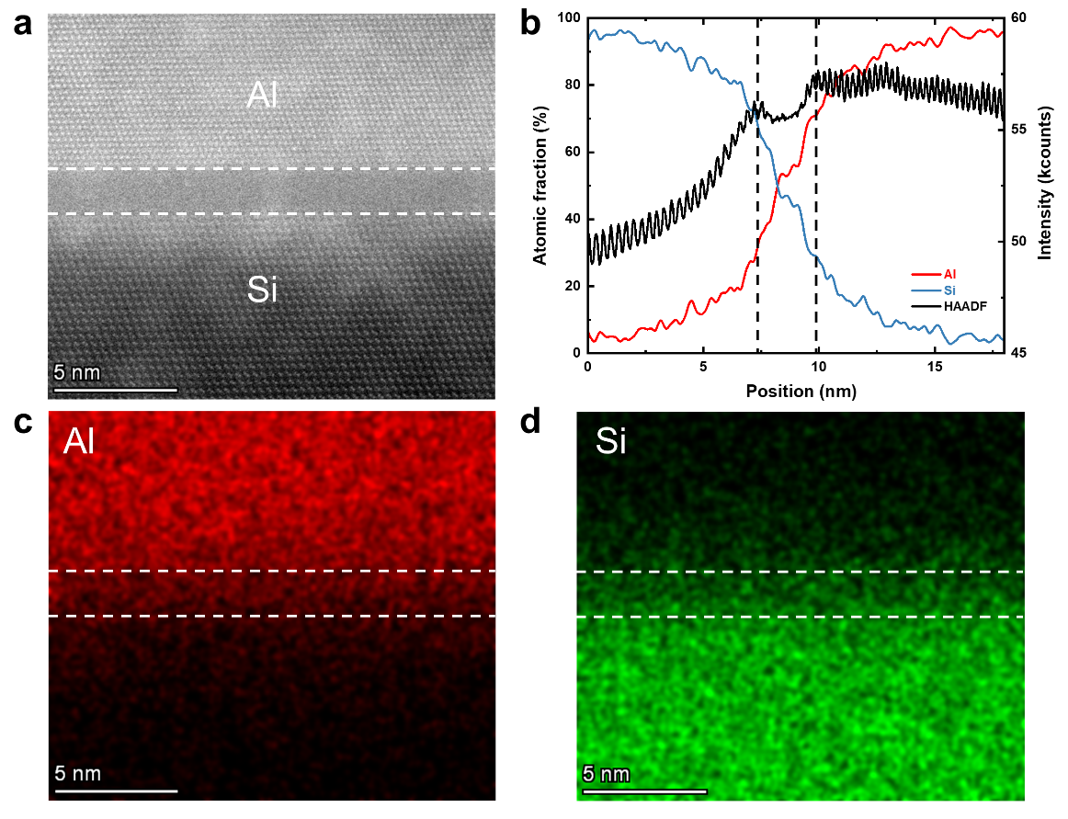
Figure S2 (a) STEM image of Al/Si Sample 2 interface. (b) EDX line scan analysis of Al/Si interface, showing the Al and Si atomic fraction at the interfacial region. (c-d) EDX mapping images taken at the Al/Si interface. (Dash lines cover the same region in (a-d)).

III. The calculated G_{pp} for Al/Si Sample 1, Sample 2 and Al/GaN interfaces
Here, to calculate the phonon-phonon transport induced interface thermal conductance alone, we follow Majumdar and Reddy’s treatment of electron-phonon coupling and use $G=\frac{G_{ep}G_{pp}}{G_{ep}+G_{pp}}$, explained in detail in the main text.
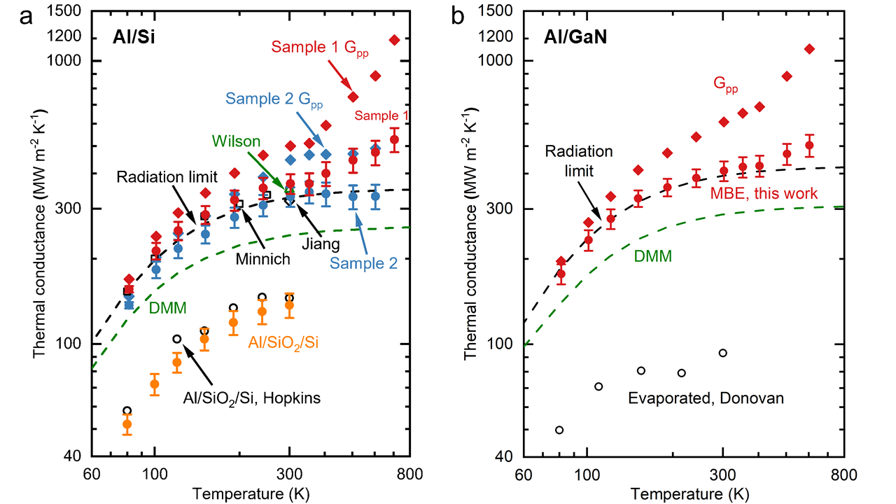
Figure S3 Thermal conductance of Al/Si and Al/GaN interfaces. (a) The calculated G_{pp} of Al/Si Sample 1 (red diamonds) and Sample 2 (blue diamonds). (b) The calculated G_{pp} of Al/GaN (red diamonds).

Ⅳ. TDTR measurement and estimation of measurement uncertainty

Before TDTR measurement, we do the sensitivity analysis to determine the optimized parameters. The sensitivity is defined as,
$$\begin{aligned}S_{α}= \frac{∂(-\frac{V_{in}}{V_{out}})}{∂lnα}\#\left( AUTONUM \right)\end{aligned}$$
where –V_{in}/V_{out} is TDTR signal, and $α$ is the parameter that is used in our thermal model. In a typical measurement, there are usually two unknown parameters, interface thermal conductance between transducer and substrate (G) and thermal conductivity of the substrate (Λ). Table S1 and S2 shows the calculated sensitivity to all parameters in our thermal model, where h_{Al}, Λ_{Al}, C_{Al}, C_{Si}, w₀ and φ are the thickness, thermal conductivity and heat capacity of Al, heat capacity of Si, laser spot radius, and phase of the lock-in amplifier, respectively.

Table S1 Sensitivity to the parameters in TDTR measurement of thermal conductance of Al/Si interface.
T | 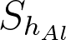 |  |  | 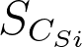 | 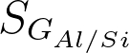 | 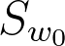 | 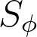
704.8 K | 0.765 | 0.055 | 0.858 | 0.437 | 0.340 | 0.061 | 7.045
604.2 K | 0.770 | 0.052 | 0.860 | 0.435 | 0.355 | 0.065 | 7.339
503.7 K | 0.780 | 0.050 | 0.870 | 0.434 | 0.320 | 0.070 | 7.633
403.5 K | 0.790 | 0.048 | 0.880 | 0.433 | 0.325 | 0.075 | 8.499
352.5 K | 0.799 | 0.047 | 0.882 | 0.433 | 0.327 | 0.080 | 9.111
302.5 K | 0.813 | 0.038 | 0.893 | 0.426 | 0.366 | 0.085 | 10.229
242.0 K | 0.817 | 0.038 | 0.894 | 0.402 | 0.386 | 0.112 | 10.972
191.7 K | 0.825 | 0.037 | 0.894 | 0.398 | 0.429 | 0.114 | 12.709
151.3 K | 0.831 | 0.036 | 0.897 | 0.342 | 0.489 | 0.174 | 14.171
121.3 K | 0.840 | 0.033 | 0.905 | 0.304 | 0.556 | 0.214 | 17.557
101.3 K | 0.856 | 0.029 | 0.911 | 0.170 | 0.635 | 0.354 | 22.145
81.2 K | 0.860 | 0.025 | 0.915 | 0.188 | 0.710 | 0.339 | 26.238

Table S2 Sensitivity to parameters in TDTR measurement of thermal conductance of Al/GaN interface.
T |  |  |  |  | 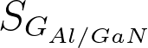
604.2 K | 0.480 | 0.014 | 0.510 | 0.260 | 0.360 | 0.120 |  | 9.585
503.7 K | 1.000 | 0.040 | 1.030 | 0.257 | 0.310 | 0.010 |  | 9.299
403.5 K | 0.980 | 0.020 | 1.000 | 0.430 | 0.310 | 0.020 |  | 10.744
352.5 K | 0.960 | 0.030 | 0.980 | 0.430 | 0.300 | 0.030 |  | 11.190
302.5 K | 0.930 | 0.020 | 0.960 | 0.434 | 0.312 | 0.020 |  | 11.458
242.0 K | 0.890 | 0.020 | 0.910 | 0.430 | 0.300 | 0.020 |  | 12.838
191.7 K | 0.834 | 0.030 | 0.862 | 0.440 | 0.310 | 0.030 |  | 14.151
151.3 K | 0.754 | 0.014 | 0.784 | 0.414 | 0.380 | 0.030 |  | 16.092
121.3 K | 0.655 | 0.015 | 0.686 | 0.440 | 0.427 | 0.036 |  | 17.308
101.3 K | 0.550 | 0.016 | 0.580 | 0.410 | 0.470 | 0.040 |  | 18.325
81.2 K | 0.366 | 0.020 | 0.400 | 0.370 | 0.550 | 0.069 |  | 19.352
After all the sensitivity parameters are calculated, the measurement uncertainty of interface thermal conductance of Al/Si and Al/GaN interfaces can be calculated using the following equation:
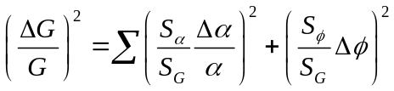 (2)
The uncertainties we used for the parameters are shown in the following table.
Table S3 Uncertainties for the parameters used in our thermal model.
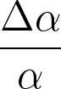 | uncertainty
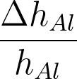 | ±3.75%
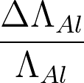 | ±10%
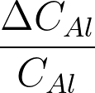 | ±2%
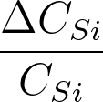 | ±2%
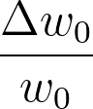 | ±10%
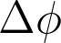 | 0.001
Put the uncertainties in Tab. S3 into Eq.2, we then calculated the measurement uncertainty of G, which shows in our Fig. 1 in the main text.

Ⅴ. Raw TDTR data for Sample 1 and Sample 2
TDTR raw data of Sample1 and Sample 2 are presented here from 80 K to 700 K. Here, G₁ and G₂ represent the measured thermal conductance of Sample 1 and Sample 2 respectively.
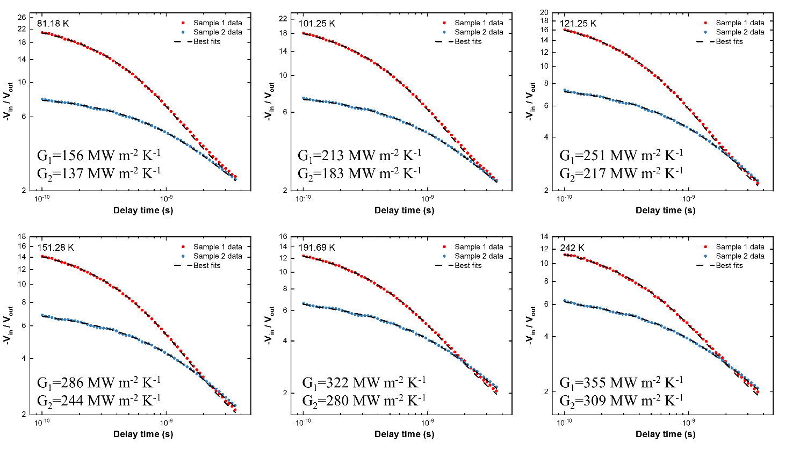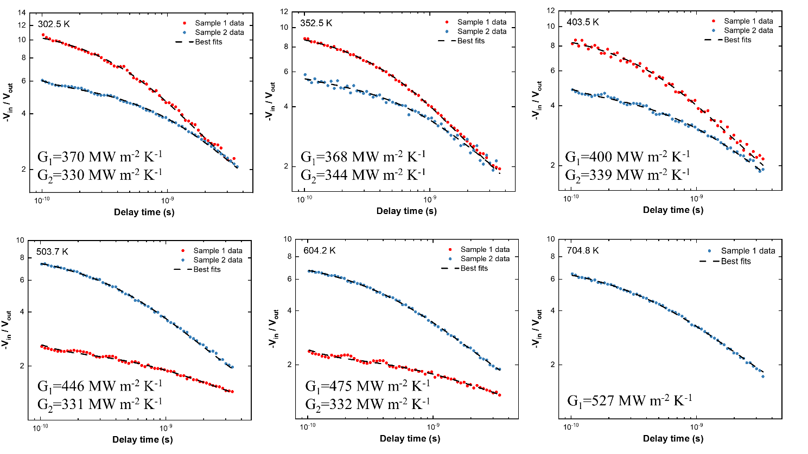
Figure S4 Measured TDTR signals from 80 K to 700 K for Al/Si Sample1 and Sample 2.
Here, we used modulation frequency of 10.1 MHz to measure Sample 1. The 1/e² radius of both pump beam and probe beam is 10.6 μm form 80 K to 350 K and 5.3 μm form 400 K to 700 K. For Sample 2, we used the 1/e² radius of 10.6 μm of the pump beam and probe beam with modulation frequency of 10.1 MHz from 80 K to 400 K and 1.01 MHz for 500 K and 600 K.

Ⅵ. MD simulation

Table S4 Simulated result of thermal conductance as a function of temperature by MD. dT is temperature difference of heat bath, and ΔT is simulated temperature drop across interface obtained from linear fit.
Interface | Length L (nm) | Heat bath  dT (K) | Temperature T (K) | Temperature drop ΔT (K) | Heat flux  J (ev ps⁻¹) | Thermal conductance  G (MW m⁻² K⁻¹)
sharp | 44 | 60 | 300 | 63.64 | 0.9 | 623
sharp | 44 | 60 | 500 | 48.00 | 0.73 | 738
sharp | 44 | 60 | 700 | 35.23 | 0.57 | 826
rough | 44 | 60 | 300 | 57.42 | 1.02 | 496
rough | 44 | 60 | 500 | 39.43 | 0.83 | 533
rough | 44 | 60 | 700 | 28.78 | 0.67 | 567

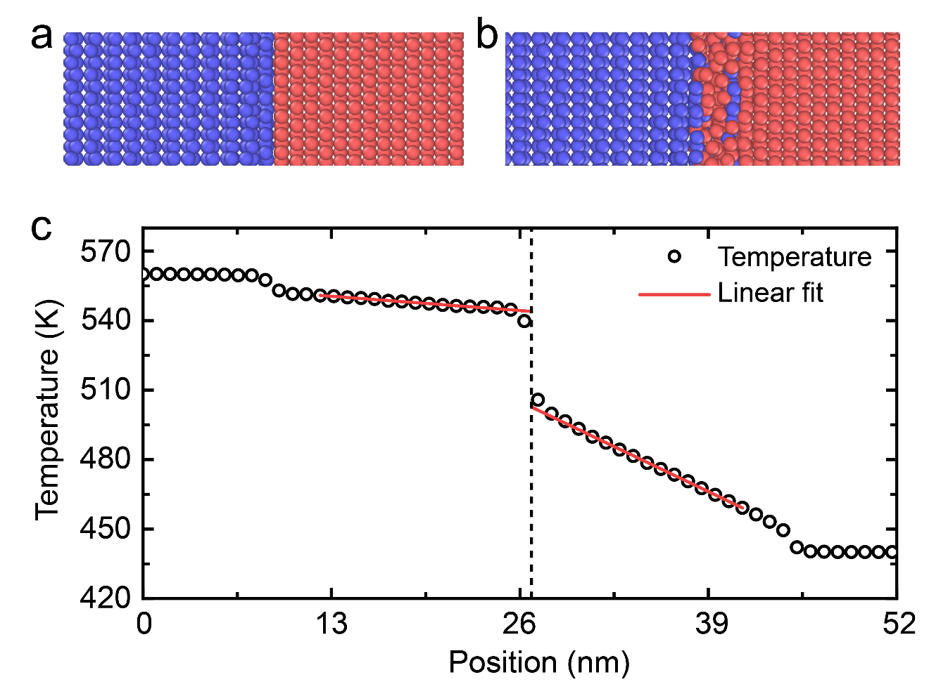
Figure S5 Computational geometry across a rectangle-shaped interface of with (a) sharp and (b) rough configuration of Al/Si interface. (c) An example of simulated temperature profile of sharp interface at 500 K with length of 33 nm and heat bath temperature difference of 60 K.

References
1. Cheng, F. et al. Epitaxial Growth of Atomically Smooth Aluminum on Silicon and Its Intrinsic Optical Properties. ACS Nano 10, 9852–9860 (2016).
2. Chou, Y. H. et al. High-Operation-Temperature Plasmonic Nanolasers on Single-Crystalline Aluminum. Nano Lett. 16, 3179–3186 (2016).
3. Hopkins, P. E., Norris, P. M., Stevens, R. J., Beechem, T. E. & Graham, S. Influence of Interfacial Mixing on Thermal Boundary Conductance Across a Chromium/Silicon Interface. J. Heat Transf. 130, (2008).

