Supplementary Figure 1: Study visit flowchart illustrating all procedures for participants during each visit

Outpatient department (OPD)
+
Private clinics
Prescreening visit
2nd prenatal visit
(1st trimester)
- Fulfilled the eligibility criteria
- Showed willingness to participate and be compliant
- Signed a written consent form

Screening visit
11- 17.5 weeks of GA

Screening tests: 25- Hydroxyvitamin D level (25(OH) D), calcium, phosphate, magnesium, creatinine and thyroid stimulating hormone (TSH). Urine calcium test in a fasting urine spot or 24 h urine collection

25(OH) D level

>30 ng/ml excluded
<10 ng/ml excluded
10-30 ng/ml
*Except visit 4, visits coincide with routine prenatal visits
GA: Gestational Age

Eligible and enrolled
25(OH)D 10-30 ng/ml

- Maternal weight, height and blood pressure were measured
- Participants filled out the questionnaire on maternal and related paternal information.
- Pregnant women were randomized to one of two vitamin D doses

Visit 1 (2nd Trimester)
15-18 weeks of GA

Research assistants made phone calls between the first and second visits, as well as between the second and third visits, every two weeks to remind participants to take their study pills and to check for any adverse events

- Maternal weight, blood pressure, health and diet assessment
- Adverse events (if any) were recorded
- Pill counts assessed compliance to trial medication
- Blood and urine tests were carried out

Visit 2 (3rd Trimester)
27-32 weeks of GA

On the first day postpartum:
- Maternal data collected: weight, blood pressure, health status, and diet assessment; delivery details: mode and complications; neonatal measurements.
- Maternal and cord blood collected for 25(OH)D levels and genetic analyses (vitamin D gene polymorphisms and RNA expression).
- Placental samples collected and stored at −80°C.
Visit 3 (Delivery)
37-41 weeks of GA

Visit 4
1 month postpartum neonatal Bone mineral density (BMD)
During first month post-partum:
- Infant anthropometric and feeding information documented.
- Infant bone mineral content (BMC) measured via dual-energy X-ray absorptiometry (DXA) scan by a certified technician at AUBMC.
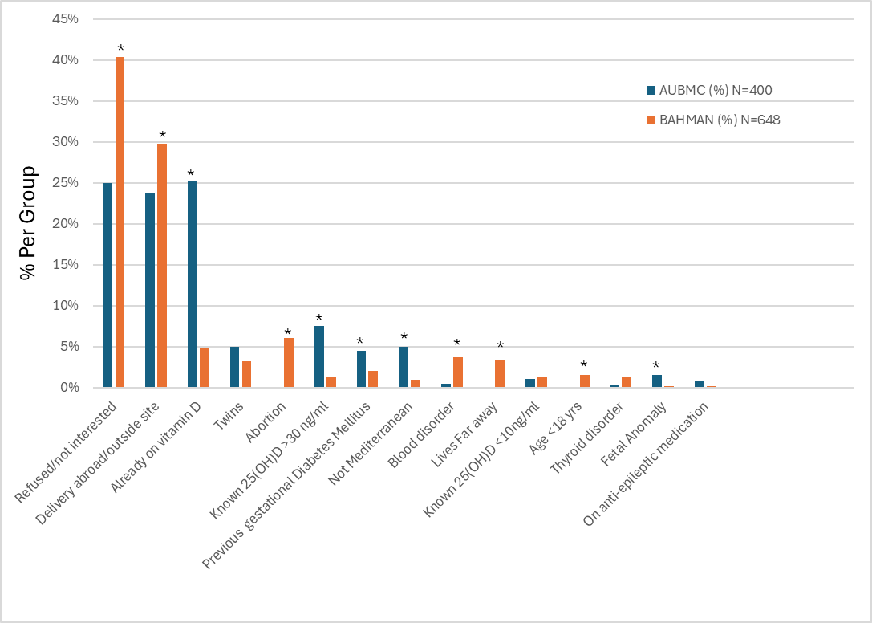
Supplementary Figure 2: Reasons for non-participation among 1,048 Study pregnant women at the pre-screening visit by study site
P-value=0.0001

*indicates p<0.05 statistically significant difference between study sites.
25OH)D: 25-hydroxyVitamin D

Supplementary Table 1. Social, reproductive, and lifestyle characteristics of randomized participants at AUBMC vs. Bahman

 |  | Overall  (N=330) N (%) |  |  | AUBMC  (N=154) N (%) | Bahman (N=176) N (%) |  |  | P-Value*
Social Characteristics
Age (years) |  | 29.5 ± 4.9 |  |  | 30.6 ± 4.5 | 28.6 ± 5 |  |  | 0.000
Education | Below High School |  | 31 (9.4) | 1 (0.6)* |  |  | 30 (17)* | 0.000
Education | High School | 49 (14.8) |  |  | 17 (11) | 32 (18.2)
Education | College | 250 (75.8) |  |  | 136 (88.3)* | 114 (64.8)*
Spouse Education | Below High School | 60 (18.2) |  |  | 2 (1.3) | 58 (33) |  |  | 0.000
Spouse Education | High School | 58 (17.6) |  |  | 18 (11.8) | 40 (22.7) |  |  | 0.000
Spouse Education | College | 212 (64.2) |  |  | 134 (87) | 78 (44.3) |  |  | 0.000
Occupation | No | 179 (54.2) |  |  | 51 (33.1) | 128 (72.7) |  |  | 0.000
Occupation | Yes | 151 (45.8) |  |  | 103 (66.9) | 48 (27.3) |  |  | 0.000
Reproductive Characteristics
Gestational Age (weeks) |  | 16.6 ± 1.2 |  |  | 16.2 ± 1 | 16.9 ± 1.1 |  |  | 0.000
Parity | Nulliparous | 132 (40) |  |  | 77 (50)* | 55 (31.3)* |  |  | 0.000
Parity | Primiparous | 104 (31.5) |  |  | 54 (35.1) | 50 (28.4) |  |  | 0.000
Parity | Multiparous | 94 (28.5) |  |  | 23 (14.9)* | 71 (40.3)* |  |  | 0.000
Gravidity | Primigravida | 115 (34.8) |  |  | 64 (41.6)* | 51 (29)* |  |  | 0.017
Gravidity | Multigravida | 215 (65.2) |  |  | 90 (58.4)* | 125 (71)* |  |  | 0.017
Previous Abortion | Yes | 102 (30.9) |  |  | 47 (30.5) | 55 (31.3) |  |  | 0.886
Lifestyle
BMI (kg/m²) |  | 25.1 ± 4.1 |  |  | 24.6 ± 3.9 | 25.4 ± 4.2 |  |  | 0.089
Active Smoker | No | 290 (87.9) |  |  | 146 (94.8) | 144 (81.8) |  |  | 0.000
Active Smoker | Yes | 40 (12.1) |  |  | 8 (5.2) | 32 (18.2) |  |  | 0.000
Passive Smoker | No | 117 (35.6) |  |  | 78 (50.6) | 39 (22.2) |  |  | 0.000
Passive Smoker | Yes | 212 (64.4) |  |  | 75 (48.7) | 137 (77.8) |  |  | 0.000
Spouse Smoker | No | 142 (43.2) |  |  | 87 (56.5) | 55 (31.3) |  |  | 0.000
Spouse Smoker | Yes | 187 (56.8) |  |  | 66 (42.9) | 121 (69.3) |  |  | 0.000
Exercise during pregnancy | No | 292 (88.5) |  |  | 135 (87.7) | 157 (89.2) |  |  | 0.661
Exercise during pregnancy | Yes | 38 (11.5) |  |  | 19 (12.3) | 19 (10.8) |  |  | 0.661
Exercise before pregnancy | No | 203 (61.5) |  |  | 96 (62.3) | 107 (60.8) |  |  | 0.774
Exercise before pregnancy | Yes | 127 (38.5) |  |  | 58 (37.7) | 69 (39.2) |  |  | 0.774
Veiling | No | 133 (40.3) |  |  | 110 (71.4) | 23 (13.1) |  |  | 0.000
Veiling | Yes | 197 (59.7) |  |  | 44 (28.6) | 153 (86.9) |  |  | 0.000
Independent t-test and Chi-Square test comparing randomized subjects by center (P<0.05)

Supplementary Table 2.A. Adverse events (AEs) reported by trial arm and between study visits
 |  | High Dose (2857 IU/day)  (N= 154, 49.5%) | Low Dose (715 IU/day)  (N= 157, 50.5%) | P-value
AEs between Visit 1 and Visit 2 | No | 122 (79.2%) | 118 (75.2%) | 0.394
AEs between Visit 1 and Visit 2 | Yes | 32 (20.8%) | 39 (24.8%) | 0.394
AEs between Visit 2 and Visit 3 | No | 133 (90.5%) | 129 (87.2%) | 0.367
AEs between Visit 2 and Visit 3 | Yes | 14 (9.5%) | 19 (12.8%) | 0.367
Independent t-test and Chi-Square test comparing randomized subjects by center (P<0.05)

Supplementary Table 2.B. Serious adverse events (SAEs) reported between 2015-2018 in the current preg D trial and at AUBMC overall
Reported SAEs  (2015-2018) | Preg D trial  (N of normal admission= 330) | Data of (NCPNN) at AUBMC  (N of normal admission= 5333)
Preterm/NICU | 11 (3.3%) | 427 (8%)
Gastrointestinal Infection | 1 (0.3%)* | NA
Preterm Contractions | 3 (0.9 %)* | NA
Placenta Previa | 1 (0.3%)* | 7 (0.1%)
Congenital Anomaly | 1 (0.3%) | 198 (3.7%)
Urinary Tract Infections | 2 (0.6%) | 265 (5%)
Low/ High Blood Pressure | 2 (0.6%) | 114 (2.1%)
PROM/ PPROMª | 2 (0.6%) | 60 (1.1%)
IUFD^{b} | 3 (0.9%)* | 52 (0.9%)
NICU/ Respiratory Distress | 4 (1.2%) | 122 (2.3%)
Placental Abruption/Low APGAR | 1 (0.3%) | 26 (0.5%)
Total | 31 (9.4%) | 1888 (35.4%)
ª Premature Rupture of Membranes/ Preterm Premature Rupture of Membranes
^{b Intrauterine Fetal Death}
Chi square test comparing SAEs in PregD trial to those reported in NCPNN (National Collaborative Perinatal Neonatal Network) at AUBMC
*Indicates significance: Each subscript letter denotes a subset of GROUP categories whose column proportions do not differ significantly from each other at the .05 level.
Note: The similarity in serious adverse events between the study population and the general population supports the generalizability of the results to the broader population within the domain of external validity.

Supplementary Table 3. Social, reproductive, and lifestyle characteristics of completers vs. dropouts
Total Randomized (N=330)
 |  | Completed  (N=292, 88.5%) |  | DROPPED OUT  (N=38, 11.5%)
 |  |  | N (%) |  | N (%) | P-value
Social Characteristics
Age (years) (Mean ±SD) |  |  | 29 ± (4.9) |  | 28.1 ± (5.2) | 0.276
Center | AUBMC |  | 128 (43.8) |  | 26 (68.4) | 0.004
Center | Bahman |  | 164 (56.2) |  | 12 (31.6) | 0.004
Education | Below High School |  | 26 (8.9) |  | 5 (9.4) | 0.516
 | High School |  | 42 (14.4) |  | 7 (18.4) | 0.516
 | College |  | 224 (76.7) |  | 26 (68.4) | 0.516
Spouse Education | Below High School |  | 56 (19.2) |  | 4 (10.8)
Spouse Education | High School |  | 52 (17.8) |  | 6 (16.2) | 0.403
 | College |  | 184 (6) |  | 27 (73)
Occupation (Employed) | No |  | 156 (53.4) |  | 23 (60.5) | 0.408
Occupation (Employed) | Yes |  | 136 (46.6) |  | 15 (39.5) | 0.408
Reproductive Characteristics
Parity | Nulliparous |  | 115 (39.4) |  | 17 (44.7) | 0.341
Parity | Primiparous |  | 90 (30.8) |  | 14 (36.8) | 0.341
Parity | Multiparous |  | 87 (29.8) |  | 7 (18.4) | 0.341
Gravidity | Nulligravida |  | v 0 (0) |  | 0 (0) | 0.525
Gravidity | Primigravida |  | 100 (34.2) |  | 15 (39.5) | 0.525
Gravidity | Multigravida |  | 192 (65.8) |  | 23 (60.5) | 0.525
Previous Abortion | No |  | 199 (68.2) |  | 29 (76.3) | 0.306
Previous Abortion | Yes |  | 93 (31.8) |  | 9 (23.7) | 0.306
Lifestyle
BMI (kg/m²) (Mean ±SD) |  |  | 24.96 ± (4.05) |  | 24.21 ± (4.91) | 0.481
Active Smoker | No |  | 259 (88.7) |  | 32 (84.2) | 0.42
Active Smoker | Yes |  | 33 (11.3) |  | 6 (15.8) | 0.42
Have you ever smoked | No |  | 178 (61) |  | 23 (60.5) | 0.959
Have you ever smoked | Yes |  | 114 (39) |  | 15 (39.5) | 0.959
Do you drink alcohol? | No |  | 291 (99.7) |  | 38 (100) | 0.718
Do you drink alcohol? | Yes |  | 1 (0.3) |  | 0 (0) | 0.718
Did you ever drink alcohol? | No |  | 258 (88.4) |  | 32 (84.2) | 0.461
Did you ever drink alcohol? | Yes |  | 34 (11.6) |  | 6 (15.8) | 0.461
Do you Exercise? | No |  | 259 (88.7) |  | 34 (89.5) | 0.887
Do you Exercise? | Yes |  | 33 (11.3) |  | 4 (10.5) | 0.887
Did you Exercise? | No |  | 178 (61) |  | 24 (63.2) | 0.794
Did you Exercise? | Yes |  | 114 (39) |  | 14 (36.8) | 0.794
Veiling | No |  | 115 (39.4) |  | 18 (47.4) | 0.345
Veiling | Yes |  | 177 (60.6) |  | 20 (52.6) | 0.345
Independent t-test and Chi-Square test comparing randomized subjects by center (P<0.05)
Note: The similarity in characteristics preserves internal validity, ensuring the reliability of the results within the domain of internal validity.

Supplementary Table 4. Social, reproductive, and lifestyle characteristics of high dose vs. low dose groups
Total Randomized (N=330)
 |  |  | High Dose (2857 IU/day)  (N= 165, 50%) |  |  |  |  | Low Dose (715 IU/day)  (N=165, 50%)
 |  |  |  |  | N (%) |  |  |  | N (%) | P-value
Social Characteristics
Age (years) (Mean ±SD) |  |  |  |  | 29.2 ± (4.8) |  |  |  | 29.9 ± (5) | 0.238
Center | AUBMC |  |  |  | 77 (46.7) |  |  |  | 77 (46.7) | 1
Center | Bahman |  |  |  | 88 (53.3) |  |  |  | 88 (53.3) | 1
Education | Below High School |  |  |  | 15 (9.1) |  |  |  | 16 (9.7) | 0.555
 | High School |  |  |  | 28 (17) |  |  |  | 21 (12.7) | 0.555
 | College |  |  |  | 122 (73.9) |  |  |  | 128 (77.6) | 0.555
Spouse Education | Below High School |  |  |  | 24 (14.6) |  |  |  | 36 (21.8)
Spouse Education | High School |  |  |  | 33 (20.1) |  |  |  | 25 (15.2) | 0.170
 | College |  |  |  | 107 (65.2) |  |  |  | 104 (63)
Occupation (Employed) | No |  |  |  | 92 (55.8) |  |  |  | 87 (52.7) | 0.581
Occupation (Employed) | Yes |  |  |  | 73 (44.2) |  |  |  | 78 (47.3) | 0.581
Reproductive Characteristics
Parity | Nulliparous |  |  |  |  | 74 (44.8) |  |  | 58 (35.2) | 0.187
Parity | Primiparous |  |  |  |  | 49 (29.7) |  |  | 55 (33.3) | 0.187
Parity | Multiparous |  |  |  |  | 42 (25.5) |  |  | 52 (31.5) | 0.187
Gravidity | Nulligravida |  |  |  |  |  |  |  | 0 (0) | 0.05
Gravidity | Primigravida |  |  |  |  | 66 (40) |  |  | 49 (29.7) | 0.05
Gravidity | Multigravida |  |  |  |  | 99 (60) |  |  | 116 (70.3) | 0.05
Previous Abortion | No |  |  |  |  | 120 (72.7) |  |  | 108 (65.5) | 0.153
Previous Abortion | Yes |  |  |  |  | 45 (27.3) |  |  | 57 (34.5) | 0.153
Lifestyle
BMI (kg/m²) (Mean ±SD) |  |  |  |  | 24.5 ± (3.8) |  |  |  | 25.6 ± (4.4) | 0.019
Active Smoker | No |  |  |  |  | 146 (88.5) |  |  | 145 (87.9) | 0.865
Active Smoker | Yes |  |  |  |  | 19 (11.5) |  |  | 20 (12.1) | 0.865
Have you ever smoked | No |  |  |  |  | 109 (66.1) |  |  | 92 (55.8) | 0.055
Have you ever smoked | Yes |  |  |  |  | 56 (33.9) |  |  | 73 (44.2) | 0.055
Do you drink alcohol? | No |  |  |  |  | 165 (100) |  |  | 164 (99.4) | 0.317
Do you drink alcohol? | Yes |  |  |  |  |  |  |  | 1 (0.6) | 0.317
Did you ever drink alcohol? | No |  |  |  |  | 144 (87.3) |  |  | 146 (88.5) | 0.736
Did you ever drink alcohol? | Yes |  |  |  |  | 21 (12.7) |  |  | 19 (11.5) | 0.736
Do you Exercise? | No |  |  |  |  | 148 (89.7) |  |  | 145 (87.9) | 0.601
Do you Exercise? | Yes |  |  |  |  | 17 (10.3) |  |  | 20 (12.1) | 0.601
Did you Exercise? | No |  |  |  |  | 97 (58.8) |  |  | 105 (63.6) | 0.366
Did you Exercise? | Yes |  |  |  |  | 68 (41.2) |  |  | 60 (36.4) | 0.366
Veiling | No |  |  |  |  | 67 (40.6) |  |  | 66 (40) | 0.911
Veiling | Yes |  |  |  |  | 98 (59.4) |  |  | 99 (60) | 0.911
Independent t-test and Chi-Square test comparing randomized subjects by center (P<0.05)
Note: The similarity between arms preserves internal validity, reflecting that the randomization process was conducted correctly.

