- Pre-operative pictures of few patients with sacrococcygeal teratoma (SCT)
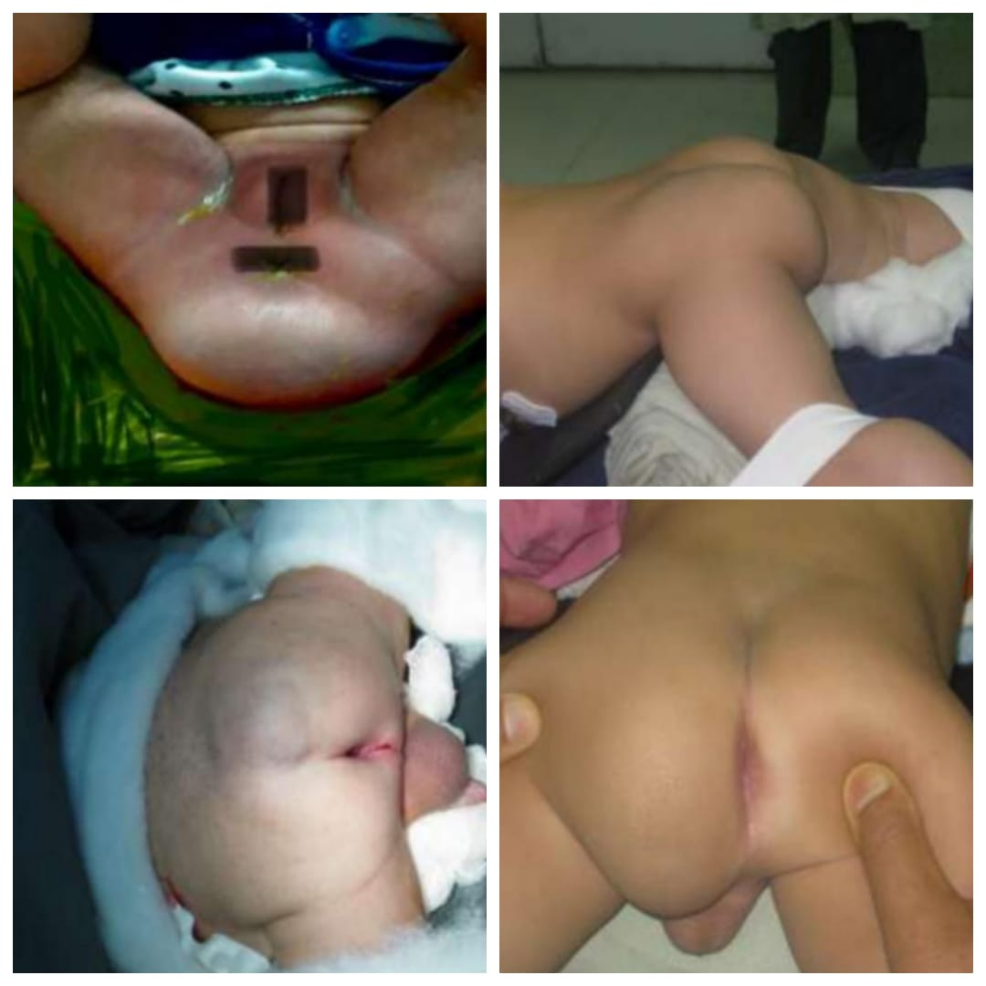

- MRI scan and post-operative pictures of a neonate with Type-4 sacrococcygeal teratoma (SCT)
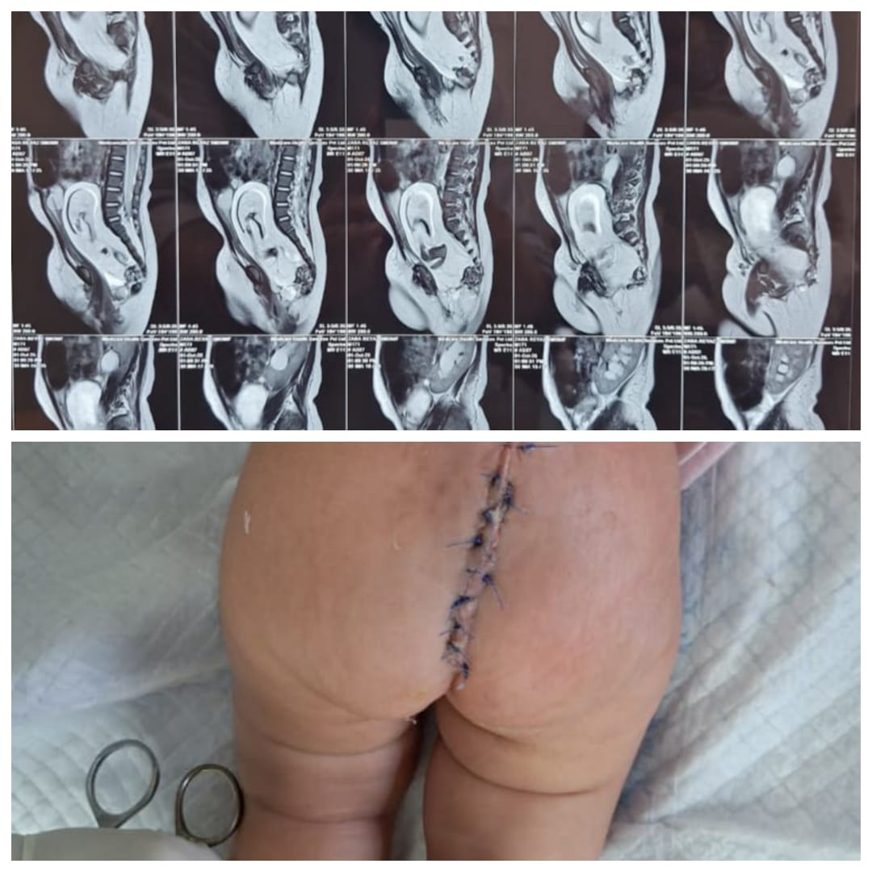

- Intraoperative and follow-up pictures of a patients operated for sacrococcygeal teratoma (SCT)
