Supplementary Material
Supplementary Tables
Supplementary Table 1. Participant characteristics (SSRI-treated vs. SSRI-untreated) at first time-point
 | Group |  | Comparison
 | SSRI-treated | SSRI-untreated | Pearson’s  Chi square | Mann Whitney test | t-test | p value
N (% of full sample) | 101 (32.2%) | 213 (67.8%)
Sex, N male (%) | 45 (44.6%) | 92 (43.2%) | 0.227 |  |  | 0.820
Age, y; M (SD) | 16.3 (6.06) | 15.6 (8.06) |  | 9975 |  | 0.264
FSIQ, M (SD) | 73.0 (13.1) | 74.5 (12.9) |  |  | 0.988 | 0.324
PIQ, M (SD) | 70.9 (11) | 70.2 (13.8) |  | 3880 |  | 0.571
VIQ, M (SD) | 76.6 (14.7) | 76.1 (14.1) |  |  | 0.263 | 0.793

TP = time-point; FSIQ = Full-scale Intelligence Quotient; PIQ = Performance Intelligence Quotient; VIQ = Verbal Intelligence Quotient ; y = years

 |  | Group |  |  |  | Comparison
 | SSRI+PS |  | noSSRI+PS | SSRI+noPS | noSSRI+noPS | p value
N (% of full sample) | 25 (%) |  | 38 (%) | 44 (%) | 208 (%)
Sex, N male (%) | 15 (60%) |  | 22 (57.9%) | 16 (36.4%) | 90 (43.3%) | 0.095ª
Age, y; M (SD) | 13.2 (3.47) |  | 13 (4.03) | 14.4 (3.91) | 15.5 (8.07) | 0.323^{b}
FSIQ, M (SD) | 79.7 (13.2)† |  | 77.3 (12.7)† | 69.5 (14.2) | 74.7 (13)† | 0.008^{c}
Supplementary Table 2. Participant characteristics (SSRI+PS vs. noSSRI+PS vs. SSRI+noPS vs. noSSRI+noPS) at first time-point

Probability values refer to Pearson chi-square testª, Kruskal–Wallis test^{b}, and one-way ANOVA^{c}. Post-hoc pairwise comparisons for FSIQ were conducted using unpaired t-tests. Significant p-values (p<0.05) are shown in bold. † p < .05 indicates the three significant comparisons: SSRI+noPS vs. SSRI+PS, SSRI+noPS vs. noSSRI+PS, and SSRI+noPS vs. noSSRI+noPS.
Supplementary Table 3. Wechsler scale versions used across assessments

 | Number of assessments | Proportion
WPPSI-III | 23 | 3.49%
WPPSI-R | 16 | 2.43%
WPPSI-IV | 1 | 0.15%
WISC-R | 22 | 3.34%
WISC-III | 91 | 13.81%
WISC-IV | 38 | 5.77%
WISC-V | 21 | 3.19%
WAIS-III | 205 | 31.11%
WAIS-IV | 62 | 9.41%
WASI-I | 116 | 17.60%
WASI-II | 64 | 9.71%
Total | 659 | 100%

WPPSI = Wechsler Preschool and Primary Scale of Intelligence; WISC = Wechsler Intelligence Scale for Children; WAIS = Wechsler Adult Intelligence Scale; WASI = Wechsler Abbreviated Scale of Intelligence.
Supplementary Table 4. Results of the mixed-model regression analyses of FSIQ, PIQ, and VIQ according to age and time-point in the SSRI-treated and SSRI-untreated groups
 |  |  | Group effect |  |  |  | Interaction with age or time-point
Dependent variable | Independent variable | Model order | p-value | Log likelihood (df) | Intercept  SSRI-treated | Intercept  SSRI-untreated | p-value | Log likelihood (df) | Age slope  SSRI-treated | Age slope  SSRI-untreated
FSIQ | Age | linear | 0.002 | 12.48, 2 | 71.99 ± 2.62 | 81.32 ± 1.85 | <0.001 | 12.18, 1 | 0.05 ± 0.13 | -0.43 ± 0.10
PIQ | Age | linear | <0.001 | 18.58, 2 | 66.45 ± 3.46 | 79.16 ± 2.51 | <0.001 | 18.14, 1 | 0.20 ± 0.17 | -0.54 ± 0.13
VIQ | Age | linear | 0.001 | 13.73, 2 | 74.85 ± 3.34 | 86.03 ± 2.67 | <0.001 | 13.34, 1 | 0.01 ± 0.16 | -0.65 ± 0.14
FSIQ | Time-point | linear | <0.001 | 19.56,2 | 69.95 ± 1.51 | 75.35 ± 1.07 | <0.001 | 19.12, 1 | 2.13 ± 0.60 | -0.80 ± 0.44
PIQ | Time-point | linear | 0.004 | 11.15, 2 | 67.65 ± 1.98 | 70.13 ± 1.44 | 0.002 | 9.89, 1 | 2.35 ± 0.78 | -0.39 ± 0.65
VIQ | Time-point | linear | <0.001 | 28.34, 2 | 72.10 ± 1.97 | 78.65 ± 1.53 | <0.001 | 28.19 1 | 2.24 ± 0.77 | -2.54 ± 0.67
Significant p-values (p<0.05) are shown in bold. FSIQ = Full-scale Intelligence Quotient; PIQ = Performance Intelligence Quotient; VIQ = Verbal Intelligence Quotient.

Supplementary Table 5. Mean age and age range (years) at each time point (TP) for SSRI-treated and SSRI-untreated groups.
 | TP1 | TP2 | TP3 | TP4
SSRI-treated | 16.3 (6–34) | 19.4 (9–33) | 22.3 (12–33) | 25.1 (15–32)
SSRI-untreated | 15.6 (4–34) | 15.2 (5–33) | 16.2 (6–30) | 17.9 (12–28)

Supplementary Table 6. Range of IQ change (ΔIQ = last − first time-point) for SSRI-treated and SSRI-untreated groups, across full-scale IQ (FSIQ), performance IQ (PIQ), and verbal IQ (VIQ).
 | Group | Range of ΔIQ (min to max)
FSIQ | SSRI-treated | -18 to +27
FSIQ | SSRI-untreated | -26 to +19
PIQ | SSRI-treated | -20 to +17
PIQ | SSRI-untreated | -26 to +23
VIQ | SSRI-treated | -23 to +22
VIQ | SSRI-untreated | -39 to +17

Supplementary Table 7. Results of the mixed-model regression analyses of FSIQ according to age and time-point in three subgroups: (1) treated with both SSRIs and psychostimulants (SSRI+PS); (2) untreated with SSRIs but treated with psychostimulants (noSSRI+PS); and (3) treated with SSRIs but untreated with psychostimulants (SSRI+noPS), across age and time-points
 |  |  | Group effect |  |  |  |  |  |  |  |  |  | Interaction with age or time-point
Dependent variable | Independent variable | Model order | p-value | Log likelihood (df) | Intercept  SSRI+PS | Intercept  noSSRI+PS | Intercept  SSRI+noPS |  | p-value |  | Log likelihood (df) | Age slope  SSRI+PS |  | Age slope  noSSRI+PS | Age slope  SSRI+noPS
FSIQ | Age | linear | <0.001 | 25.74, 4 | 70.10 ± 3.52 | 82.67 ± 4.29 | 68.38 ± 5.18 |  | 0.004 |  | 10.99, 2 | 0.88 ± 0.38 |  | -0.37 ± 0.25 | -0.05 ± 0.31
FSIQ | Time-point | linear | <0.001 | 24.39, 4 | 78.84 ± 3.05 | 75.02 ± 3.34 | 68.18 ± 2.61 |  | 0.004 |  | 10.98, 2 | 4.25 ± 1.67 |  | -1.35 ± 1.49 | 0.80 ± 1.51
Significant p-values (p<0.05) are shown in bold. FSIQ = Full-scale Intelligence Quotient.

Supplementary Table 8. Results of the two-by-two mixed-model regression analyses of FSIQ according to age and time-point in participants with 22q11.2DS, stratified into three subgroups based on SSRI and/or psychostimulant (PS) treatment, across ages and time-points.
 |  |  |  | Group effect |  |  |  | Interaction with age or time-point
Two-by-two  comparison | Dependent variable | Independent variable | Model order | p-value | Log likelihood (df) | Intercept  Group1 | Intercept  Group2 | p-value | Log likelihood (df) | Age slope  Group1 | Age slope  Group2
SSRI+PS vs. noSSRI+PS | FSIQ | Age | linear | 0.004 | 11.17, 2 | 67.69 ± 5.17 | 80.15 ± 4.36 | 0.003 | 8.68, 1 | 0.92 ± 0.30 | -0.22 ± 0.26
SSRI+PS vs. noSSRI+PS | FSIQ | Time-point | linear | 0.004 | 10.84, 2 | 76.84 ± 3.48 | 78.88 ± 3.15 | 0.004 | 8.43, 1 | 3.14 ± 1.51 | -1.44 ± 1.60
SSRI+PS vs. SSRI+noPS | FSIQ | Age | linear | <0.001 | 17.80, 2 | 68.65 ± 5.26 | 69.78 ± 3.57 | 0.0140 | 6.04, 1 | 0.88 ± 0.31 | -0.03 ± 0.19
SSRI+PS vs. SSRI+noPS | FSIQ | Time-point | linear | <0.001 | 15.24,2 | 75.52 ± 3.59 | 68.27 ± 2.85 | 0.030 | 4.73, 1 | 4.08 ± 1.56 | 0.69 ± 1.43
noSSRI+PS vs. SSRI+noPS | FSIQ | Age | linear | 0.045 | 6.21, 2 | 81.75 ± 4.50 | 69.96 ± 3.50 | 0.350 | 0.87, 1 | -0.33 ± 0.27 | -0.03 ± 0.18
noSSRI+PS vs. SSRI+noPS | FSIQ | Time-point | linear | 0.024 | 7.47, 2 | 78.03 ± 3.13 | 67.92 ± 2.70 | 0.156 | 2.01, 1 | -1.12 ± 1.53 | 1.08 ± 1.29
Significant p-values (p<0.05) are shown in bold. FSIQ = Full-scale Intelligence Quotient.

Supplementary Table 9. Results of correlations analyses between change in IQ scores and individual characteristics.
 | Spearman’s correlations |  | Pearson’s correlations
 | r | p-value | r | p-value | adjusted p
Δ Full-scale IQ
Treatment duration | 0.294 | 0.009 |  |  | 0.036
Age at treatment onset | -0.216 | 0.060 |  |  | 0.120
Dosage | 0.111 | 0.412 |  |  | 0.412
Baseline FSIQ |  |  | -0.142 | 0.218 | 0.291
Δ Performance IQ
Treatment duration | 0.310 | 0.027 |  |  | 0.068
Age at treatment onset |  |  | -0.125 | 0.381 | 0.508
Dosage | 0.028 | 0.853 |  |  | 0.853
Baseline PIQ |  |  | -0.297 | .034 | 0.068
Δ Verbal IQ
Treatment duration | 0.204 | 0.106 |  |  | 0.212
Age at treatment onset | -0.281 | 0.024 |  |  | 0.096
Dosage | -0.182 | 0.232 |  |  | 0.310
Baseline VIQ |  |  | -0.115 | 0.367 | 0.367

Significant FDR corrected p-values (p<0.05) are shown in bold. Δ represents the difference between the last and to the first IQ scores.

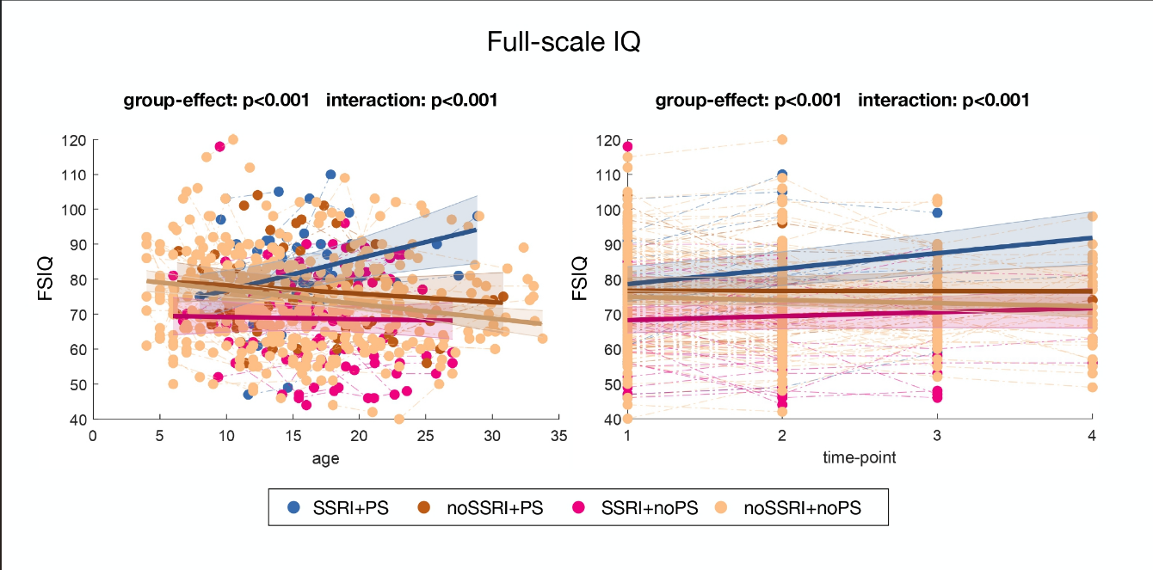
Supplementary Figures
Supplementary Figure 1. Developmental trajectories of full-scale IQ (FSIQ) into four subgroups of participants: (1) treated with both SSRIs and PS (SSRI+PS); (2) untreated with SSRIs but treated with PS (noSSRI+PS); and (3) treated with SSRIs but untreated with PS (SSRI+noPS); and (4) untreated with SSRIs and PS (noSSRI+noPS), across age and time-points.

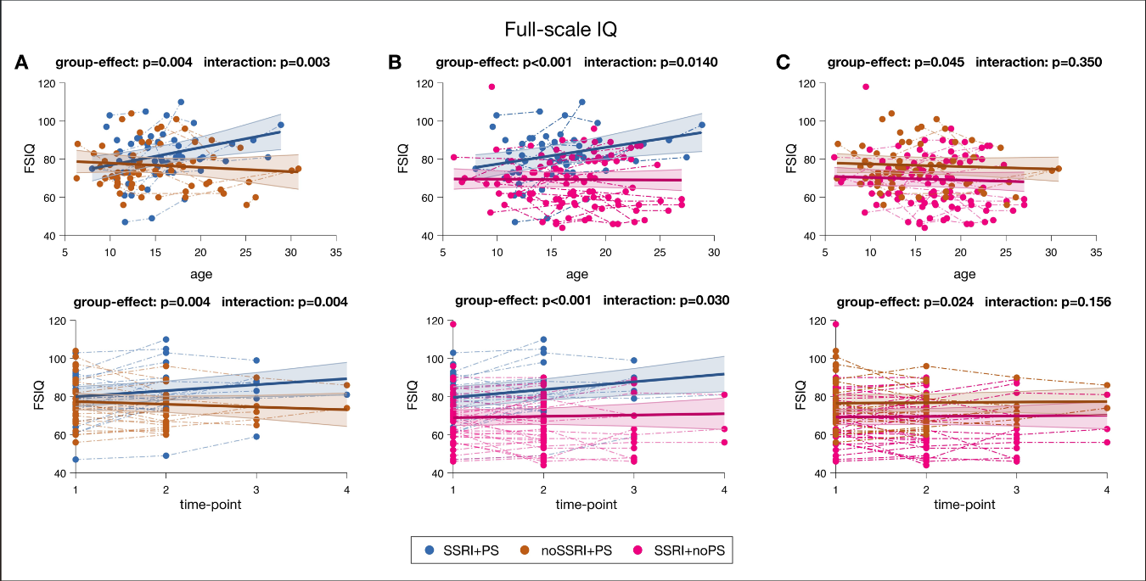
Supplementary Figure 2. Two-by-two comparisons of full-scale IQ (FSIQ) in participants with 22q11.2DS, stratified into three subgroups based on SSRI and/or psychostimulant (PS) treatment, across ages and time points. A. SSRI+PS vs. noSSRI+PS; B. SSRI+PS vs. SSRI+noPS; C. noSSRI+PS vs. SSRI+noPS.

