Supplementary note on the corrected area normalization method for gas chromatography
Reaction products were analyzed by GC (Agilent-7890, FID, HP-5 column: 30 m × 320 μm × 0.25 μm) using area normalization.
Under the same gas chromatograph detection conditions, the peak areas of citral and pseudoionone at different concentrations were determined. The corresponding peak areas with concentrations were determined as shown in below, and the relative correction factors were calculated.
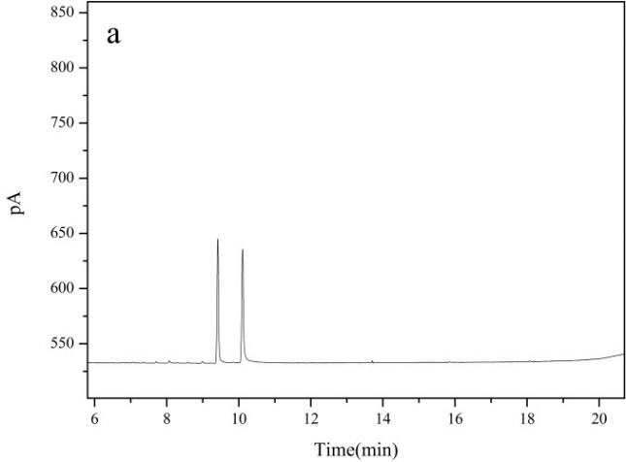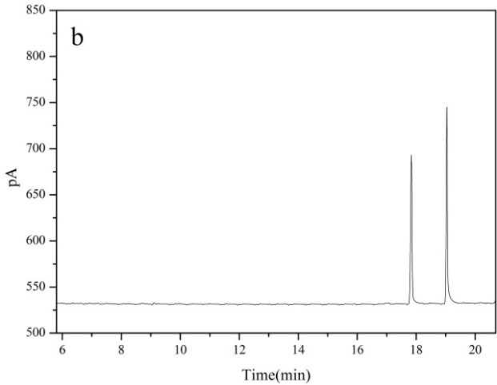
Fig.1 Gas chromatogram of citral (a) and pseudoionone (b) standard samples
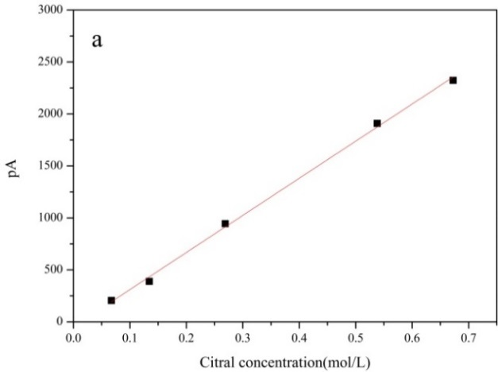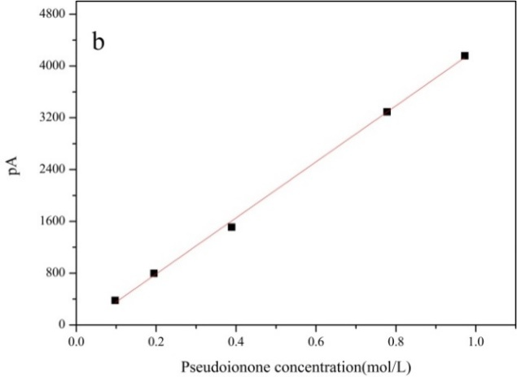
Fig.2 The standard curves of citral (a) and pseudoionone (b)
The standard curve equation of citral was Y=3571.2x-46.763, R²=0.9985, and the standard curve equation of pseudoionone was Y=4327.2x-76.912, R²=0.9988. Assuming that the correction factor of pseudoionone (target product) is F_{PS}=1, comparing the slopes of the standard curves of pseudoionone and citral, the relative correction factors of citral is F_{citral} =1.21.

Supplementary Material that shares the numerical data underlying key figures
Figure 1(1) (±SD)
wt%  Time(h) | 3.5 | 4.0 | 4.5 | 5.0 | 5.5
0.5 | 15.87±0.49 | 76.52±0.75 | 31.38±1.35 | 53.90±0.99 | 55.46±1.15
1.0 | 71.59±1.81 | 85.38±1.07 | 76.66±0.75 | 66.15±1.31 | 75.05±1.40
1.5 | 77.83±1.53 | 91.32±1.60 | 82.03±1.44 | 87.09±1.90 | 91.12±1.83
2.0 | 89.97±1.53 | 99.89±0.15 | 90.59±1.49 | 94.67±0.82 | 96.12±0.79
3.0 | 99.42±1.03 | 99.81±0.33 | 98.34±1.57 | 99.64±0.47 | 99.18±1.14
4.0 | 99.78±0.50 | 100.00±0.00 | 100.00±0.01 | 99.79±0.47 | 99.72±0.53

Figure 1(2) (±SD)
wt%  % | 3.5 | 4.0 | 4.5 | 5.0 | 5.5
X | 89.97±1.53 | 99.89±0.15 | 90.57±1.34 | 93.49±1.00 | 95.77±1.70
S | 96.56±1.02 | 99.68±0.39 | 96.88±0.93 | 97.64±1.20 | 97.63±0.96

Figure 1(3) (±SD)
°C  % | 200 | 250 | 300 | 350 | 400
X | 87.01±0.93 | 95.02±0.72 | 99.91±0.19 | 94.25±0.41 | 75.12±1.55
S | 98.91±0.54 | 97.83±0.63 | 99.81±0.34 | 99.96±0.05 | 99.62±0.58

Figure 1(4) (±SD)
h  % | 5 | 10 | 15 | 20 | 25
X | 77.70±0.77 | 93.08±0.80 | 100.00±0.00 | 94.79±0.21 | 86.60±0.48
S | 91.67±0.91 | 97.68±0.52 | 99.41±0.46 | 97.90±0.60 | 95.53±0.49

Figure 5(a) (±SD)
g  % | 0.20 | 0.35 | 0.50 | 0.65 | 0.80
X | 68.10±1.21 | 76.70±1.52 | 100.00±0.95 | 100.00±1.64 | 97.40±1.54
S | 94.10±1.41 | 97.00±1.50 | 99.20±0.95 | 98.20±0.64 | 100.00±1.68

Figure 5(b) (±SD)
h  % | 1 | 2 | 3 | 4 | 5
X | 75.60±1.48 | 98.10±1.84 | 100.00±0.95 | 100.00±1.35 | 100.00±1.40
S | 90.20±1.66 | 95.70±1.74 | 99.20±0.95 | 96.10±1.47 | 95.20±1.51

Figure 5(c) (±SD)
°C  % | 35 | 40 | 45 | 50 | 55
X | 82.20±1.54 | 92.20±1.48 | 96.50±1.52 | 100.00±0.95 | 98.30±1.16
S | 94.50±1.43 | 97.80±1.23 | 99.00±1.42 | 99.20±0.95 | 99.20±1.51

Figure 5(d) (±SD)
ratio  % | 1:3 | 1:5 | 1:7 | 1:9 | 1:11
X | 93.90±1.38 | 97.60±1.63 | 97.50±1.19 | 100.00±0.95 | 95.90±0.79
S | 96.50±1.48 | 97.70±1.52 | 98.10±1.74 | 99.20±0.95 | 97.30±1.10

