Table S1. Analysis of physicochemical properties of SpHDZ family members
Gene ID | Gene length  (bp) | Protein name | Exon/  intron | Length (aa) | MW (Da) | Isoelectric points | Instability index | Aliphatic index | Grand average of hydropathicity | Predicted subcellular location
Spor0001840.1 | 855 | SpHDZ1 | 2/1 | 284 | 31016.95 | 8.57 | 53.73 | 69.08 | -0.605 | nucleus
Spor0003220.1 | 1005 | SpHDZ2 | 3/2 | 334 | 37387.98 | 5.01 | 63.94 | 59.28 | -0.866 | nucleus
Spor0014950.1 | 1098 | SpHDZ3 | 3/2 | 365 | 40759.97 | 5.89 | 50.81 | 57.97 | -0.933 | nucleus
Spor0027420.1 | 2559 | SpHDZ4 | 18/2 | 852 | 92786.94 | 6.11 | 47.68 | 85.77 | -0.062 | nucleus
Spor0073050.1 | 2517 | SpHDZ5 | 9/2 | 838 | 91036.15 | 6.00 | 51.37 | 78.10 | -0.313 | nucleus
Spor0075400.1 | 780 | SpHDZ6 | 2/3 | 259 | 29531.73 | 4.73 | 45.73 | 64.44 | -0.879 | nucleus
Spor0084440.1 | 717 | SpHDZ7 | 2/2 | 238 | 27655.67 | 5.76 | 75.89 | 57.39 | -1.125 | nucleus
Spor0085850.1 | 717 | SpHDZ8 | 2/2 | 238 | 27594.54 | 5.86 | 70.82 | 57.39 | -1.152 | nucleus
Spor0088140.1 | 2253 | SpHDZ9 | 8/2 | 750 | 83206.56 | 5.53 | 51.41 | 80.61 | -0.280 | nucleus
Spor0095550.1 | 852 | SpHDZ10 | 4/2 | 283 | 32656.26 | 4.82 | 58.39 | 66.47 | -0.862 | nucleus
Spor0120950.1 | 1002 | SpHDZ11 | 3/2 | 333 | 37136.39 | 5.79 | 51.61 | 67.09 | -0.781 | nucleus
Spor0151680.1 | 708 | SpHDZ12 | 3/2 | 235 | 27191.73 | 6.36 | 71.66 | 70.89 | -0.705 | nucleus
Spor0158660.1 | 792 | SpHDZ13 | 2/2 | 263 | 29046.89 | 8.04 | 58.03 | 73.08 | -0.625 | nucleus
Spor0165560.1 | 984 | SpHDZ14 | 2/2 | 327 | 37151.09 | 4.56 | 58.97 | 63.49 | -0.956 | nucleus
Spor0165910.1 | 942 | SpHDZ15 | 3/2 | 313 | 34885.83 | 5.88 | 61.57 | 58.37 | -0.829 | nucleus
Spor0184680.1 | 2598 | SpHDZ16 | 11/3 | 865 | 94974.01 | 6.06 | 49.15 | 77.45 | -0.397 | nucleus
Spor0204270.1 | 2532 | SpHDZ17 | 18/3 | 843 | 92488.87 | 5.66 | 52.43 | 86.69 | -0.103 | cytoplasm
Spor0207910.1 | 735 | SpHDZ18 | 2/3 | 244 | 28171.72 | 8.25 | 61.91 | 68.40 | -0.789 | nucleus
Spor0224260.1 | 750 | SpHDZ19 | 3/2 | 249 | 27423.74 | 9.07 | 46.54 | 55.70 | -0.866 | nucleus
Spor0238180.1 | 1005 | SpHDZ20 | 3/2 | 334 | 37446.02 | 5.00 | 66.39 | 61.02 | -0.839 | nucleus
Spor0243560.1 | 1089 | SpHDZ21 | 3/1 | 362 | 40481.62 | 5.85 | 52.3 | 56.85 | -0.956 | nucleus
Spor0256220.1 | 2562 | SpHDZ22 | 18/2 | 853 | 92726.80 | 6.07 | 47.77 | 85.91 | -0.058 | chloroplast
Spor0259180.1 | 651 | SpHDZ23 | 3/2 | 216 | 24765.33 | 5.49 | 59.71 | 57.78 | -0.978 | nucleus
Spor0260120.1 | 777 | SpHDZ24 | 3/2 | 258 | 29678.46 | 6.62 | 59.49 | 70.78 | -0.788 | nucleus
Spor0292710.1 | 1149 | SpHDZ25 | 4/2 | 382 | 41386.31 | 9.00 | 55.41 | 57.25 | -0.778 | nucleus
Spor0311920.1 | 792 | SpHDZ26 | 2/2 | 263 | 29887.97 | 4.68 | 43.50 | 63.50 | -0.897 | nucleus
Spor0314320.1 | 2496 | SpHDZ27 | 9/2 | 831 | 90252.41 | 6.00 | 50.97 | 79.33 | -0.285 | nucleus
Spor0336210.1 | 2502 | SpHDZ28 | 9/2 | 833 | 90580.80 | 5.97 | 51.49 | 79.14 | -0.305 | nucleus
Spor0338580.1 | 780 | SpHDZ29 | 2/5 | 259 | 29442.50 | 4.76 | 44.76 | 62.20 | -0.894 | nucleus
Spor0370140.1 | 783 | SpHDZ30 | 2/2 | 260 | 29021.80 | 7.57 | 54.20 | 75.42 | -0.643 | nucleus
Spor0374140.1 | 924 | SpHDZ31 | 3/3 | 307 | 34276.29 | 6.01 | 61.66 | 59.87 | -0.813 | nucleus
Spor0388560.1 | 993 | SpHDZ32 | 3/2 | 330 | 37556.91 | 4.79 | 63.21 | 60.55 | -0.900 | nucleus
Spor0392140.1 | 2565 | SpHDZ33 | 18/2 | 854 | 92898.04 | 6.03 | 48.75 | 85.23 | -0.071 | chloroplast
Spor0398220.1 | 648 | SpHDZ34 | 3/2 | 215 | 24651.80 | 7.67 | 56.98 | 67.58 | -0.879 | nucleus
Spor0400230.1 | 2532 | SpHDZ35 | 19/2 | 843 | 92532.90 | 5.66 | 53.13 | 86.57 | -0.104 | cytoplasm
Spor0413760.1 | 2565 | SpHDZ36 | 11/4 | 854 | 94243.36 | 6.16 | 51.21 | 78.69 | -0.403 | nucleus
Spor0475200.1 | 2040 | SpHDZ37 | 10/3 | 679 | 76089.61 | 6.73 | 47.69 | 79.65 | -0.444 | nucleus
Spor0490750.1 | 792 | SpHDZ38 | 2/1 | 263 | 29310.10 | 7.56 | 53.13 | 70.46 | -0.693 | nucleus
Spor0511370.1 | 990 | SpHDZ39 | 3/2 | 329 | 36779.49 | 5.88 | 58.73 | 54.65 | -1.007 | nucleus
Spor0511690.1 | 987 | SpHDZ40 | 3/2 | 328 | 37085.99 | 4.53 | 58.00 | 64.79 | -0.898 | nucleus
Spor0516400.1 | 714 | SpHDZ41 | 2/1 | 237 | 27510.43 | 6.04 | 71.74 | 56.37 | -1.174 | nucleus
Spor0519080.1 | 2253 | SpHDZ42 | 8/2 | 750 | 83122.31 | 5.58 | 47.86 | 79.69 | -0.304 | nucleus
Spor0542040.1 | 2532 | SpHDZ43 | 19/2 | 843 | 92483.80 | 5.58 | 53.36 | 86.23 | -0.104 | cytoplasm
Spor0561210.1 | 2568 | SpHDZ44 | 11/4 | 855 | 94024.10 | 6.07 | 50.02 | 79.03 | -0.376 | nucleus
Spor0572280.1 | 858 | SpHDZ45 | 4/2 | 285 | 32793.32 | 4.84 | 56.05 | 66.00 | -0.902 | nucleus
Spor0592860.1 | 768 | SpHDZ46 | 3/2 | 510 | 59266.96 | 7.14 | 61.62 | 68.90 | -0.809 | nucleus

Table S2. WGD/segmental dumplication event of SpHDZs
Gene name | Gene ID | Duplication type
SpHDZ1 | Spor0001840.1 | WGD or Segmental
SpHDZ2 | Spor0003220.1 | WGD or Segmental
SpHDZ3 | Spor0014950.1 | WGD or Segmental
SpHDZ4 | Spor0027420.1 | WGD or Segmental
SpHDZ5 | Spor0073050.1 | WGD or Segmental
SpHDZ6 | Spor0075400.1 | WGD or Segmental
SpHDZ7 | Spor0084440.1 | WGD or Segmental
SpHDZ8 | Spor0085850.1 | WGD or Segmental
SpHDZ9 | Spor0088140.1 | WGD or Segmental
SpHDZ10 | Spor0095550.1 | WGD or Segmental
SpHDZ11 | Spor0120950.1 | WGD or Segmental
SpHDZ12 | Spor0151680.1 | WGD or Segmental
SpHDZ13 | Spor0158660.1 | WGD or Segmental
SpHDZ14 | Spor0165560.1 | WGD or Segmental
SpHDZ15 | Spor0165910.1 | WGD or Segmental
SpHDZ16 | Spor0184680.1 | WGD or Segmental
SpHDZ17 | Spor0204270.1 | WGD or Segmental
SpHDZ18 | Spor0207910.1 | WGD or Segmental
SpHDZ19 | Spor0224260.1 | WGD or Segmental
SpHDZ20 | Spor0238180.1 | WGD or Segmental
SpHDZ21 | Spor0243560.1 | WGD or Segmental
SpHDZ22 | Spor0256220.1 | WGD or Segmental
SpHDZ23 | Spor0259180.1 | WGD or Segmental
SpHDZ24 | Spor0260120.1 | WGD or Segmental
SpHDZ25 | Spor0292710.1 | WGD or Segmental
SpHDZ26 | Spor0311920.1 | WGD or Segmental
SpHDZ27 | Spor0314320.1 | WGD or Segmental
SpHDZ28 | Spor0336210.1 | WGD or Segmental
SpHDZ29 | Spor0338580.1 | WGD or Segmental
SpHDZ30 | Spor0370140.1 | WGD or Segmental
SpHDZ31 | Spor0374140.1 | WGD or Segmental
SpHDZ32 | Spor0388560.1 | WGD or Segmental
SpHDZ33 | Spor0392140.1 | WGD or Segmental
SpHDZ34 | Spor0398220.1 | WGD or Segmental
SpHDZ35 | Spor0400230.1 | WGD or Segmental
SpHDZ36 | Spor0413760.1 | WGD or Segmental
SpHDZ37 | Spor0475200.1 | WGD or Segmental
SpHDZ38 | Spor0490750.1 | WGD or Segmental
SpHDZ39 | Spor0511370.1 | WGD or Segmental
SpHDZ40 | Spor0511690.1 | WGD or Segmental
SpHDZ41 | Spor0516400.1 | WGD or Segmental
SpHDZ42 | Spor0519080.1 | WGD or Segmental
SpHDZ43 | Spor0542040.1 | WGD or Segmental
SpHDZ44 | Spor0561210.1 | WGD or Segmental
SpHDZ45 | Spor0572280.1 | WGD or Segmental
SpHDZ46 | Spor0592860.1 | WGD or Segmental

Table S3. Ka, Ks, and Ka/Ks values for the homologous gene pair gene1 and gene2 in SpHDZs
Gene1 | Gene2 | Ka | Ks | Ka/Ks
SpHDZ2 | SpHDZ20 | 0.008932 | 0.033498 | 0.266654
SpHDZ3 | SpHDZ11 | 0.025490 | 0.130237 | 0.195717
SpHDZ3 | SpHDZ15 | 0.320874 | 1.506143 | 0.213043
SpHDZ3 | SpHDZ21 | 0.005834 | 0.059940 | 0.097337
SpHDZ3 | SpHDZ39 | 0.360863 | 1.443587 | 0.249977
SpHDZ4 | SpHDZ22 | 0.004138 | 0.028064 | 0.147435
SpHDZ7 | SpHDZ8 | 0.015829 | 0.014484 | 1.092854
SpHDZ7 | SpHDZ41 | 0.024851 | 0.037067 | 0.670417
SpHDZ8 | SpHDZ41 | 0.019470 | 0.021953 | 0.886909
SpHDZ9 | SpHDZ42 | 0.016627 | 0.059367 | 0.280068
SpHDZ10 | SpHDZ45 | 0.022833 | 0.081160 | 0.281330
SpHDZ11 | SpHDZ15 | 0.336659 | 1.562072 | 0.215521
SpHDZ11 | SpHDZ39 | 0.366450 | 1.763189 | 0.207834
SpHDZ13 | SpHDZ38 | 0.019863 | 0.028822 | 0.689169
SpHDZ14 | SpHDZ40 | 0.011672 | 0.055982 | 0.208498
SpHDZ15 | SpHDZ39 | 0.002746 | 0.085846 | 0.031984
SpHDZ16 | SpHDZ36 | 0.012376 | 0.094833 | 0.130499
SpHDZ16 | SpHDZ44 | 0.006886 | 0.038774 | 0.177587
SpHDZ17 | SpHDZ35 | 0.005214 | 0.063859 | 0.081649
SpHDZ17 | SpHDZ43 | 0.002603 | 0.033813 | 0.076986
SpHDZ18 | SpHDZ24 | 0.039178 | 0.081344 | 0.481636
SpHDZ18 | SpHDZ46 | 0.026793 | 0.047180 | 0.567879
SpHDZ21 | SpHDZ11 | 0.025478 | 0.118809 | 0.214445
SpHDZ21 | SpHDZ15 | 0.322840 | 1.514175 | 0.213212
SpHDZ21 | SpHDZ39 | 0.355634 | 1.555731 | 0.228596
SpHDZ25 | SpHDZ19 | 0.021319 | 0.105273 | 0.202511
SpHDZ26 | SpHDZ6 | 0.018266 | 0.086908 | 0.210172
SpHDZ26 | SpHDZ29 | 0.016450 | 0.065508 | 0.251118
SpHDZ27 | SpHDZ5 | 0.010030 | 0.058862 | 0.170391
SpHDZ27 | SpHDZ28 | 0.011629 | 0.066262 | 0.175494
SpHDZ27 | SpHDZ42 | 0.331611 | 2.308793 | 0.143630
SpHDZ28 | SpHDZ5 | 0.006821 | 0.027886 | 0.244612
SpHDZ29 | SpHDZ6 | 0.009863 | 0.058982 | 0.167222
SpHDZ30 | SpHDZ13 | 0.023505 | 0.065648 | 0.358045
SpHDZ30 | SpHDZ38 | 0.038926 | 0.059912 | 0.649716
SpHDZ35 | SpHDZ43 | 0.004690 | 0.063905 | 0.073389
SpHDZ36 | SpHDZ44 | 0.016587 | 0.091152 | 0.181974
SpHDZ42 | SpHDZ5 | 0.330505 | 2.725318 | 0.121272
SpHDZ46 | SpHDZ24 | 0.035535 | 0.072147 | 0.492529

Table S4. Prediction of SpHDZs secondary structure
Protein name | Alpha helix (%) | Extended Strand (%) | Random coil (%) | Distribution of secondary structure elements
SpHDZ1 | 30.63 | 13.73 | 55.63 | 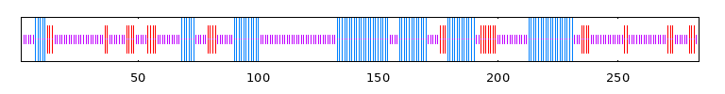
SpHDZ2 | 36.83 | 9.88 | 53.29 | 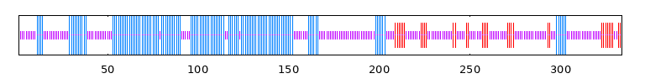
SpHDZ3 | 25.75 | 18.36 | 55.89 | 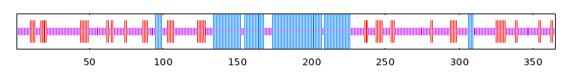
SpHDZ4 | 31.57 | 18.66 | 49.77 | 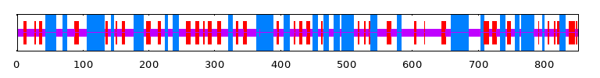
SpHDZ5 | 28.52 | 20.41 | 51.07 | 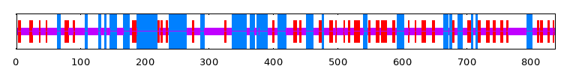
SpHDZ6 | 46.33 | 12.74 | 40.93 | 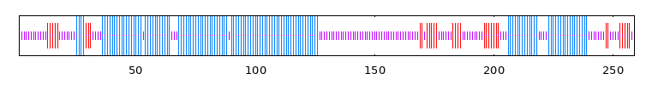
SpHDZ7 | 51.68 | 10.50 | 37.82 | 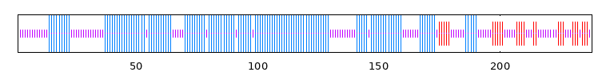
SpHDZ8 | 47.90 | 16.87 | 38.24 | 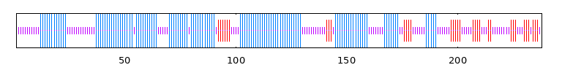
SpHDZ9 | 33.87 | 20.53 | 45.60 | 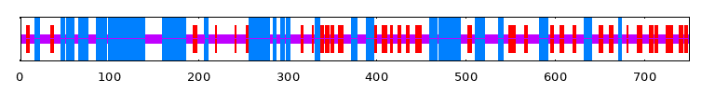
SpHDZ10 | 36.75 | 12.72 | 50.53 | 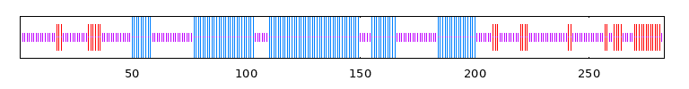
SpHDZ11 | 28.83 | 16.52 | 54.65 | 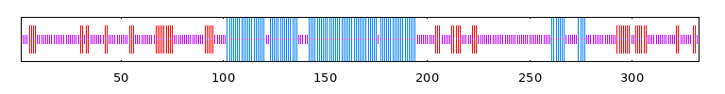
SpHDZ12 | 44.26 | 8.51 | 47.23 | 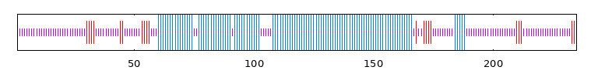
SpHDZ13 | 42.21 | 9.13 | 48.67 | 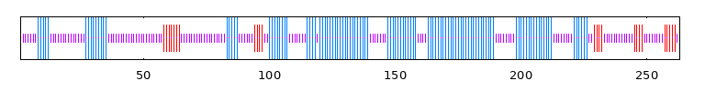
SpHDZ14 | 40.98 | 11.31 | 47.71 | 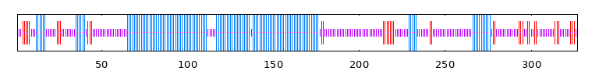
SpHDZ15 | 30.03 | 12.46 | 57.51 | 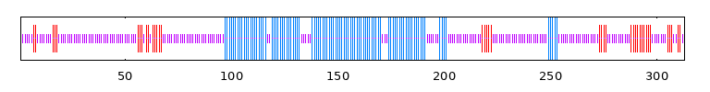
SpHDZ16 | 29.60 | 18.84 | 51.56 | 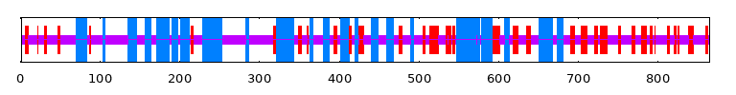
SpHDZ17 | 36.77 | 16.37 | 46.86 | 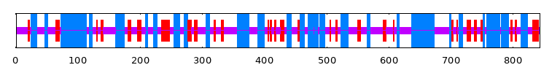
SpHDZ18 | 48.36 | 11.89 | 39.75 | 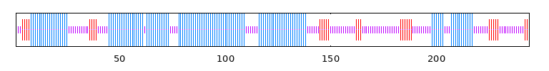
SpHDZ19 | 28.11 | 22.49 | 49.40 | 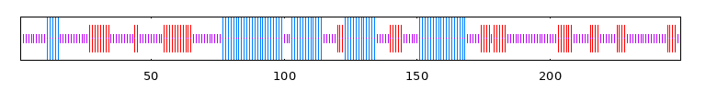
SpHDZ20 | 31.74 | 12.87 | 55.39 | 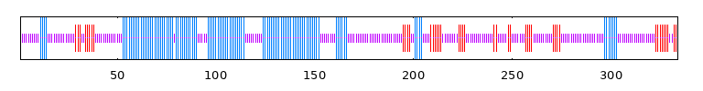
SpHDZ21 | 21.90 | 16.57 | 55.52 | 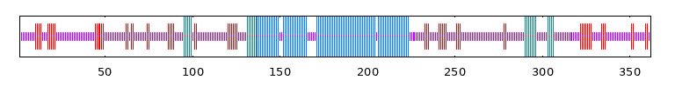
SpHDZ22 | 32.12 | 18.17 | 49.71 | 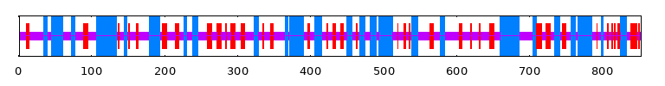
SpHDZ23 | 44.44 | 13.43 | 42.13 | 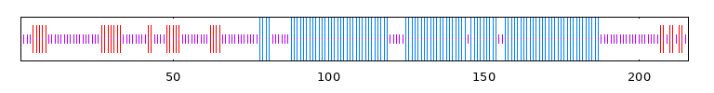
SpHDZ24 | 51.16 | 10.47 | 38.37 | 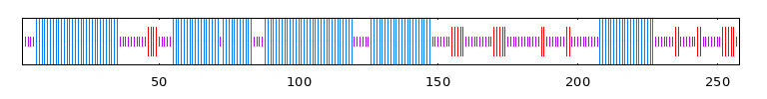
SpHDZ25 | 24.08 | 19.11 | 56.81 | 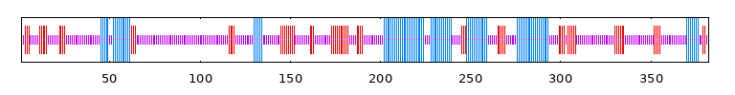
SpHDZ26 | 49.05 | 13.69 | 37.26 | 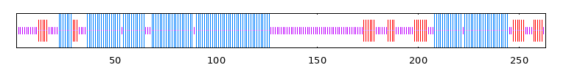
SpHDZ27 | 30.45 | 20.70 | 48.86 | 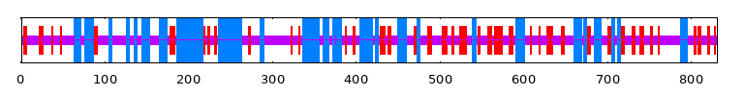
SpHDZ28 | 29.77 | 20.17 | 50.06 | 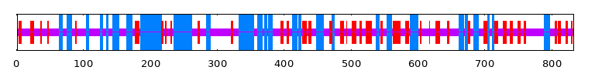
SpHDZ29 | 45.56 | 11.97 | 42.47 | 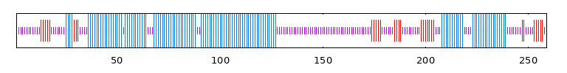
SpHDZ31 | 33.88 | 12.05 | 54.07 | 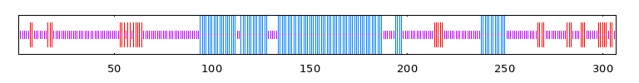
SpHDZ32 | 37.27 | 13.64 | 49.09 | 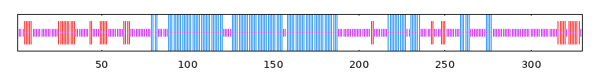
SpHDZ33 | 31.85 | 17.56 | 50.59 | 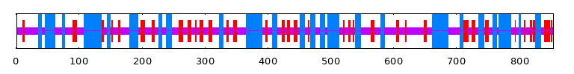
SpHDZ34 | 48.84 | 11.63 | 39.53 | 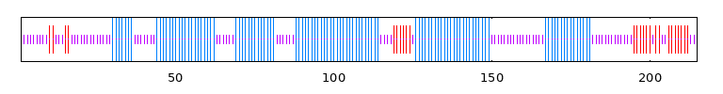
SpHDZ35 | 36.30 | 16.37 | 47.33 | 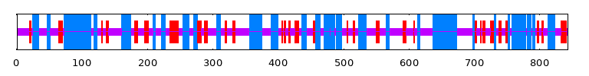
SpHDZ36 | 33.14 | 16.28 | 50.59 | 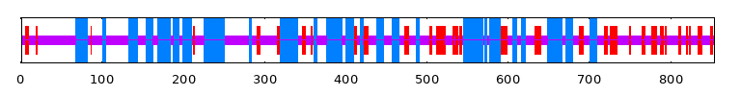
SpHDZ37 | 32.99 | 24.01 | 43.00 | 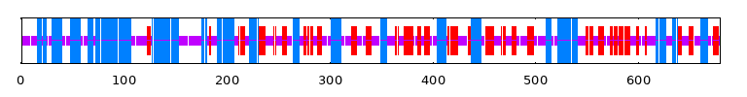
SpHDZ38 | 44.87 | 6.84 | 48.29 | 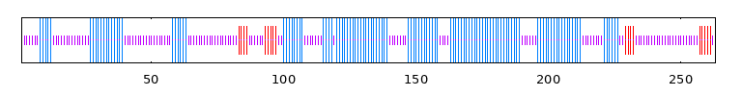
SpHDZ39 | 30.40 | 11.85 | 57.75 | 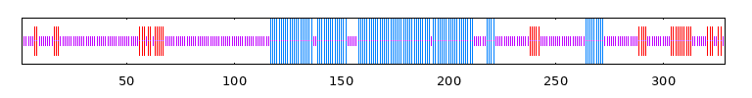
SpHDZ40 | 44.82 | 10.98 | 44.21 | 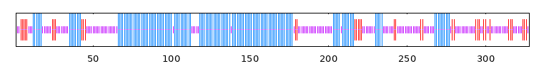
SpHDZ41 | 47.68 | 11.81 | 40.51 | 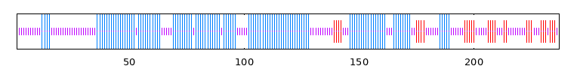
SpHDZ42 | 32.80 | 20.13 | 47.07 | 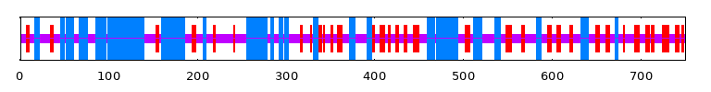
SpHDZ43 | 36.42 | 16.73 | 46.86 | 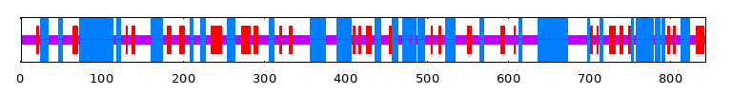
SpHDZ44 | 31.46 | 17.66 | 50.88 | 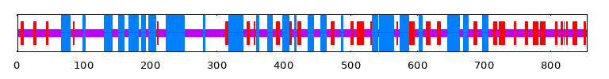
SpHDZ45 | 34.39 | 15.44 | 50.18 | 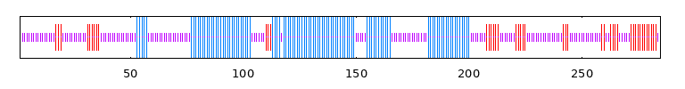
SpHDZ46 | 52.16 | 10.20 | 37.65 | 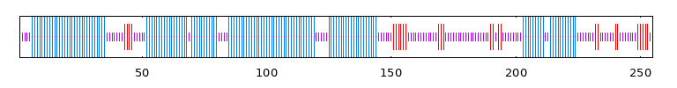

Table S5. Primers used in this study
Forward primer | Reverse primer | Description
CCGGGCACTATTTCCACCAT | AGCCAAGGCCAAAATCCAGT | qRT-PCR for SpHDZ39
AGGGAGTGATATCGAGCCGT | AAGGCCGAGATCTCTAGCCA | qRT-PCR for SpHDZ41
TTGGCATCGTTGAGGGTCT | CAGTGGGAACACGGAAAGC | qRT-PCR for SpGAPDH
GAGAACACGGGGGACTCTAGAATGAGTACTACTTGTACTGG | GCTCACCATGGTACCCCCGGGAACCTTAGTTTTTTTTATCT | Sublocation for SpHDZ39
GAGAACACGGGGGACTCTAGAATGCAAGGGAGTGATATCGA | GCTCACCATGGTACCCCCGGGAGTCCACGAGTCCCACCAGT | Sublocation for SpHDZ41
GCCACCTCGCCCAATGGTACCGTAATGATTACTCGCGTAATGATTACTC | TGCGTCCGGCGTAGAGGATCCGAGTAATCATTACGCGAGTAATCATTAC | Cloning MA0573 into pHis2
GCCACCTCGCCCAATGGTACCGTAATAATTACTCGCGTAATAATTACTC | TGCGTCCGGCGTAGAGGATCCGAGTAATTATTACGCGAGTAATTATTAC | Cloning MA0573_mutant into pHis2
GCCACCTCGCCCAATGGTACCCAATTATTCAATTATTCAATTATT | TGCGTCCGGCGTAGAGGATCCAATAATTGAATAATTGAATAATTG | Cloning MA0008 into pHis2
GCCACCTCGCCCAATGGTACCCAAATATTCAAATATTCAAATATT | TGCGTCCGGCGTAGAGGATCCAATATTTGAATATTTGAATATTTG | Cloning MA0008_mutant into pHis2

