Supplementary information for
Gas-liquid interface enhanced selective adsorption of long-chain PFAS by novel floating macroporous resins
Xiangzhe Jiang ª, Yihua Luo ª, Wei Wang ^{b}, Qianxin Zhang ^{a,c}, Jiaxin Zhu ª, Wenjing Zong ª, Gang Yu ^{a,c}, Shubo Deng ^{a,d,*}
a State Key Laboratory of Regional Environment and Sustainability, Beijing Key Laboratory for Emerging Organic Contaminants Control, School of Environment, Tsinghua University, Beijing 100084, China
b State Key Laboratory of Plateau Ecology and Agriculture, Qinghai University, Xi’ning, Qinghai Province 810016, China
c Advanced Interdisciplinary Institute of Environment and Ecology, Guangdong Provincial Key Laboratory of Wastewater Information Analysis and Early Warning, Beijing Normal University, Zhuhai 519087, China
d Research Division for Wastewater Pollution and Carbon Reduction, Sichuan Energy Internet Research Institute, Tsinghua University, Chengdu 610213, China
* Corresponding author, Tel.: +86-10-62792165. Fax: +86-10-62794006.
E-mail: dengshubo@tsinghua.edu.cn (S. Deng)

Text S1. Synthesis procedure of AERs
5 g of chloromethylated polystyrene resin (gel-type or macroporous-type) was added into a 100 mL three-neck flask and swelled overnight in 40 mL of N,N-dimethylformamide. Then 50 mmol of aminating agent was added, and the mixture was stirred at 80 °C (40 °C for trimethylamine) for 20 h. The synthesized AER was sequentially washed with methanol, 1 mol/L HCl and deionized water, filtered for 5 min to remove interstitial water, and finally sealed for storage. The list of synthesized AERs is shown in Table S1.

Text S2. Description of the wetting states of solid surfaces
For smooth solid surfaces, wettability is related to the intrinsic hydrophilicity of the material. Hydrophilic materials have an intrinsic contact angle $θ$ < 90°, while hydrophobic materials have an intrinsic contact angle $θ$ > 90°. For rough solid surfaces, wettability depends on both the intrinsic hydrophilicity and the surface morphology of the material. The wetting states of rough solid surfaces can generally be classified into the Wenzel state and the Cassie state, as shown in Figure S3.
In the Wenzel wetting state, the liquid fully contacts with the rough solid surface, and the apparent contact angle $θ_{W}$ is related to the surface roughness:
$$\cos{θ_{W}}=r·\cos{θ}$$
where $r$ is the surface roughness, defined as the ratio of the actual contact area to the apparent contact area. In the Wenzel state, an increase in roughness makes hydrophilic surfaces more hydrophilic and hydrophobic surfaces more hydrophobic.
In the Cassie wetting state, air is trapped in surface depressions, and the liquid contacts a composite surface of solid and gas. The apparent contact angle $θ_{C}$ is related to the proportion of the solid-liquid interface and the gas-liquid interface:
$$\cos{θ_{C}}=f·\cos{θ}+f-1$$
where $f$ is the proportion of the solid-liquid interface in the composite surface. In the Cassie state, an increase in roughness always makes the solid surface more hydrophobic.

Text S3. Pretreatment procedures and instrument parameters for PFAS analysis
Water samples were first filtered through a 0.8 μm polyethersulfone (PES) syringe filter (discarding the initial 5 mL of filtrate), and then purified by solid-phase extraction using Waters Oasis WAX cartridges (150 mg, 6 mL). The cartridges were activated sequentially with 4 mL of 0.5% ammonium hydroxide in methanol, 4 mL of methanol, and 4 mL of ultrapure water. Then 40 mL of each sample was loaded at a flow rate of 2 mL/min. The cartridges were rinsed with 4 mL of 25 mmol/L ammonium acetate solution, dried under vacuum, and eluted sequentially with 4 mL of methanol and 4 mL of 0.5% ammonium hydroxide in methanol. The eluate was filtered through a 0.22 μm nylon syringe filter (discarding the initial 1 mL of filtrate) for PFAS concentration analysis.
PFAS concentrations were determined using UltiMate 3000 ultra-high performance liquid chromatography (Thermo Fisher Scientific, USA) coupled with API 3200 triple quadrupole mass spectrometry (AB SCIEX, USA). An XBridge BEH C18 column (3.5 μm, 3 mm × 150 mm, Waters, USA) was used for separation. The mobile phases consisted of 10 mmol/L ammonium acetate in ultrapure water (phase A) and methanol (phase B), with a flow rate of 0.3 mL/min, column temperature of 30°C, and injection volume of 10 μL. The initial proportion of phase B was 40%, then gradually increased to 100% from 1 min to 11 min, maintained until 16 min, and then reverted to the initial proportion. Data acquisition was performed using electrospray ionization (ESI) in negative mode with multiple reaction monitoring (MRM). The MRM parameters for target PFAS are provided in Table S8.
To avoid background contamination and adsorption, Teflon or glass containers were not used in adsorption experiments or sample analysis. Blank samples, calibration standards and duplicate samples were analyzed every 20 samples to monitor background contamination and instrumental stability. Quality assurance and quality control (QA/QC) parameters, including limits of detection (LODs), limits of quantification (LOQs), PFAS recoveries, and relative standard deviations (RSDs), are provided in Table S9.

Fig. S1. FTIR spectra of (a) gel-type AERs with long-chain quaternary amine groups and their precursor material (Gel-Cl-resin), and (b) macroporous-type AERs with long-chain quaternary amine groups and their precursor material (MP-Cl-resin).

Fig. S2. N 1s XPS spectra of (a) Gel-Cl-resin, (b) MP-Cl-resin, (c) Gel-(12-1-1), (d) MP-(12-1-1), (e) Gel-(16-1-1), and (f) MP-(16-1-1).

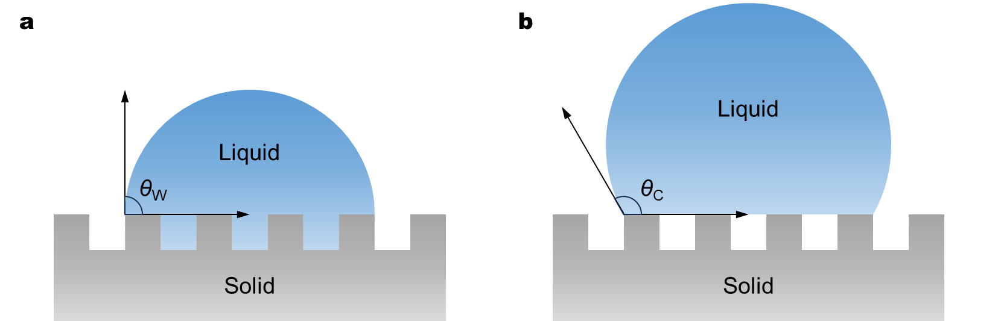
Fig. S3. Schematic diagram of (a) the Wenzel wetting state, and (b) the Cassie wetting state.

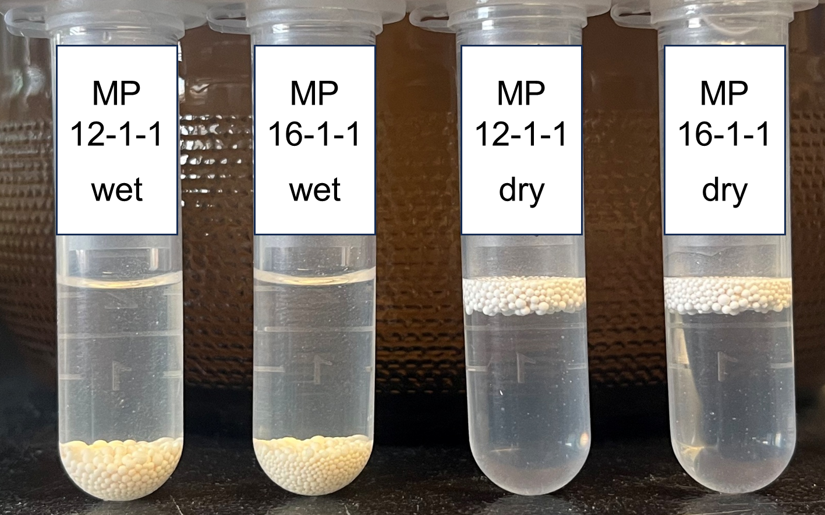
Fig. S4. Photos of macroporous AERs with long-chain quaternary amine groups in wet and dry states after being shaken in water for 30 days.

Fig. S5. Removal of PFAS from chromium-plating wastewater by macroporous AERs with long-chain quaternary amine groups in wet and dry states before and after degassing. 40 mg of AER (wet weight) was added to 200 mL of the second batch of chromium-plating wastewater and shaken for 48 h.

Fig. S6. Removal of different PFAS by PFA694E and synthesized macroporous AERs with long-chain quaternary amine groups in wet and dry states from spiked ultrapure water. The concentration of each PFAS was 50 μg/L. 40 mg of AER (wet weight) was added to 200 mL of the solution and shaken for 48 h.

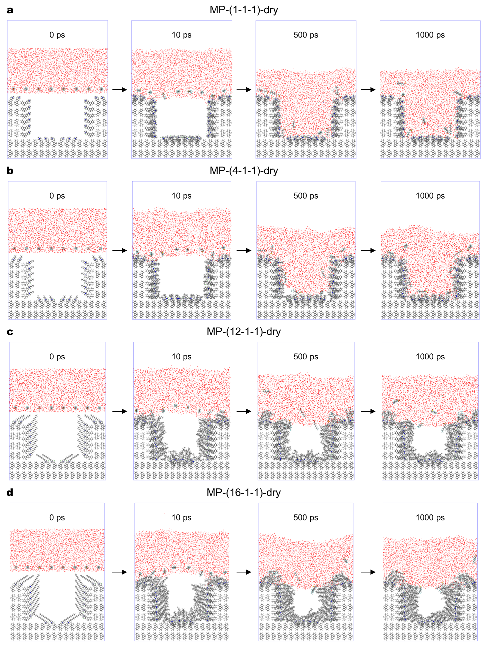
Fig. S7. Molecular dynamics simulation snapshots of the wetting state on the surface of dry macroporous AERs, including (a) MP-(1-1-1), (b) MP-(4-1-1), (c) MP-(12-1-1), and (d) MP-(16-1-1).
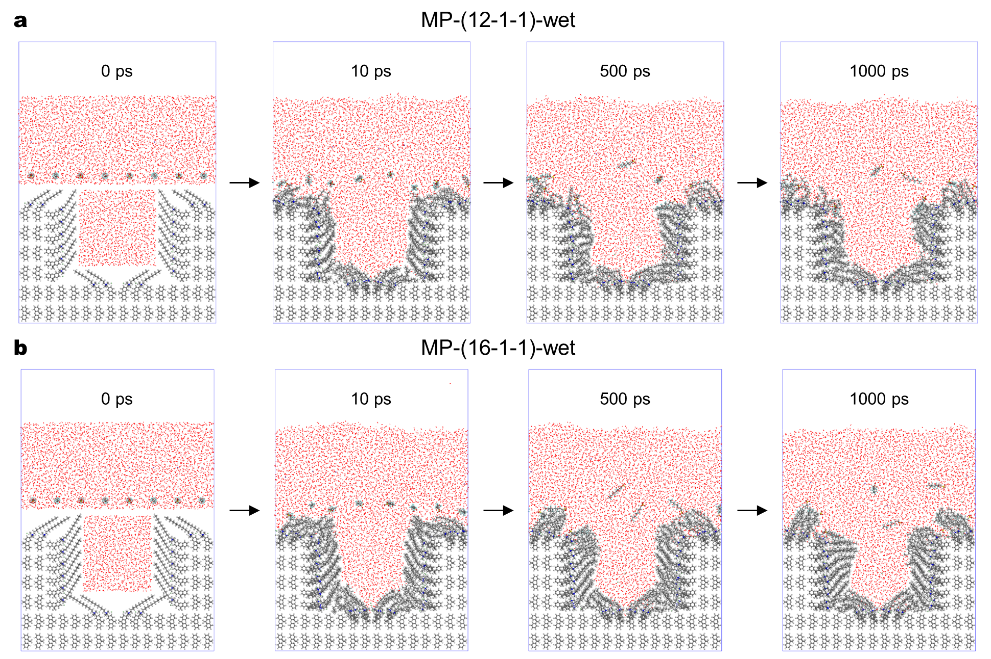
Fig. S8. Molecular dynamics simulation snapshots of the wetting state on the surface of wet macroporous AERs, including (a) MP-(12-1-1), and (b) MP-(16-1-1).

Fig. S9. Potential of mean force (PMF) profiles for the adsorption of (a) PFHxS, (b) PFBS, (c) PFHxA, (d) PFBA, and (e) GenX at the gas-liquid interface.

Fig. S10. Potential of mean force (PMF) profiles for the adsorption of (a) chloride, and (b) nitrate at the gas-liquid interface.

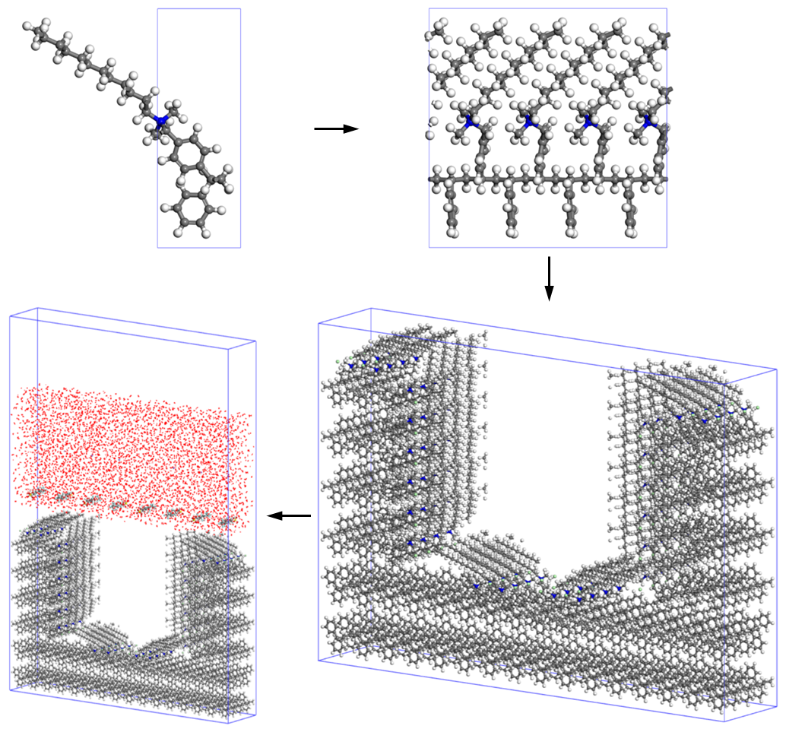
Fig. S11. Modeling process for simulating the surface wetting states of macroporous AERs.

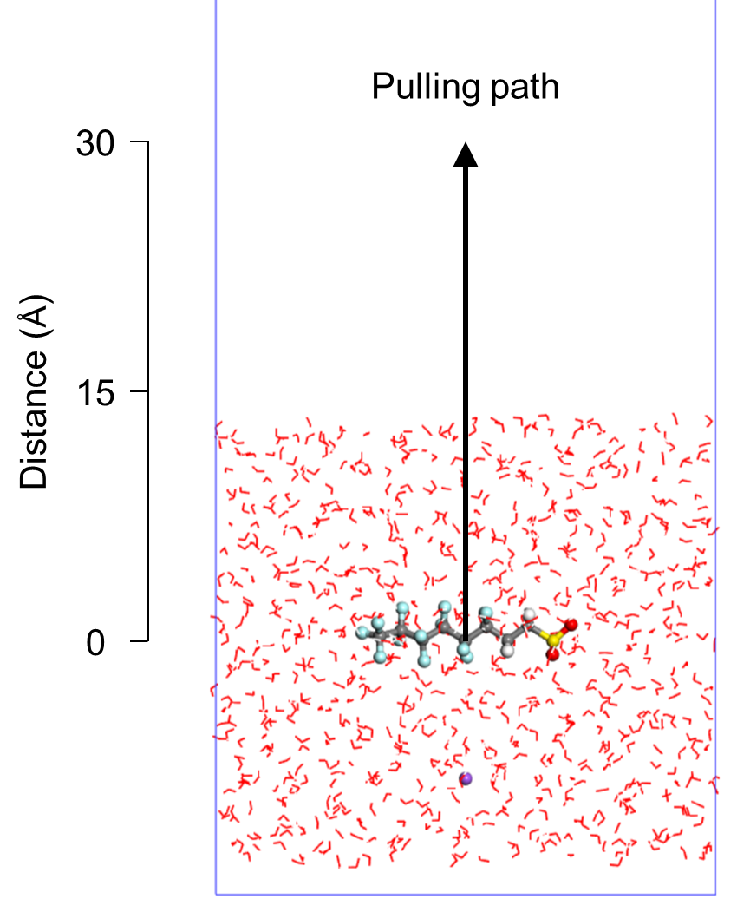
Fig. S12. Initial model for calculating the potential of mean force (PMF) of PFAS adsorption at the gas-liquid interface using umbrella sampling.

Table S1. List of synthesized AERs
Aminating agent | Functional group | Pore structure | Name of the AER
Trimethylamine | 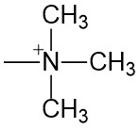 | Gel | Gel-(1-1-1)
Trimethylamine |  | Macroporous | MP-(1-1-1)
Triethylamine | 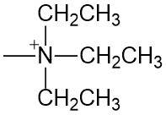 | Gel | Gel-(2-2-2)
Triethylamine |  | Macroporous | MP-(2-2-2)
Tributylamine | 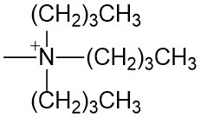 | Gel | Gel-(4-4-4)
Tributylamine |  | Macroporous | MP-(4-4-4)
Trihexylamine | 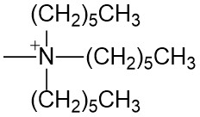 | Gel | Gel-(6-6-6)
Trihexylamine |  | Macroporous | MP-(6-6-6)
N,N-Dimethylbutylamine | 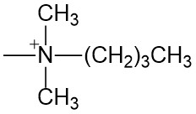 | Gel | Gel-(4-1-1)
N,N-Dimethylbutylamine |  | Macroporous | MP-(4-1-1)
N,N-Dimethyloctylamine | 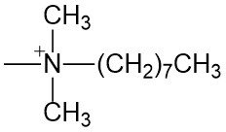 | Gel | Gel-(8-1-1)
N,N-Dimethyloctylamine |  | Macroporous | MP-(8-1-1)
N,N-Dimethyldodecylamine | 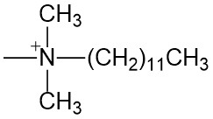 | Gel | Gel-(12-1-1)
N,N-Dimethyldodecylamine |  | Macroporous | MP-(12-1-1)
N,N-Dimethylhexadecylamine | 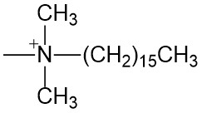 | Gel | Gel-(16-1-1)
N,N-Dimethylhexadecylamine |  | Macroporous | MP-(16-1-1)

Table S2. Basis properties of commercial and synthesized AERs *
AER | Moisture  content (%) | Elemental content of dry AER (%) |  |  | N content of  wet AER (%)
AER | Moisture  content (%) | C | H | N | N content of  wet AER (%)
PFA694E | 41 | 78.45 | 8.24 | 2.60 | 1.53
LSI106G | 44 | 75.50 | 9.56 | 2.95 | 1.65
Gel-(1-1-1) | 44 | 67.08 | 8.39 | 4.92 | 2.76
Gel-(2-2-2) | 41 | 70.54 | 8.98 | 4.09 | 2.41
Gel-(4-4-4) | 41 | 76.09 | 8.25 | 2.75 | 1.62
Gel-(6-6-6) | 18 | 75.67 | 9.08 | 2.36 | 1.94
Gel-(4-1-1) | 39 | 71.67 | 8.95 | 4.18 | 2.55
Gel-(8-1-1) | 26 | 73.84 | 9.94 | 4.05 | 3.00
Gel-(12-1-1) | 19 | 75.20 | 10.68 | 3.53 | 2.86
Gel-(16-1-1) | 18 | 76.55 | 10.72 | 3.05 | 2.50
MP-(1-1-1) | 60 | 64.59 | 8.60 | 5.59 | 2.24
MP-(2-2-2) | 59 | 69.99 | 8.80 | 4.02 | 1.65
MP-(4-4-4) | 57 | 69.33 | 7.85 | 4.19 | 1.80
MP-(6-6-6) | 51 | 73.73 | 8.03 | 2.07 | 1.01
MP-(4-1-1) | 58 | 70.01 | 9.35 | 4.82 | 2.02
MP-(8-1-1) | 53 | 73.38 | 9.57 | 3.98 | 1.87
MP-(12-1-1) | 51 | 74.52 | 9.91 | 3.22 | 1.58
MP-(16-1-1) | 50 | 75.60 | 9.72 | 2.67 | 1.34
* Data were determined in our previous study (https://doi.org/10.1016/j.watres.2024.122749).

Table S3. Concentrations of PFAS in chromium-plating wastewater ª
PFAS ^{b} | Concentration (μg/L)
PFAS ^{b} | First batch of wastewater | Second batch of wastewater
PFOS | 5.06 | 7.56
6:2 FTS | 30.0 | 28.9
PFHpS ^{c} | 0.36 | 0.41
PFHxS ^{c} | 0.55 | 0.32
ª Data were determined in our previous study (https://doi.org/10.1016/j.watres.2024.122749).
ª Concentrations of other PFAS were below 0.1 μg/L.
^{b} Removal was not analyzed due to low concentrations.

Table S4. Water quality parameters of chromium-plating wastewater ª
Index | Value (mg/L)
Index | First batch of wastewater | Second batch of wastewater
pH ^{b} | 7.3 | 7.5
TOC | 33.2 | 17.4
Cr | <0.1 | <0.1
Na | 830 | 940
Ca | 1,120 | 830
Cl⁻ | 270 | 1,090
NO₃⁻ | 270 | 210
SO₄²⁻ | 3,300 | 2,400
ª Data were determined in our previous study (https://doi.org/10.1016/j.watres.2024.122749).
^{b} Dimensionless.

Table S5. Selectivity coefficients of PFAS relative to chloride (NaCl) during the adsorption by different AERs
PFAS | $$K_{PFAS/{Cl}^{-}(NaCl)}$$
PFAS | PFA694E | MP-(12-1-1)-wet | MP-(16-1-1)-wet | MP-(12-1-1)-dry | MP-(16-1-1)-dry
PFBA | 1.1 × 10² | 9.4 × 10¹ | 1.5 × 10² | 1.1 × 10² | 8.1 × 10¹
PFHxA | 8.9 × 10² | 3.4 × 10² | 5.4 × 10² | 5.9 × 10³ | 1.4 × 10³
PFOA | 2.9 × 10³ | 1.6 × 10³ | 1.7 × 10³ | 2.1 × 10⁴ | 1.7 × 10⁴
PFBS | 3.7 × 10³ | 2.6 × 10³ | 3.5 × 10³ | 1.0 × 10⁴ | 7.0 × 10³
PFHxS | 1.7 × 10⁴ | 7.4 × 10³ | 6.4 × 10³ | 4.0 × 10⁴ | 2.5 × 10⁴
PFOS | 1.2 × 10³ | 1.8 × 10³ | 8.9 × 10² | 2.9 × 10⁴ | 2.1 × 10⁴
6:2 FTS | 9.1 × 10² | 6.7 × 10² | 6.3 × 10² | 1.9 × 10⁴ | 1.4 × 10⁴
GenX | 7.8 × 10² | 3.0 × 10² | 5.1 × 10² | 6.2 × 10³ | 9.9 × 10²
HFPO-TA | 7.3 × 10² | 1.4 × 10³ | 1.5 × 10³ | 2.3 × 10⁴ | 2.4 × 10⁴

Table S6. Selectivity coefficients of PFAS relative to chloride (CaCl₂) during the adsorption by different AERs
PFAS | $$K_{PFAS/{Cl}^{-}({CaCl}_{2})}$$
PFAS | PFA694E | MP-(12-1-1)-wet | MP-(16-1-1)-wet | MP-(12-1-1)-dry | MP-(16-1-1)-dry
PFBA | 9.1 × 10¹ | 7.2 × 10¹ | 1.1 × 10² | 1.1 × 10² | 5.7 × 10¹
PFHxA | 7.9 × 10² | 3.1 × 10² | 4.9 × 10² | 5.8 × 10³ | 1.3 × 10³
PFOA | 2.6 × 10³ | 1.1 × 10³ | 1.2 × 10³ | 4.2 × 10⁴ | 2.1 × 10⁴
PFBS | 4.6 × 10³ | 2.1 × 10³ | 3.5 × 10³ | 1.1 × 10⁴ | 4.4 × 10³
PFHxS | 1.7 × 10⁴ | 5.2 × 10³ | 3.8 × 10³ | 9.1 × 10⁴ | 3.7 × 10⁴
PFOS | 1.3 × 10³ | 1.5 × 10³ | 5.7 × 10² | 3.4 × 10⁴ | 2.7 × 10⁴
6:2 FTS | 1.1 × 10³ | 6.3 × 10² | 5.7 × 10² | 5.1 × 10⁴ | 1.7 × 10⁴
GenX | 6.6 × 10² | 2.7 × 10² | 4.4 × 10² | 5.2 × 10³ | 9.2 × 10²
HFPO-TA | 8.2 × 10² | 9.5 × 10² | 7.1 × 10² | 3.7 × 10⁴ | 1.4 × 10⁴

Table S7. Selectivity coefficients of PFAS relative to nitrate (NaNO₃) during the adsorption by different AERs
PFAS | $$K_{PFAS/{NO}_{3}^{-}}$$
PFAS | PFA694E | MP-(12-1-1)-wet | MP-(16-1-1)-wet | MP-(12-1-1)-dry | MP-(16-1-1)-dry
PFBA | 9.7 | 6.5 | 1.1 × 10¹ | 5.7 | 1.9
PFHxA | 7.3 × 10¹ | 6.0 × 10¹ | 6.9 × 10¹ | 1.9 × 10² | 6.3 × 10¹
PFOA | 3.0 × 10² | 3.5 × 10² | 3.9 × 10² | 2.9 × 10³ | 2.3 × 10³
PFBS | 9.8 × 10² | 5.4 × 10² | 5.2 × 10² | 7.7 × 10² | 2.6 × 10²
PFHxS | 2.7 × 10³ | 2.2 × 10³ | 1.7 × 10³ | 4.0 × 10⁴ | 6.6 × 10³
PFOS | 1.1 × 10³ | 1.5 × 10³ | 1.4 × 10³ | 1.2 × 10⁴ | 1.1 × 10⁴
6:2 FTS | 1.3 × 10² | 1.3 × 10² | 1.7 × 10² | 9.0 × 10³ | 1.8 × 10³
GenX | 7.0 × 10¹ | 5.2 × 10¹ | 6.8 × 10¹ | 1.8 × 10² | 5.9 × 10¹
HFPO-TA | 3.5 × 10² | 6.3 × 10² | 1.0 × 10³ | 3.6 × 10⁴ | 1.9 × 10⁴

Table S8. MRM parameters for target PFAS
PFAS | Q1 (Da) | Q3 (Da) | DP (V) | EP (V) | CE (V) | CXP (V)
PFBA | 212.6 | 168.9 | −15.0 | −3.5 | −8.0 | −2.0
PFHxA | 312.7 | 268.9 | −15.0 | −3.0 | −8.0 | −4.0
PFOA | 412.9 | 369.0 | −20.0 | −6.0 | −10.0 | −4.0
PFBS | 298.7 | 80.0 | −55.0 | −8.0 | −50.0 | 0.0
PFHxS | 398.7 | 80.0 | −65.0 | −8.5 | −70.0 | 0.0
PFOS | 498.8 | 80.0 | −85.0 | −10.0 | −88.0 | 0.0
6:2 FTS | 427.0 | 81.0 | −55.0 | −7.0 | −60.0 | 0.0
GenX | 328.9 | 284.9 | −14.4 | −3.5 | −31.8 | −2.0
HFPO-TA | 494.9 | 184.9 | −16.0 | −2.2 | −35.0 | −0.6

Table S9. Quality assurance and quality control (QA/QC) parameters for target PFAS
PFAS | LOD (μg/L) | LOQ (μg/L) | Recovery (%) | RSD (%)
PFBA | 0.06 | 0.18 | 102 | 6.8
PFHxA | 0.08 | 0.24 | 101 | 4.6
PFOA | 0.06 | 0.17 | 90 | 3.0
PFBS | 0.04 | 0.13 | 95 | 5.9
PFHxS | 0.02 | 0.07 | 99 | 3.1
PFOS | 0.02 | 0.05 | 85 | 3.1
6:2 FTS | 0.17 | 0.52 | 95 | 4.1
GenX | 0.32 | 0.96 | 98 | 8.1
HFPO-TA | 0.19 | 0.56 | 99 | 5.9

