Producing Green Fuel Ammonia in Equatorial Waters, Piping It Worldwide, and Removing Atmospheric CO₂ to Return to 1960s Temperatures by 2100

Hiroshi Kobayashi*
Professor Emeritus of Tokyo Denki University, 5 Senju-Asahi-cho, Adachi-ku, Tokyo, Japan

Supplementary Information
Supplementary Note:

Kobayashi, H. Carbon-free energy supply system using floating offshore photovoltaics and hydrogen energy carriers: towards the achievement of the Paris agreement goal. J. Jpn Soc. Energy Resour. 43, 274–284 (2022).

Permission to share this article was obtained from the Japan Society of Energy and Resources.

The English translated version of the pdf file of the aforementioned paper (Reference 5) can be downloaded here.

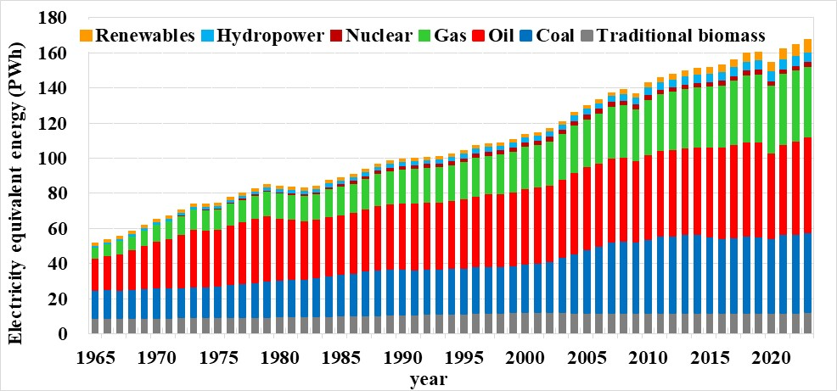
Supplementary Fig. S1. Trends in global primary energy consumption by energy source from 1965 to 2023. Until the mid-19th century, traditional biomass (burning solid fuels, such as wood, agricultural waste, and charcoal) was the main energy source used worldwide. Since the 1960s, global energy demand has continued to increase (by an average of approximately 5.6% per year). In 2023, fossil fuel energy accounted for approximately 85% (91% if traditional biomass is included) of global energy demand. Since 2000, the social and economic growth of emerging countries in the Asia-Pacific region has been remarkable, and the share of the global energy demand accounted for by developed countries, centered on OECD member countries, has decreased significantly. However, depending on the future policies of major countries such as the United States, Russia, China, and India, greenhouse gas emissions may increase further, potentially devastatingly impacting human societies and the global ecosystem [1].

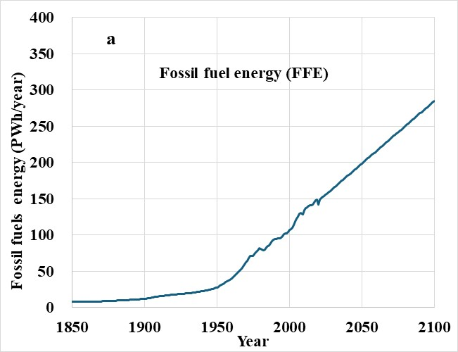 | 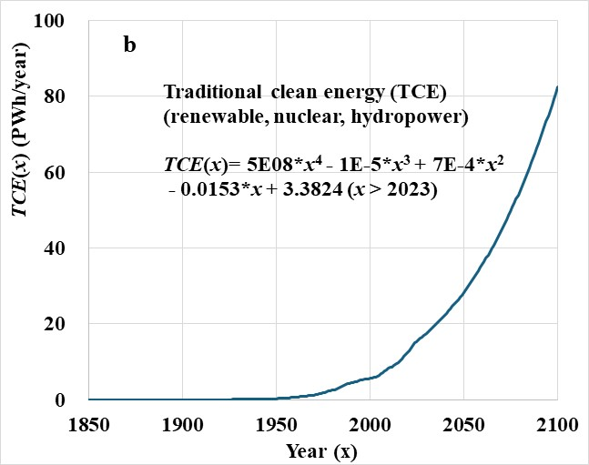
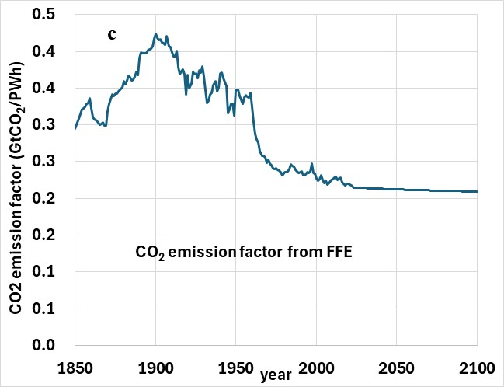 | 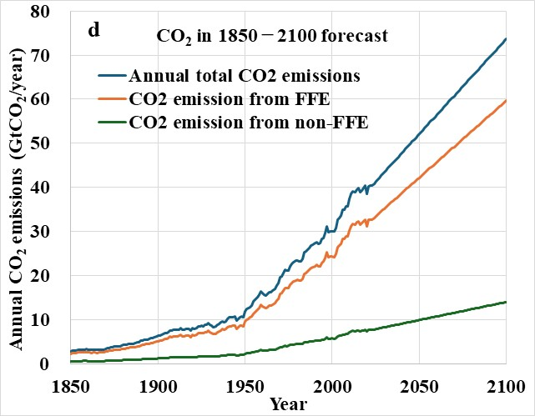
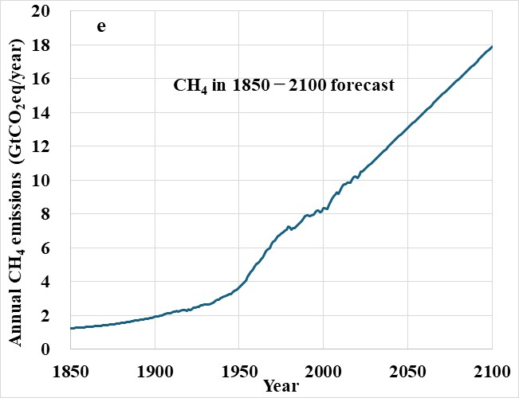 | 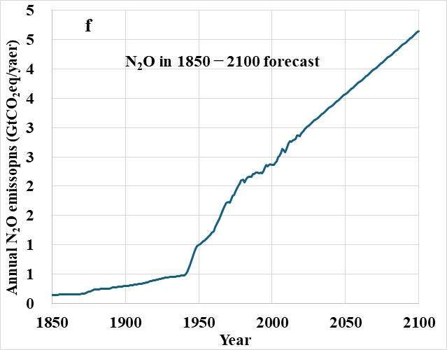
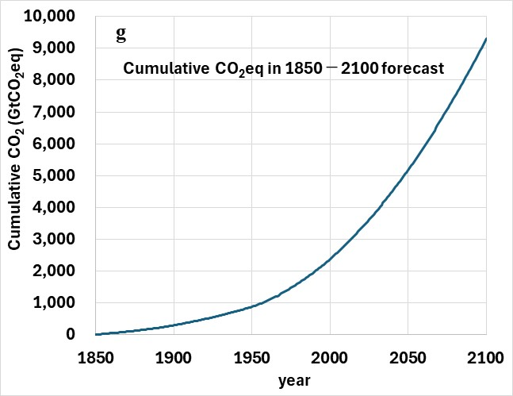 | 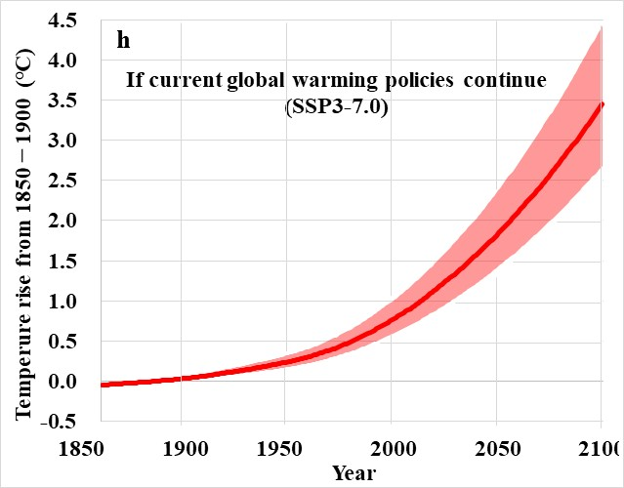
Supplementary Fig. S2. Historical trends and projections for global warming components through 2100. (a) Fossil fuel energy (FFE). (b) Traditional clean energy (TCE: renewable, nuclear, and hydropower). Although rapid growth is expected, by 2100, TCE amounts will only reach 29% of FFE and account for 22% of the total primary energy. (c) CO₂ emissions factor from FFE. Before 1970, when coal was the main source, the emission factor was high. (d) to (g) GHG components. CO₂ from non-FFE is caused by land use change and land management (deforestation, degradation, regeneration after farmland abandonment, peat drainage, etc.). (h) The SSP3-7.0 scenario (cumulative CO₂ is double the current level in 2100) where global warming policies continue. The surface temperature will rise to 3.5 [2.5 to 4.4] ℃ by 2100 [2-3].

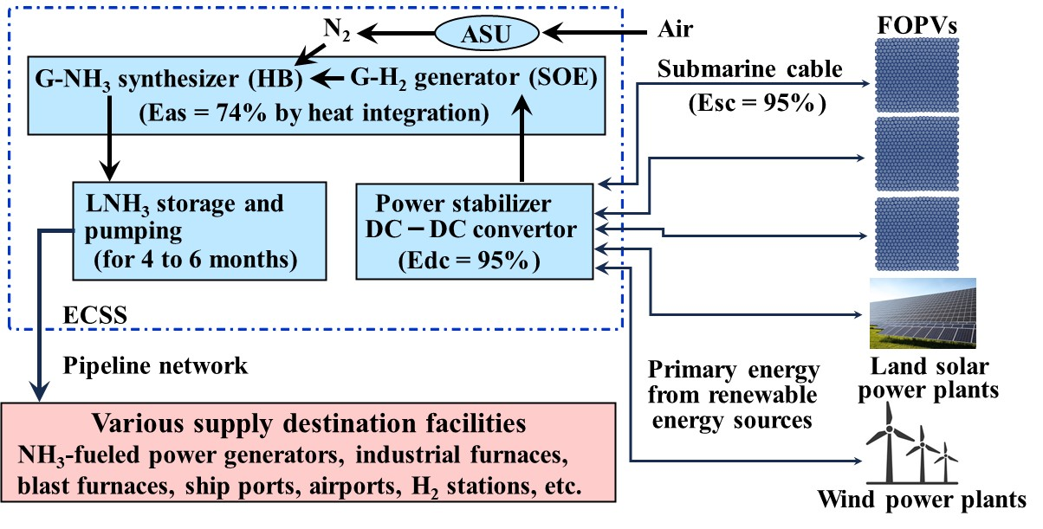
Supplementary Fig. S3. Carbon-free energy supply system (CFESS). The G-NH₃ synthesis system uses a solid oxide electrolyzer (SOE) operating at high temperatures (650°C) to electrolyze green hydrogen from renewable electricity. It also synthesizes NH₃ from H₂ and N₂ under high temperature and pressure conditions (450-600°C, 10-25 MPa) using the Haber-Bosch (HB) method. These components are thermally integrated. Even including the energy required for the ASU to separate nitrogen gas from air, a high NH₃ synthesis efficiency of 74% is achieved. The HB method, developed in 1913, is still widely used for NH₃ production as a fertilizer raw material, but catalyst research aims to achieve NH₃ synthesis at lower temperatures and pressures to improve production efficiency [4-5].
The synthesized G-NH₃ is pressurized to become LNH₃ and stored in tanks. The ECSS supplies LNH₃ to various supply destination facilities through a pipeline network. For details on the FOPV, ECSS, LNH₃ pipeline network, and various supply destination facilities, refer to Fig. 3.

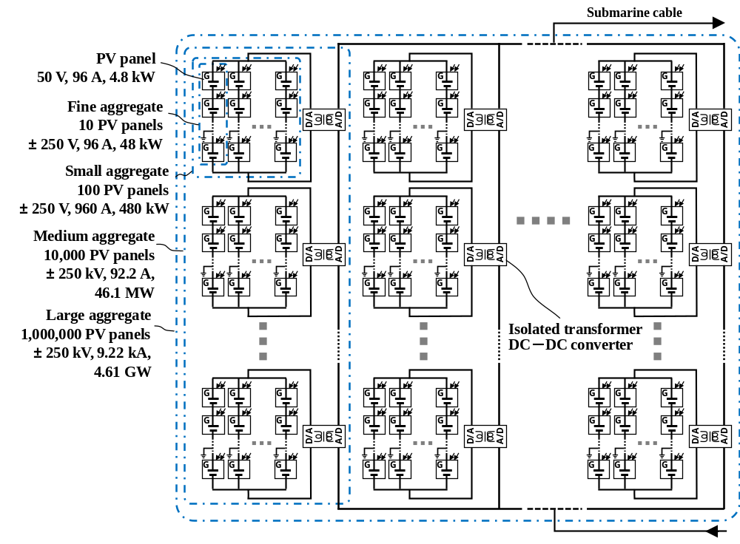
Supplementary Fig. S4. Four-layer connection circuit of FOPV preventing PID in PV modules. As with the design of the previous PV panel [6], the maximum potential difference between the PV module and frame (ground) was ±2.60 kV, however, this potential difference could have a significant impact on the performance and lifespan of the PV module due to the potential-induced degradation (PID) phenomenon. PID can be prevented by reducing the potential difference between the PV module and frame to 500 V or less. To achieve this, the small aggregate is divided into two layers, and the fine aggregate, a series connection of 10 PV panels, is connected in parallel to limit the maximum potential difference to ±250 V. Therefore, the FOPV has a four-layer structure overall. See the example of the performance specifications of the FOPV in Supplementary Table S1.

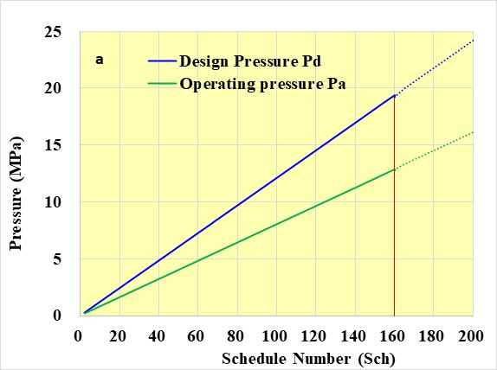 | 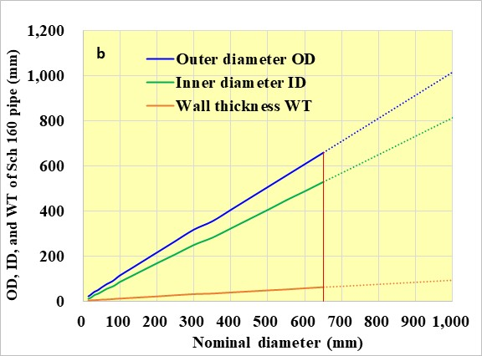
Supplementary Fig. S5 Properties of carbon steel pipes used for high-pressure piping. (a) Design and operating pressures according to the Schedule (Sch). Relationship between the design pressure (Pd) and Sch number is shown, representing the wall thickness of the pressure pipe when the strength of allowable tensile (Sat) = 121 N/mm², used for STS 480, with the highest Sat at −40 ℃ < T < 60 ℃. Pd indicates the pressure that can withstand instantaneous pressurization, and Po indicates the operational pressure that can withstand long-term operation. Po can be expressed as follows: Po = Pd/SF = 12.9 MPa, where SF is the safety factor generally set to 1.5 for piping. For carbon steel pipes used for high-pressure piping, the Sch ranges from 2 to 160. Dotted lines in the figure indicate Sch values that exceed the standard, along with the corresponding Pd and Po values. (b) Outer diameter (OD), inner diameter (ID), and wall thickness (WT) of Sch 160. In JIS G 3455:2020 [7], the nominal diameter is defined from 15 to 650 for Sch 160. Solid lines: OD, ID, and WT of a nominal diameter; dotted lines: OD, ID, and WT when the nominal diameter of Sch 160 = 1,000 (maximum nominal diameter of thin pipes with Sch = 10S or 20S). The ID for a nominal diameter of 1,000 is ~1.5 times larger than that for 650, and the amount of LNH₃ transport can be increased by a factor of 5. If the pressure resistance strength of JIS G 3455 is extended to that of Sch 200, LNH₃ transport can be increased by ~6.5 times; this will reduce the required number of pipelines without compromising the supply. The service life of pipelines is up to 50–70 years [8]; thus, pipelines of different diameters and pressures will become part of the network.

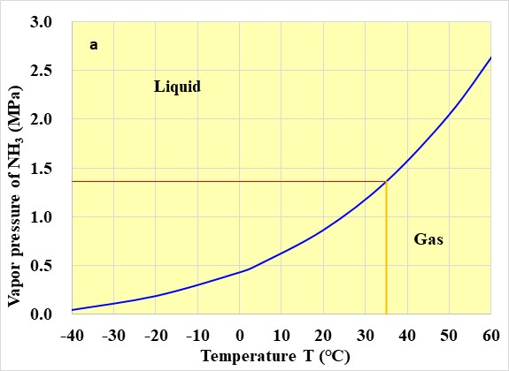
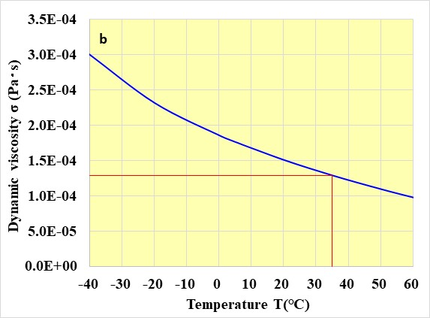
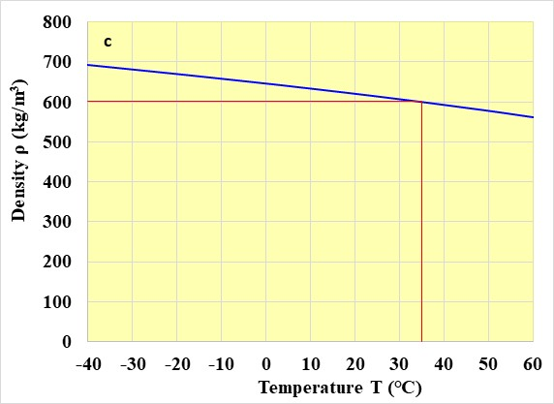
Supplementary Fig. S6. Temperature characteristics of LNH₃. Physical properties of NH₃ were calculated using FLUIDAT [9]. At 20°C and 0.1 MPa, NH₃ exists as a gas but liquefies when pressurized at 0.86 MPa or higher. (a) Vapor pressure curve for NH₃. For buried pipelines with an average temperature of 35°C, the pressure (Pr) required to maintain LNH₃ in its liquid state is calculated as: Pr = 1.36 × SF = 2.05 MPa, where SF is the safety factor. Pr increases when T > 35°C and decreases when T ≤ 35°C. Assuming the most pressure-resistant pipe (Schedule 160), the pressure inside the pipeline for LNH₃ transport must be maintained between 2.05 and 12.9 MPa. (b) Dynamic viscosity (σ) represents a fluid’s resistance to movement, while kinematic viscosity (ν = σ/ρ) reflects the fluid’s inherent flow resistance. Lower liquid temperatures reduce fluidity, while rising liquid temperatures increase viscosity. For LNH₃, ρ = 601 kg/m³ (35°C and 12.9 MPa), compared to that of NH₃ gas, ρ = 0.679 kg/m³ (35°C, 0.1 MPa), a difference of 1:855. The ν values of LNH₃ and NH₃ are 1.45 × 10⁻⁷ and 1.59 × 10⁻⁵, respectively, indicating LNH₃ is 110 times less viscous than gaseous NH₃, making LNH₃ transport significantly denser and more efficient. (c) Density (ρ) of LNH₃ changes by 20.6% across a temperature range of −40 to 60°C. Thus, temperature effects on LNH₃ density must be considered when analyzing pipeline transport characteristics.

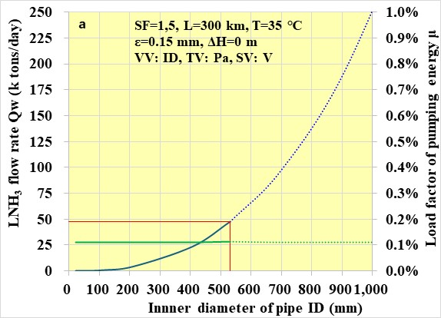 | 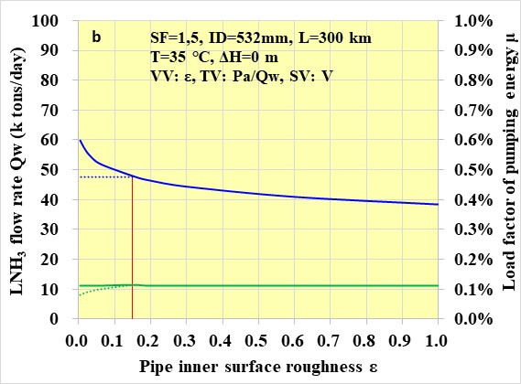
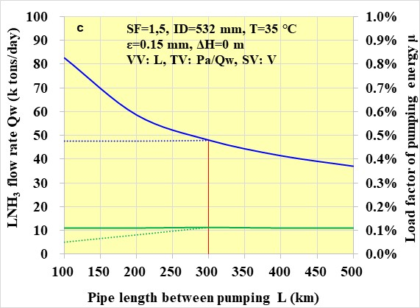 | 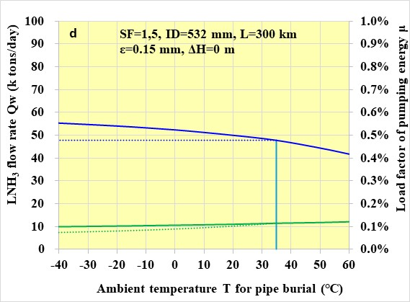
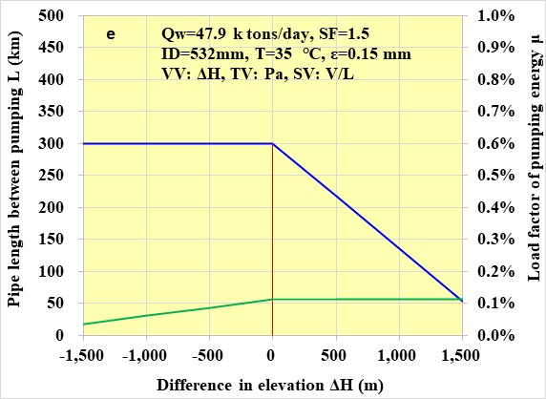 | 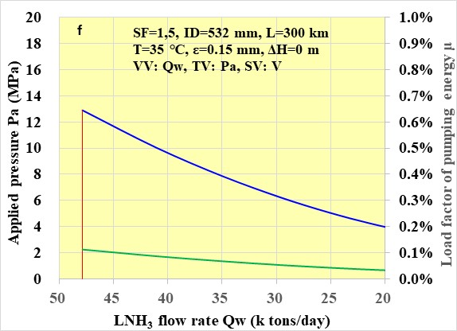
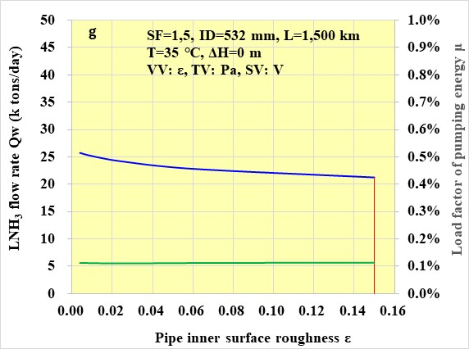 | 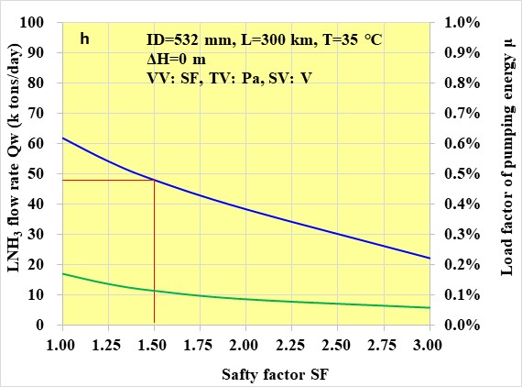
Supplementary Fig. S7. Performance analysis results of LNH₃ pipeline transportation. (a) Although Qw increases as the number of IDs increases, it remains constant at μ = 0.11% because Ep and Npw increase at approximately the same rate as Qw increases, and this cancels out in the formula for μ. (b) When ε < 0.15mm, the solid line shows that μ decreases as λ becomes smaller, i.e., as the surface becomes smoother, Ep decreases. The broken line indicates that if Ep is kept constant, Qw can be increased by reducing λ. (c) For the solid line for L < 300 km, if Qw is kept constant, L is shortened, i.e., Ep is reduced, so μ decreases. For L > 300 km, although Qw decreases, μ = 0.11% is constant. (d) As T increases, σ decreases, and the fluidity of LNH₃ increases, but Pr increases. In LNH₃ transport, Pr has a greater contribution than σ, and decreases with increasing temperature. (e) A negative ΔH indicates a downward slope, and a positive ΔH indicates an upward slope. On a downward slope, the self-weight pressure of LNH₃ is added to the far end, and to prevent Pa and Hp from exceeding the upper limit (Pa = 12.8 MPa), L cannot be increased, although it contributes to the decrease in μ. (f) LNH₃ is supplied to the destination facility from the pipe that branched off in the middle of L, and even if the Qw of the trunk pipeline presents a corresponding decrease, the Pa necessary to maintain Pr > 2.05 is determined. (g) When L = 1,500 km, the standard value of ε = 0.150 mm reduces Qw to about 45% of the value for L = 300 km; however, when the inner pipe surface is coated with Teflon or other material, the value increases to approximately 54% for ε = 0.004 mm. (h) This shows the relationship between SF and Qw. This SF is adapted to the applied Pa and NH₃ liquid maintenance pressure Pr.

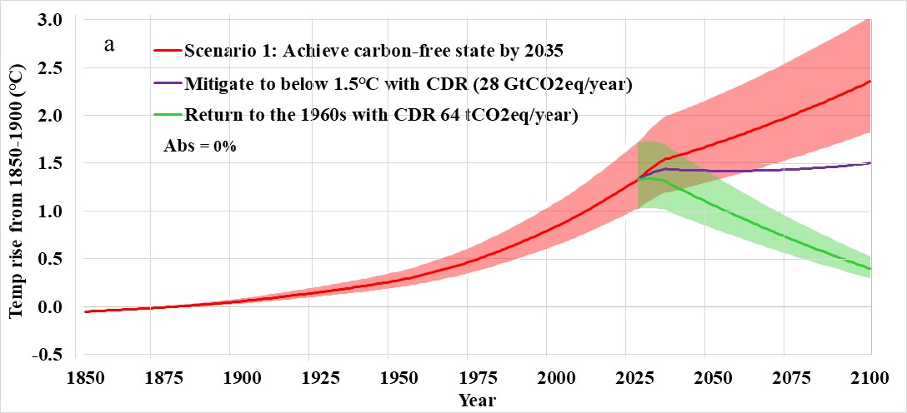
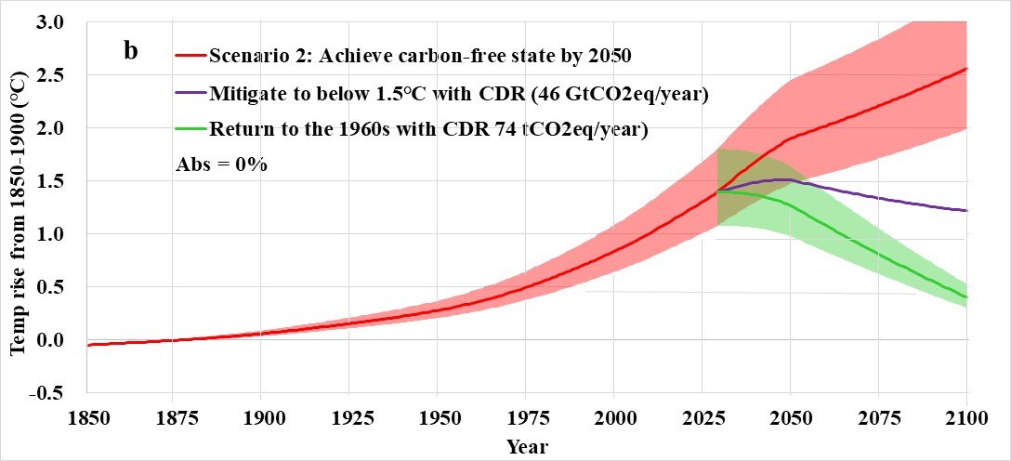
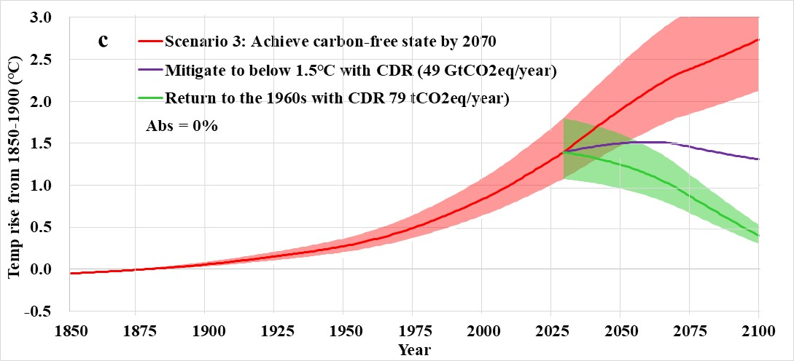
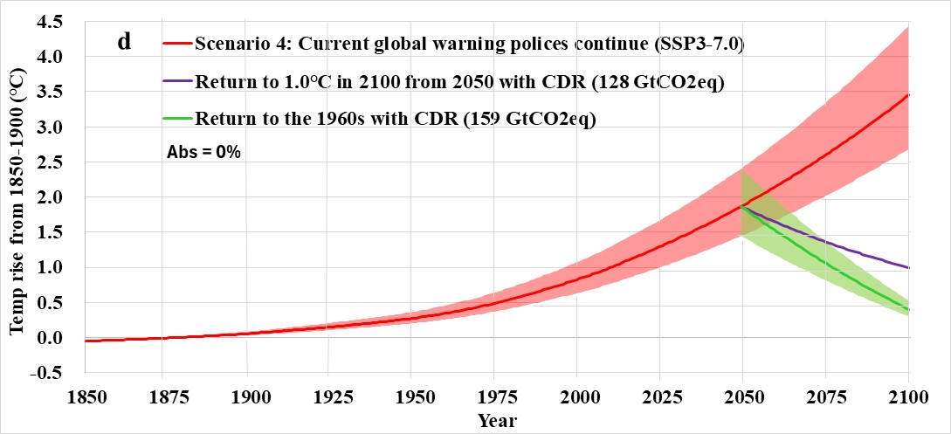
Supplementary Fig. S8. Verification of the simple numerical analysis model by setting Abs = 0%. In Scenarios 1 to 3 of Fig. 4, the temperature rate decreased after the carbon-free state due to the absorption of atmospheric CO₂ by land and oceans (Abs = 1.07%). The Abs value was set to 0% in this figure to validate the simple numerical analysis model. This figure shows that the temperature rises rapidly after the carbon-free state in Scenarios 1 to 3. For example, comparing the median temperature projections for 2100 with Abs = 1.07% and 0%, Scenarios 1, 2, and 3 show temperatures rising from 1.4°C to 2.4°C, from 1.6°C to 2.6°C, and from 1.8°C to 2.7°C, respectively. Correspondingly, the CDR required to return to 1960s temperatures varies from 33 to 64 GtCO₂eq in Scenario 1, 40 to 74 GtCO₂eq in Scenario 2, and 48 to 79 GtCO₂eq in Scenario 3.
When Abs=0%, the temperature rise is due to "16% of CO₂ emissions are from non-FFEs," as stated in (9), and when Abs=1.07%, it means that the impact of CO₂ absorption by land and ocean is stronger than CO₂ emissions from non-FFEs. However, such a rise is not observed in Scenario 4. The lack of change is because, as indirectly stated in (10), the temperature rise due to TCRE before reaching a carbon-free state includes CO₂ absorption by land and ocean.

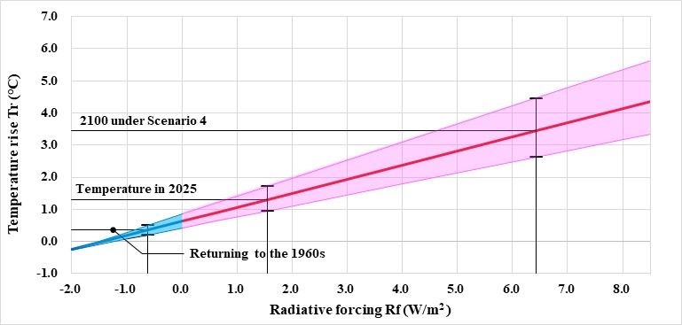
Supplementary Fig. S9. Radiative forcing and temperature rise based on SSP scenarios. To return temperatures to 1960s levels, CO₂eq must be removed from the atmosphere. In addition, in Scenario 4, temperatures will rise by 3.5 [2.5 to 4.4]°C by 2100, significantly changing the current energy balance. This figure shows the relationship between radiative forcing (Rf) and temperature rise (Tr) in the following five IPCC SSP scenarios, using a linear approximation (upper 95%, best estimate, lower 5%). To the right of Rr = 0 (Rf > 0: light red), the Earth continues to warm, and to the left (Rf < 0: light blue), the Earth cools. The best estimate of Rf for temperatures in the 1960s is −0.51 W/m² (0.4°C), and the Rf in Scenario 4 for 2100 is 6.4 W/m². As of 2025, it can be seen that the Earth is warming at Rf = 1.55 W/m².
If temperatures could be returned to 1960s levels, would global warming stop? Randers et al. claim that "even if CO₂eq emissions were to stop, temperatures would continue to rise due to methane emissions from melting permafrost and lower albedo due to melting glaciers and snow. To prevent this, 33 GtCO₂eq must be continuously removed annually from the atmosphere” [10]. In other words, achieving RF < 0 alone will not stop global warming, and CO₂eq removal must continue thereafter. The advantage of achieving Rf < 0 is that the amount of CDR can be significantly reduced, as shown in Fig. 6, and the sooner this is achieved, the weaker the impact of global warming on humanity and ecosystems.
SSP1-1.9: 1.4 [1.0 to 1.8]℃ in 2081–2100
SSP1-2.6: 1.8 [1.3 to 2.4]℃ in 2081–2100
SSP2-4.5: 2.7 [2.2 to 3.5]℃ in 2081–2100
SSP3-7.0: 3.6 [2.8 to 4.4]℃ in 2081–2100
SSP5-8.5: 4.5 [3.3 to 5.7]℃ in 2081–2100
Note: In the IPCC AR6 WG1 report, these five scenarios are called SSPx-y. Here, “SSPx” refers to the Shared Socioeconomic Pathway describing the underlying socioeconomic trends, as described in the introduction. “y” represents the radiative forcing value (W/m²) caused by the scenario in 2081–2100.
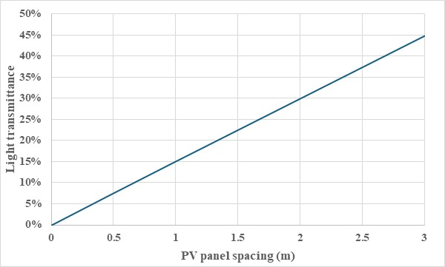
Supplementary Fig. S9. PV panel spacing and light transmittance. As shown in Fig. 4 of a previous paper [6], the FOPV comprises 1 million hexagonal PV panels (3 m per side) flexibly connected in a honeycomb structure. The PV panels are spaced 0.6 m apart, but this interval can be increased. Additionally, to avoid the effects of tsunamis and ocean currents, the system is installed at water depths ≥50 m and in areas with ocean currents ≤1 knot. This figure shows the PV panel spacing and light transmittance (assuming that 70% of the space between PV panels is light-transmissive, accounting for light blockage by connectors, etc.), with values of 0% to 45% at 0 to 3 m.
It is believed that the impact of changes in light transmittance on ecosystems and environmental conditions varies significantly depending on the target time and space. For instance, a change in light transmittance from 9% to 45% during spring blooms in areas with highly productive waters would not be considered negligible. In contrast, the impact is likely minimal in areas with low productivity during wintertime. It is essential to consider various environmental impact assessments (e.g., effects on oceanic primary production and the ecosystems that utilize it, local ocean currents due to changes in surface momentum fluxes, and surface stratification due to changes in heat flux) and mitigation strategies alongside infrastructure development.

Supplementary Table S1. Performance specifications of an FOPV plant. Each FOPV occupies an exclusive area of 28.1 km² and achieves a maximum power generation capacity of ± 250 kV, 9.22 kA, and 4.61 GW. The annual average power generation is 940 MW, which is equivalent to 8.23 TWh/year and comparable to nuclear and thermal power plants. The FOPV plant incorporates several advanced features: (a) Stationary function: screw propellers prevent displacement by ocean currents and strong winds. (b) Submerging function: panels can be submerged to withstand waves up to 20 m in height during storms. (c) Lighthouse function: prevents collisions with ships. (d) Automatic detour function: this activates when PV panels fail. (e) Introducing multiple AI-equipped transport, assembly, and maintenance robots: by streamlining the assembly of 1 million PV panels and automating maintenance, these robots will significantly reduce construction time and costs.
Parameter | Value | Unit and remarks
FOPV structure | Four-layer honeycomb structure
Length of a hexagon's side (Hpv) | 3 | m
PV panel area (Spv) | 23.4 | m², =3(√3/2Hpv²)
PV panel thickness (Hpv) | 60 | cm
Number of PV panels in fine aggregate (Nfp) | 10 | PV panels
Small aggregate capacity (Csa) | 10 | fine aggregates
Medium aggregate capacity (Cma) | 100 | small aggregates
Largr aggregate capacity (Cla) | 100 | medium aggregates
Number of PV panels in FOPV (Nfopv) | 1,000,000 | PV panels, =Nfp･Csa･Cma･Cla
Spacing between PV panels (Ppv) | 60 | cm
FOPV area (Sfopv) | 28.3 | km², =3(√3/2(Hpv+Ppv/2)²)･Nfopv
PV cell effective area of PV panel (Sepv) | 20.0 | m²
Maximum all-sky solar radiation (Rmax) | 1,000 | W/m²
Annual average all-sky solar radiation (Ravg) | 240 | W/m²
PV module conversion efficiency (Epv) | 24.0%
PV panel nominal maximum output (Wpv) | 4.80 | kW, =Sepv･Rmax･Epv
PV panel DC output voltage (Vpv) | 50.0 | V
PV panel maximum output current (Apv) | 96.0 | A, =Wpv/Vpv
Fine aggregate maximim output power (Wfa) | 48.0 | kW. =Wpv･Nfp
Fine aggregate maximum output voltage (Vfa) | ±250 | V, for PID measures
Fine aggregate maximum output current (Afa) | 96.0 | A, =Wfa/Vfa=Apv
Small aggregate maximum output power (Wsa) | 480 | kW, =Wfa･Csa
Small aggregate maximum output voltage (Vsa) | ±250 | V, =Vfa
Small aggregate maximum output current (Sma) | 960 | A, =Wsa/Vsa
DC-DC convertor efficence (Efs) | 96% | see Supplementary Fig. S4.
Medium aggregate maximum output power (Wma) | 46.1 | MW, =Wsa･Cma･Efs
Medium aggregate maximum output voltage (Vma) | ±250 | kV, =Vsa･Cma
Medium aggregate maximum output current (Ama) | 92.2 | A
Large aggregate maximum output power (Wla) | 4.61 | GW, =Wma･Cla
Large aggregate maximum output voltage (Vla) | ±250 | kV, =Vma
Large aggregate maximum output current (Ala) | 9.22 | kA, =Wla/Vla
FOPV operating rate (Rop) | 85% | for maintenance
FOPV annual average power generation (Wfopv) | 940 | MW/plant, =Nfopv･Sepv･Ravg･Epv･Efs･Rop
FOPV annual average current (Ifopv) | 1.88 | kA, =Wfopv/Vla, Ala/Ifopv=4.90
FOPV annual power generation capacity (Pfopv) | 8.23 | TWh/plant, =Wfopv･(hours per year)

Supplementary Table S2. Comparison of hydrogen energy carrier (HEC) characteristics with existing energy sources. H₂ in its gaseous state has a low energy density, is highly flammable, and burns explosively under standard conditions, making it unsuitable for storage and transportation. To address these issues, H₂ is converted into HECs for easier storage and transport. The Strategic Innovation Promotion (SIP) Program by the Japanese Cabinet Office (2014–2018) conducted extensive research on HEC, garnering global attention [11-12]. This study examined four HEC types, including LNH₃. The volumetric energy density of LNH₃ is lower than that of FFEs, but much higher than that of lithium-ion batteries and hydrogen gas. LNH₃ is the most promising HEC; its volumetric and mass energy densities are lower than those of crude oil and liquefied natural gas; this necessitates advancements in combustion technology to manage flame temperatures and heat radiation, as well as the development of high-performance catalysts for NH₃ decomposition [13]. Research is underway to commercialize NH₃ fuel cells, NH₃-specific gas turbine generators, and NH₃-fueled ships, with commercialization expected by 2026 [14]. The energy density of uranium is more than 10,000 times that of fossil fuels; however, the problem of the final disposal of nuclear fuel has yet to be solved.
In addition, methanol has attracted attention as a carbon-neutral synthetic fuel due to its capacity to be synthesized from green hydrogen and CO₂ from power plants and the atmosphere. However, the combustion of synthetic fuels results in the emission of CO₂ into the atmosphere. As illustrated in Fig. 1a, as energy consumption rises, the production of synthetic fuels as a substitute for fossil fuels will necessitate the capture of 42 Gt of CO₂ from the atmosphere and power plants in 2050 and 60 Gt in 2100. Furthermore, to return temperatures to 1960s levels by 2100, adding these amounts to the CDR quantities in Scenarios 1 to 4 of Fig. 4 would be necessary.
Hydrogen energy carriers | Volumetric energy density | Mass energy density | Storage conditions | Long-term storage | Remarks
High pressure hydrogen gas (H₂) | △ 767/1,200 Wh/L | ◎ 32,900 Wh/kg | △ 35/70MPa | △ | △ Highly flammable, explosive
Liquid hydrogen (LH₂) | 〇 2,330 Wh/L | ◎ 32,900 Wh/kg | ✖ －253℃ | ✖ | △ Highly flammable, explosive
Fuel liquefied ammonia (LNH₃) | 〇 3,960 Wh/L | 〇 5,810 Wh/kg | ◎ Room temp., 0.86MPa | ◎ | △ Acute toxicity, 〇 Many achievements
Methylcyclohexane (MCH) | △ 1,550 Wh/L | △ 2,010 Wh/kg | ◎ Room temperature | 〇 | 〇 Flammability comparable to gasoline
(ref.) Liquefied natural gas (LNG) | ◎ 6,977 Wh/L | ◎ 15,167 Wh/kg | ✖ －161.5℃ | △ | ✖ CO₂ emissions
(ref.) Crude oil | ◎ 10,628 Wh/L | ◎ 12,541 Wh/kg | ◎ Room temperature | ◎ | ✖✖ Large amount of CO₂ emissions
(ref.) Coal | ◎ 9,972 Wh/L | 〇 7,150 Wh/kg | ◎ Room temperature | ◎ | ✖✖ Large amount of CO₂ emissions
(ref.) Li-ion secondary battery | ✖ 520 Wh/L | ✖ 201 Wh/kg | ◎ Room temperature | ✖ | ✖ Lithium is a rare metal and expensive
(ref.) Uranium fuel | ◉ 7.6×10⁹Wh/L | ◉ 4.2×10⁸ Wh/kg | 〇 Cooled in fuel pool | ✖Cooling required | ✖✖✖ Final disposal method not defined
Note: ◉, ◎, 〇, △, ✖, ✖✖, and ✖✖✖ represent better to worse from left to right, respectively.

Supplementary Table S3. Numerical analysis of LNH₃ pipeline transport performance. This table provides an example of a numerical analysis of LNH₃ pipeline transport characteristics using the Goal Seek function in Microsoft Excel. This method incorporates variable values from the analysis results and standard reference values. Owing to the high liquid flow velocity (V), large pipe inner diameter (ID), and small kinematic viscosity (ν), LNH₃ transport by pipelines is turbulent. Consequently, the Reynolds number (Re), which measures the influence of viscosity on flow, is high. The pipe friction coefficient (λ) for turbulent flow in rough pipes is calculated using Colebrook’s equation (Supplementary Table S3). As this equation is implicit and involves logarithms and square roots, it cannot be solved directly. Therefore, the following steps were implemented in Excel:
Step I: The Callback formula was specified in the formula input cell, the target value was set to 0, and the variable cell was designated as λ. Then, the Goal Seek function determined λ.
Step II: For multiple IDs, the formula input cell (objective variable) was set to [Pa variable value − Pa standard value], the target value was set to 0, and change cell (SV) was set to V. The Goal Seek function was then used to calculate Qw, and the relationship between ID and Qw was plotted (Supplementary Fig. S7a). The same procedure was followed for Supplementary Fig. S7b–h.
Parameter | Variable value | Unit | Reference value | Remarks
Safety factor (SF) | 1.50 |  | 1.5 | Variable variable (VV)
Ambient temperature for pipe burial (T) | 35 | ℃ | 35 | See figure M1-2, T➪σ, ρ, ν, Pr, VV
Dynamic viscosity of LNH₃ (σ) | 1.29E-04 | Pa･s | 1.29E-04 | Pa･s= kg/(m･s), see figure M1-2(b)
Density of LNH₃ (ρ) | 601 | kg/m³ | 601 | See figure M1-2(c)
Kinematic viscosity of LNH₃ (ν) | 2.16E-07 | m²/s | 2.16E-07 | = σ/ρ
Speed of moving fluid (V) | 2.07 | m/s | 2.07 | Search variable (SV)
Inner diameter of pipe (ID) | 0.532 | m | 0.532 | Sch160, VV
Reynolds number (Re) | 5.11E+06 |  | 5.11E+06 | = V･ID/ν
Cross section area of pipe (A) | 0.445 | m² | 0.445 | = πID²/2
Pipe inner surface roughness (ε) | 0.150 | mm | 0.150 | Steel pipe in use (uniform rust) condition, VV
Coefficient of pipe friction (λ) | 0.0149 |  | 0.0149 | 1/√λ+2 log(ε/3.71*ID+2.51/Re√λ)=0
LNH₃ flow rate (Q) | 0.921 | m³/s | 0.922 | = AV
LNH₃ flow rate per day (Qw) | 47,836 | tons/day | 47,879 | = ρQ*3600*24/1000, Target variable (TV)/VV
Velocity head (Hv) | 0.219 | m | 0.219 | = V²/2g
Applied pressure (Pa) | 12.9 | MPa | 12.9 | = design pressure*2/3, VV
Pressure head (Hp) | 2,190 | m | 2,190 | = P/(ρg)
Pipe length between relay pumps (L) | 300 | km | 300 | SV/VV
Difference in elevation (ΔH) | 0 | m | 0 | ΔHp = ΔH･ρg, VV
Pressure loss (ΔP) | 10.9 | MPa | 10.9 | = λL/d･ρV²/2
NH₃ liquid sustaining pressure (Pr) | 2.05 | MPa | 2.05 | Vapor pressure at T ℃ x 1.5, , see figure M1-2(a)
Pressure pump efficiency (η) | 90% |  | 90% | Energy conversion efficiency without fevering
Pressure pump energy (Ep) | 13.2 | MW | 13.2 | = (Hv+Hp)･Qρg/η, here g = 9.8 m/s²
Annual average power generation of FOPV (Wfopv) | 940 | MW/plant | 940 | Average annual power generation of FOPV
Electricity-to-LNH₃ conversion efficiency (Eas) | 74.0% |  | 74.0% | Including nitrogen air separation efficiency
Daily production of LNH₃ by FOPV (Qpv) | 2,593 | tons/day | 2593 | = Wfopv･Eas･Esc･Edc/5,810 Wh/kg, see Supplementary Fig. S3
Number of FOPV plants per pipeline (Npv) | 18.4 | FOPVs | 18.4 | = Qw/Qpv
FOPV load factor of pumping energy (η) | 0.114% |  | 0.114% | = Ep/(Wfopv･Eas･Esc･Edc) for 300 km, see Table 1

Supplementary Table S4. Continental modeling. To evaluate resource depletion, continents were modeled as targets for energy transport. These modeled continents—Eurasia, North and South America, and Africa—are rectangular areas extending from the equatorial zone to high latitudes. Each continent has a population density of 20 people/km² or more.
Item | Value | Unit | Remarks
Area of modelled continent (Amc) | 1.27E+08 | km² | 85.2% of the total land area.
Population of modelled continent (Pmc) | 6.44E+09 | persons | 99% of the world's population.
Average population density (Pad) | 50.9 | persons/km² | =Pmc/Amc
East-west distance of modelled continent (Lew) | 31,675 | km | =Amc/Lns
Latitudinal distance of modelled continent (Lns) | 4,000 | km

Supplementary Table S5. Resources for submarine HVDC cables between FOPV plants and landing stations. The reserves of copper (Cu) and aluminum (Al) required for the manufacture of submarine cables (two cables, one for the positive pole and one for the negative pole) required to transmit CFE2100 generated in equatorial waters to land from the FOPV plant have been evaluated. Note that the power from the FOPV is not smoothed to avoid overloading the FOPV. As a result, Cu accounts for approximately 20% of the resource consumption, while Al accounts for approximately 3%. Notes: The voltage drop, and conductor cross-sectional area calculations were performed using established formulas (https://www.kk-mitsuboshi.co.jp/product/calc/).
Item | Copper | Aluminum | Unit | Remarks
Average submarine cable length (Lsma) | 300 | 300 | km | An average cable length of 300 km is assumed.
Number of submarine cables (Nsmc) | 51,840 | 51,840 | cables | FOPVs for CFE2100
Maximum transmission voltage (Vsmx) | 500 | 500 | kV
Maximum transmission current (Ismx) | 9.22 | 9.22 | kA | Transmission without leveling
Power transmission loss (Msc) | 5% | 5%
Conductor diameter30 (Dsmc) | 67.8 | 90.1 | mm | Copper is next to sliver, and aluminum is next to copper.
Submarine cable conductor weight (Wsmc) | 2.12E+04 | 1.04E+04 | tons | Copper and aluminum have specific gravities of 8.96 and 2.71 g/cm³, respectively.
Total conductor weight (Wtsc) | 1.10E+09 | 5.38E+08 | tons | = Nsmc･Wsmc
Conductor reserves [15] (Rcdc) | 5.60E+09 | 1.65E+10 | tons | Estimated copper resources, including undiscovered.
Total conductor weight/reserves (ξsrc) | 19.6% | 3.3% |  | Aluminum is the best conductor for submarine cables.

Supplementary Table S6. Resources for LNH₃ pipelines and HVDC grids in intra-continental energy transport. Energy consumption peaks at high latitudes during winter. A system capable of efficiently transporting energy from equatorial waters to high latitudes with minimal losses and without depleting construction resources is critical. This table shows the estimated utilization rates of major mineral resources in the HVDC and LNH₃ transportation networks under the CFE2100 scenario. The energy transported through both networks is calculated based on the transport capacity of the LNH₃ pipeline. Even when a battery is used to smooth the current before transmission in the intercontinental power grid, aluminum accounts for approximately 56% of the total reserves. Iron is the most abundant metal with the lowest energy loss during LNH₃ transport. It accounts for approximately 4% of the total reserves. The primary challenge in HVDC grid is the inability to store electrical energy cheaply and in large quantities (for 4–6 months) and the power grid's inertia loss.
Item | HVDC grid | LNH₃ pipeline network | Unit | Remarks
Average west–east spacing (Swe) | 11.3 | 11.3 | km | = Lew/Npp
Average latitudinal spacing (Sns) | 300 | 300 | km | Standard unit length of pipeline transport.
Total energy transport length (Ltt) | 1.17E+07 | 1.17E+07 | km | = Lew/Swe･Lns+Lns/Sns･Lew
Transmission voltage (Vtx) | 500 | － | kV | TES efficiency = 90%, see Supplementaryy Table S11.
Average transmission current (Itx) | 31.2 | － | kA | Vtx･Itx･Npv･Etes･(hours/year) = 137 TWh/year
LNH₃ flow rate (Qw) | － | 47,836 | tons/day | Qw･ED_{NH3}(=5,810 Wh/kg)･(days/year) = 101 TWh/year
Transmission media | Aluminum | Steel
Transmission unit length (Ltu) | 1,000 | 300 | km
Energy loss over Ltu (Mtu) | 5.00% | 0.11%
Transmission material diameter (Dtm) | 303 | ID: 532 | mm | Pipe OD: 660 mm
Material weight over Ltu (Wmu) | 3.90E+05 | 2.84E+05 | tons | Specific gravity: Al = 2.72, Fe = 7.87 g/cm³
Total material weight (Wtm) | 9.10E+09 | 8.56E+09 | tons | = Wmu･Ltt/Ltu×2 ways in HVDC grid
Material reserves [15] (Rmt) | 1.63E+10 | 2.30E+11 | tons | Suppose that aluminum reserves are 1/4 of bauxite reserves
Resource usage rate (Wtm/Rmt) (Umr) | 56.0% | 3.7% |  | LNH₃ pipeline can transport carbon-free energy worldwide.
Total energy loss over Lns (Mel) | 20.0% | 1.52% |  | = Mtu･Lns/Ltn
Energy storage | Not at any | Anywhere |  | HVDC grids can only store energy in LNH₃ before converting it into electricity.

Supplementary Table S7. Comparison of GHG types and characteristics. The table details the key properties of the three primary greenhouse gases: CO₂, CH₄, and N₂O, including their greenhouse gas intensity, atmospheric lifetime, atmospheric proportion, emission sources, removal mechanisms, and impact factor (product of GHG intensity, lifetime, and proportion). The impact factor reveals that N₂O poses the most significant threat to global warming, followed by CO₂, then CH₄. While CO₂ removal remains energy-intensive, proposed methods for mitigating the emission of CH₄ and N₂O, such as their catalytic conversion to CO₂, bacterial absorption, or decomposition via ultraviolet rays or chemical reactions, represent potentially lower-energy alternatives. However, these technologies are currently in early-stage development; their commercialization is expected to occur soon [16-17].
Items | CO₂ | CH₄ | N₂O
GHG intensity | 1 | 86 times | 265 times
Atmospheric lifetime | Hundreds to thousands of years | 10 years | 121 years
Atmospheric proportion  (in 2024) | 75.0% | 19.5% | 5.5%
Emission source | Fossil fuels | Natural gas well leakage  Agriculture/Livestock | Agricultural soil management  Stationary combustion, wastewater treatment
Removal mechanisms | DACCS, BECCS, etc.  (see Fig. 7) | CH₄ is removed from the atmosphere by means of photocatalysts, zeolites, and metal catalysts associated with porous polymer networks. | N₂O is removed from the atmosphere by nitrogen-fixing bacteria and cyanobacteria, or by decomposition through ultraviolet rays and chemical reactions.
Impact factor | Hundreds to thousands | 168 | 32,000

Supplementary Table S8. Earth’s energy balance due to the installation of FOPVs. Sea ice typically reflects 60%–70% of solar radiation due to its white, snowy surface. In contrast, seawater reflects only around 10% of solar radiation, with the remainder absorbed by the ocean [18]. However, the surface of the FOPV plant is covered with solar panels. According to the Ministry of the Environment, solar panel glass has a reflectivity of approximately 8% [19]. Assuming that the solar reflectance of the FOPV frame is 65%, similar to that of sea ice, the following table shows the reflected solar energy and the solar energy absorbed by the ocean, calculated based on Table 1 and Supplementary Table S1.
According to this, installing FOPV increases the difference in reflected solar energy (Dsre) between with and without FOPV by 155 PWh. It reduces the difference in solar energy absorbed by the ocean (Doae) by -367 PWh, cooling the ocean beneath the FOPV. However, the electricity generated by the FOPV (Pbfv) of 416 PWh in 2100 is released as thermal energy through various processes. As a result, the Earth's energy balance change due to FOPV installation (Eeb) is -106 PWh. This results in a decrease in radiative energy of -0.024 W/m² globally. This decrease in radiative energy functions to cool the Earth, although the amount is negligible.
Parameter | Value | Unit and remarks
Solar radiation energy to FOPVs in 2100 (Refv) | 2486 | PWh, =Spv･Nfopv･Ravg･Nfv (Nfv in Table 1)
Power generation energy of FOPVs in 2100 (Pbfv) | 416 | PWh, =Refv･Sepv/Spv･Epv･Efs･Rop, see Supplementary Table S1)
G-NH₃ hydrogen energy in 2100 (Phe) | 285 | PWh, CFE2100 in Table 1
Solar radiation reflected by the FOPVs in 2100 (Rsr) | 404 | PWh, =Refv･((Spv-Sepv)/Spv･65%+Sepv/Spv･8%), see Table1 and Supplementary Table S1)
Solar radiation reflected energy by the ocean without FOPVs (Rnfv) | 249 | PWh, =Refv･10%
Difference in solar reflected energy with and without FOPVs (Dsre) | -155 | PWh, =Rnfv - Rsr
Ocean absorption energy in 2100 with FOPVs (Oae) | 1870 | PWh, =Refv･92% - Pbfv
Ocean absorption energy in 2100 without FOPVs (Oanpv) | 2237 | PWh, =Refv･90%
Difference in ocean absorbed energy with and without FOPVs (Doae) | -367 | PWh, =Oae - Oanpv
Changes in Earth's energy balance due to FOPV installation (Eeb) | -106 | PWh, =Pbfv+Dsre+Doae
Decrease in radiant energy at the Earth's surface in 2100 | -0.024 | W/m², =Eeb/Esfa/(hours per year), Esfa=510 million Km²

Supplementary Table S9: Verification of radiative forcing based on SSP scenarios using NASA Earth's energy budget [20]. To verify the validity of Supplementary Fig. S9, NASA's “Earth's Energy Budget in 2009” was used. According to the notes in the figure, the data is the average of ten years (assuming 2000 to 2009). When comparing the temperature rise Tdio relative to 1850 to 1900 estimated from the difference (Dio) between the radiant energy incoming to the Earth's surface (Iic) and the energy outgoing from the Earth's surface (Osf) with the average actual temperature rise Taar in the Excel file used for numerical analysis of global warming, the difference Dioa between the two is 0.0°C, which is within the error range, as shown in this table. Therefore, Supplementary Fig. S9 can be considered a reasonable linear approximation.
Parameter | Value | Unit and remarks
Absorption of solar radiation by the earth's surface (Ias) | 163.3 | W/m², see NASA Earth's energy budget¹⁹
Back radiation from greenhouse gasses (Ibg) | 340.3 | W/m², see NASA Earth's energy budget¹⁹
Emission from the Earth's surface (Oes) | 398.2 | W/m², see NASA Earth's energy budget¹⁹
Thermals (conduction/convection) (Otm) | 18.4 | W/m², see NASA Earth's energy budget¹⁹
latent heat (change of state) (Olh) | 86.4 | W/m², see NASA Earth's energy budget¹⁹
Incoming solar radiation to the earth’s surface (Iic) | 503.6 | W/m², =Ias+Ibg
Outgoing from the earth’s surface (Osf) | 503.0 | W/m², =Oes+Otm+Olh
Difference in incoming and outgoing radiation (Dio) | 0.6 | W/m², =Iic-Osf
Temperature prediction from Dio in 2000 to 2009 (Tdio) | 0.9 [0.6 to 1.2] | ℃, see Supplementary Fig. S9
Average actual surface temperature rise in 2000 to 2009 (Taar) | 0.9 [0.7 to 1.0] | ℃, see The Excel file in Data availability
Difference in best estimates of Tdio and Taar (Dioa) | 0.0 [-0.1 to 0.1] | ℃, range at Tr = 0℃ in Supplementary Fig. S9

Supplementary Table S10. Comparison of energy storage capabilities. Energy storage methods that smooth out the large fluctuations of renewable energy include (a) batteries, (b) compressed air energy storage (CAES) [21], (c) thermal energy storage (TES) [22], and (d) hydrogen energy carriers. Lithium-ion batteries are suitable for small-scale, short-term applications due to their high energy density and initial cost. CAES is a technology that stores electricity as compressed air and is considered a promising solution for addressing the instability of renewable energy. It works by compressing excess electricity during periods of low demand and generating electricity by expanding the compressed air during periods of high demand, enabling flexible responses to regional electricity demand. TES is a technology that stores thermal energy, such as concentrated sunlight, for later reuse. Adopting various technologies makes it possible to store excess thermal energy for several hours, days, or even months. The scale of storage and use varies from individual processes to districts, towns, or regions, ranging from small-scale to large-scale applications. Examples include balancing energy demand between day and night, storing summer heat for winter heating, or storing winter cool air for summer cooling. Hydrogen energy carriers such as LNH₃ (with energy density is much higher than that of a to c), synthesized from hydrogen and nitrogen using electrical energy, enable the transportation of large amounts of energy over long distances via pipelines with little loss.
This paper's power stabilizer, shown in Supplementary Fig. S3 is suitable for short-term smoothing, making lithium-ion or lead-acid batteries appropriate. CAES and TES may be suitable for storing traditional regional clean energy (TCE).
Type of energy storage |  | Energy density | Efficiency | Remarks
(a) Battery | Li-ion | 700 Wh/L  150－250 Wh/kg | 90－95% | Longer (5-10 years or more) lifespan and higher upfront cost.
(a) Battery | lead-acid | 60 to 110 Wh/L  30－50 Wh/kg | 80－90% | Shorter (3-5 years) lifespan and lower upfront cost.
(b) Compressed air energy storage (CAES) |  | 4 to 32 Wh/L | 70－80% | Energy is stored in underground caverns and porous layers, enabling grid-scale energy storage.
(c) Thermal energy storage (TES) |  | 50 to 600 Wh/L | 70－90% | Stores excess energy and releases it as needed to compensate for the intermittent nature of renewable energy sources. Energy density varies widely depending on the energy storage material. Summer heat can also be stored for use in winter heating.
(d) Liquefied ammonia (LNH₃) |  | 3,960 Wh/L  5,810 Wh/kg | 74% | As a hydrogen energy carrier, it has a high energy density, and the energy storage material itself can be transported over long distances via pipelines with little energy loss. See Supplementary Table S2.

Supplemental References
- Energy Institute - Statistical Review of World Energy (2024). https://ourworldindata.org/grapher/global-primary-energy
- IEA, World Energy Outlook 2024, World electricity generation in the Stated Policies Scenario (STEPS) (2010－2035). https://www.iea.org/reports/world-energy-outlook-2024/executive-summary
- IEA, World Energy Outlook 2023. https://www.iea.org/reports/world-energy-outlook-2023/executive-summary
- Zhang, H., Wang, L., Maréchal, F. & Desideri, U., Techno-economic comparison of green ammonia production processes. Appl. Energy 259, 114135 (2020). https://doi.org/10.1016/j.apenergy.2019.114135
- Ye, T.N., et al. Vacancy-enabled N₂ activation for ammonia synthesis on an Ni-loaded catalyst. Nature 583, 391–395 (2020). https://doi.org/10.1038/s41586-020-2464-9
- Kobayashi, H. Carbon-free energy supply system using floating offshore photovoltaics and hydrogen energy carriers: towards the achievement of the Paris Agreement goal. J. Jpn. Soc. Energy Resour. 43, 274–284 (2020). https://doi.org/10.24778/jjser.43.6_274
- Japanese Industrial Standards Committee. JIS: G3455: Carbon steel pipes for high pressure service (2020). https://webdesk.jsa.or.jp/preview/pre_jis_g_03455_000_000_2020_e_ed10_ch.pdf
- Wong, C., et al. Life Expectancy of Decommissioned Pipelines Under External Corrosion: Probabilistic Modeling, International Pipeline Conference, ASME (2021).
- FLUIDAT® on the net, (Accessed 2024). https://www.fluidat.com/default.asp
- Randers, J. & Goluke, U. An earth system model shows self-sustained thawing of permafrost even if all man-made GHG emissions stop in 2020. Sci. Rep. 10, 18456 (2020). 10.1038/s41598-020-75481-z, PubMed: 33184311.
- Shiozawa, B. The potential of ammonia as a CO₂-free fuel and hydrogen energy carrier (Parts 1–14) - Results of SIP Energy Carriers (2019–2024). https://ieei.or.jp/2019/11/expl191107/
- The Future of Hydrogen, Seizing today’s opportunities, IEA, (2019). https://www.iea.org/reports/the-future-of-hydrogen
- Ogasawara, K., Miyazaki, M., Miyashita, K., Abe, H., Kitano, M., Hosono, H. et al. Ammonia decomposition over water-durable hexagonal BaTiO_{3−x}N_{y}-supported Ni catalysts. Adv. Energy Mater. 13 (2023). https://doi.org/10.1002/aenm.202301286
- Using Ammonia as Fuel | Carbon Dioxide-free Power Generation Using Ammonia | Toward the commercialization of gas turbines using 100% ammonia, IHI, (2024). https://www.ihi.co.jp/en/sustainable/environmental/climatechange/ammonia_energy/
- Mineral Commodity Summaries 2024, U.S. Geological Survey. https://doi.org/10.3133/mcs2024
- Crownhart, C. Pulling methane out of the atmosphere could slow global warming—if we can figure out how to do it, MIT Technology Review (2021). https://www.technologyreview.com/2021/09/27/1036284/methane-removal-slow-global-warming/
- Nitrous Oxide Emissions, EPA. (2025). https://www.epa.gov/ghgemissions/nitrous-oxide-emissions#nitrous
- Does ice change the Earth's climate? Hokkaido University, Institute of Low Temperature Science. https://www2.lowtem.hokudai.ac.jp/wwwod/kaihyo/kikou.htm
- Solar power generation system landscape survey, Ministry of the Environment, Japan (1989). https://www.env.go.jp/content/900492244.pdf
- Earth's Energy Budget, My NASA data (2022). https://mynasadata.larc.nasa.gov/basic-page/earths-energy-budget
- Gao, Z. et al., Thermodynamic analysis of isothermal compressed air energy storage system with droplets injection, ScienceDirect, Energy, (2023). https://doi.org/10.1016/j.energy.2023.129304
- Reed, S. et al., High temperature thermal storage materials with high energy density and conductivity, Science Direct, Solar Energy, (2018). https://doi.org/10.1016/j.solener.2018.02.005

