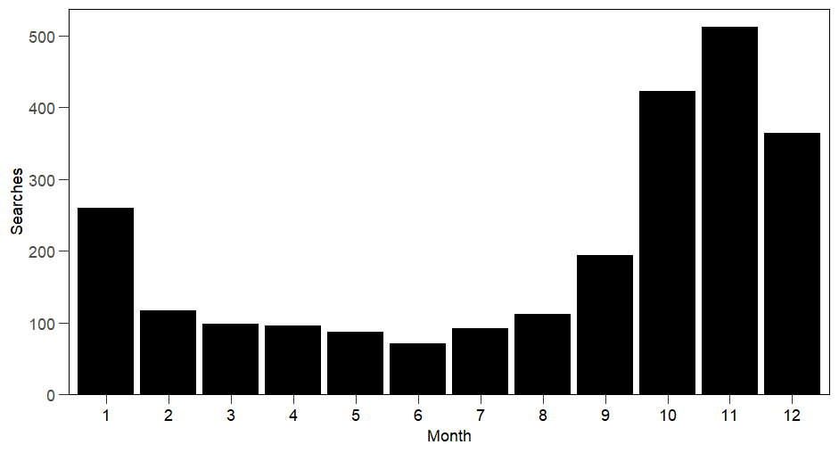
Supplementary Figure 1. Number of Google searches per month. Number of searchers in Sweden for “mouse trap” (Swedish “musfälla”) from January 2024 to January 2025 according to Google Trends.

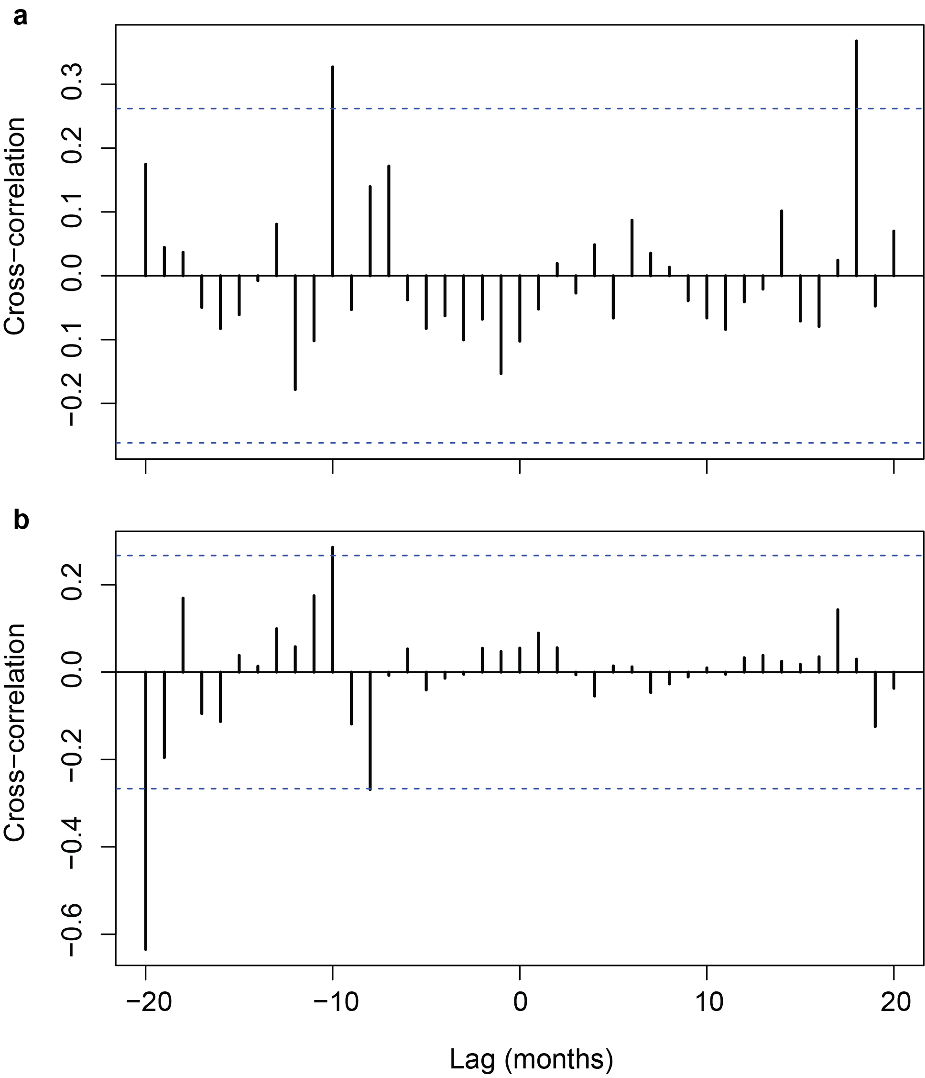
Supplementary Figure 2. Cross-correlation function plots. The plots show the lagged relationship between the monthly number of reports of indoor observations of small mammals in a) southern Sweden and the monthly TBE incidence in Sweden and in b) county of Västerbotten and the monthly incidence of tularemia incidence in the same county (see also Fig. 5). The dashed lines indicate the threshold for statistically significant cross-correlations.

