Efficacy and safety of endoscopic management in intraventricular neurocysticercosis: a systematic review and meta-analysis

Supplementary Materials

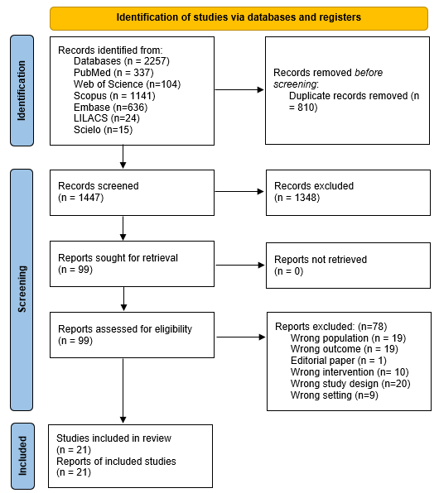
Figure S1. PRISMA 2020 flow diagram of study selection. Flow diagram summarizing identification, screening, eligibility assessment, and inclusion of studies in accordance with PRISMA 2020, including reasons for exclusion at the full-text stage.

Table S1. Search strategy
Data Base | Search strategy | #
PubMed | ("neurocysticercosis"[tiab] OR "neurocysticercosis"[MeSH] OR "cysticercosis" OR "taeniasis" OR "taenia solium" OR "cestodiasis") AND ("intraventricular" OR "ventricular" OR "hydrocephalus" OR "cerebral ventricles"[MeSH]) AND ("endoscopy"[MeSH] OR "endoscopic" OR "neuroendoscopic" OR "neuroendoscopy"[MeSH] OR "surgical" OR "ventriculostomy"[MeSH] OR "surgery" OR "minimally invasive" OR "Minimally Invasive Surgical Procedures"[MeSH]) | 352
Scopus | ( TITLE-ABS-KEY(neurocysticercosis) OR TITLE-ABS-KEY(cysticercosis) OR INDEXTERMS(cysticercosis) OR TITLE-ABS-KEY("taenia solium") OR INDEXTERMS("taenia solium") OR TITLE-ABS-KEY(taeniasis) OR TITLE-ABS-KEY(cestode*)) AND ( TITLE-ABS-KEY(intraventricular) OR TITLE-ABS-KEY(ventricular) OR TITLE-ABS-KEY("ventricle*") OR TITLE-ABS-KEY(hydrocephalus) OR INDEXTERMS(hydrocephalus) OR INDEXTERMS("cerebral ventricles") OR TITLE-ABS-KEY("csf") OR TITLE-ABS-KEY("csf obstruction") OR TITLE-ABS-KEY("csf pathway") OR TITLE-ABS-KEY(obstructive))  AND ( TITLE-ABS-KEY(endoscop*) OR TITLE-ABS-KEY(neuroendoscop*) OR TITLE-ABS-KEY(ventriculoscop*) OR TITLE-ABS-KEY(ventriculostom*) OR TITLE-ABS-KEY("minimally invasive") OR INDEXTERMS(endoscopy) OR INDEXTERMS(neuroendoscopy) OR INDEXTERMS("Minimally Invasive Surgical Procedures")) | 218
Embase | (neurocysticercosis.tw. OR exp neurocysticercosis/ OR cysticercosis OR taeniasis OR "taenia solium" OR cestodiasis) AND (intraventricular OR ventricular OR hydrocephalus OR exp "cerebral ventricles"/) AND (exp endoscopy/ OR endoscopic OR neuroendoscopic OR exp neuroendoscopy/ OR surgical OR exp ventriculostomy/ OR surgery OR "minimally invasive" OR exp "Minimally Invasive Surgical Procedures"/) | 606
Web of Sciences | ((TI=neurocysticercosis OR AB=neurocysticercosis) OR ALL=neurocysticercosis OR cysticercosis OR taeniasis OR "taenia solium" OR cestodiasis) AND (intraventricular OR ventricular OR hydrocephalus OR ALL="cerebral ventricles") AND (ALL=endoscopy OR endoscopic OR neuroendoscopic OR ALL=neuroendoscopy OR surgical OR ALL=ventriculostomy OR surgery OR "minimally invasive" OR ALL="Minimally Invasive Surgical Procedures") | 229
Lilacs | (neurocysticercosis OR neurocysticercosis OR cysticercosis OR taeniasis OR "taenia solium" OR cestodiasis) AND (intraventricular OR ventricular OR hydrocephalus OR "cerebral ventricles") AND (endoscopy OR endoscopic OR neuroendoscopic OR neuroendoscopy OR surgical OR ventriculostomy OR surgery OR "minimally invasive" OR "Minimally Invasive Surgical Procedures") | 26
Scielo | (neurocysticercosis OR neurocysticercosis OR cysticercosis OR taeniasis OR "taenia solium" OR cestodiasis) AND (intraventricular OR ventricular OR hydrocephalus OR "cerebral ventricles") AND (endoscopy OR endoscopic OR neuroendoscopic OR neuroendoscopy OR surgical OR ventriculostomy OR surgery OR "minimally invasive" OR "Minimally Invasive Surgical Procedures") | 15

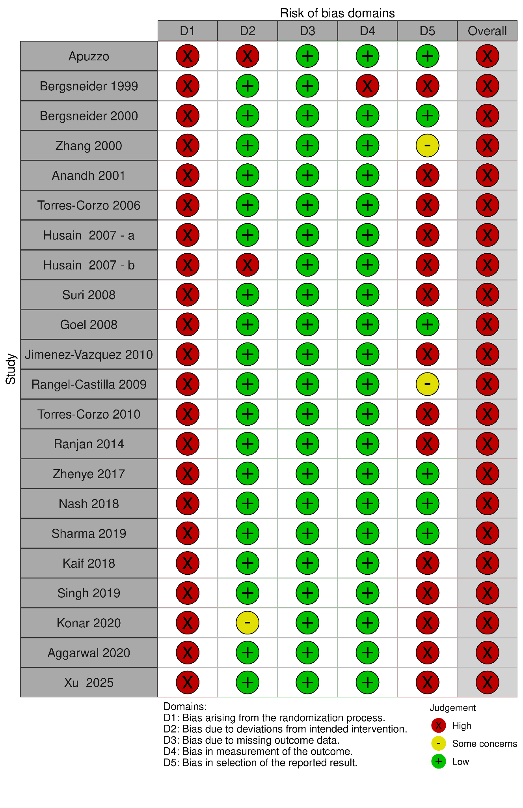
Figure S2. Risk of bias assessment of included observational studies. Graphical summary of risk of bias across the 21 observational studies included in the review. Studies were evaluated across five domains (selection of participants, deviations from intended interventions, completeness of outcome data, outcome measurement and selective reporting) and classified as having low, moderate or serious risk of bias. The figure displays the distribution of judgements by domain and by study.

