Supplementary Material

Supplementary Figures and Tables

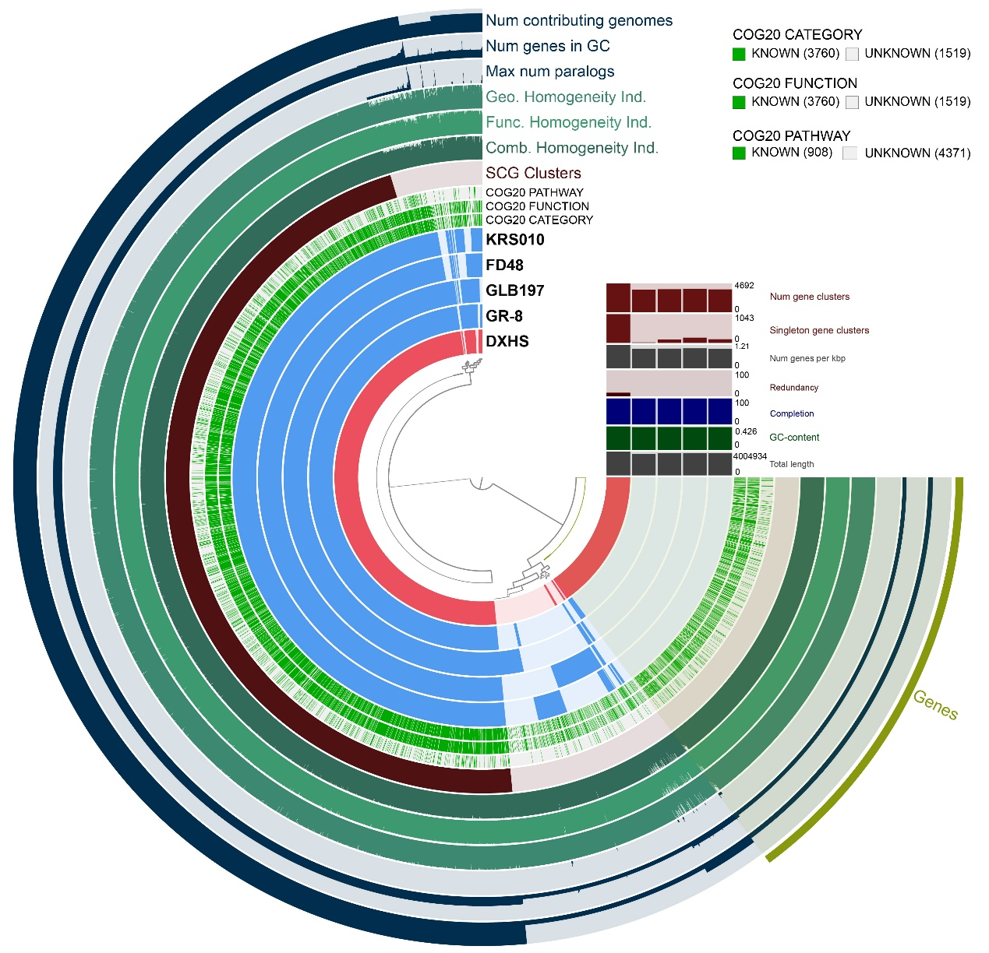
Fig S1 Genomic comparison between the DXHS strain and the reference strains

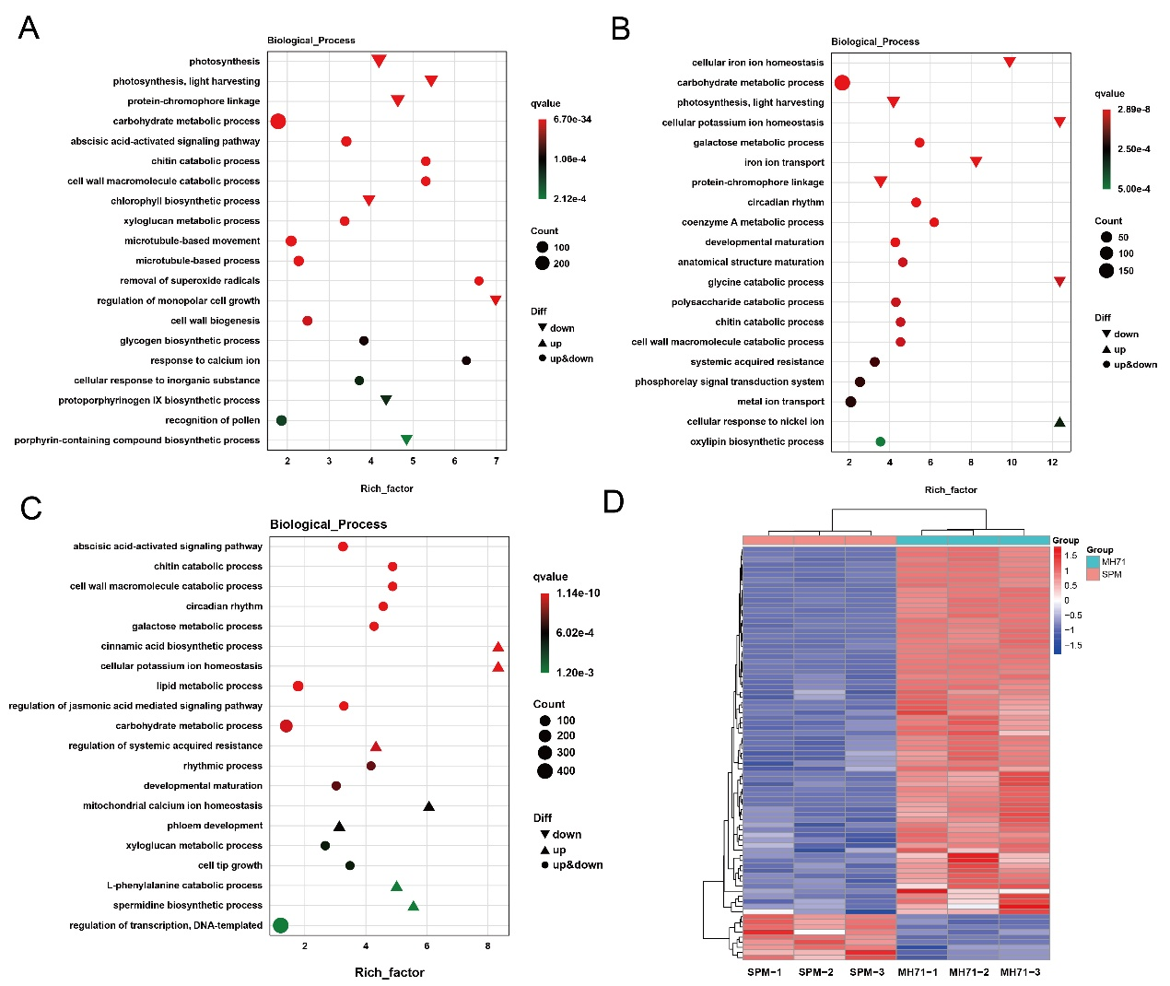
Fig S2 GO enrichment analysis of DEGs. (A) GO enrichment of DEGs in DXHS vs. CK; (B) GO enrichment of DEGs in DXHS vs. MH71; (C) GO enrichment of DEGs in MH71 vs. SPM; (D) Expression heatmap of DEGs in plant disease resistance pathway in MH71 vs. SPM.

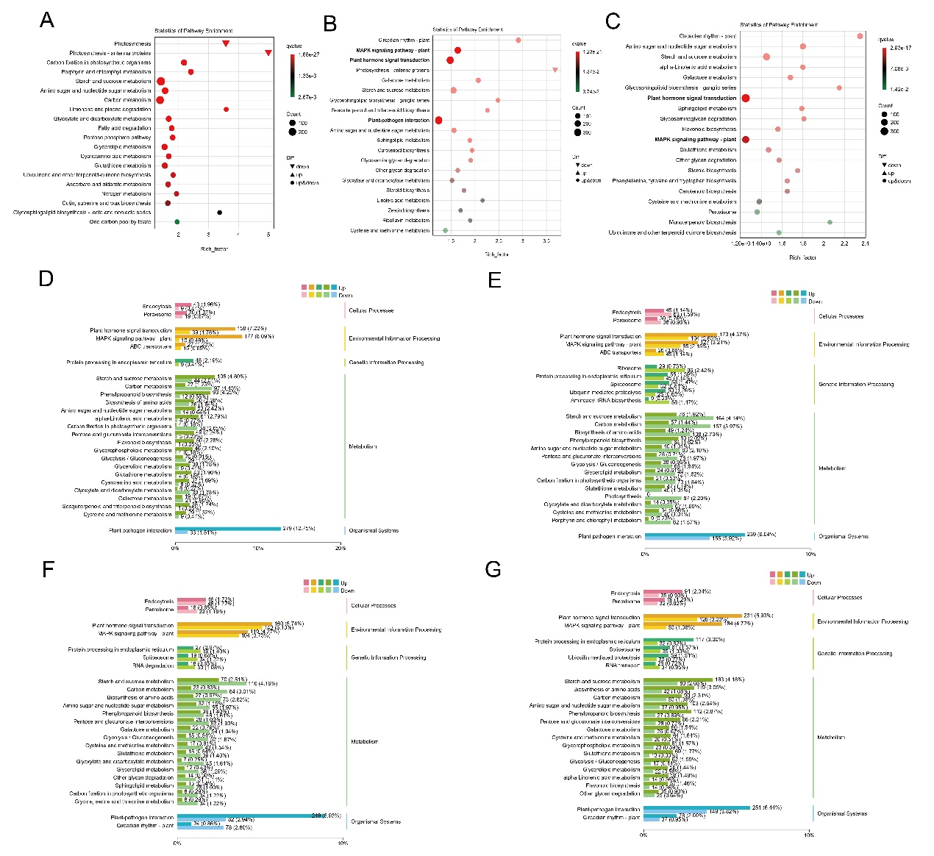
Fig S3 KEGG pathway enrichment analysis of DEGs. (A-C) KEGG pathway enrichment of DEGs in DXHS vs. CK, DXHS vs. MH71, and MH71 vs. SPM; (D-G) KEGG classification plots (upregulated/downregulated genes) of DEGs in comparisons of DXHS vs. SPM, DXHS vs. CK, DXHS vs. MH71, and MH71 vs. SPM.
Table S1 Primer sequences used for qRT-PCR validation in this study.
Target Genes | Primer Name | Primer Sequence (5′→3′)
MPK3 | MPK3-F | GACATGGCTGACCACCTCCC
MPK3 | MPK3-R | GATCGGCATGATCGGAGGGC
MPK6 | MPK6-F | GGTCAATCAGGAGACACGG
MPK6 | MPK6-R | CTTGTACTTGGCCGTGACC
PR1 | PR1-F | CTTGCGCCGCTGGTAAGGTC
PR1 | PR1-R | GCCCGGGGGATCATAGTTGC
FRK1 | FRK1-F | GCTCATCCATGTCGCTCCCC
FRK1 | FRK1-R | GCCTCCAGTTGAGTGCCAAGG
ACS6 | ACS6-F | CCGCATTGTTATGAGCGG
ACS6 | ACS6-R | GGCTGCTCTCGTGATCTTG
OXI1 | OX11-F | GCACCGCAAGTCAAAACTG
OXI1 | OX11-R | CCTGACTTCGGAGCCTTTG
VSP2 | VSP2-F | GGGTTTCGAATGAGGCTGG
VSP2 | VSP2-R | CATTCCCTTGTCGACCCAC
RTE1 | RTE1-F | GGCATTTGCAGGGAGGATGGTGC
RTE1 | RTE1-R | GCTTGCAAGTGTGGCCACCCAG
ETR | ETR-F | GCTGTTGGGGATGAGAACCGGC
ETR | ETR-R | GGCCGTCACTTGGCGCTGG
CTR1 | CTR1-F | GGTCAGGGCAACACCATCAGCCC
CTR1 | CTR1-R | GGCATCCGGTACCGTGCAGAGG
MKK9 | MKK9-F | CGCCGCCAACTCTACCGCG
MKK9 | MKK9-R | GGCCTCGGAGAACGTGCCTTGC
EIN3 | EIN3-F | CAGTCACAGGGGCATCGGAC
EIN3 | EIN3-R | GGGTTGCACCCATCGTTCC
ERF1 | ERF1-F | GGCGTCAGGGTTTGGCTTG
ERF1 | ERF1-R | CGAGTGCCTCCTCTTGAGTGC
ChiB | ChiB-F | CGCTGCATTTCTTGGGTCAAACCTC
ChiB | ChiB-R | GTATATCACTCCATATCCAGGTACCG

Table S2 The inhibition rate of B. altitudinis DXHS against F. oxysporum and C. siamense.
Target fungi | Inhibition rate (%)
F. oxysporum 1769 | 60.92±2.07
C. siamense 1755 | 57.39±3.89

