Supplementary tables
Table S1: Sample number by subregion, site and age class, including dominant land cover.
Subregion | Total | Site | Est. pop. size | Adults | Seedlings | NZLCDB landform and surrounds
Wairarapa | 41 | Allen/Lowe’s Bush (ALB) | 50-100 | 20 | 24 | Broadleaved Indigenous Hardwoods/High Producing Exotic Grassland/Herbaceous Freshwater Vegetation
 |  | Carter Scenic Reserve (CSR) | <10 | 1 |  | Herbaceous Freshwater Vegetation/Indigenous Forest/Mānuka and/or Kānuka/High Producing Exotic Grassland/Gorse and/or Broom/Deciduous Hardwoods
 |  | Fensham Reserve (FHR) | <50 | 15 | 16 | Indigenous forest/High Producing Exotic Grassland/Mānuka and/or Kānuka
 |  | Mclean’s property (PMP) | 5 | 5 |  | Mānuka and/or Kānuka/Broadleaved Indigenous Hardwoods/High Producing Exotic Grassland
Hutt Valley | 35 | Gentian Park (GEP) | <50 | 16 | 32 | Broadleaved Indigenous Hardwoods/Built-up area/Gorse and/or Broom
 |  | Kaitoke Regional Park (KTK) | <10 | 3 |  | Indigenous Forest/Broadleaved Indigenous Hardwoods
 |  | Te Haukāretu Park (THP) | <10 | 6 | 2 | Urban Parkland/Open Space/Lake or Pond/Built-up Area/River
 |  | Sylvan Way (SYL) | 10 | 10 |  | Broadleaved Indigenous Hardwoods/Built-up Area/Exotic Forest/Indigenous Forest/Gorse and/or Broom/
Kāpiti Coast | 22 | Ngā Manu/Parkwood (NMP) | <50 | 14 |  | Indigenous Forest/Built-up Area/High Producing Exotic Grassland/Herbaceous Fresh Water Vegetation/Broadleaved Indigenous Hardwoods/Urban Parkland/Open Space
 |  | Silverlea (SLV) | <30 | 8 |  | Indigenous Forest/High Producing Exotic Grassland/Mānuka and/or Kānuka
Wellington | 13 | Zealandia (ZLD) | <30 | 13 |  | Indigenous Forest/Built-up Area/Broadleaved Indigenous Hardwoods/Exotic Forest/Lake or Pond
NZLCDB = New Zealand Landcover Database

Table S2: Variant calling statistics for SNPs according to varying MAF (minor allele frequency) and LD (linkage disequilibrium).
 | MAF | % missing data allowed | Dataset | SNPs | SNPs/KB
Raw | NA | NA | all | 2,438,953 | 6.10
MAF0.00 | 0.00 | 10 | all | 1,257,304 | 3.14
MAF0.00_LD | 0.00 | 10 | all | 586,843 | 1.47
MAF0.00_nomiss_LD | 0.00 | 0 | all | 178,858 | 0.45
MAF0.00_nomiss_LD | 0.00 | 0 | Adults | 171,172 | 0.43
MAF0.00_nomiss_LD | 0.00 | 0 | AvS | 156,672 | 0.39
MAF0.05 | 0.05 | 10 | all | 648,340 | 1.62
MAF0.05_LD | 0.05 | 10 | all | 179,994 | 0.45
MAF0.05_nomiss_LD | 0.05 | 0 | all | 55,709 | 0.14
MAF0.05_nomiss_LD | 0.05 | 0 | Adults | 55,708 | 0.14
MAF0.05_nomiss_LD | 0.05 | 0 | AvS | 53,633 | 0.13
All = all adults and seedlings
Adults = only adults
AvS = All samples at sites where seedlings were collected

Table S3: Adult site level heterozygosity and standard deviations (SD) for all sites in the Greater Wellington Region
Site | polyLoc | monoLoc | H_{o} | H_{o}SD | H_{e} | H_{e}SD | uH_{e} | uH_{e}SD | Median beta-diversity | Mean beta-diversity
ALB | 48564 | 5068 | 0.24 | 0.18 | 0.23 | 0.16 | 0.24 | 0.16 | 0.18 | 0.24
FHR | 47557 | 6075 | 0.24 | 0.19 | 0.23 | 0.16 | 0.24 | 0.17 | 0.24 | 0.24
GEP | 46028 | 7604 | 0.24 | 0.21 | 0.22 | 0.17 | 0.23 | 0.17 | 0.18 | 0.23
KTK | 19117 | 34515 | 0.16 | 0.25 | 0.12 | 0.17 | 0.15 | 0.21 | 0.00 | 0.15
NGP | 46986 | 6646 | 0.25 | 0.20 | 0.24 | 0.17 | 0.25 | 0.17 | 0.20 | 0.25
PMP | 18184 | 35448 | 0.14 | 0.24 | 0.10 | 0.16 | 0.11 | 0.18 | 0.00 | 0.11
SLV | 38736 | 14896 | 0.23 | 0.22 | 0.21 | 0.18 | 0.22 | 0.19 | 0.23 | 0.22
SYL | 41023 | 12609 | 0.22 | 0.21 | 0.21 | 0.17 | 0.23 | 0.18 | 0.19 | 0.23
THP | 36927 | 16705 | 0.25 | 0.25 | 0.21 | 0.18 | 0.23 | 0.20 | 0.17 | 0.23
ZLD | 40127 | 13505 | 0.22 | 0.21 | 0.21 | 0.17 | 0.22 | 0.18 | 0.21 | 0.22
polyLoc = polymorphic loci
monoLoc = monomorphic loci
H_{o} = observed heterozygosity
H_{e} = expected heterozygosity
uH_{e} = unbiased expected heterozygosity

Table S4: Pairwise F_{ST} and confidence intervals (CI) for adult trees at all sites in the Greater Wellington Region
Population Pair | 2.5% CI | F_{ST} | 97.5% CI
NGP - SLV | 0.04 | 0.04 | 0.04
ALB - FHR | 0.05 | 0.05 | 0.05
FHR - NGP | 0.07 | 0.08 | 0.08
FHR - SYL | 0.08 | 0.08 | 0.08
NGP - SYL | 0.09 | 0.09 | 0.09
ALB - NGP | 0.09 | 0.09 | 0.09
FHR - THP | 0.1 | 0.1 | 0.1
NGP - THP | 0.1 | 0.1 | 0.1
GEP - SYL | 0.1 | 0.1 | 0.1
SYL - THP | 0.1 | 0.11 | 0.11
GEP - NGP | 0.11 | 0.11 | 0.11
ALB - SYL | 0.11 | 0.11 | 0.11
FHR - SLV | 0.11 | 0.11 | 0.11
FHR - GEP | 0.11 | 0.11 | 0.12
ALB - SLV | 0.11 | 0.12 | 0.12
SLV - SYL | 0.12 | 0.12 | 0.12
GEP - THP | 0.12 | 0.12 | 0.12
ALB - THP | 0.12 | 0.12 | 0.12
NGP - ZLD | 0.12 | 0.12 | 0.12
FHR - ZLD | 0.12 | 0.12 | 0.12
GEP - SLV | 0.12 | 0.13 | 0.13
ALB - GEP | 0.13 | 0.13 | 0.13
SYL - ZLD | 0.13 | 0.13 | 0.14
SLV - THP | 0.13 | 0.14 | 0.14
THP - ZLD | 0.14 | 0.14 | 0.15
GEP - ZLD | 0.15 | 0.15 | 0.15
ALB - ZLD | 0.15 | 0.15 | 0.16
SLV - ZLD | 0.15 | 0.16 | 0.16
KTK - NGP | 0.2 | 0.2 | 0.2
GEP - KTK | 0.21 | 0.22 | 0.22
ALB - KTK | 0.21 | 0.22 | 0.22
FHR - KTK | 0.22 | 0.22 | 0.22
FHR - PMP | 0.22 | 0.22 | 0.22
KTK - SYL | 0.22 | 0.22 | 0.22
KTK - THP | 0.22 | 0.22 | 0.23
ALB - PMP | 0.22 | 0.23 | 0.23
KTK - SLV | 0.24 | 0.24 | 0.25
NGP - PMP | 0.27 | 0.27 | 0.28
KTK - ZLD | 0.27 | 0.28 | 0.28
GEP - PMP | 0.29 | 0.29 | 0.3
PMP - SYL | 0.3 | 0.3 | 0.3
PMP - ZLD | 0.3 | 0.31 | 0.31
PMP - THP | 0.31 | 0.32 | 0.32
PMP - SLV | 0.33 | 0.34 | 0.34
KTK - PMP | 0.51 | 0.51 | 0.52

Table S5: Test for isolation by distance across Waipoua using the Mantel test statistic (r).
Comparison | r (Mantel statistic) | p-value | Upper quantiles of permutations
 |  |  | 90% | 95% | 97.5% | 99%
Between sites | 0.20 | 0.22 | 0.42 | 0.54 | 0.63 | 0.70
Between individuals | 0.25 | 0.0008 | 0.08 | 0.11 | 0.13 | 0.16
IBD was tested at two levels: between sites and between all individuals. Geographic distances were based on Euclidian distance in meters, while genetic distance was F_{ST} for subregions and sites and proportion shared alleles for indiivduals. Significance was tested for 99999 permutations.

Table S6: Spatial autocorrelation across Greater Wellington.
Bin (meters) | N | r | L.r | U.r | L.r.null | U.r.null | p-value
9997 | 1179 | 0.0702 | 0.0649 | 0.0757 | -0.0025 | 0.0030 | 0.0000
19994 | 445 | 0.0090 | 0.0068 | 0.0112 | -0.0048 | 0.0047 | 0.0000
29991 | 139 | 0.0035 | -0.0014 | 0.0082 | -0.0080 | 0.0090 | 0.2010
39988 | 891 | -0.0152 | -0.0166 | -0.0137 | -0.0034 | 0.0030 | 0.0000
49985 | 979 | -0.0213 | -0.0229 | -0.0199 | -0.0031 | 0.0032 | 0.0000
59982 | 792 | -0.0246 | -0.0262 | -0.0230 | -0.0037 | 0.0036 | 0.0000
69979 | 965 | -0.0162 | -0.0176 | -0.0148 | -0.0030 | 0.0029 | 0.0000
79976 | 182 | -0.0115 | -0.0148 | -0.0078 | -0.0072 | 0.0075 | 0.0050
89973 | 65 | -0.0254 | -0.0290 | -0.0219 | -0.0129 | 0.0147 | 0.0000
104571.4 | 468 | -0.0284 | -0.0303 | -0.0263 | -0.0042 | 0.0039 | 0.0000
Autocorrelation coefficient (r) was calculated with 1000 permutations to give upper (U.r) lower (L.r) bounds.
N = number of pairwise comparisons per distance class
null = values for the null hypothesis of no autocorrelation

Table S7: Spatial autocorrelation across Waipoua.
Bin (meters) | N | r | L.r | U.r | L.r.null | U.r.null | p-value
998.5 | 96 | 0.029 | 0.019 | 0.043 | -0.005 | 0.008 | 0.000
1997 | 18 | 0.006 | -0.007 | 0.018 | -0.010 | 0.023 | 0.151
2995.5 | 4 | -0.003 | NA | NA | -0.021 | 0.033 | 0.425
3994 | 10 | -0.001 | -0.009 | 0.009 | -0.014 | 0.030 | 0.558
4992.5 | 20 | -0.003 | -0.009 | 0.002 | -0.010 | 0.019 | 0.341
5991 | 7 | 0.006 | -0.001 | 0.013 | -0.016 | 0.035 | 0.186
6989.5 | 28 | 0.005 | -0.002 | 0.012 | -0.009 | 0.015 | 0.151
7988 | 49 | 0.004 | 0.000 | 0.009 | -0.007 | 0.009 | 0.130
8986.5 | 7 | 0.007 | -0.005 | 0.019 | -0.018 | 0.033 | 0.162
9985 | 39 | 0.004 | -0.012 | 0.036 | -0.008 | 0.011 | 0.176
10983.5 | 35 | -0.006 | -0.012 | 0.000 | -0.008 | 0.012 | 0.098
11982 | 91 | -0.008 | -0.012 | -0.005 | -0.005 | 0.006 | 0.001
12980.5 | 19 | 0.000 | -0.005 | 0.006 | -0.010 | 0.019 | 0.540
13979 | 78 | 0.002 | -0.002 | 0.005 | -0.006 | 0.007 | 0.250
14977.5 | 24 | 0.002 | -0.004 | 0.010 | -0.010 | 0.015 | 0.283
15976 | 53 | -0.008 | -0.012 | -0.003 | -0.007 | 0.009 | 0.014
16974.5 | 22 | -0.004 | -0.010 | 0.003 | -0.010 | 0.015 | 0.285
17973 | 43 | -0.005 | -0.011 | 0.000 | -0.007 | 0.011 | 0.101
18971.5 | 23 | -0.015 | -0.021 | -0.010 | -0.010 | 0.016 | 0.002
19970 | 19 | -0.019 | -0.023 | -0.014 | -0.010 | 0.018 | 0.000
20968.5 | 49 | -0.009 | -0.014 | -0.004 | -0.007 | 0.009 | 0.005
21967 | 2 | -0.002 | NA | NA | -0.027 | 0.031 | 0.510
22965.5 | 0 | Na | NA | NA | NA | NA | NA
23964 | 12 | 0.003 | -0.004 | 0.011 | -0.013 | 0.022 | 0.243
24962.5 | 16 | -0.011 | -0.018 | -0.004 | -0.011 | 0.023 | 0.024
25961 | 5 | -0.018 | NA | NA | -0.020 | 0.029 | 0.041
26959.5 | 23 | -0.008 | -0.013 | -0.003 | -0.009 | 0.016 | 0.043
27958 | 0 | Na | NA | NA | NA | NA | NA
28956.5 | 0 | Na | NA | NA | NA | NA | NA
29955 | 0 | Na | NA | NA | NA | NA | NA
31152.81 | 28 | -0.011 | -0.016 | -0.006 | -0.009 | 0.013 | 0.008
Autocorrelation coefficient (r) was calculated with 1000 permutations to give upper (U.r) lower (L.r) bounds.
N = number of pairwise comparisons per distance class
null = values for the null hypothesis of no autocorrelation

Table S8: Pairwise private allele content and allele frequency difference (AFD) between all sites and age groups.
Cohort | pop2 | fixed | priv1 | priv2 | Chao1 | Chao2 | totalpriv | AFD
GEP_A | GEP_S | 0 | 974 | 4308 | 64 | 242 | 5282 | 0.048
ALB_A | ALB_S | 0 | 1693 | 2435 | 90 | 152 | 4128 | 0.07
FHR_A | FHR_S | 0 | 3311 | 2563 | 208 | 193 | 5874 | 0.072
ALB_S | FHR_A | 0 | 4168 | 2419 | 279 | 123 | 6587 | 0.093
ALB_A | FHR_A | 0 | 3929 | 2922 | 242 | 148 | 6851 | 0.1
NGP_A | SLV_A | 0 | 10449 | 2199 | 497 | 161 | 12648 | 0.105
ALB_S | FHR_S | 0 | 4824 | 2327 | 274 | 103 | 7151 | 0.109
ALB_A | FHR_S | 0 | 4643 | 2888 | 272 | 163 | 7531 | 0.115
ALB_S | NGP_A | 0 | 4767 | 2447 | 316 | 103 | 7214 | 0.116
FHR_A | NGP_A | 0 | 4611 | 4040 | 295 | 236 | 8651 | 0.119
ALB_A | NGP_A | 0 | 4518 | 2940 | 290 | 138 | 7458 | 0.121
GEP_S | SYL_A | 0 | 10201 | 1862 | 485 | 67 | 12063 | 0.122
GEP_A | SYL_A | 0 | 8624 | 3619 | 402 | 165 | 12243 | 0.124
FHR_A | SYL_A | 0 | 10109 | 3575 | 464 | 187 | 13684 | 0.125
FHR_S | NGP_A | 0 | 4586 | 4763 | 306 | 262 | 9349 | 0.127
NGP_A | SYL_A | 0 | 9964 | 4001 | 415 | 195 | 13965 | 0.128
ALB_S | SYL_A | 0 | 10575 | 2292 | 523 | 90 | 12867 | 0.13
GEP_S | NGP_A | 0 | 5764 | 3388 | 319 | 123 | 9152 | 0.13
FHR_A | GEP_S | 5 | 3504 | 5309 | 127 | 267 | 8813 | 0.131
ALB_A | GEP_S | 0 | 3761 | 4559 | 166 | 213 | 8320 | 0.134
ALB_A | SYL_A | 0 | 10600 | 3059 | 483 | 111 | 13659 | 0.134
ALB_S | GEP_S | 0 | 3723 | 3779 | 161 | 146 | 7502 | 0.134
GEP_A | NGP_A | 0 | 5364 | 6322 | 296 | 278 | 11686 | 0.134
FHR_A | GEP_A | 1 | 6571 | 5042 | 302 | 265 | 11613 | 0.135
ALB_S | SLV_A | 0 | 12296 | 1726 | 646 | 96 | 14022 | 0.136
ALB_A | SLV_A | 0 | 11973 | 2145 | 595 | 107 | 14118 | 0.137
FHR_S | SYL_A | 0 | 9920 | 4134 | 457 | 196 | 14054 | 0.137
ALB_A | GEP_A | 0 | 6940 | 4404 | 333 | 202 | 11344 | 0.138
ALB_S | GEP_A | 0 | 6970 | 3692 | 336 | 142 | 10662 | 0.138
FHR_A | ZLD_A | 0 | 10788 | 3358 | 361 | 203 | 14146 | 0.138
NGP_A | ZLD_A | 0 | 10639 | 3780 | 334 | 234 | 14419 | 0.138
FHR_A | SLV_A | 0 | 11862 | 3041 | 532 | 138 | 14903 | 0.14
GEP_S | SLV_A | 0 | 13168 | 2542 | 606 | 75 | 15710 | 0.14
SYL_A | THP_A | 0 | 10255 | 6159 | 439 | 260 | 16414 | 0.14
FHR_S | GEP_S | 1 | 3493 | 6046 | 126 | 281 | 9539 | 0.141
SLV_A | SYL_A | 4 | 7031 | 9318 | 285 | 400 | 16349 | 0.141
SYL_A | ZLD_A | 15 | 8221 | 7325 | 229 | 350 | 15546 | 0.141
FHR_A | THP_A | 0 | 13642 | 3012 | 597 | 138 | 16654 | 0.142
GEP_A | THP_A | 0 | 12580 | 3479 | 551 | 133 | 16059 | 0.142
FHR_S | GEP_A | 0 | 6458 | 5677 | 282 | 258 | 12135 | 0.143
FHR_S | ZLD_A | 8 | 10575 | 3893 | 365 | 222 | 14468 | 0.143
GEP_A | SLV_A | 0 | 11944 | 4652 | 520 | 170 | 16596 | 0.143
GEP_S | ZLD_A | 0 | 10972 | 1737 | 373 | 74 | 12709 | 0.143
GEP_S | THP_A | 0 | 14098 | 1663 | 647 | 50 | 15761 | 0.143
NGP_A | THP_A | 0 | 12993 | 2934 | 552 | 151 | 15927 | 0.143
FHR_S | THP_A | 0 | 13240 | 3358 | 592 | 151 | 16598 | 0.144
ALB_S | THP_A | 0 | 14288 | 1909 | 679 | 68 | 16197 | 0.146
GEP_A | ZLD_A | 0 | 9803 | 3902 | 310 | 191 | 13705 | 0.146
ALB_A | THP_A | 0 | 14059 | 2422 | 668 | 123 | 16481 | 0.147
ALB_S | ZLD_A | 0 | 11518 | 2339 | 422 | 108 | 13857 | 0.147
FHR_S | SLV_A | 0 | 11673 | 3600 | 559 | 180 | 15273 | 0.147
ALB_A | ZLD_A | 0 | 11312 | 2875 | 380 | 129 | 14187 | 0.149
THP_A | ZLD_A | 21 | 7576 | 10776 | 193 | 495 | 18352 | 0.152
SLV_A | ZLD_A | 5 | 8153 | 9544 | 202 | 439 | 17697 | 0.153
SLV_A | THP_A | 2 | 9584 | 7775 | 388 | 325 | 17359 | 0.154
THP_A | THP_S | 0 | 23075 | 2168 | 466 | 114 | 25243 | 0.154
ALB_S | PMP_A | 35 | 31664 | 542 | 787 | 31 | 32206 | 0.182
ALB_A | PMP_A | 24 | 31041 | 661 | 759 | 64 | 31702 | 0.183
FHR_A | PMP_A | 40 | 30541 | 1168 | 690 | 88 | 31709 | 0.184
KTK_A | THP_A | 273 | 4292 | 22102 | 188 | 458 | 26394 | 0.188
FHR_S | PMP_A | 70 | 29994 | 1369 | 680 | 93 | 31363 | 0.189
KTK_A | SYL_A | 234 | 3164 | 25070 | 146 | 596 | 28234 | 0.189
GEP_S | KTK_A | 126 | 31023 | 778 | 908 | 41 | 31801 | 0.19
GEP_A | KTK_A | 226 | 28887 | 1976 | 781 | 93 | 30863 | 0.191
KTK_A | SLV_A | 358 | 3869 | 23488 | 168 | 504 | 27357 | 0.195
SYL_A | THP_S | 198 | 27445 | 2442 | 621 | 89 | 29887 | 0.195
ALB_A | KTK_A | 136 | 30508 | 1061 | 885 | 65 | 31569 | 0.196
GEP_A | THP_S | 114 | 31397 | 1389 | 830 | 61 | 32786 | 0.196
FHR_A | THP_S | 126 | 32628 | 1091 | 864 | 54 | 33719 | 0.197
KTK_A | NGP_A | 110 | 1525 | 29394 | 86 | 757 | 30919 | 0.197
GEP_S | THP_S | 109 | 34045 | 703 | 973 | 24 | 34748 | 0.198
ALB_A | THP_S | 189 | 33465 | 921 | 947 | 43 | 34386 | 0.2
ALB_S | KTK_A | 149 | 31009 | 820 | 928 | 48 | 31829 | 0.2
PMP_A | ZLD_A | 766 | 3213 | 25156 | 128 | 572 | 28369 | 0.201
ALB_S | THP_S | 120 | 33994 | 708 | 997 | 34 | 34702 | 0.202
NGP_A | THP_S | 147 | 32241 | 1275 | 838 | 87 | 33516 | 0.202
PMP_A | THP_A | 522 | 5436 | 24179 | 240 | 384 | 29615 | 0.202
PMP_A | SYL_A | 305 | 3629 | 26468 | 182 | 507 | 30097 | 0.202
SLV_A | THP_S | 437 | 26012 | 3296 | 541 | 122 | 29308 | 0.202
FHR_A | KTK_A | 195 | 29975 | 1535 | 811 | 87 | 31510 | 0.203
FHR_S | THP_S | 339 | 32269 | 1480 | 860 | 69 | 33749 | 0.203
GEP_S | PMP_A | 144 | 31927 | 749 | 777 | 37 | 32676 | 0.204
GEP_A | PMP_A | 212 | 29798 | 1954 | 670 | 108 | 31752 | 0.205
FHR_S | KTK_A | 253 | 29324 | 1632 | 772 | 60 | 30956 | 0.207
KTK_A | ZLD_A | 622 | 4227 | 25237 | 114 | 686 | 29464 | 0.21
NGP_A | PMP_A | 165 | 30550 | 1748 | 666 | 121 | 32298 | 0.21
THP_S | ZLD_A | 721 | 3769 | 27876 | 75 | 728 | 31645 | 0.21
KTK_A | THP_S | 2766 | 14491 | 11394 | 259 | 178 | 25885 | 0.211
PMP_A | SLV_A | 443 | 4833 | 25385 | 214 | 425 | 30218 | 0.212
KTK_A | PMP_A | 3389 | 14609 | 13676 | 215 | 340 | 28285 | 0.215
CSR_A | SLV_A | 555 | 1921 | 32630 | 78 | 591 | 34551 | 0.22
PMP_A | THP_S | 3892 | 15422 | 13258 | 342 | 135 | 28680 | 0.222
CSR_A | NGP_A | 86 | 570 | 39529 | 25 | 873 | 40099 | 0.228
CSR_A | KTK_A | 4205 | 8178 | 19268 | 103 | 279 | 27446 | 0.234
CSR_A | SYL_A | 819 | 2291 | 35287 | 72 | 697 | 37578 | 0.234
ALB_A | CSR_A | 222 | 40983 | 446 | 1012 | 14 | 41429 | 0.236
ALB_S | CSR_A | 219 | 41737 | 458 | 1068 | 10 | 42195 | 0.239
CSR_A | ZLD_A | 1438 | 2875 | 34975 | 49 | 799 | 37850 | 0.241
CSR_A | THP_S | 5097 | 10007 | 18000 | 118 | 212 | 28007 | 0.244
CSR_A | GEP_S | 424 | 775 | 42110 | 17 | 1059 | 42885 | 0.244
CSR_A | GEP_A | 586 | 1521 | 39522 | 44 | 908 | 41043 | 0.246
CSR_A | THP_A | 851 | 2838 | 31738 | 66 | 509 | 34576 | 0.247
CSR_A | FHR_A | 369 | 944 | 40474 | 38 | 943 | 41418 | 0.248
CSR_A | FHR_S | 512 | 1208 | 39990 | 59 | 945 | 41198 | 0.252
CSR_A | PMP_A | 7113 | 11457 | 21614 | 111 | 413 | 33071 | 0.265
A = adults, S = seedlings.

Table S9: Private alleles and allelic frequency difference (AFD) per site and age group compared to all other sites pooled.
Cohort | pop2 | N1 | N2 | fixed | priv1 | priv2 | totalpriv | AFD
ALB_A | Rest | 20 | 166 | 0 | 0 | 5069 | 5069 | 0.089
ALB_S | Rest | 25 | 161 | 0 | 0 | 4327 | 4327 | 0.086
CSR_A | Rest | 1 | 185 | 0 | 0 | 45606 | 45606 | 0.239
FHR_A | Rest | 15 | 171 | 0 | 0 | 6076 | 6076 | 0.082
FHR_S | Rest | 16 | 170 | 0 | 0 | 6824 | 6824 | 0.097
GEP_A | Rest | 16 | 170 | 0 | 0 | 7605 | 7605 | 0.096
GEP_S | Rest | 32 | 154 | 0 | 0 | 4271 | 4271 | 0.099
KTK_A | Rest | 3 | 183 | 0 | 0 | 34516 | 34516 | 0.191
NGP_A | Rest | 14 | 172 | 0 | 0 | 6647 | 6647 | 0.095
PMP_A | Rest | 5 | 181 | 0 | 0 | 35449 | 35449 | 0.191
SLV_A | Rest | 8 | 178 | 0 | 0 | 14897 | 14897 | 0.115
SYL_A | Rest | 10 | 176 | 0 | 0 | 12610 | 12610 | 0.104
THP_A | Rest | 6 | 180 | 0 | 0 | 16706 | 16706 | 0.121
THP_S | Rest | 2 | 184 | 0 | 0 | 37613 | 37613 | 0.191
ZLD | Rest | 13 | 173 | 0 | 0 | 13506 | 13506 | 0.123

Table S10: Pairwise comparisons in expected heterozygosity difference (H_{e}_diff), allelic content and allele frequency difference (AFD) across sites and age groups where seedlings were collected.
Cohort 1 | Cohort 2 | H_{e}_diff | H_{e}_diff significance | fixed_alleles | priv1 alleles | priv2 alleles | Tot_priv alleles | AFD
ALB_A | ALB_S | 0.000905 | sig @0.05 | 0 | 1693 | 2435 | 4128 | 0.07
ALB_A | FHR_A | -0.003631 | sig @0.001 | 0 | 3929 | 2922 | 6851 | 0.1
ALB_A | FHR_S | 0.000673 | non-sig @0.05 | 0 | 4643 | 2888 | 7531 | 0.115
ALB_A | GEP_S | 0.009561 | sig @0.001 | 0 | 3761 | 4559 | 8320 | 0.134
ALB_A | GEP_A | 0.008259 | sig @0.001 | 0 | 6940 | 4404 | 11344 | 0.138
ALB_A | THP_A | 0.016705 | sig @0.001 | 0 | 14059 | 2422 | 16481 | 0.147
ALB_A | THP_S | 0.105889 | sig @0.001 | 189 | 33465 | 921 | 34386 | 0.2
ALB_S | FHR_A | -0.004536 | sig @0.001 | 0 | 4168 | 2419 | 6587 | 0.093
ALB_S | FHR_S | -0.000232 | non-sig @0.05 | 0 | 4824 | 2327 | 7151 | 0.109
ALB_S | GEP_S | 0.008656 | sig @0.001 | 0 | 3723 | 3779 | 7502 | 0.134
ALB_S | GEP_A | 0.007354 | sig @0.001 | 0 | 6970 | 3692 | 10662 | 0.138
ALB_S | THP_A | 0.0158 | sig @0.001 | 0 | 14288 | 1909 | 16197 | 0.146
ALB_S | THP_S | 0.104984 | sig @0.001 | 120 | 33994 | 708 | 34702 | 0.202
FHR_A | FHR_S | 0.004304 | sig @0.001 | 0 | 3311 | 2563 | 5874 | 0.072
FHR_A | GEP_S | 0.013192 | sig @0.001 | 5 | 3504 | 5309 | 8813 | 0.131
FHR_A | GEP_A | 0.01189 | sig @0.001 | 1 | 6571 | 5042 | 11613 | 0.135
FHR_A | THP_A | 0.020336 | sig @0.001 | 0 | 13642 | 3012 | 16654 | 0.142
FHR_A | THP_S | 0.10952 | sig @0.001 | 126 | 32628 | 1091 | 33719 | 0.197
FHR_S | GEP_S | 0.008888 | sig @0.001 | 1 | 3493 | 6046 | 9539 | 0.141
FHR_S | GEP_A | 0.007586 | sig @0.001 | 0 | 6458 | 5677 | 12135 | 0.143
FHR_S | THP_A | 0.016032 | sig @0.001 | 0 | 13240 | 3358 | 16598 | 0.144
FHR_S | THP_S | 0.105216 | sig @0.001 | 339 | 32269 | 1480 | 33749 | 0.203
GEP_A | GEP_S | 0.001302 | sig @0.001 | 0 | 974 | 4308 | 5282 | 0.048
GEP_A | THP_A | 0.008446 | sig @0.001 | 0 | 12580 | 3479 | 16059 | 0.142
GEP_A | THP_S | 0.09763 | sig @0.001 | 114 | 31397 | 1389 | 32786 | 0.196
GEP_S | THP_A | 0.007144 | sig @0.001 | 0 | 14098 | 1663 | 15761 | 0.143
GEP_S | THP_S | 0.096328 | sig @0.001 | 109 | 34045 | 703 | 34748 | 0.198
THP_A | THP_S | 0.089184 | sig @0.001 | 0 | 23075 | 2168 | 25243 | 0.154

Table S11: Adult and seedling site level heterozygosity and standard deviations (SD) and inbreeding for all sites where seedlings were collected.
Cohort | polyLoc | monoLoc | H_{o} | H_{o}SD | H_{e} | H_{e}SD | uH_{e} | uH_{e}SD | Average individual F_{IS}
ALB_A | 48564 | 5053 | 0.24 | 0.18 | 0.23 | 0.16 | 0.24 | 0.16 | 0.03
ALB_S | 49306 | 4311 | 0.21 | 0.17 | 0.23 | 0.16 | 0.23 | 0.16 | 0.06
FHR_A | 47557 | 6060 | 0.24 | 0.19 | 0.23 | 0.16 | 0.24 | 0.17 | 0.01
FHR_S | 46809 | 6808 | 0.21 | 0.19 | 0.23 | 0.16 | 0.24 | 0.17 | 0.02
GEP_A | 46028 | 7589 | 0.24 | 0.21 | 0.22 | 0.17 | 0.23 | 0.17 | 0.12
GEP_S | 49362 | 4255 | 0.19 | 0.17 | 0.22 | 0.16 | 0.22 | 0.16 | 0.14
THP_A | 36927 | 16690 | 0.25 | 0.25 | 0.21 | 0.18 | 0.23 | 0.20 | 0.07
THP_S | 16020 | 37597 | 0.19 | 0.32 | 0.12 | 0.19 | 0.17 | 0.26 | 0.30
polyLoc = polymorphic loci
monoLoc = monomorphic loci
H_{o} = observed heterozygosity
H_{e} = expected heterozygosity
uH_{e} = unbiased expected heterozygosity

Supplementary figures
Figure S1: Land cover types surrounding the remnant S. maire stands sampled on the Kāpiti Coast. Red depicts extant wetland habitat. Information was derived from the New Zealand Landcover Database version 5 (LRIS), geographical borders from NZ Coastlines and Islands Polygons (LINZ) and Greater Wellington Regional Council.

Figure S2: Land cover types surrounding the remnant S. maire stands sampled in Wellington City. Red depicts extant wetland habitat. Information was derived from the New Zealand Landcover Database version 5 (LRIS), geographical borders from NZ Coastlines and Islands Polygons (LINZ) and Greater Wellington Regional Council.
Figure S3: Land cover types surrounding the remnant S. maire stands sampled in the Hutt River Valley. Red depicts extant wetland habitat. Information was derived from the New Zealand Landcover Database version 5 (LRIS), geographical borders from NZ Coastlines and Islands Polygons (LINZ) and Greater Wellington Regional Council.
Figure S4: Land cover types surrounding the remnant S. maire stands sampled in the Wairarapa. Red depicts extant wetland habitat. Information was derived from the New Zealand Landcover Database version 5 (LRIS), geographical borders from NZ Coastlines and Islands Polygons (LINZ) and Greater Wellington Regional Council.
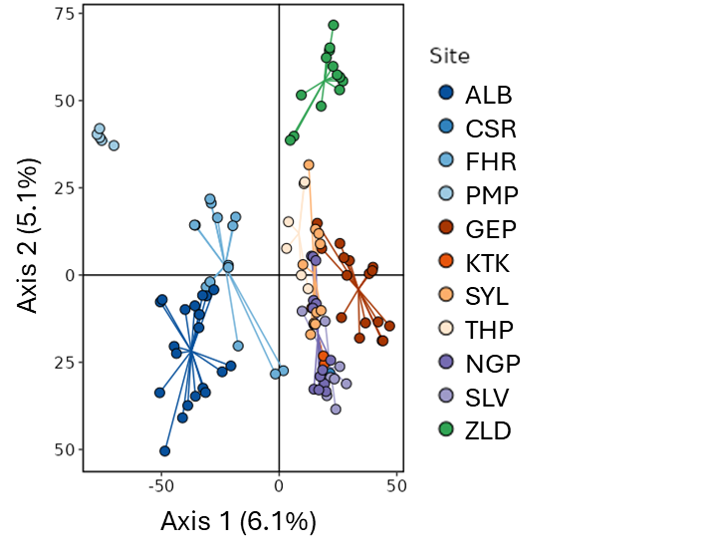
Figure S5 Principal component analysis for 111 reproductive age S. maire trees sampled in the Greater Wellington Region. Analyses were based on 55,708 SNPs at a minor allele frequency of 0.05, filtered for linkage disequilibrium and without missing information. Individual points represent single trees coloured according to sampling sites. Points are coloured according to region, with tones according to sample site.

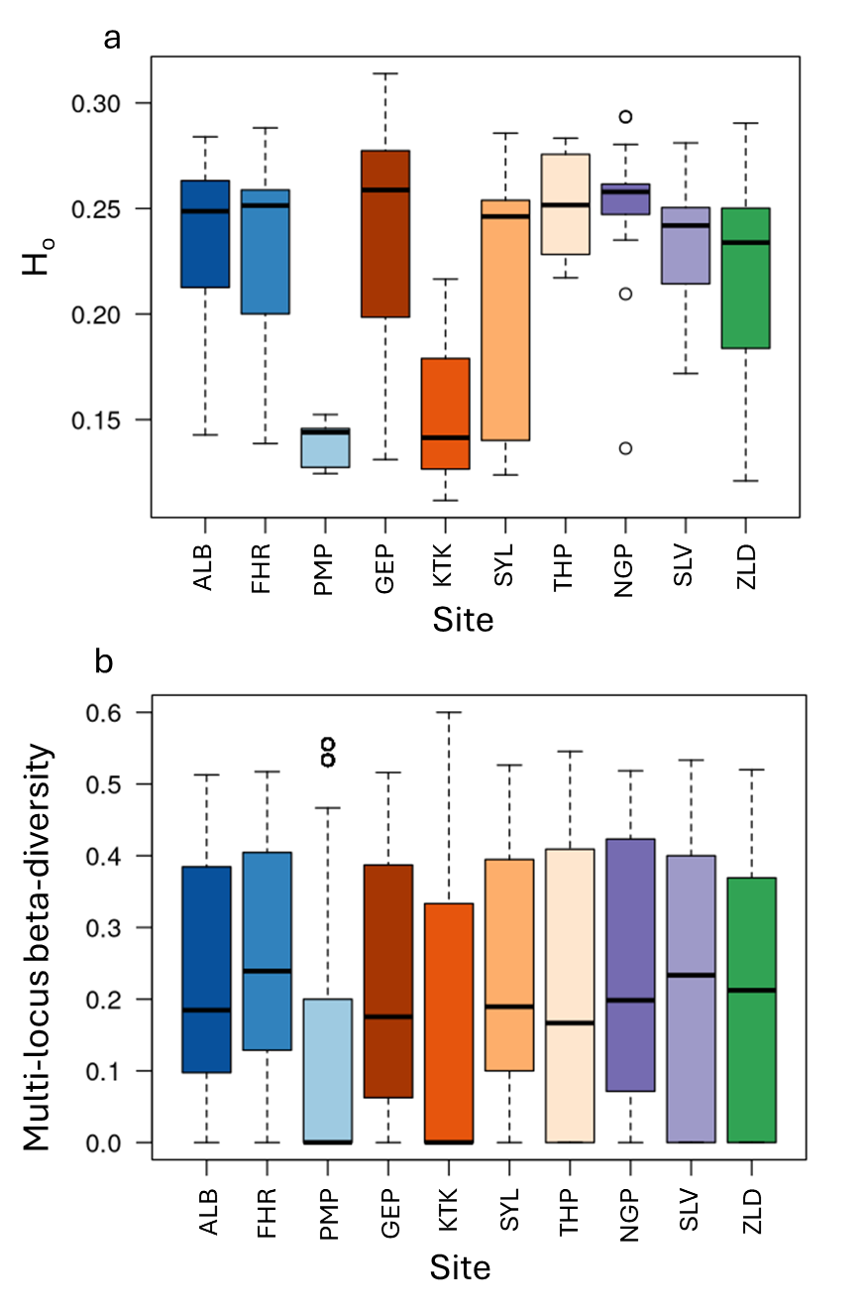
Figure S6: Genetic diversity in adult trees per site. A) Per-site distribution of individual observed heterozygosity (Ho). B) Beta diversity distribution across all loci per site.
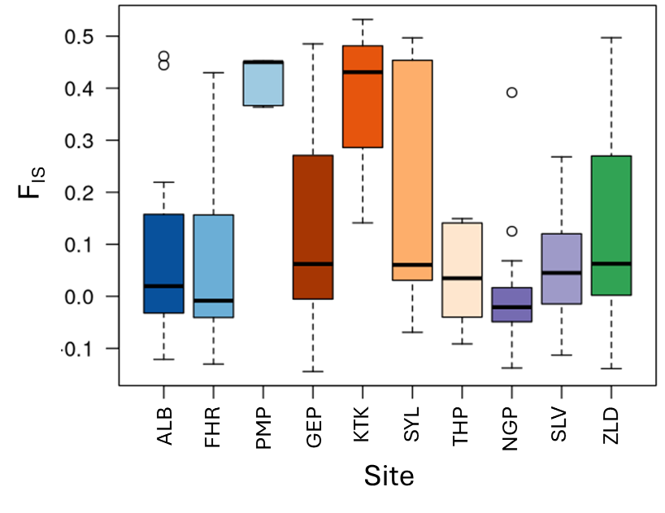
Figure S7: The distribution of individual inbreeding values for each sampling site.
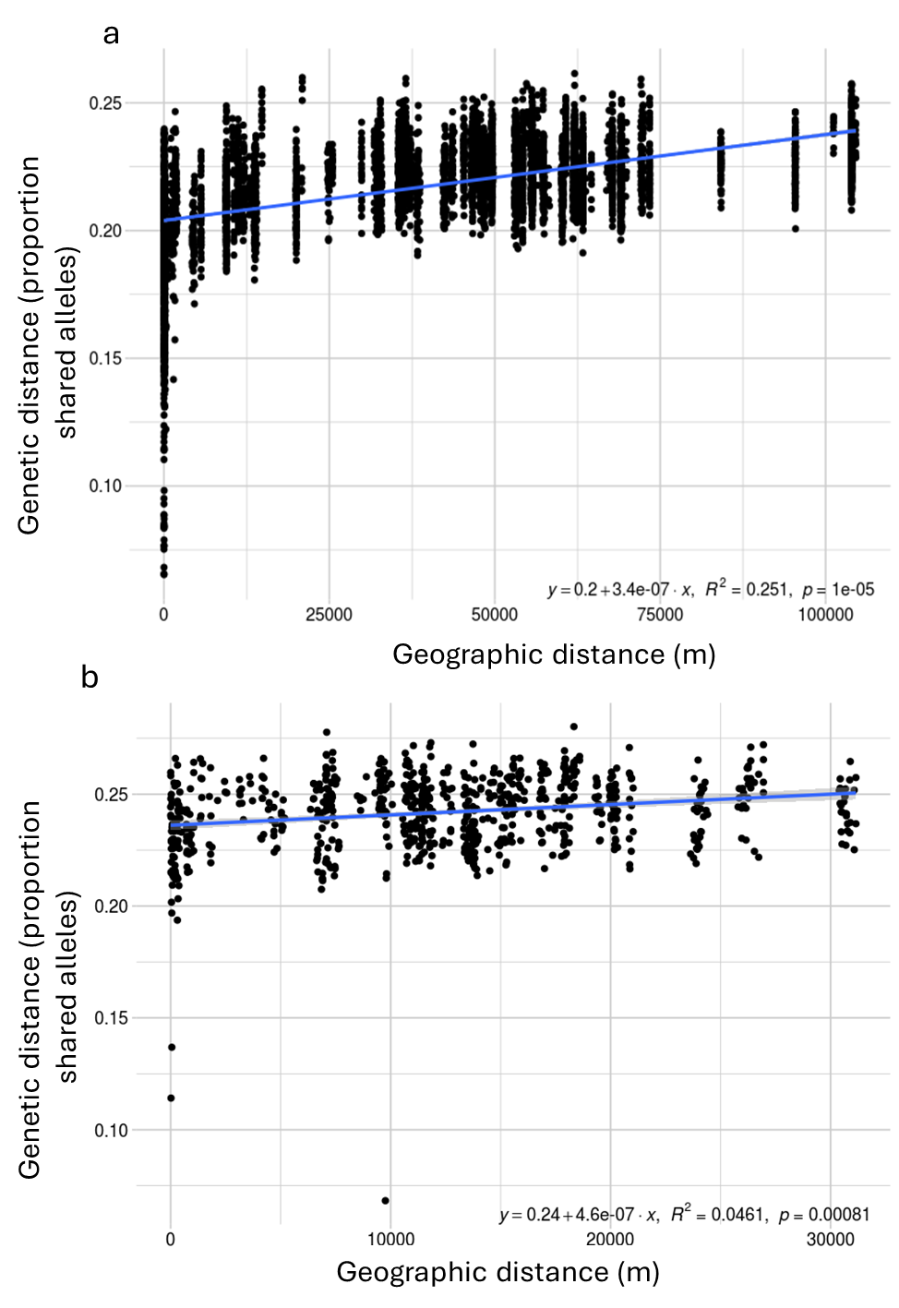
Figure S8: Genetic versus geographic distance for adult trees across A) Greater Wellington and B) Waipoua. Each point represents a pairwise comparison in genetic distance, based on pairwise shared alleles plotted according to pairwise Euclidean geographic distance in meters. The linear equation describing the trendline, correlation coefficient and p-value for the test of significant isolation by distance is shown in the bottom right corner.

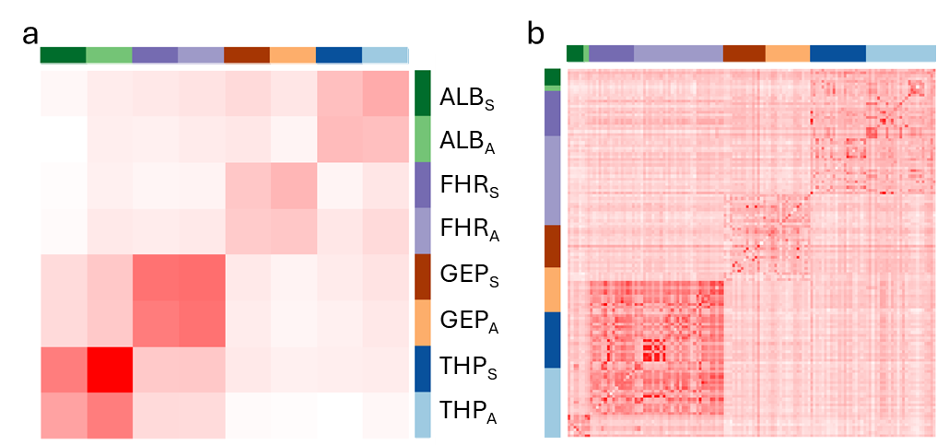
Figure S9: Heatmaps representing kinship of A) adult and seedling cohorts across sampling sites and B) all individuals from the adult-seedling pair dataset. Calculations were performed using Weir and Goudet (2017)’s beta-estimators and based on 156,672 SNPs filtered for linkage disequilibrium and missing information but not minor allele frequency. Inbreeding coefficients are displayed on the diagonal. Individuals are grouped into sites from which they were sampled, as depicted by multi-coloured bars alongside each heatmap.

