Extended Data Figure 1 | TEM and XRD characterizations of aCNS. a, selected-area electron diffraction (SAED) pattern of aCNS. b, XRD spectrum of aCNS.

Extended Data Table 1 | pH, surface area, pore volume and volatile % of AB, KJ and aCNS. AB was commercially available acetylene black (Soltex, Acetylene Black 50%-01) and KJ was commercially available Ketjenblack carbon black(Ketjenblack EC-600JD).

Extended Data Figure 2 | Different components to make a Na/Cl coin cell battery.

Extended Data Figure 3 | Electrochemical impedance spectroscopy (EIS) of battery during its first discharge and the first discharge of a Na/Cl battery using neutral electrolyte. a, Impedance measurements along the curve of first discharge of the battery when 4M AlCl₃ in SOCl₂ + 2 wt% NaFSI/NaTFSI was used as the electrolyte. b, first discharge curve of Na/Cl battery when 4M AlCl₃ + 4M NaCl in SOCl₂ was used as the electrolyte.

Extended Data Figure 4 | Percentage change of the mass spectrum intensity of Cl₂ and SCl₂ in charged and discharged battery compared to their respective fragmented intensity. By taking the mass spectrum of pure electrolyte, pure SO₂Cl₂ and pure S₂Cl₂, the intensity ratio between Cl₂ and SOCl₂, Cl₂ and SO₂Cl₂, Cl₂ and S₂Cl₂ could be determined, respectively. Similarly, the ratio between SCl₂ and SOCl₂, SCl₂ and SO₂Cl₂, SCl₂ and S₂Cl₂ could also be calculated (Extended Data Table 2). From these ratios, we could calculate the fragmented intensity of either Cl₂ or SCl₂, the intensity of Cl₂ or SCl₂ contributed by fragmentations of SOCl₂, S₂Cl₂ and SO₂Cl₂, in the actual opened battery spectrum. Afterward, the percent difference between the actual intensity of Cl₂ or SCl₂ and its fragmented intensity could be calculated and were reported in this figure. See Text S1 for detailed analysis.

Extended Data Figure 5 | Ar normalized mass spectroscopy data of the species in battery at different battery states (after first discharge, 0 hour retention, 24 hours retention, 72 hours retention, 120 hours retention and discharged). See Text S1 for detailed analysis.

Extended Data Figure 6 | Characterizations of sodium immersed in 4 M AlCl₃ in SOCl₂ with and without 2 wt% NaFSI/NaTFSI and charge – discharge curves of the normal battery versus decayed battery a, atomic percentage of different elements on the Na metal when immersed in 4 M AlCl₃ in SOCl₂ with and without 2 wt% NaFSI/NaTFSI as additives. b, F 1s spectrum of Na immersed in 4 M AlCl₃ in SOCl₂ with/without additives. c, S 2p spectrum of Na immersed in 4 M AlCl₃ in SOCl₂ with/without additives. d, Cl 2p spectrum of Na immersed in 4 M AlCl₃ in SOCl₂ with/without additives. e, charge – discharge curves of the battery at normal state and after the battery started to decay.

Extended Data Figure 7 | RGA300 setup with chamber connected. See Text S1 for detailed analysis.

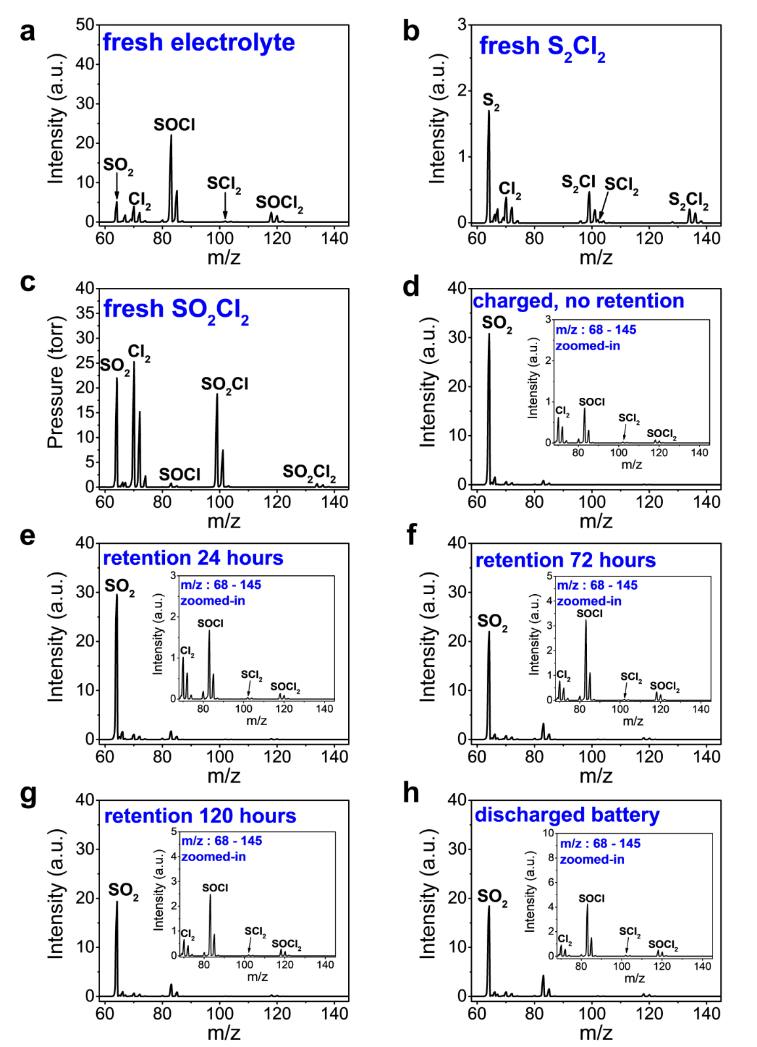
Extended Data Figure 8 | Argon normalized mass spectrum of standard solutions and species inside battery at different states a, fresh electrolyte. b, fresh S₂Cl₂. c, fresh SO₂Cl₂. d, species in charged battery with no retention. e, species in charged battery retained for 24 hours at open-circuit. f, mass spectrum of species in charged battery retained for 72 hours at open-circuit. g, mass spectrum of species in charged battery retained for 120 hours at open-circuit. h, mass spectrum of species in discharged battery. See Text S1 for detailed analysis.

Extended Data Table 2 | Ratios between peak intensity of different species/fragments and peak intensity of molecular peak in pure S₂Cl₂, pure SO₂Cl₂ and fresh electrolyte. See Text S1 for detailed analysis.

