SUPPLEMENTAL INFORMATION

Assessing the external exposome of South African children using wearable passive samplers and high-resolution mass spectrometry

Jeremy P. Koelmel¹, Elizabeth Z. Lin¹, Kayley DeLay¹,
Antony J. Williams², Yakun Zhou¹, Riana Bornman³,
Muvhulawa Obida³, Jonathan Chevrier⁴, Krystal J. Godri Pollitt^{1*}

¹ Department of Environmental Health Sciences,
School of Public Health,
Yale University, New Haven, CT, 06520, USA
² Center for Computational Toxicology and Exposure,
Office of Research and Development,
United States Environmental Protection Agency,
Research Triangle Park, North Carolina, United States
³ University of Pretoria Institute for Sustainable
Malaria Control and School of Health Systems and Public Health,
University of Pretoria, Pretoria, South Africa
⁴ Department of Epidemiology, Biostatistics and Occupational Health,
Faculty of Medicine, McGill University, Montréal, QC, Canada.

*Corresponding Author: krystal.pollitt@yale.edu

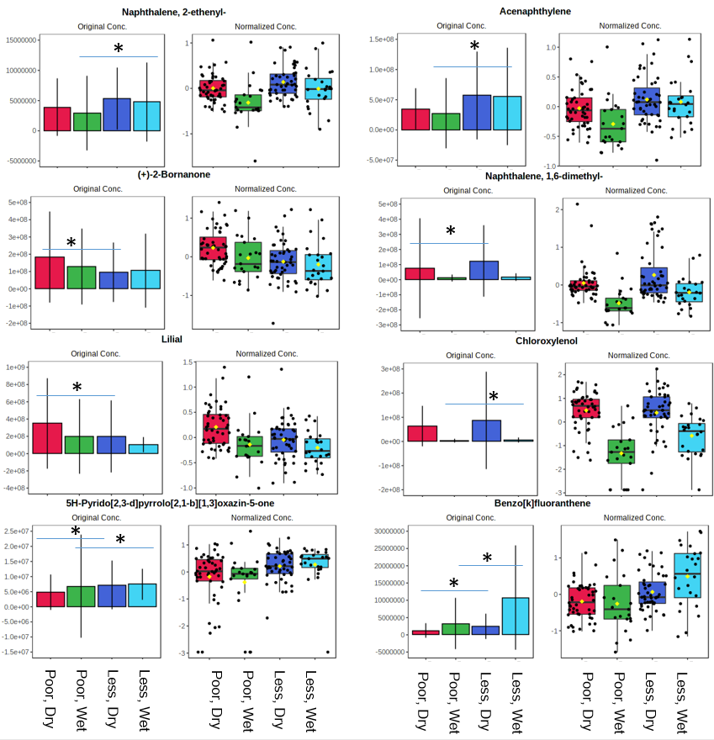
Figure S1: A subset of chemicals and their significance across poverty level (more poor: “poor”, less poor: “less”), grouped by season (wet season: “wet”, dry season: “dry”). Significance is based on a post-hoc Fisher’s LSD test and ANOVA with Hochberg correction (adjusted p-value). Significant comparisons between poor and less poor are shown. Raw intensity (“original conc.”) and normalized (log-scaled and mean centered) data are shown, with statistics performed on the normalized data.

