SUPPORTING INFORMATION

Restoration Ecology

Propagation method and species drive survival patterns across reef zones in coral seeding on the Great Barrier Reef

S. Jurriaans, C. Lefevre, S. Ferguson, C. Randall

Table S1 Spawning and deployment metadata

Table S1 Summary of coral species, propagation methods, reproduction, deployment and monitoring dates.
Propagation method | Species | Date reproduction  (spawning/microfrag) | Genotypes (n) | Settlement Date | Assembly Date | Median spat density (min-max) | Tabs per device (total n) | Deployment Date | Monitoring Dates
Sexual propagation  (spat) | Acropora loripes | 14 Dec 2022 | 3 | 19 Dec | 27 Dec ‘22 | 8 (2-18) | 1 (250) | 29-31 Dec | 8-12 Apr;  21-25 Jul;  18-20 Oct
Sexual propagation  (spat) | Mycedium elephantotus | 13 Dec 2022 | 5 | 19 and 21 Dec | 27 Dec ‘22 | 8 (1-32) | 1 (250) | 29-31 Dec | 8-12 Apr;  21-25 Jul;  18-20 Oct
Sexual propagation  (spat) | Montipora turtlensis | 19-20 Dec 2022 | 6 | 23 Dec | 27 Dec ‘22 | 3 (1-29) | 1 (250) | 29-31 Dec | 8-12 Apr;  21-25 Jul;  18-20 Oct
Sexual propagation  (spat) | Galaxea fascicularis | 13 Dec 2022 | 4 | 19 Dec | 27 Dec ‘22 | 4 (1-17) | 3 (150) | 29-31 Dec | 8-12 Apr;  21-25 Jul;  18-20 Oct
Asexual propagation  (microfrag) | Acropora loripes | 28 – 30 Nov 2022 | 6 | n/a | 20 Dec ‘22 | 1 | 1 (250) | 29-31 Dec | 8-12 Apr;  21-25 Jul;  18-20 Oct
Asexual propagation  (microfrag) | Goniastrea retiformis | 14 – 18 Nov 2022 | 4 | n/a | 20 Dec ‘22 | 1 | 1 (250) | 29-31 Dec | 8-12 Apr;  21-25 Jul;  18-20 Oct
Asexual propagation  (microfrag) | Montipora turtlensis | 21 – 24 Nov 2022 | 5 | n/a | 22 Dec ‘22 | 1 | 1 (250) | 29-31 Dec | 8-12 Apr;  21-25 Jul;  18-20 Oct
Asexual propagation  (microfrag) | Galaxea fascicularis | 14 – 18 Nov 2022 | 3 | n/a | 27 Dec ‘22 | 1 | 3 (150) | 29-31 Dec | 8-12 Apr;  21-25 Jul;  18-20 Oct

Table S2 F1 scores

Table S2 Accuracy of machine-learning classification for major benthic categories in ReefCloud image analyses. F1 scores indicate model performance for each benthic category based on comparison with human annotations and range from 0-1 with 1 being perfect classification.
Category | F1 Score
Epilithic algal matrix (EAM) | 0.92
Acropora | 0.91
Sof Coral | 0.84
Hard Coral | 0.83
Sand | 0.78
Crustose coralline algae (CCA) | 0.74

Table S3 Models tested
Table S3. List of models tested for coral survival and growth, showing fixed and random effect structures, AIC values, and chi-square (χ²) tests for nested model comparisons. Models include baseline random- and main-effects, species and propagation method interactions with environmental covariates (reef zone, nominal wave energy, flow velocity), the final selected model, genotype effects (microfrags only), density dependence (spat only), and benthic community predictors at both site- and tab-level scales. Model comparisons were performed between model sets delineated by thick boxed borders. CCA = crustose coralline algae. PC1 and PC2 are the centroids of the benthic community ordination (Figure S2).
Model set | Model | AIC | Chisq | df | p
Baseline | survival ~ (1|site) | 9095.9 | na | na | na
random | survival ~ (1|device) | 8380.0 | 715.91 | 0
effects | survival ~ (1|site/device) | 8382.0 | 0.00 | 1 | 1
Baseline main effects (m1) | survival ~ species + propagation method + nominal wave energy + census + reef zone + flow velocity + (1|device) | 5126.9 | na | na | na
Interactions | m1, . ~ . + species * census | 5093.1 | 41.826 | 4 | <0.001
 | m1, . ~ . + species * reef zone | 5079.1 | 71.785 | 12 | <0.001
 | m1, . ~ . + propagation method * reefzone | 5080.1 | 14.8 | 3 | 0.002
 | m1, . ~ . + propagation method * census | 5126.0 | 2.8911 | 1 | 0.09
Flow velocity | survival ~ species * census + species * flow velocity + propagation method * flow velocity + (1|device) | 5090.6 | na | na | na
Reef zone (final model) | survival ~ species * census + species * reef zone + propagation method * reef zone + (1|device) | 5032.9 | 81.6285 | 12 | <0.001
Nominal wave energy | survival ~ species * census + species * nominal wave energy + propagation method * nominal wave energy + (1|device) | 5041.7 | 3.2191 | 6 | 0.781
Growth | survival (final) ~ species + reef zone + propagation method + (1|site) | 1825.7 | na | na | na
 | size (cm3) ~ species + reef zone + propagation method + (1|site) | 1716.9 | na | na | na
 | size (cm3) ~ species + reef zone + propagation method + (1|site) + species * propagation method | 1665.0 | 55.917 | 2 | <0.001
Genotype effects | survival (final) ~ species + reef zone + genotype | 1025.2 | na | na | na
 | survival (final) ~ species + reef zone + (1|genotype) + (1|site) | 1027.9 | na | na | na
Density dependence | survival (final) ~ scale(colonies deployed) * species + ((1|site) | 587.8 | na | na | na
Benthic community | survival (final) ~ PC1 + PC2 + species + propagation method + (1|device) | 1825.7 | na | na | na
(site) | survival (final) ~ PC1 + PC2 + species + propagation method + (1|site) + (1|device) | 1824.2 | 3.448 | 1 | 0.063
 | survival (final) ~ reef zone + species + propagation method + (1|site) + (1|device) | 1820.3 | 5.919 | 1 | 0.015
 | survival (final) ~ PC1 + PC2 + reef zone + species + propagation method + (1|site) + (1|device) | 1823.7 | 0.620 | 2 | 0.733
 | survival (final) ~ PC1 + PC2 + species + propagation method + (1|site) + (1|device) + species * PC1 + species * PC2 | 1828.3 | 1.348 | 3 | 0.718
Benthic community (tab) | survival ~ species + reef zone + dominant tab community | 522.5 | na | na | na
Tab percent cover | survival ~ species + reef zone + percent CCA | 616.5 | na | na | na
 | survival ~ species + reef zone * percent CCA | 621.4 | 1.195 | 3 | 0.754
 | survival ~ reef zone + species * percent CCA | 619.0 | 1.506 | 2 | 0.471

Table S4 Odds ratios
Table S4 Summary of odds ratios (OR) from the generalized linear mixed model assessing survival across species (Galaxea fascicularis, Goniastrea retiformis, Montipora turtlensis, Acropora loripes, Mycedium elephantotus), reef zones, propagation methods, and time. Odds ratios greater than 1 indicate increased odds of survival relative to the reference group, while values less than 1 indicate reduced survival odds. The reference categories are: Acropora loripes (species), back reef (reef zone), microfrags (propagation method), and baseline time (centred census = 0).
Effect group | Comparison /Term | OR | 95% CI | p.value
Species | G. fascicularis vs A. loripes | 0.78 | 0.40–1.51 | 0.46
 | G. retiformis vs A. loripes | 3.28 | 1.95–5.52 | 0.00
 | M. elephantotus vs A. loripes | 0.03 | 0.02–0.07 | 0.00
 | M. turtlensis vs A. loripes | 0.98 | 0.71–1.34 | 0.89
Time | Per unit increase in time | 0.66 | 0.58–0.76 | 0.00
Reef zone | Flank vs Back | 2.87 | 1.59–5.18 | 0.00
 | Front vs Back | 3.84 | 2.09–7.04 | 0.00
 | Lagoon vs Back | 0.39 | 0.18–0.86 | 0.02
Propagation method | Spat vs Microfrag | 0.22 | 0.13–0.35 | 0.00
Species × Census | G. fascicularis × Time | 0.97 | 0.77–1.23 | 0.79
 | G. retiformis× Time | 1.15 | 0.90–1.47 | 0.27
 | M. elephantotus × Time | 0.30 | 0.18–0.48 | 0.00
 | M. turtlensis × Time | 1.02 | 0.85–1.23 | 0.83
Species × Reef zone | G. fascicularis × Flank | 0.37 | 0.14–0.96 | 0.04
 | G. retiformis × Flank | 0.16 | 0.08–0.33 | 0.00
 | M. elephantotus × Flank | 0.90 | 0.39–2.04 | 0.79
 | M. turtlensis × Flank | 0.48 | 0.30–0.77 | 0.00
 | G. fascicularis × Front | 0.22 | 0.08–0.57 | 0.00
 | G. retiformis × Front | 0.11 | 0.05–0.22 | 0.00
 | M. elephantotus × Front | 0.67 | 0.28–1.62 | 0.38
 | M. turtlensis × Front | 0.30 | 0.19–0.49 | 0.00
 | G. fascicularis × Lagoon | 2.73 | 0.75–9.92 | 0.13
 | G. retiformis × Lagoon | 1.23 | 0.48–3.20 | 0.66
 | M. elephantotus × Lagoon | 1.27 | 0.35–4.56 | 0.71
 | M. turtlensis × Lagoon | 2.24 | 1.18–4.26 | 0.01
Reef × Propagation | Spat × Flank | 0.28 | 0.14–0.57 | 0.00
 | Spat × Front | 0.20 | 0.10–0.41 | 0.00
 | Spat × Lagoon | 1.01 | 0.39–2.63 | 0.98

Table S5 EMMs

Table S5 Estimated marginal means of survival (survival probability) by reef zone, propagation method and species.
 | Reef zone | Survival prob | SE | 95% CI
Propagation method
spat | Lagoon | 0.26 | 0.06 | 0.16-0.39
 | Back | 0.36 | 0.04 | 0.28-0.44
 | Flank | 0.18 | 0.03 | 0.13-0.24
 | Front | 0.13 | 0.02 | 0.09-0.18
microfrag | Lagoon | 0.61 | 0.07 | 0.46-0.74
 | Back | 0.72 | 0.04 | 0.64-0.79
 | Flank | 0.78 | 0.03 | 0.71-0.84
 | Front | 0.77 | 0.03 | 0.69-0.83
Species
Acropora loripes | Lagoon | 0.43 | 0.07 | 0.31-0.57
 | Back | 0.66 | 0.03 | 0.59-0.73
 | Flank | 0.75 | 0.03 | 0.68-0.80
 | Front | 0.77 | 0.03 | 0.70-0.83
Galaxea fascicularis | Lagoon | 0.62 | 0.12 | 0.38-0.81
 | Back | 0.60 | 0.07 | 0.46-0.73
 | Flank | 0.46 | 0.08 | 0.31-0.61
 | Front | 0.36 | 0.07 | 0.23-0.51
Goniastrea retiformis | Lagoon | 0.76 | 0.07 | 0.58-0.87
 | Back | 0.86 | 0.03 | 0.79-0.91
 | Flank | 0.61 | 0.05 | 0.50-0.71
 | Front | 0.54 | 0.06 | 0.43-0.65
Montipora turtlensis | Lagoon | 0.63 | 0.06 | 0.50-0.74
 | Back | 0.65 | 0.04 | 0.58-0.72
 | Flank | 0.58 | 0.04 | 0.50-0.66
 | Front | 0.50 | 0.04 | 0.42-0.58
Mycedium elephantotus | Lagoon | 0.03 | 0.02 | 0.00-0.10
 | Back | 0.06 | 0.02 | 0.03-0.12
 | Flank | 0.08 | 0.03 | 0.04-0.16
 | Front | 0.07 | 0.03 | 0.03-0.15

Table S6 Pairwise contrasts
Table S6 Tukey-adjusted pairwise contrasts from the GLMM. Estimates on the log-odds scale with odds ratios (OR). census_sc = 0; averaged over species.
 | Contrast | Odds Ratio |  | SE | Z ratio | p
Reef zone
Lagoon | microfrag / spat | 4.53 |  | 1.91 | 3.58 | 0.0003
Back | microfrag / spat | 4.58 |  | 1.13 | 6.15 | <.0001
Flank | microfrag / spat | 16.15 |  | 4.20 | 10.69 | <.0001
Front | microfrag / spat | 22.66 |  | 6.07 | 11.64 | <.0001
Propagation method
Microfrag | lagoon / back | 1.62 |  | 0.58 | 1.34 | 0.5407
 | lagoon / flank | 2.22 |  | 0.81 | 2.21 | 0.1214
 | lagoon / front | 2.12 |  | 0.77 | 2.07 | 0.1638
 | back / flank | 0.73 |  | 0.19 | -1.23 | 0.6102
 | back / front | 0.76 |  | 0.20 | -1.04 | 0.7273
 | flank / front | 1.05 |  | 0.28 | 0.17 | 0.9982
Spat | lagoon / back | 1.60 |  | 0.57 | 1.33 | 0.5467
 | lagoon / flank | 0.62 |  | 0.22 | -1.33 | 0.5434
 | lagoon / front | 0.42 |  | 0.15 | -2.39 | 0.0797
 | back / flank | 2.56 |  | 0.64 | 3.77 | 0.0009
 | back / front | 3.77 |  | 0.96 | 5.19 | <.0001
 | flank / front | 1.47 |  | 0.38 | 1.50 | 0.4401
Reef zone
Lagoon | Alor / Gfas | 0.47 |  | 0.27 | -1.33 | 0.6704
 | Alor / Gret | 0.25 |  | 0.10 | -3.42 | 0.0056
 | Alor / Mele | 23.12 |  | 14.40 | 5.05 | <.0001
 | Alor / Mtur | 0.46 |  | 0.13 | -2.77 | 0.0444
 | Gfas / Gret | 0.52 |  | 0.34 | -1.01 | 0.8515
 | Gfas / Mele | 49.14 |  | 39.00 | 4.91 | <.0001
 | Gfas / Mtur | 0.97 |  | 0.55 | -0.06 | 1.0000
 | Gret / Mele | 93.77 |  | 67.30 | 6.32 | <.0001
 | Gret / Mtur | 1.85 |  | 0.77 | 1.48 | 0.5734
 | Mele / Mtur | 0.02 |  | 0.01 | -6.30 | <.0001
Back | Alor / Gfas | 1.28 |  | 0.43 | 0.74 | 0.9469
 | Alor / Gret | 0.30 |  | 0.08 | -4.49 | 0.0001
 | Alor / Mele | 29.36 |  | 10.30 | 9.67 | <.0001
 | Alor / Mtur | 1.02 |  | 0.17 | 0.14 | 0.9999
 | Gfas / Gret | 0.24 |  | 0.09 | -3.63 | 0.0027
 | Gfas / Mele | 22.87 |  | 10.50 | 6.83 | <.0001
 | Gfas / Mtur | 0.80 |  | 0.27 | -0.67 | 0.9621
 | Gret / Mele | 96.46 |  | 40.90 | 10.77 | <.0001
 | Gret / Mtur | 3.36 |  | 0.89 | 4.58 | <.0001
 | Mele / Mtur | 0.04 |  | 0.01 | -9.60 | <.0001
Flank | Alor / Gfas | 3.51 |  | 1.25 | 3.53 | 0.0038
 | Alor / Gret | 1.89 |  | 0.47 | 2.60 | 0.0709
 | Alor / Mele | 32.79 |  | 12.20 | 9.37 | <.0001
 | Alor / Mtur | 2.12 |  | 0.37 | 4.36 | 0.0001
 | Gfas / Gret | 0.54 |  | 0.21 | -1.59 | 0.5031
 | Gfas / Mele | 9.35 |  | 4.55 | 4.60 | <.0001
 | Gfas / Mtur | 0.60 |  | 0.21 | -1.43 | 0.6100
 | Gret / Mele | 17.32 |  | 7.38 | 6.70 | <.0001
 | Gret / Mtur | 1.12 |  | 0.27 | 0.48 | 0.9894
 | Mele / Mtur | 0.07 |  | 0.02 | -7.36 | <.0001
Front | Alor / Gfas | 5.95 |  | 2.13 | 4.98 | <.0001
 | Alor / Gret | 2.82 |  | 0.73 | 4.00 | 0.0006
 | Alor / Mele | 43.68 |  | 17.80 | 9.28 | <.0001
 | Alor / Mtur | 3.39 |  | 0.64 | 6.52 | <.0001
 | Gfas / Gret | 0.47 |  | 0.18 | -1.94 | 0.2984
 | Gfas / Mele | 7.34 |  | 3.75 | 3.90 | 0.0009
 | Gfas / Mtur | 0.57 |  | 0.20 | -1.59 | 0.5027
 | Gret / Mele | 15.52 |  | 7.13 | 5.92 | <.0001
 | Gret / Mtur | 1.21 |  | 0.29 | 0.77 | 0.9390
 | Mele / Mtur | 0.08 |  | 0.03 | -6.25 | <.0001
Species
Acropora | back / flank | 0.66 |  | 0.15 | -1.85 | 0.251
loripes | back / front | 0.58 |  | 0.14 | -2.32 | 0.094
 | back / lagoon | 2.53 |  | 0.79 | 2.95 | 0.017
 | flank / front | 0.89 |  | 0.21 | -0.50 | 0.958
 | flank / lagoon | 3.86 |  | 1.23 | 4.23 | 0.000
 | front / lagoon | 4.35 |  | 1.41 | 4.55 | <.0001
Galaxea | back / flank | 1.79 |  | 0.78 | 1.34 | 0.536
fascicularis | back / front | 2.69 |  | 1.16 | 2.29 | 0.100
 | back / lagoon | 0.93 |  | 0.54 | -0.13 | 0.999
 | flank / front | 1.50 |  | 0.66 | 0.93 | 0.791
 | flank / lagoon | 0.52 |  | 0.30 | -1.12 | 0.676
 | front / lagoon | 0.34 |  | 0.20 | -1.82 | 0.263
Goniastrea | back / flank | 4.07 |  | 1.41 | 4.07 | 0.000
retiformis | back / front | 5.37 |  | 1.87 | 4.81 | <.0001
 | back / lagoon | 2.05 |  | 0.98 | 1.49 | 0.444
 | flank / front | 1.32 |  | 0.43 | 0.85 | 0.832
 | flank / lagoon | 0.50 |  | 0.23 | -1.48 | 0.448
 | front / lagoon | 0.38 |  | 0.18 | -2.07 | 0.165
Montipora | back / flank | 1.36 |  | 0.31 | 1.36 | 0.528
turtlensis | back / front | 1.92 |  | 0.44 | 2.84 | 0.023
 | back / lagoon | 1.13 |  | 0.36 | 0.37 | 0.982
 | flank / front | 1.42 |  | 0.33 | 1.50 | 0.438
 | flank / lagoon | 0.83 |  | 0.26 | -0.59 | 0.935
 | front / lagoon | 0.59 |  | 0.19 | -1.67 | 0.338
Mycedium | back / flank | 0.73 |  | 0.31 | -0.75 | 0.878
elephantotus | back / front | 0.86 |  | 0.39 | -0.33 | 0.988
 | back / lagoon | 1.99 |  | 1.29 | 1.06 | 0.713
 | flank / front | 1.18 |  | 0.54 | 0.36 | 0.984
 | flank / lagoon | 2.72 |  | 1.78 | 1.53 | 0.422
 | front / lagoon | 2.30 |  | 1.55 | 1.24 | 0.603

Figure S1 Random effects site

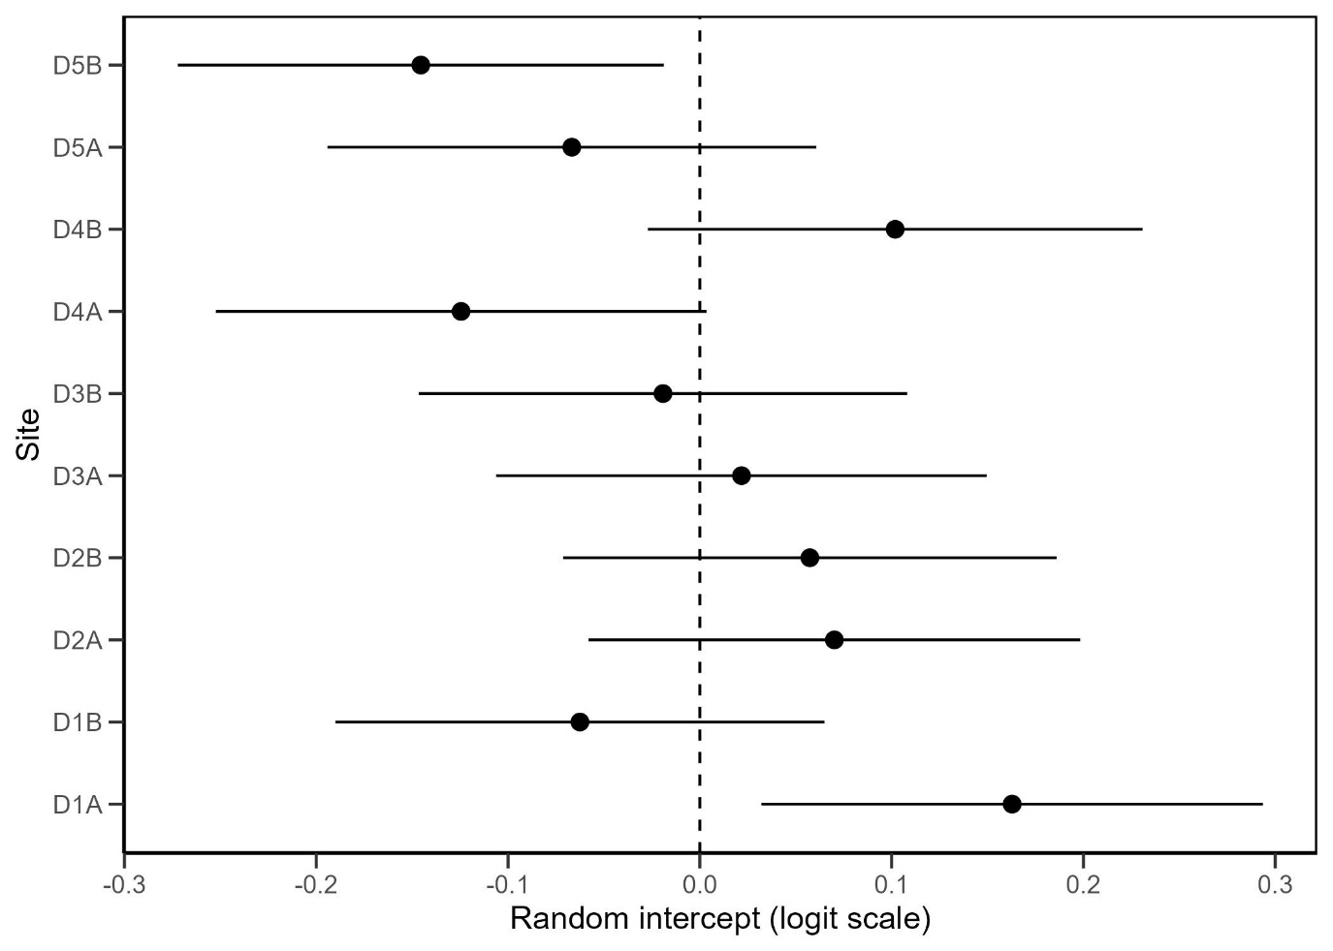
Figure S1 Site level random effects on survival. Estimates (±95% CI) of site random intercepts from a binomial GLMM (survival ~ 1 + (1|site)). Effects are centred on zero (variance = 0.013; ICC <1%) indicating negligible variation in survival among sites.

Figure S2 PCA

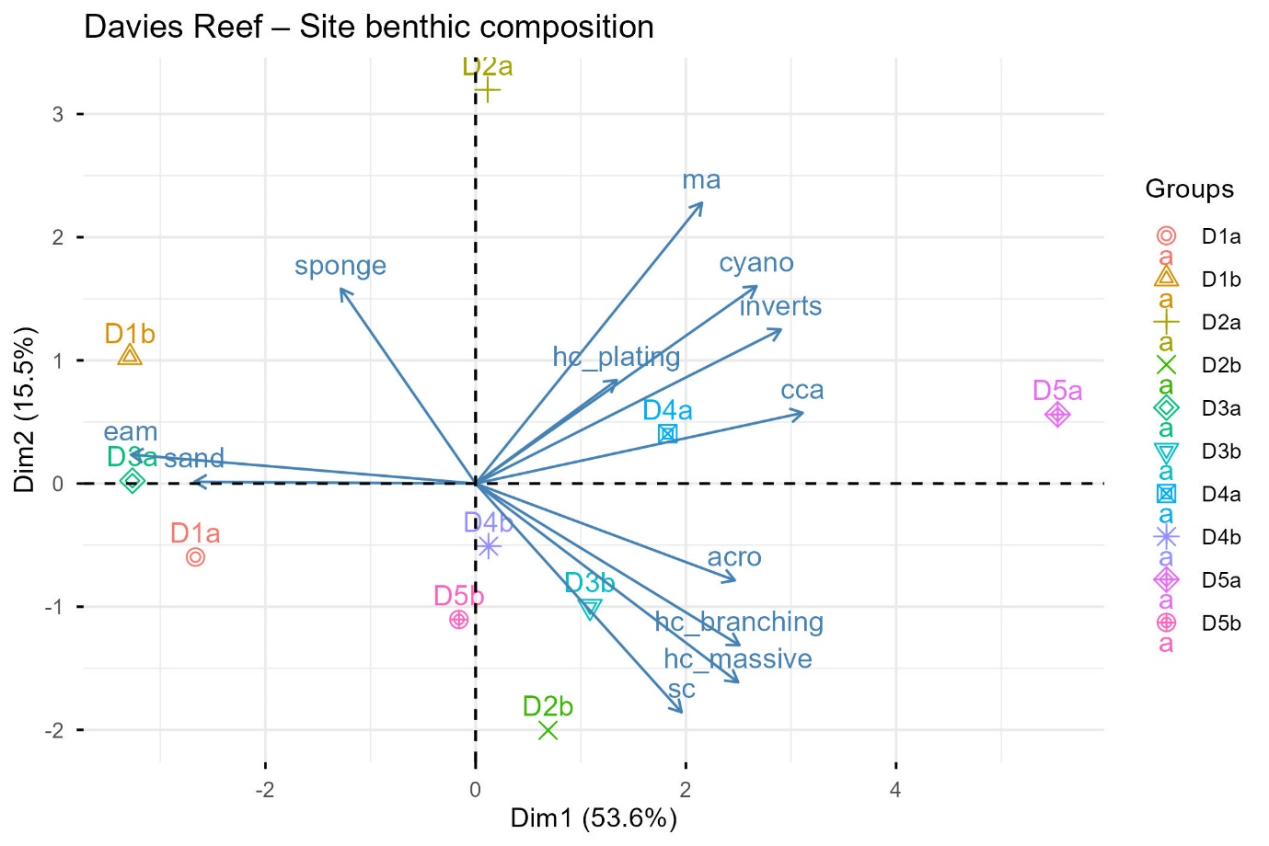
Figure S2 Principal component analysis (PCA) of benthic community composition at Davies Reef.
The first two axes explain 69 % of the total variation (Dim1 = 53.6 %, Dim2 = 15.5 %). Each point represents a site with arrows indicating the contribution and direction of major benthic groups to the ordination. Sites on the right are characterised by higher (coral) cover (Acropora, non-Acropora hard corals, crustose coralline algae), whereas those on the left are dominated by sand and epilithic algal matrix.
Abbreviations:
eam = epilithic algal matrix
ma = macroalgae
cca = crustose coralline algae
cyano = cyanobacteria
inverts = invertebrates, mostly tunicates, ascidians
hc_plating/massive/branching = non-Acropora hard coral by growth forms;
acro = Acropora
sc = soft coral
sponge = sponges
sand = sand/silt

