Supplementary Information
Table of Contents
Supplementary Information 1
Table S1. Contextual information about En-ROADS simulation sessions from which survey data were collected. 2
Table S2. Mann-Whitney U tests to compare pre- to post-survey gains from participants from virtual sessions to those from in-person sessions 5
Figure S1. Coding tree with themes and codes identified through iterative qualitative analysis of interviews. 6
Survey instrument 7
Consent to participate 7
Survey questions 7
Semi-structured interviews questions 8
Informed consent 8
Interview questions 8
Privacy Policy Statement 9

Table S1. Contextual information about En-ROADS simulation sessions from which survey data were collected. Information provided includes: session date (‘Sess’n date’); the organization that hosted the session; the total number of participants surveyed; the percent of session participants who provided usable surveys (i.e., matched pre- and post-surveys); the type of simulation (‘Sim type’) that was used, i.e., an interactive En-ROADS workshop (‘Workshop’) or a Climate Action Simulation (‘CAS’); whether or not participants were affiliated with a host organization with a focus on sustainability or climate change (‘Prior sust’); whether the facilitator was a member of the MIT Climate Pathways Project team, trained by the team, or neither a team member nor trained by the team; and how long the session was (‘Sess’n length’).

Sess’n date | Host organization | Total survey-ed | % Usable surveys | Sim Type | Sector | Prior Sust | Platform | Facilitat-or  trained | Sess’n Length
May-2021 | Advisory Board for Environmental Science, UMass Lowell | 8 | 13% | Workshop | Private, mixed | Yes | Virtual | Team | 1.0
Jun-2021 | American Apparel & Footware Association (AAFA) | 15 | 27% | Workshop | ? | No | Virtual | Team | 1.5
Oct-2021 | AXA Investment Managers | 44 | 25% | Workshop | Private, finance | No | Virtual | Team | 1.7
Oct-2021 | SOCAP Global | 21 | 19% | Workshop | NGO | No | Virtual | Yes | 1.3
Nov-2021 | Terra.do | 30 | 27% | Workshop | Private, tech | Yes | Virtual | No | 1.0
Mar-2022 | TTI/Vanguard | 20 | 20% | Workshop | Private, sust | No | Virtual | Team | 1.0
Mar-2022 | Terra.do | 33 | 33% | Workshop | Private, sust | Yes | Virtual | No | 1?
Mar-2022 | Terra.do | 15 | 20% | Workshop | Private, sust | Yes | Virtual | No | 1
Mar-2022 | Trenton Computer Festival | 5 | 20% | Workshop | Private, tech | No | Virtual | Team | 1
Apr-2022 | Terra.do | 8 | 38% | Workshop | Private, sust | Yes | Virtual | No | 1.0
Apr-2022 | Geneva Science and Diplomacy Anticipator (GESDA) | 3 | 33% | Workshop | NGO | Yes | Virtual | Team | 1.0
Apr-2022 | Terra.do | 19 | 47% | Workshop | Private, sust | Yes | Virtual | No | 1.0
May-2022 | TRUMPF SE + Co. KG | 40 | 25% | Workshop | Private, energy | No | Virtual | Team | 1.5
May-2022 | State Government of Tyrol, Austria | 17 | 29% | CAS | Gov't | No | Virtual | Team | 4.0
Jun-2022 | Massachusetts state representative campaign event | 23 | 30% | Workshop | General public | No | In Person | Team | 2.0
Jun-2022 | MIT Sloan Executive Education | 40 | 53% | Workshop | Private, finance | No | In Person | Team | 3.0
Sep-2022 | European Commission Directorate General, Climate Action | 18 | 33% | Workshop | Gov't | No | Virtual | Team | 1.5
Sep-2022 | United Nations General Assembly Session | 4 | 50% | Workshop | General public | No | Virtual | Team | 1.5
Oct-2022 | TRUMPF SE + Co. KG | 4 | 75% | Workshop | Private, energy | No | Virtual | Team | 1.0
Oct-2022 | World Wildlife Foundation | 1 | 100% | Workshop | NGO | Yes | Virtual | Team | 1.0
Nov-2022 | European Climate Pact | 46 | 13% | Workshop | NGO | Yes | Virtual | Team | 1.0
Dec-2022 | Uniper SE | 3 | 67% | CAS | Private, energy | No | Virtual | Team | 2.0
Jan-2023 | VDMA, association for machinery and equipment manufacturing | 20 | 65% | Workshop | NGO | No | In Person | Team | 1.0
Feb-2023 | EnBW AG | 39 | 18% | CAS | Private, energy | No | Virtual | Team | 2.3
Mar-2023 | US Department of State | 14 | 50% | Workshop | Gov't | No | Virtual | Team | 2.0
Mar-2023 | MIT Industrial Liaison Program | 87 | 40% | Workshop | Private, tech | No | In Person | Team | 1.8
Mar-2023 | Stuttgart city government | 11 | 27% | Workshop | Gov't | No | In Person | Team | 1.5
Apr-2023 | Technical University of Munich | 94 | 28% | Workshop | NGO | No | Hybrid | Team | 1.0
Apr-2023 | Citizen's Climate Lobby | 23 | 35% | Workshop | NGO | Yes | In Person | Team | 2.0
Jun-2023 | Fulbright Transatlantic Alumni Conference | 17 | 18% | Workshop | Private, mixed | No | In Person | Team | 1.5
Jul-  2023 | EnBW AG, Executive Board of Directors | 6 | 50% | Workshop | Private, energy | No | In Person | Team | 0.8
Jul-  2023 | US Department of State, Foreign Service Institute | 28 | 71% | Workshop | Gov't | No | In Person | Team | 2.0
Jul-  2023 | Harvard Kennedy School, program for municipal and state leaders | 62 | 32% | Workshop | Gov't | No | In Person | Team | 1.5
Oct-2023 | US Department of State, Foreign Service Institute | 29 | 59% | Workshop | Gov't | No | In Person | Team | 3.0
Oct-2023 | EnBW AG, Global Management Board | 12 | 25% | Workshop | Private, energy | No | Virtual | Team | 1.5
Apr-2021 | MIT Sloan MBA Program | 62 | 8% | Workshop | Private, tech | Yes | Virtual | Team | 1.5, 3.5
Jul-  2021 | Terra.do | 28 | 25% | Workshop | Private, sust | Yes | Virtual | No | 1.0

Table S2. Mann-Whitney U tests to compare pre- to post-survey gains from participants from virtual sessions to those from in-person sessions. ‘U’ refers the Mann-Whitney U statistic.

 | Virtual |  |  | In-person
 | N | Mean | SD | N | Mean | SD | U | p | Cohen’s_d
Climate change affect:
Personal importance of cc | 142 | 0.028 | 0.204 | 128 | 0.039 | 0.385 | 8982 | 0.709 | 0.036
Empowerment to address cc | 141 | 0.106 | 0.517 | 127 | 0.236 | 0.584 | 8003 | 0.052 | 0.236
Climate solutions:
Carbon price | 141 | 0.284 | 0.525 | 122 | 0.328 | 0.521 | 8261 | 0.511 | 0.084
Methane & non-CO₂ GHGs | 141 | 0.078 | 0.598 | 122 | 0.189 | 0.580 | 7820 | 0.137 | 0.187
Energy efficiency: buildings | 141 | 0.121 | 0.615 | 122 | 0.172 | 0.612 | 8238 | 0.498 | 0.084
Energy efficiency: transport | 141 | -0.035 | 0.659 | 122 | -0.049 | 0.558 | 8675 | 0.890 | -0.022
Carbon capture tech | 141 | 0.028 | 0.573 | 122 | -0.164 | 0.566 | 9983 | 0.007 | -0.337
Electrify transport | 141 | -0.149 | 0.413 | 122 | -0.115 | 0.411 | 8328 | 0.512 | 0.083
New zero carbon energy | 141 | -0.050 | 0.577 | 122 | -0.008 | 0.596 | 8308 | 0.571 | 0.071
Sequester soil carbon | 141 | -0.099 | 0.419 | 122 | -0.066 | 0.380 | 8322 | 0.485 | 0.084
Plant trees | 141 | -0.284 | 0.539 | 122 | -0.311 | 0.604 | 8906 | 0.568 | -0.049

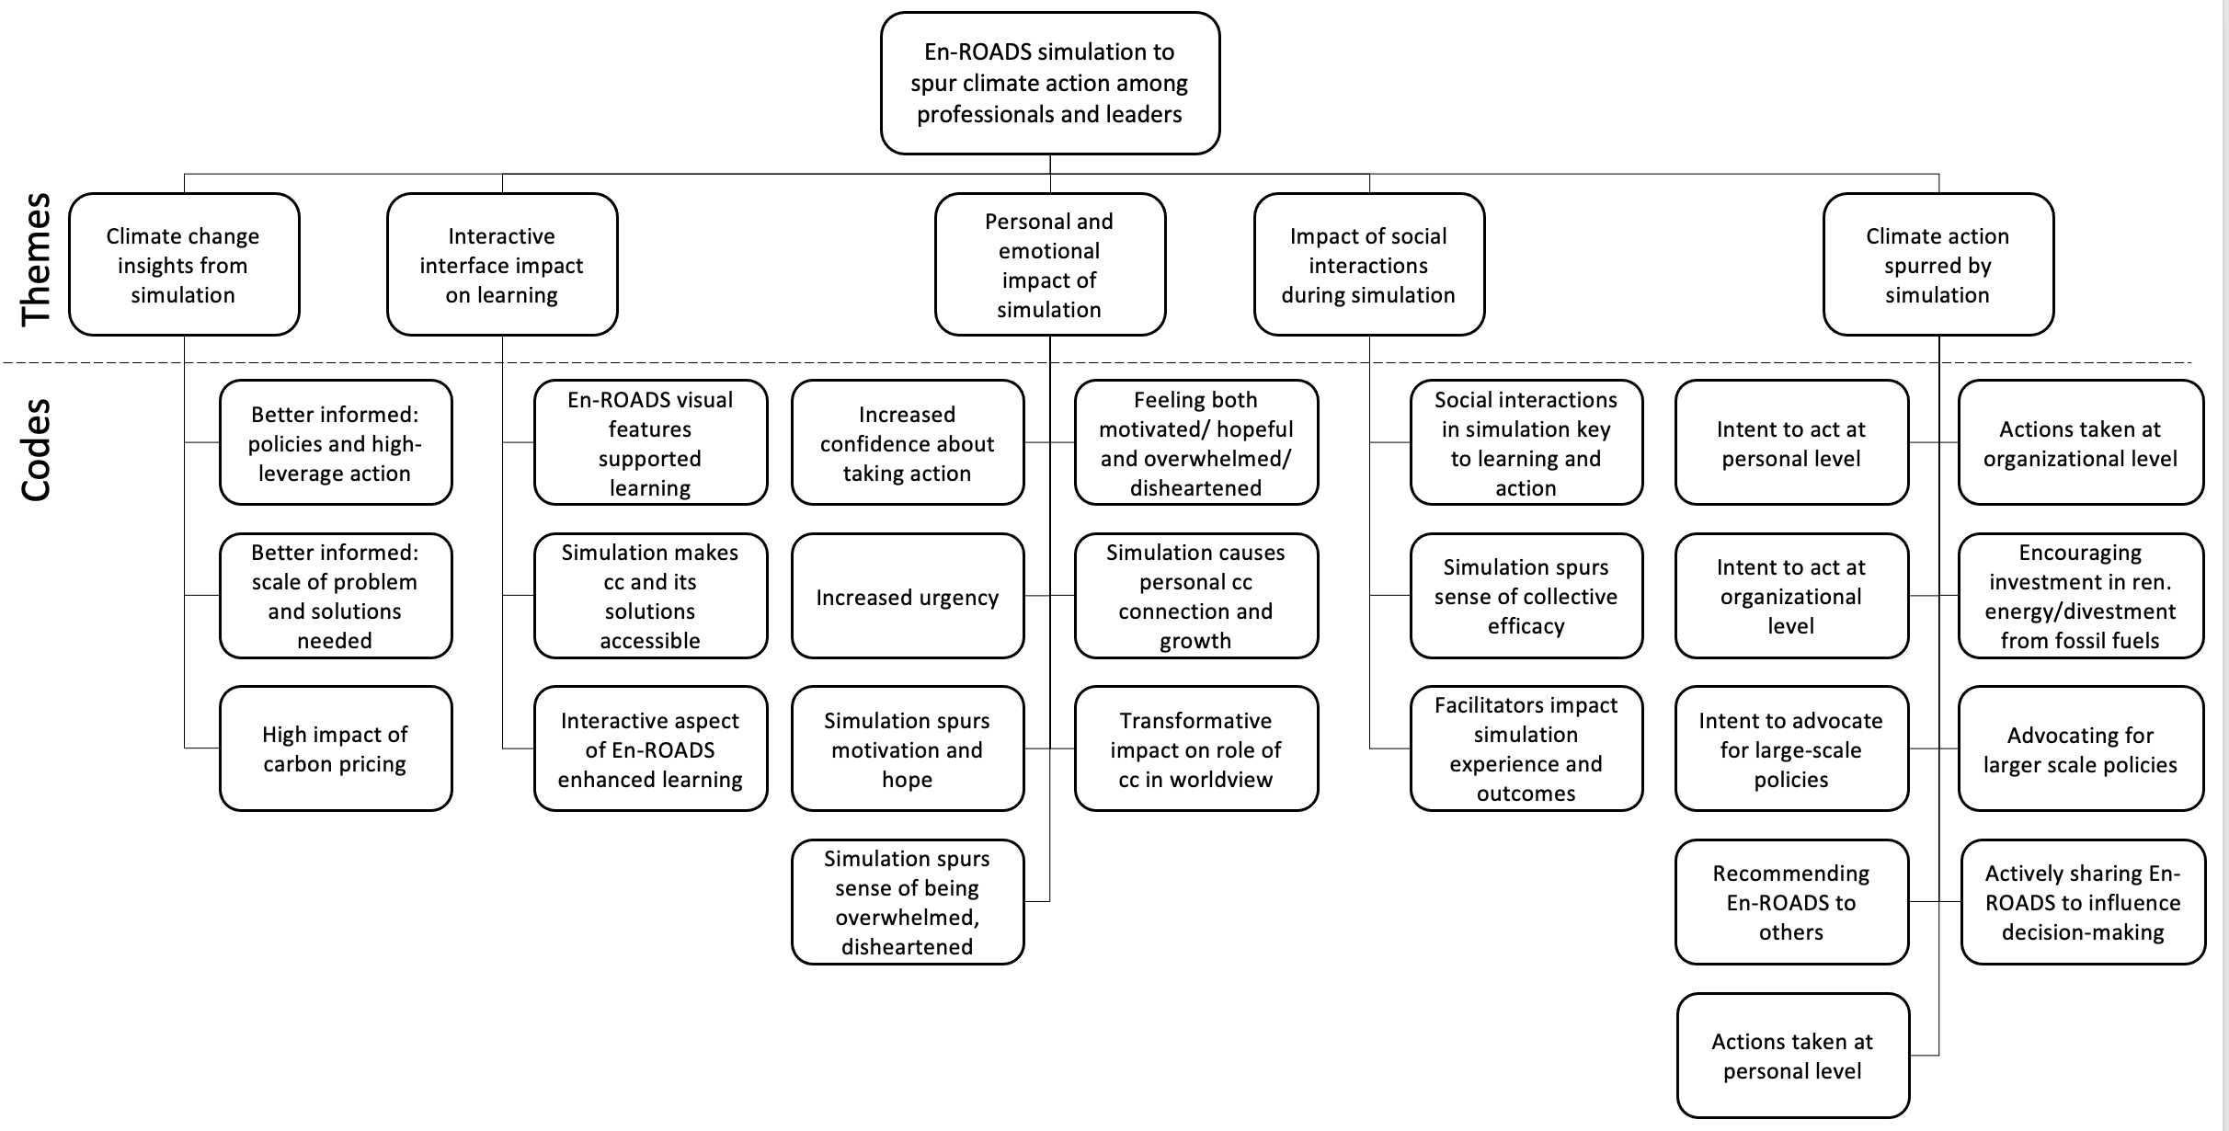

Figure S1. Coding tree with themes and codes identified through iterative qualitative analysis of interviews.

Survey instrument

Consent to participate
You are invited to participate in a voluntary research survey for the Climate Pathways Project. Your responses will be confidential. This survey should take approximately 5-10 minutes to complete. You are free to skip any questions or questions you do not want to answer and can withdraw your participation at any time. With any type of research participation, there is a risk for stress or disclosure.
We’re minimizing these risks for disclosure by not sharing identifiable information with anyone; all reporting out will be done in aggregate with no reference to individuals.
There is no benefit to you for your participation. If you have any questions or would like further information on this research please contact Juliette Rooney-Varga (Juliette_RooneyVarga@uml.edu) or Kenneth Rath (krathreer@gmail.com). For questions about your rights as a participant, concerns or complaints contact the IRB@uml.edu or at 978-934-4134. Thank you for your participation!
Please select your choice below. You may print a copy of this consent form for your records. Clicking on the “Agree” button indicates that: - You have read and understood the above information. - You voluntarily agree to participate in the research.
- Agree
- Disagree

Survey questions
- What is your name? _____________________________________
- How important is the issue of climate change to you personally?
  - Very important
  - Somewhat important
  - Not very important
  - Not at all important
- How do you feel about being able to contribute personally to address the issue of climate change?
  - Very empowered
  - Somewhat empowered
  - Not very empowered
  - Not at all empowered
- Which of the following policies do you think would be most effective in addressing climate change? (Drag and drop up to three items from the list into the box labeled 'Most effective policies.')
  - Plant trees
  - Electrify transport
  - Sequester carbon in soils
  - Improve energy efficiency of buildings
  - Improve energy efficiency of transport
  - Cut emissions of methane and other non-CO2 gases
  - Carbon capture technology
  - Put a price on carbon
  - R&D for a new zero-carbon energy supply

Semi-structured interviews questions

Informed consent
Do you agree to allowing the Climate Pathways Project research team to use the data you provide in this interview? Your information will be used exclusively for research purposes, and any identifiable information you provide will only be available to the research team. All identifications will be removed before the data are shared with anyone else. If you would like to find out more about how your information will be used and stored, please consult our Privacy Policy Statement, which can be accessed through the link provided.

Interview questions
- Tell me about how you thought about climate change in the past, what brought you to the session?
- Thinking back to your En-ROADS session, do you remember anything that surprised you about climate change or energy transition?
- How did the experience make you feel?
- How did it make you feel about climate action?
- Did you have any conversations with your colleagues about the simulation afterwards?
- Do you think other people in the simulation session had a similar experience to you? Why or why not?
- Have your thoughts changed about what actions or policies are effective for addressing climate change? If so, how?
- Did your experience with En-ROADS have any effect on what you think about your ability to make a difference?
- Is there anything that you plan to do differently because of your experience during the simulation?
- Think about your experience in the En-ROADS session compared to other ways that you might learn about climate solutions. How do you think interacting with En-ROADS and the people in your simulation session affect what you took away from the session?
- What other groups might find a workshop with En-ROADS valuable? Would you be able to reach out to them for us?

Privacy Policy Statement
The Climate Pathways Project (CPP) is a project run out of the Massachusetts Institute of Technology with several collaborating partners, including a learning research arm that is led by researchers at and associated with the University of Massachusetts Amherst. This privacy policy will explain how this research team will use the personal data that we collect from you when you use our survey.

Topics:
- What data do we collect?
- How do we collect your data?
- How will we use your data?
- How do we store your data?
- What are your data protection rights?
- How to contact us
- How to contact the appropriate authority

What data do we collect?
The data we collect depends on which survey you are being asked to take. There is a short version of the survey, which we typically use in support of shorter simulations of the En-ROADS model, and a long version, which we use with the Climate Action Simulation and typically with groups such as students. The short version collects the following:
- Your name
- Your attitudes toward climate change and climate solutions

In addition to these, the long version also collects the following:
- More detailed background information (gender, education level, socioeconomic status)
- Plans for climate action
- Opinions about the role of government in society
- Influences on your climate opinions
- Reactions to the En-ROADS model

How do we collect your data?
The only data we collect are the responses you provide to our surveys. You will be asked to take two surveys, one prior to your participation in the En-ROADS simulation and one following it. If you take the short version, the questions on the two surveys are identical. If you take the long version, detailed background information is only collected on the first survey and reactions to En-ROADS are only collected on the second.

How will we use your data?
We are collecting these data from a large number of sessions using the En-ROADS model held across the world. Ultimately, our goal is to be able to understand the impacts of the model on users, both overall and based on the characteristics of the various sessions and users. We intend to publish this research in academic and popular journals, and to make it available to potential users of En-ROADS so they can know what to expect from the simulation.

We collect names solely so that we can match responses by individual on the first and second survey; we don’t use the names for any other purpose. In truth, we don’t need names—any identifier will do, as long as it is the same across both surveys. Names are just the easiest identifier to ask for and remember. But should you prefer to use a different identifier (such as the name of a pet, a favorite movie character, or a random string of numbers), that is perfectly fine with us, as long as the identifier is used on both surveys.

Other background variables on the longer version of the survey are used so that we can see if people from different backgrounds react to the simulation differently. You are free not to answer any of these questions if they you prefer not to.

How do we store your data?
Data will be controlled by Dr. Kenneth Rath, who is one of the researchers in the team based out of the University of Massachusetts Lowell and who is based in Amherst, Massachusetts, in the United States. Data are collected through a Qualtrics account to which only Dr. Rath has accessed and then downloaded into a Dropbox account which is, again, only accessible by him. He matches the responses from the two surveys and then strips the data of names before sharing it with the rest of the research team. The de-identified data are then stored in a Google Drive folder that is accessible to the entire research team.

The Climate Pathways Project will keep your deidentified data indefinitely, as it may help us with further research projects.

What are your data protection rights?
The Climate Pathways would like to make sure you are fully aware of your data protection rights. Every participant is entitled to the following:
- The right to access – You have the right to request the project for copies of your personal survey responses. We will provide this on request.
- The right to erasure – You have the right to request that your data (some or all of your survey responses) be removed from the study.
If you make a request, we will respond to you within a month. If you choose to exercise either of these rights, please contact Dr. Rath (krathreer@gmail.com; +1 413 559 1951).

How to contact us
If you have questions about the Climate Pathways Project’s privacy policy, the data we hold on you, or you would like to exercise one of your data protection rights, please do not hesitate to contact us. The person of contact is Dr. Kenneth Rath (krathreer@gmail.com; +1 413 559 1951)

How to contact the appropriate authority
This project is under the oversight of the Internal Review Board of the University of Massachusetts, Lowell. Should you wish to report a complaint or feel that the Climate Pathways Project has not addressed your concern in a satisfactory manner, you may contact them at IRB@uml.edu or +1 978-934-4134.

