Supplementary Materials for
Repositioning of Ertiprotafib via Supramolecular Assembly Enables Biomarker-Guided Therapy for Acute Kidney Injury

Hochung Jang, Dongwon Shin, Byeongmin Park, Jae-Hyeon Lee, Youngri Ryu, Junha Lee, Eunbyeol Ko, Yoon Sook Ko, Hee Young Lee, Young Eun Choi, Se Won Oh, Sang-Kyung Jo, Sangmine Lee, Jooho Park, Kwangmeyung Kim, Sun Hwa Kim, Myung-Gyu Kim, Yoosoo Yang, Man Kyu Shim

*Correspondence to:
Man Kyu Shim (E-mail: mks@kist.re.kr), Yoosoo Yang (E-mail: yangys@skku.edu),
Myung-Gyu Kim (E-mail: gyu219@hanmail.net) and Sun Hwa Kim (E-mail: sunkim@kist.re.kr).

This file includes:
Supplementary Figures 1-12

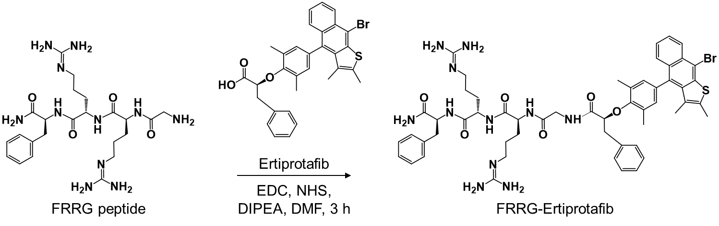
Supplementary Figure 1. Synthetic scheme of the ertiprotafib prodrug composing SENs.

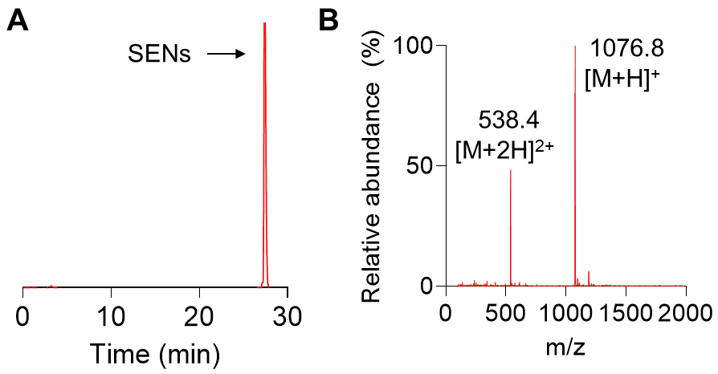
Supplementary Figure 2. (A) HPLC spectrum (purity) and (B) mass spectra (calculated for C₅₄H₆₄BrN₁₁O₆S, found: 1076.8 m/z [M+H]⁺ and 538.4 m/z [M+2H]²⁺) of ertiprotafib prodrug.

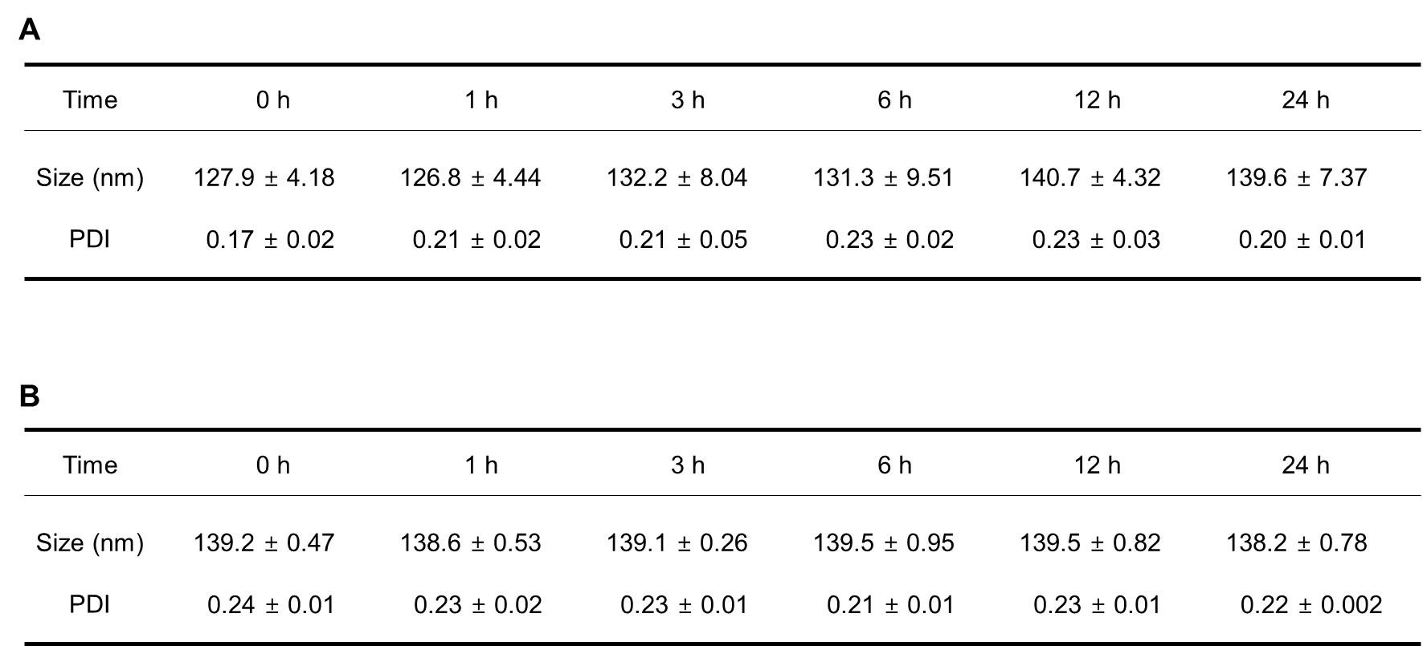
Supplementary Figure 3. Detailed information on the average size and polydispersity index (PDI) of SENs during time-dependent incubation in (A) PBS and (B) mouse serum (n=3).

Supplementary Figure 4. Classification of major intermolecular interactions observed at 300 ns of simulation time.

Supplementary Figure 5. Quantitative data of cellular uptake of SENs in HK-2 cells. MFI data are presented as mean ± SD.

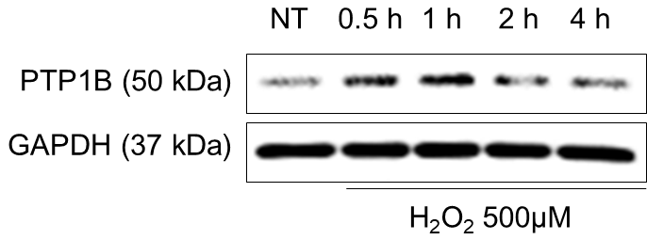
Supplementary Figure 6. PTP1B expression in HK-2 cells before and after incubation with H₂O₂.
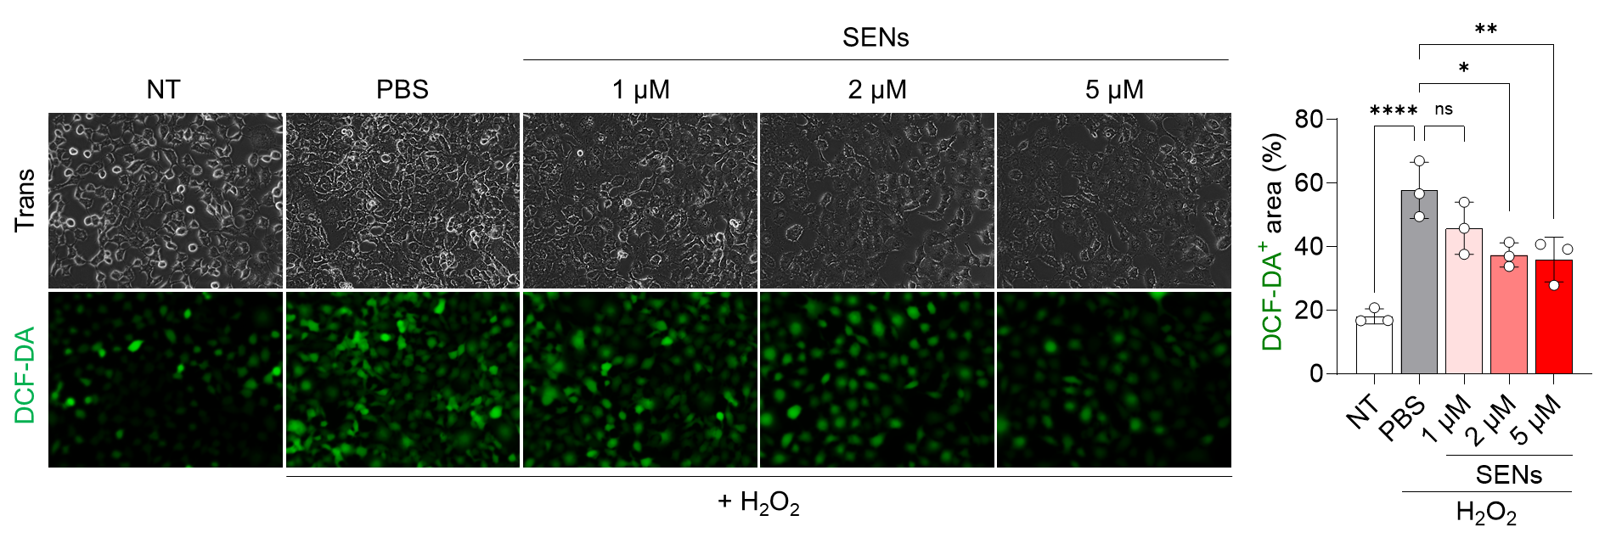
Supplementary Figure 7. Intracellular ROS in H₂O₂-treated tubular cells following incubation with varying concentrations of SENs. DCF-DA-positive areas are represented as mean ± SEM.

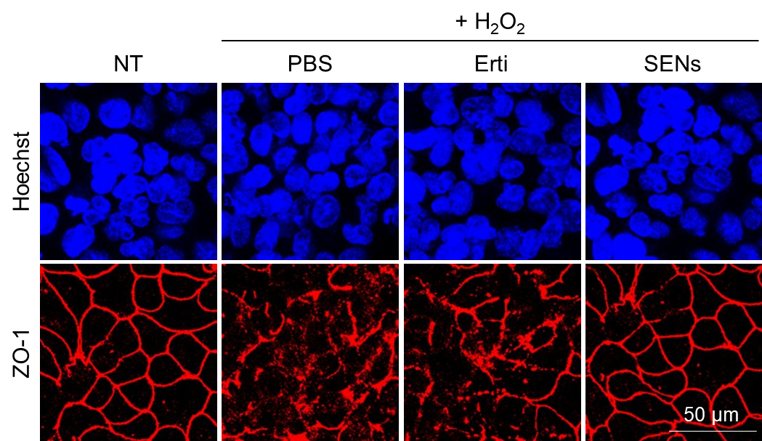
Supplementary Figure 8. Channel images of representative CLSM images showing expression of the tight junction marker ZO-1 in H₂O₂-treated tubular cells following incubation with SENs or ertiprotafib.

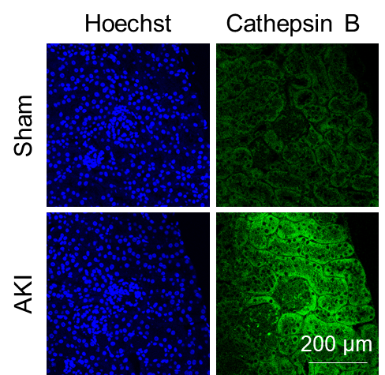
Supplementary Figure 9. Channel images of representative CLSM images showing expression of cathepsin B in renal tissues from healthy and AKI mice.

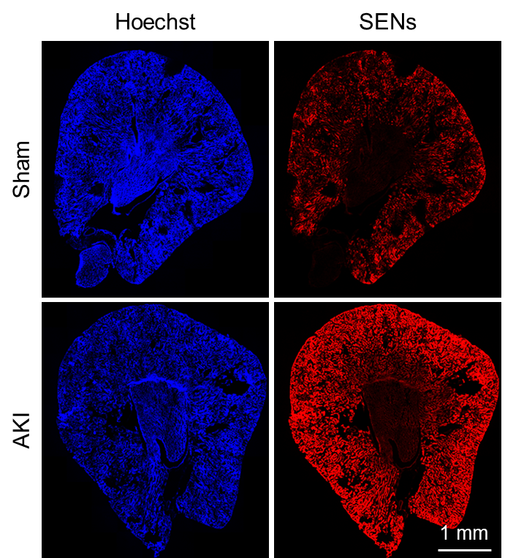
Supplementary Figure 10. Channel images of representative CLSM images showing renal tissues from healthy and AKI mice treated with SENs.

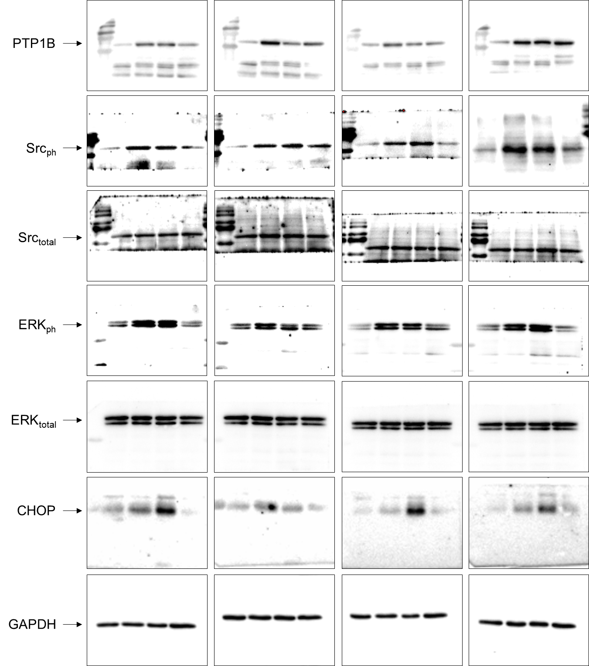
Supplementary Figure 11. Uncropped western blot data corresponding to Figure 5C.
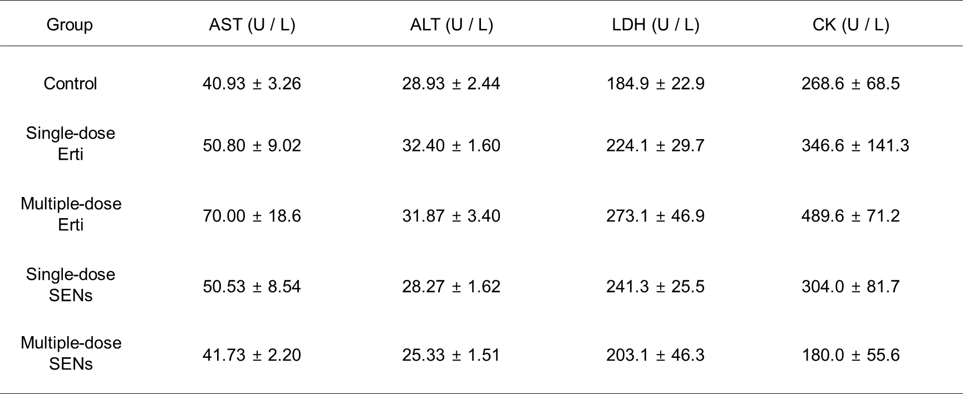
Supplementary Figure 12. Detail information on hematological parameters.

