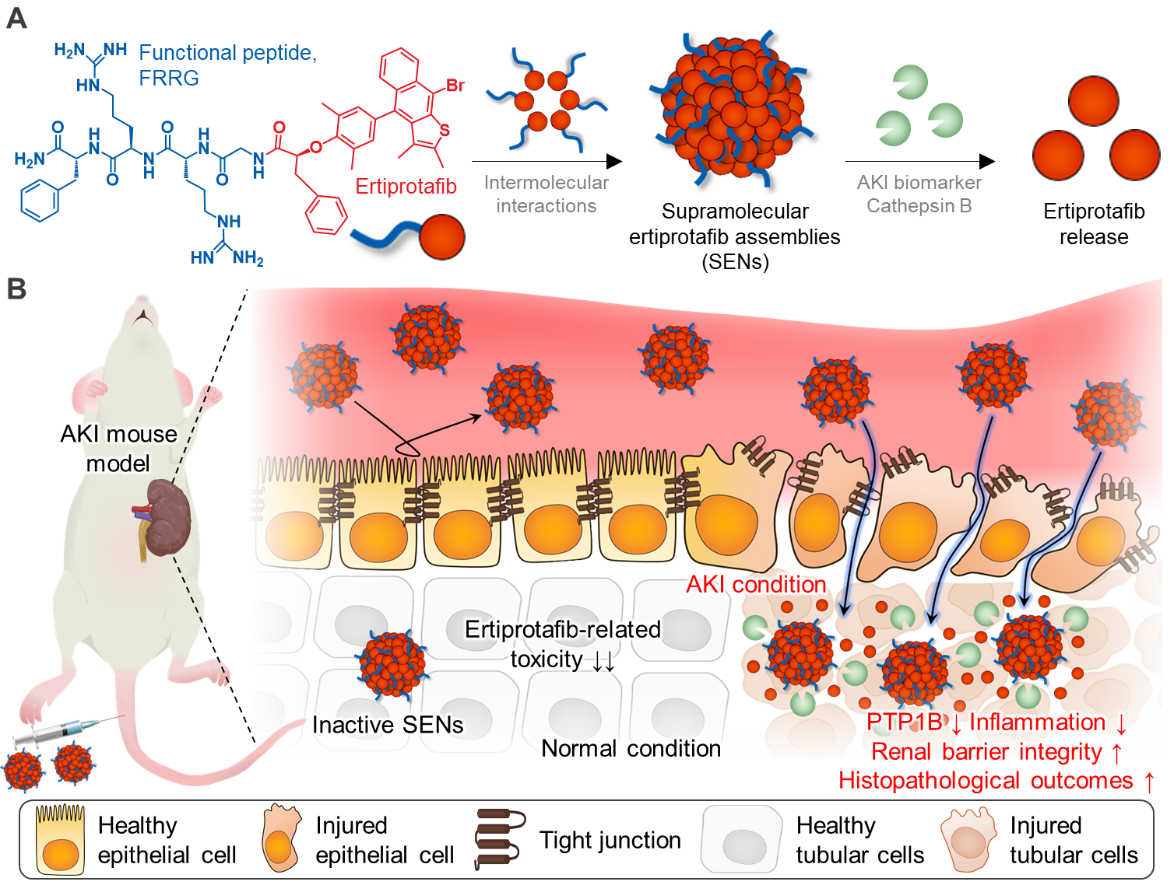
Scheme 1. Biomarker-guided acute kidney injury (AKI) treatment using supramolecular ertiprotafib assemblies (SENs). (A) Chemical structure of SENs. Conjugation of ertiprotafib with FRRG enables spontaneous self-assembly through intermolecular interactions, selectively releasing the active ingredient via cathepsin B–mediated enzymatic cleavage. (B) Mechanism of biomarker-guided AKI therapy. In an AKI mouse model, intravenously administered SENs accumulate in the inflamed kidney by penetrating the interstitium facilitated by tight junction disruption during disease onset followed by enzymatic activation by the AKI biomarker cathepsin B to precisely deliver ertiprotafib into injured tubular cells. Ultimately, ertiprotafib inhibits PTP1B-dependent Src/ERK signaling pathways, thereby significantly improving inflammatory responses, renal barrier integrity and histopathological outcomes.

