Suppl Figure 1: Internal composite at baseline, 3, 6, 9, 12 and 18 months
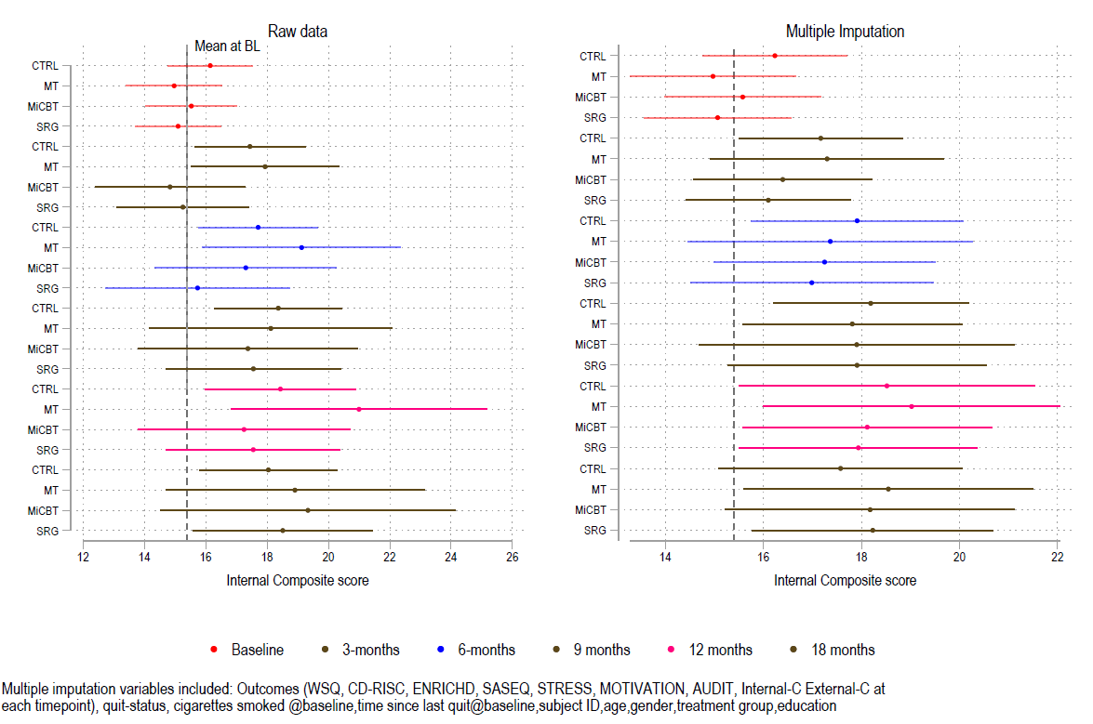
Suppl Figure 2: External composite at baseline, 3, 6, 9, 12 and 18 months
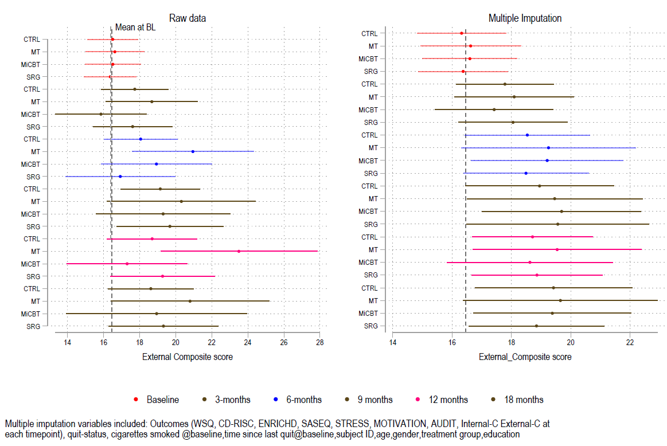
Suppl Figure 3: Equanimity at baseline, 2, 3 and 5 months
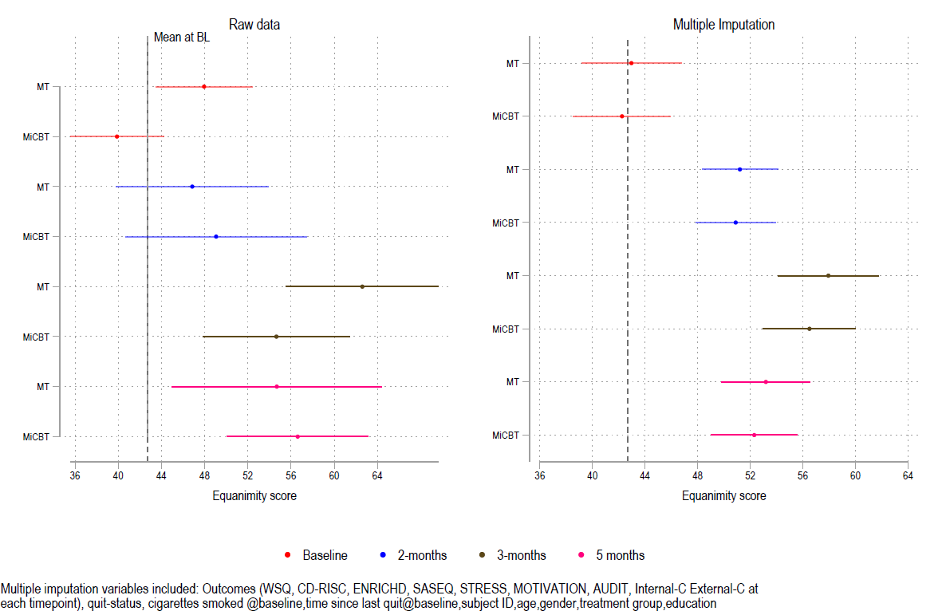
Suppl Figure 4: Motivation at baseline, 3, 6, 9, 12 and 18 months
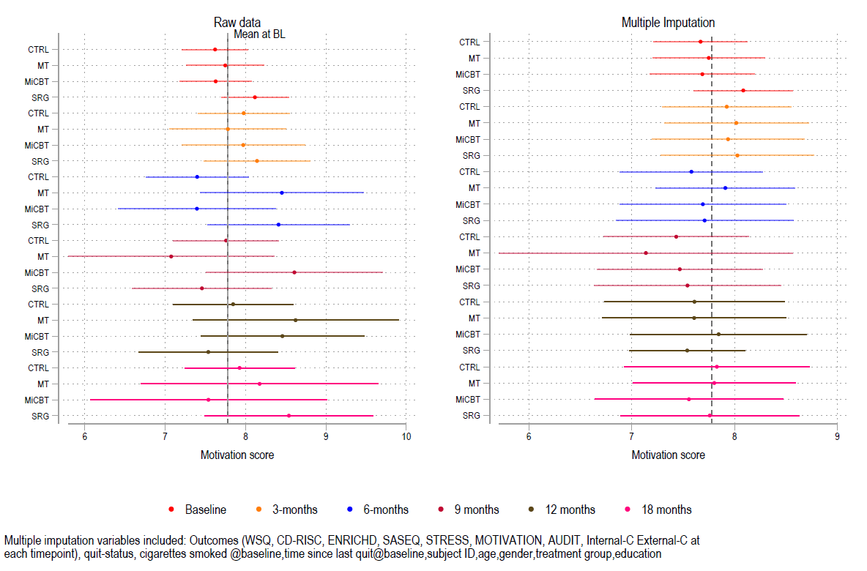

Suppl Figure 5: SEQ-12 at baseline, 3, 6, 9, 12 and 18 months
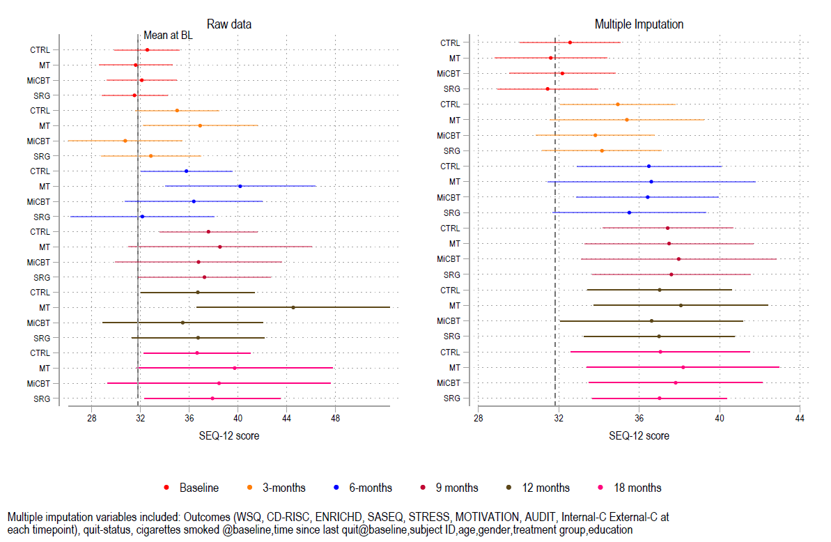
Suppl Figure 6: STRESS at baseline, 3, 6, 9, 12 and 18 months
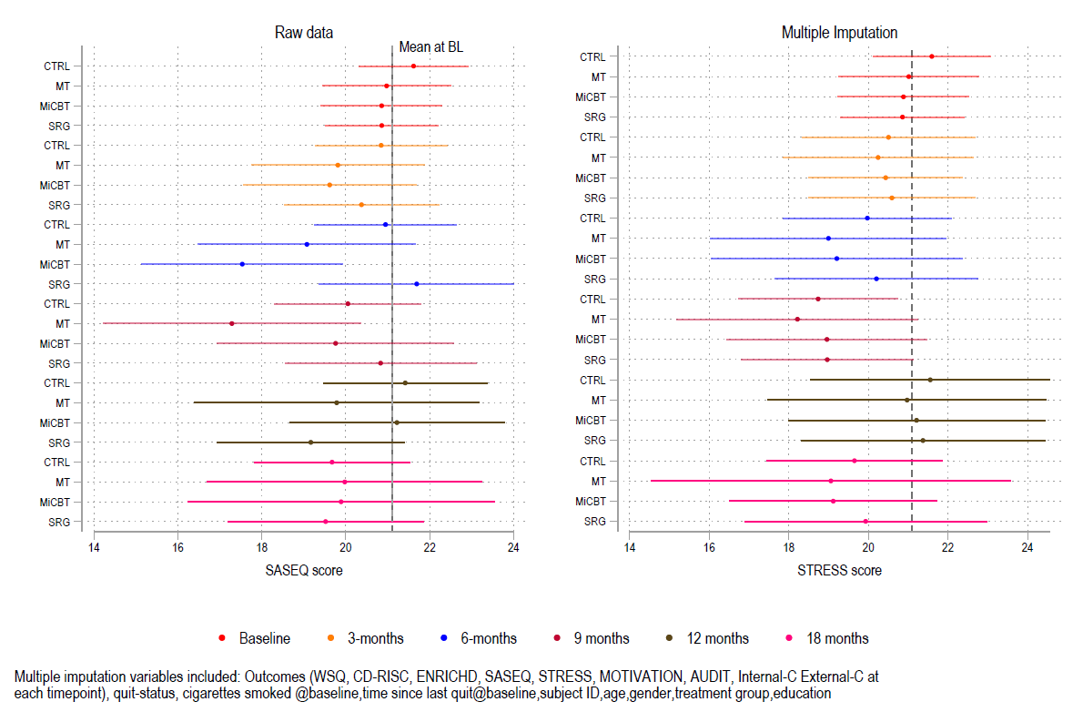

Suppl Figure 7: CD-RISC adjusted probability of smoking at 3, 6, 9, 12 and 18 months
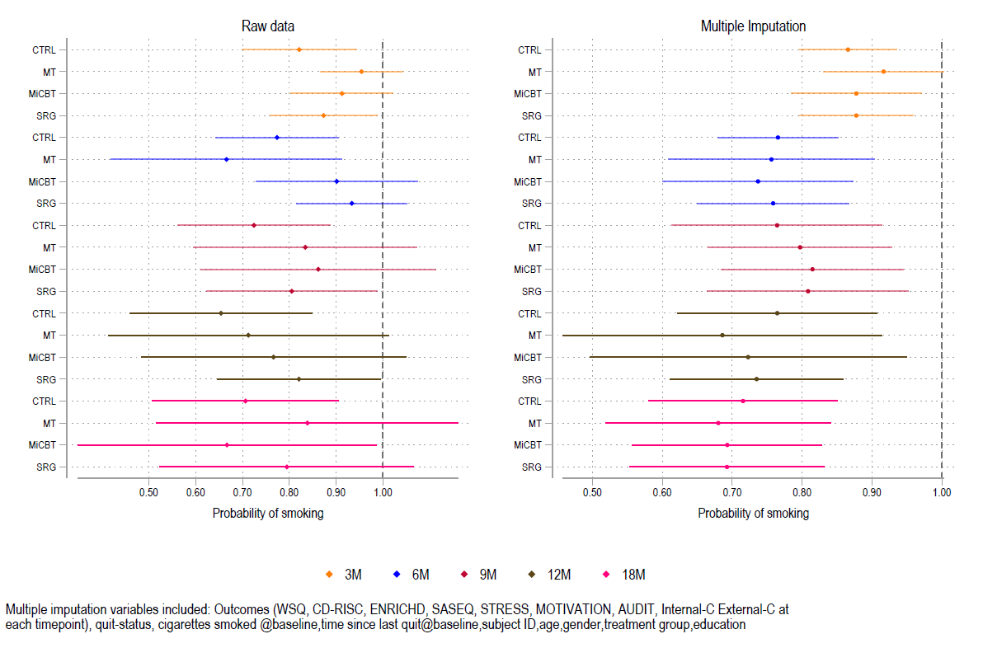
Suppl Figure 8: AUDIT at baseline, 6, 12 and 18 months
