Supplementary material

Supplementary table 1. Eligibility criteria for consumers, medical providers and genetic counsellors.
Consumers |  | Medical providers | Genetic counsellors
Inclusion | Exclusion | Inclusion | Inclusion | Exclusion
Identified themselves as a woman | Had not received their genetic test result | Clinical geneticists or oncology specialists | Associate or certified genetic counsellor | Genetic counsellors with no breast cancer genetics experience
Aged 18 years or older | Had a diagnosis of cancer recorded in the clinical genetics database | Involved in the care of women at risk of breast cancer | Located in Victoria
Have had predictive genetic testing for a known familial pathogenic variant in BRCA1, BRCA2, PALB2, ATM, or CHEK2 in the previous five years | Had a known cognitive disorder | Were fluent in written and spoken English | Were fluent in written and spoken English
Had an email address recorded | Opted out of receiving invitations to research
Were fluent in written and spoken English

Supplementary table 2. Pairwise comparison between groups for items where significant differences were observed.
 | A v B | A v C | A v D | B v C | B v D | C v D
4. Simple | 1.000 | <0.001* | 0.014* | <0.001* | 0.157 | 0.310
5. Effortful | 1.000 | <0.001* | 0.398 | <0.001* | 0.483 | 0.038*
6. Inform risk | 1.000 | 0.233 | 1.000 | 0.047* | 1.000 | 0.179
8. Important | 1.000 | 0.995 | 0.841 | 0.051 | 1.000 | 0.014*
10. Understand | 0.691 | 0.218 | 1.000 | 0.001* | 0.031* | 1.000
12. Can explain | 0.710 | 0.034* | 1.000 | <0.001* | 0.697 | 0.017*
13. Need more time | 0.636 | 0.167 | 1.000 | <0.001* | 0.229 | 0.306
14. Need explanation | 0.045* | 1.000 | 0.551 | 0.001* | <0.001* | 1.000
15. Confident | 0.765 | 0.140 | 0.551 | 0.001* | 1.000 | 0.025*
16. Not confident | 1.000 | 0.217 | 1.000 | 0.016* | 1.000 | 0.204
*Significant difference

Table 3. Medical practitioners perspectives about polygenic breast cancer risk visual tools with illustrative quotes
Theme 1: Tailoring the complexity of reports for patients and clinicians
Clinicians and patients should be provided with different risk reports | “I guess different people have different ways of understanding things so it might be useful to have a few different options so if one doesn’t make sense to them another there’s [another] that does.” (MP01)
 | “You can’t show maths or statistics to a patient on the street. You’ve gotta give them pictures. And then if it’s too dumbed down you won’t confer any information to the clinicians. So clinicians won’t respond to the same stuff that patients might respond to.” (MP02)
Clinicians and patients should be provided the same risk reports | “Ideally, we should try and align [the reports], because if patients have a report and they go to a doctor [who has] a different report then they might interpret it slightly differently and it might just increase confusion.” (MP06)
The utility of visual tools for patients compared to clinicians | “People are familiar with [Figure 1] and therefore find it easier to understand. It’s almost a little bit too simple though, I think in that it’s just sort of about the lifetime risk and I feel like it’s, yeah, it’s lacking the sort of age-related risk I think.” (MP11)
 | “I don’t find it [Figure 1] helpful to my interpretation. I think 12 out of 100 out of 55 out of 100 speaks volumes to me and I don’t need a square of 100 stick figures to round that home.” (MP10)
 | “Because [Figure 4 is] an unfamiliar way of presenting data... I would just worry that people would come away and be a bit overwhelmed and not understanding what it means.” (MP11)
Theme 2: Comparing a patient’s risk to other risk groups
Comparing a patients’ breast cancer risk to a BRCA pathogenic variant is useful | “That comparator of having BRCA nearby, you know, people have heard of it and think ‘wow look I’m, that’s quite a significant risk’. And maybe that will, you know, maybe they will have heard of that and think okay that’s… maybe I need to have something done about it.” (MP03)
Comparing a patients’ risk to the average population risk is useful | “If I was the patient and you were telling me I was the purple line and I’m looking at this I’d think, ‘Jesus, I’m a long way away from the general population.” (MP07)
Theme 3: Comparing absolute risk v. relative risk
Absolute risk is simpler and more meaningful | “(Absolute risk is) much easier to understand, much more meaningful than a relative risk for which you don’t really have a firm idea of baseline. So I don’t really like relative risks for describing risks, for the purposes of informing patients.” (MP09)
 | “If we go back to [Figure 3] and I tell someone your relative risk of BC is 10, what does that actually mean? Am I going to get BC or not? Whereas if we go back to the previous risk figure [Figure 2] and I say your risk is 72%, that means that by the time you reach 80 years old the chance that you would have developed BC in that it is 72%. That’s meaningful to patients.” (MP10)
Theme 4: Illustrating a patient’s risk over time
Providing risk over time is more useful that absolute lifetime risk alone | “Unless there’s context to that figure 1 [pictogram]… they may perceive it as everyday they’re at a one in two chance of getting cancer. Where we know its cumulative, the risk increases with age, which figure 2 shows.” (MP05)
Age-based tools may help patients consider the timing of prophylactic surgery | “[Figure 2] is useful for me as a clinician to be able to put things into perspective so I can say to a woman who’s 35 that that at the moment even with this increased PR right now your risk of cancer over the next few years is still fairly low, but you can see for example by the age of 40 your risk is so going to be quite different, it’s going to be about 10% as opposed to the population risk which is about 3% or something like that. And that might be an age where you might consider mastectomy because by that stage you’ve completed your family, or hopefully completed the family.” (MP10)
 | “If you’re seeing a 60-year-old woman and her absolute risk is 40% and her residual risk is 8%, you know that’s useful information. So if we have that information I think that’s very useful, women want to know that kind of stuff and it’s helpful for them to make a decision about surgery.” (MP01)
Theme 5: Visualising tool preferences
Bell curve is too complex for patients | “I think the bell curve is just too sophisticated to be explaining to most lay people, I don’t think it’s that helpful.” (MP11)

Table 4. Consumers’ perspectives about polygenic breast cancer risk visual tools with illustrative quotes
Theme 1: Attitudes about polygenic testing for breast cancer risk
Women wanted to know their own PRS for breast cancer | “I’m someone who thinks more information is always better” (C01)
Women wanted to know their own PRS for breast cancer | “I’ve had a diagnosis so give me all the information please” (C02)
Women wanted to know their own PRS for breast cancer | “I would probably pay more attention to it [polygenic information] cause its more specific for me” (C03)
PRS would be empowering for decision-making | “It’s helpful to know a bit more about what your risk is… it helps you then make what is the right decision” (C04)
PRS would be empowering for decision-making | “Recommendations in terms of preventative stuff. So obviously for BRCA1, like hysterectomy or mastectomy” (C02)
Theme 2: Visual tool preference
Icon array and lifetime cumulative risk graphs were the simplest to understand | “The first one… it’s like just very easy to interpret, I guess, but I like that the second one actually has the age as well” (C03)
 | “Makes you want to keep on top of it and you know, be aware of it that as you’re getting older, these things can change” (C05)
Bell curve was the hardest to understand | “I had no idea how to look at this one... I found the third one especially confusing” (C01)
Bell curve was the hardest to understand | “The third one is horrendous, uh for, you know, you’re probably dealing with average people who you know don’t understand it” (C06)
The bell curve and sliding scale require an explanation to understand | “Three and four. I don’t look at those and instantly know what I’m looking at… when you walk me through them, I can understand… but I think one and two, I could look at without someone um, kind of, giving me context, and take away information” (C03)
Theme 3: Opinions about breast cancer PRS communication
Written information is an adjunct to verbal counselling | “It needs to be both [verbal and written]. I think doing just one or the other is, um, is going to leave a gap” (C07)
Written information is an adjunct to verbal counselling | “Definitely followed up with some form of specific email or information because it's very overwhelming in these conversations [during genetics appointments] and it's hard to get your head around” (C02)
Written information is an adjunct to verbal counselling | “I would definitely not recommend giving people their results and skipping like in person verbal counselling.” (C01)
Written information is an adjunct to verbal counselling | “Having a supportive atmosphere and a chance to process and ask questions [is good] … and a letter with all that information in it, so you can review it later” (C03)
Patients appreciate speaking to a genetics health professional before and after testing | “I liked that I could go there and the person I was speaking to was very familiar and knew everything they were talking about.” (C01)
 | “There’s a level of comfort [at genetic services]. The um knowledge and experience” (C06)
GPs play a role in testing, either through testing or follow up | “In an ideal world, if you could go to your GP and talk to them, but I, I realise that not every GP has the capacity or the expertise” (C07)
 | “So maybe people would want to have that conversation with their GP… because I had to come to [capital city], it didn’t bother me, but yeah, maybe it being available through GPs could be a good thing for people who wouldn’t want to go through all the trouble” (C06)

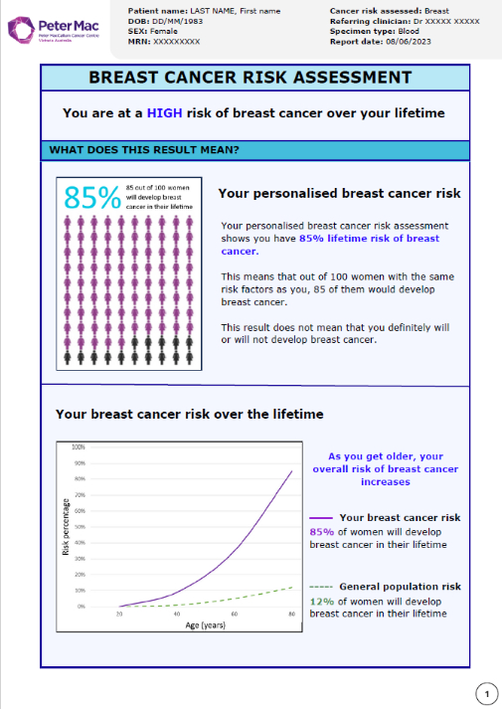
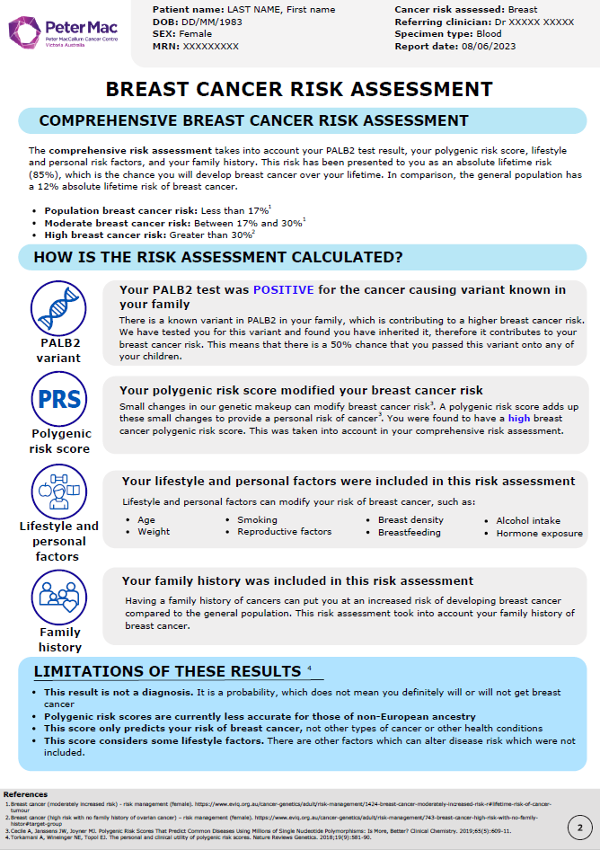
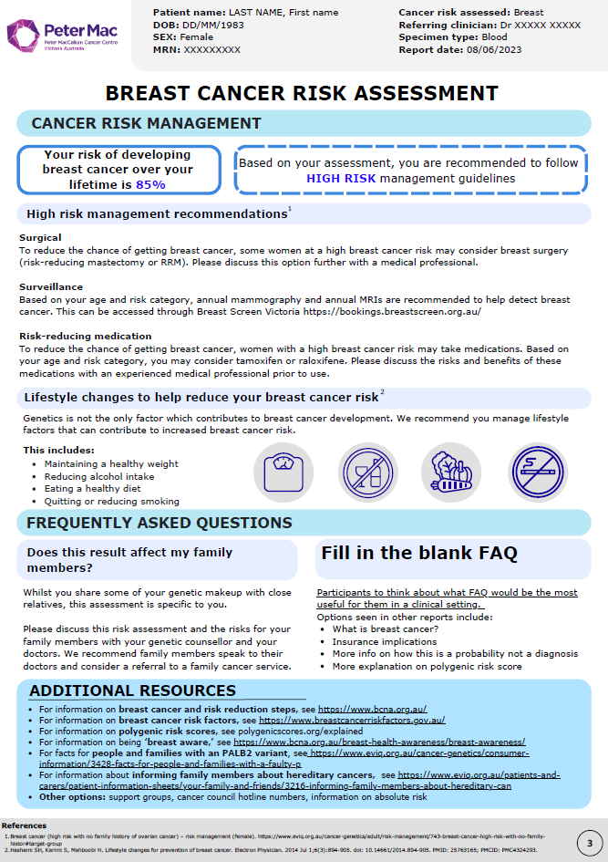
Supplementary figure 1. High risk comprehensive risk report prototype.

Table 5. Genetic counsellors’ feedback regarding the content, layout and visual tools in a comprehensive breast cancer risk report prototype with illustrative quotes
Category 1: Visual tools
Visual tools are helpful to communicate risk | "I think visuals help to contextualize a lot of what we’re talking about. Especially if they’re given this report after the appointment to look at. Because you know in the appointment, if you’re giving someone a bad news result … they might just hear ‘positive’ [single gene test result] and zone out of everything. But having kind of something tangible in multiple forms of communication can be helpful for understanding." (GC04)
Visual tools are helpful to communicate risk | “When I trained, we used to have little plastic pocketbooks that we took in and showed pictures, and I kind of miss those days. People understand pictures. Words can be a little bit lost in translation sometimes, particularly when in genetics we're speaking a different language." (GC10)
Lifetime cumulative risk visual is helpful to display risk over time | “I’d normally use this sort of thing in reference to like screening, so like we’re not thinking that you need to have screening when you’re 15 because your risk is then the same as a woman in the general population. When the risk starts to deviate, that’s when we start putting in place screening or risk management interventions." (GC01)
Visual tools may be confronting for patients | “I think like these images can be really valuable for some people, but I found before when I show them to people, they’ve had the opposite effect when I’ve thought they’re going to be reassuring, they actually terrify people." (GC01)
Visual tools may be confronting for patients | “I think it might be alarming to see it like that, but I think it shows them that they do need to be proactive and take the right measures. It also shows them that there are women that still don't develop breast cancer, even when their risk is high." (GC08)
Age-related information should be added to the lifetime cumulative graph | “I think the really key piece of information that’s missing is what is the risk from their age until 80. So, what’s their remaining lifetime risk? And then I think sometimes it can be helpful to have 5- and 10-year risks if someone’s wanting to make a decision about mastectomy.” (GC02)
Category 2: Content
Caveats should be included which recognise that risk changes over time | “Given the evolving nature of genetic risk and ... cancer risk management, ... I think some sort of disclaimer about that for people … where they're not recommended to engage in risk management immediately, could be helpful.” (GC09)
Lifestyle and personal factors and family history should be individualised | “I really do think if we’re going to use this as an individualised report, we do need to individualise it, thinking about the lifestyle factors and family history. I think that that data has to be inputted into there so that people understand what’s been factored in." (GC06)
 | “I mean you've said we've taken into your account your family history and what did that do? … Like if it said because you have no relatives with breast cancer, this lowered your risk or because you have multiple relatives with breast cancer, this increases your risk. Because I think people almost want that acknowledgement." (GC07)
The report should incorporate actionable information to guide cancer risk management | “Just … kind of empowering them to make that decision when they get to that point, instead of saying I know I need to get a mammogram now, but I don’t know where or how to do that or even who to start that off with. People can get petrified just from making that first step so … not having to make that decision can be a good start stepping stone." (GC04)
Additional resources should be included to guide positive lifestyle changes | “I’d probably also include a reference … like to the Cancer Council Vic … Sometimes when we’re talking to people about eating a healthy diet, they may not have an idea about what a healthy diet is.” (GC06)
Familial implications of the result need to be clearer | “While the combined risk assessment is specific to this person, there’s really important like monogenic [single gene] implications with these results. And I think that’s always been a worry with the combined risk assessment is the emphasis not being on the single gene part anymore and therefore what will patients take away and how does it sort of filter down to the family?” (GC02)
Category 3: Layout
The exclusion of red was appreciated | “I think red just comes off as a very alarming colour, and we want to keep people calm." (GC08)
There were mixed preferences regarding the report length | "It's too long, I think like three pages, it's too many pages … I would feel really sad giving a patient three pages. Because it would just feel like a bit overwhelming. For me and for them." (GC07)
There were mixed preferences regarding the report length | "Psychologically, I don't think... there's a big difference between a three-page or a four-page report. And so, I think it is just about prioritising the important stuff at the beginning knowing that people peter off at the end.” (GC09)
The order of content on pages 1 and 2 could be changed | “I guess what you’ve considered page one, I had to flip over to page 2 to see that the BRCA2 test was negative because I guess, without that knowledge it’s not helpful at all. So that for me I would want to see that first up.” (GC05)
The order of content on pages 1 and 2 could be changed | “I do personally [want the risk statement first], but I can understand that some people may feel that it could sound quite ... threatening, is the word that's coming up for me. Like it could sound harsh, but I feel like sometimes it can, these things can be softened too much that we lose the meaning.” (GC09)

Table 6. Genetic counsellors’ perspectives on how they would use the comprehensive breast cancer risk report with illustrative quotes
Theme 1: Report as a resource within clinic
Selectively choosing content to use within an appointment | “I would literally show the patient the graph in the appointment and talk them through with that graph because I think that it’s really helpful.” (GC05)
Selectively choosing content to use within an appointment | “I think it would come in handy in two different places. So, showing them how the risk was calculated and what the PRS is and those sort of things and then also for the risk management side of things.” (GC01)
A future resource to reference what was communicated to the patient | “I think it's a good summary like when we go back and families contact us again to go back and go, oh, this is what we told them at the time.” (GC10)
 | “Quick and easy way for professionals to get that information.” (GC10)
The report could help save time | “We spend a lot of time explaining this and then trying to write it into letters ... and I just think words can only go so far. I think also we're in a time poor era right now where we're providing complex information in a place where we're not afforded a lot of time to do that.” (GC10)
Theme 2: Report provided as a patient resource after clinic
Patients could refer to report after their appointment | “Often people don't remember much of the conversation because they're like completely overwhelmed. You know, when you are feeling emotional, your brain doesn't quite work as it should.” (GC07)
Patients could refer to report after their appointment | “At the moment … you're directing people to a lot of different resources for different parts of it [the cancer risk assessment]. And so, I think for a combined polygenic risk score to be meaningful, to have that kind of combined summary, I think is really useful for both the clinician and the patient.” (GC09)
The report could be a future resource for patients | “I guess one thing that can happen with these reports is that people take them and provide them to their family members… Some people might put this away and then pull it out many years later to show their children.” (GC09)
The report could be a future resource for patients | “If this is an 18, 20-year-old and we’re giving them this information and then potentially if they’re family planning in the future, where would they need to go? Who would they need to contact?” (GC06)
The report is an adjunct resource to counselling | “It’s how the counsellor, the health professional, helps the person understand it. I think that's the important factor that goes along with this. If it was just being sent out with no discussion, maybe there’d have to be some sort of, I don’t know, preamble, but these aren’t often just given for no reason like without that discussion first.” (GC10)
Theme 3: The use of the report is contextualised by patient and setting
Patients have different preferences and engagement with risk information | “Some people want to know the time and some people want to know how the … clock works.” (GC02)
 | “It’s very person dependent as to what will resonate.” (GC05)
 | “People don’t have to engage so much if they don’t want to, because that first page has the kind of what this means for you in terms of your risk.” (GC01)
Online appointments influence the way the report would be utilised | “I think it’s still feasible. I think if there was a patient particularly where I wanted to show parts of the report to, like I have done that before through Telehealth because there’s sort of screen sharing capabilities.” (GC03)
 | “I mean if it was on Telehealth, it would be an absolute no because what am I doing? Like just putting it up next to my face and pointing at it. Like I don't think that would go super well. I'm not savvy enough to share my screen on Telehealth.” (GC07)
 | “It's definitely more challenging to do so, but not impossible … It probably would mean that I'd use it physically with a smaller group of patients, but you can do so by just sharing via Zoom and I've done that a handful of times. Otherwise, it's just describing in a lot of detail that I will send you a summary and this is what it will have on it.” (GC09)

