Supplementary information

Forest and Prescribed Fire Impacts on Mercury Cycling and Exposure: A Global Bibliometric Analysis, Scientific Response-Lag Evaluation and Focused Review
Yener Ulus¹, Elif Yıldırım², Martin Tsz-Ki Tsui^{3,4,5}, Tyler Cameron Webber¹, Habibullah Uzun⁶
¹Biology and Environmental Science Department, College of Sciences, Auburn University at Montgomery, Montgomery, AL, United States
²Department of Statistics and Quality Coordinator, Konya Technical University, Konya 42250., Turkey
³School of Life Sciences, The Chinese University of Hong Kong, Hong Kong SAR, China
⁴State Key Laboratory of Marine Environmental Health, City University of Hong Kong, Kowloon Tong, Kowloon, Hong Kong SAR, China
⁵Department of Earth and Environmental Sciences, Institute of Environment, Energy and Sustainability, The Chinese University of Hong Kong, Hong Kong SAR, China
⁶Department of Environmental Engineering, Istanbul Technical University, Istanbul, Türkiye

Correspondence to: Elif Yildirim (edil@ktun.edu.tr)

Table S1. PICOS criteria
PICOS | Description
Population | All published academic studies on the Hg pollution and exposure in various ecosystems related to wildfire and controlled fires. All studies on environmental pollution in different ecosystems after wildfires, the effects of Hg on human health, and policies related to the subject.
Intervention | Studies that theoretically address the issue of fire impact on Hg cycling. Examining studies on the effects of this pollution on human health, the environment, and ecosystems, and the measures/policies taken in this regard.
Comparator | A comparison of the levels of productivity and collaboration levels of studies in the field of research across years, authors, institutions, countries and thematic trends.
Outcomes | The analysis and visualization of the development trends, citation levels, keyword patterns, collaboration networks, trend topics, and scientific structures of the literature on wildfire-driven on Hg.
Study designs | Articles related to the subject, published in English and indexed in the WoS database, only in the “Research Article” and “Early Access” categories.

Table S2. Characteristics of the data set used for bibliometric analysis
Description | Results
Main Information About Data
Timespan | 1999:2025
Sources (Journals, Books, etc) | 43
Documents | 94
Annual Growth Rate % | 7.13
Document Average Age | 9.74
Average citations per doc | 31.66
References | 4145
Document Contents
Keywords Plus (ID) | 378
Author's Keywords (DE) | 253
Authors
Authors | 526
Authors of single-authored docs | 0
Authors Collaboratıon
Single-authored docs | 0
Co-Authors per Doc | 6.32
International co-authorships % | 32.63
Document Types
article | 94
article; early access | 1

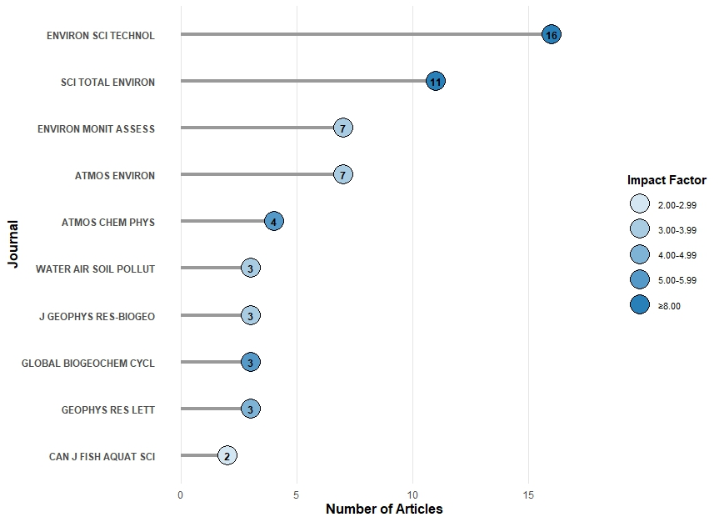

Figure S1. Top 10 most relevant sources

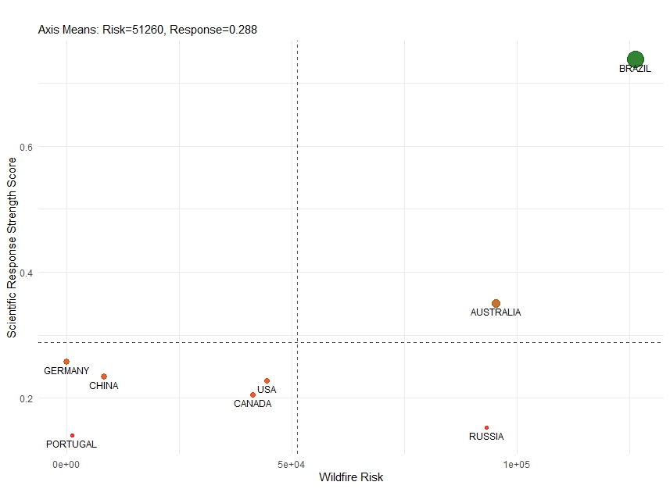
Figure S2. Scientific response matrix

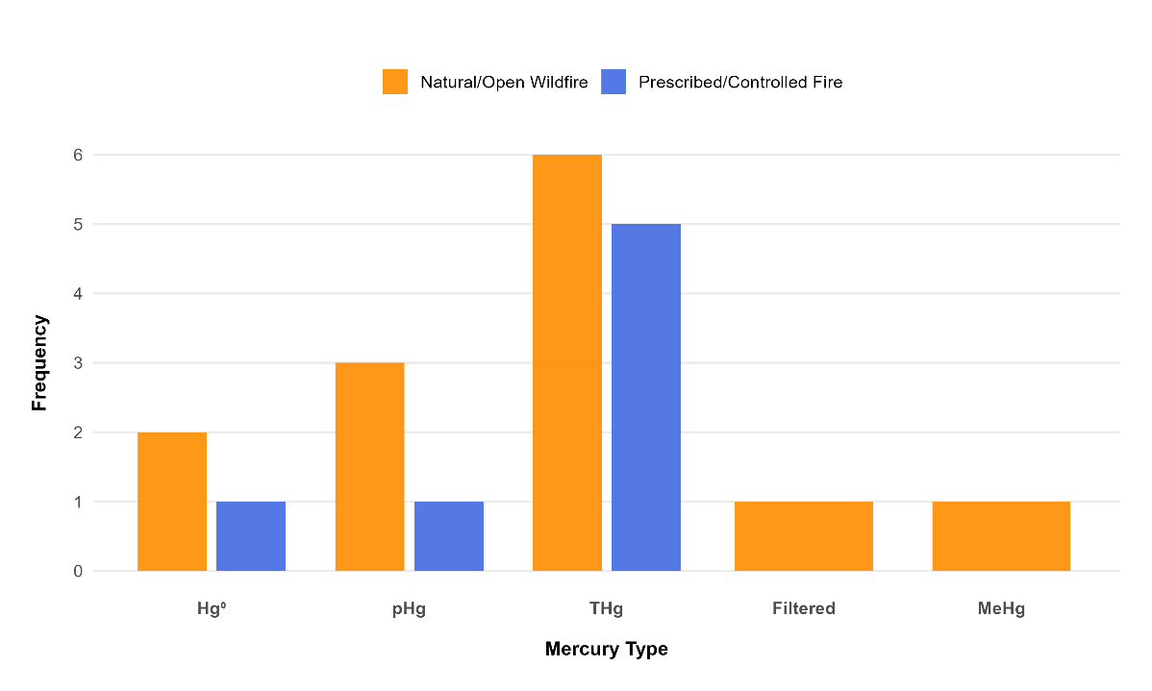
Figure S3. Hg Types by Fire Type

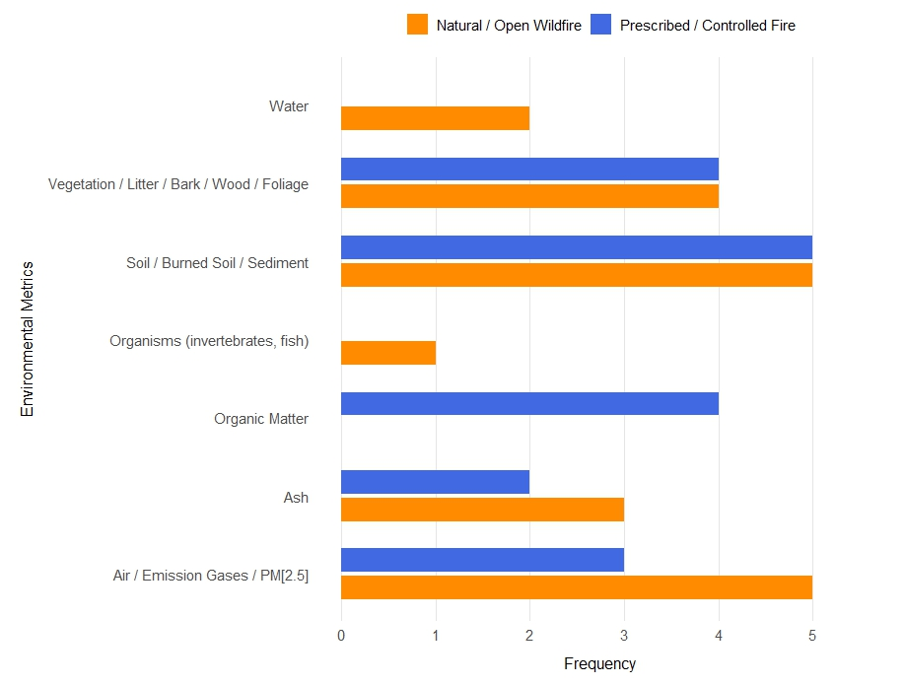
Figure S4. Environmental Metrics by Fire Type

Article | Objectives of the Study | Study Region (Country)
Friedli et al., 2003 | To measure Hg emissions from biomass burning using laboratory and airborne methods and estimate their contribution to atmospheric Hg. | United States and Canada — laboratory burns in Missoula, Montana, and wildfire measurements near Hearst, Ontario.
Kelly et al., 2006 | To determine how forest fire affects Hg accumulation in fishes through food web changes and increased Hg inputs. | Canada — Moab Lake, Jasper National Park, Alberta.
Sigler et al., 2003 | To measure Hg emissions from a large-scale Canadian boreal forest fire and evaluate their long-range atmospheric transport. | Canada — Northern Quebec boreal forest, with plume transport observed over the northeastern United States.
Zhang et al., 2013 | To characterize PM₂.₅ emissions and chemical tracers, including particulate Hg, from various biomass burning types to distinguish emission sources. | United States — Lake Tahoe Basin, California–Nevada region.
Friedli et al., 2001 | To quantify Hg emissions from burning vegetation and litter and assess their contribution to the atmospheric Hg budget. | United States — Vegetation samples collected from seven locations across MT, ID, CA, CT, SC, WA, and FL.
Turetsky et al., 2006 | To quantify Hg stocks in boreal soils and assess how wildfires and climate-driven drought increase Hg emissions to the atmosphere. | Western Canada — Boreal forests and peatlands across Alberta, Saskatchewan, Manitoba, and the Northwest Territories.
Table S3. Review of the 10 Most-Cited Wildfire Articles and Key Studies on Prescribed Burning

Table S3 - Continued
Article | Objectives of the Study | Study Region (Country)
Biswas et al., 2007 | To quantify Hg release from Rocky Mountain forest fires of varying severity and determine its dependence on vegetation type and soil organic matter. | United States — Northwestern Wyoming (Boulder Creek, Green Knoll, and East Table wildfire sites).
Burton et al., 2016 | To evaluate how the 2009 Station Fire in California affected trace element (including Hg) concentrations in streams and stormflow. | United States — Angeles National Forest, San Gabriel Mountains, Southern California.
Huang et al., 2011 | To develop a high-resolution inventory of Hg emissions from biomass burning in China using China-specific emission factors. | China — Covering mainland provinces, excluding small South China Sea islands.
Friedli et al., 2003 | To measure Hg emissions from August 2001 wildfires in Washington and an agricultural waste fire in Oregon, estimating their atmospheric contribution. | United States — Washington State (Cascade Mountains) and northeastern Oregon.
Melendez-Perez et al., 2014 | To quantify Hg emissions from soil and biomass during a prescribed fire in the Amazonian rainforest and compare these values to previous emission estimates from another Amazonian site (Alta Floresta). The study aimed to identify the main Hg sources (biomass vs. soil), estimate emission factors, and evaluate the relationship between soil temperature and Hg release. | Rio Branco, Acre State, southwestern Amazonia, Brazil.

