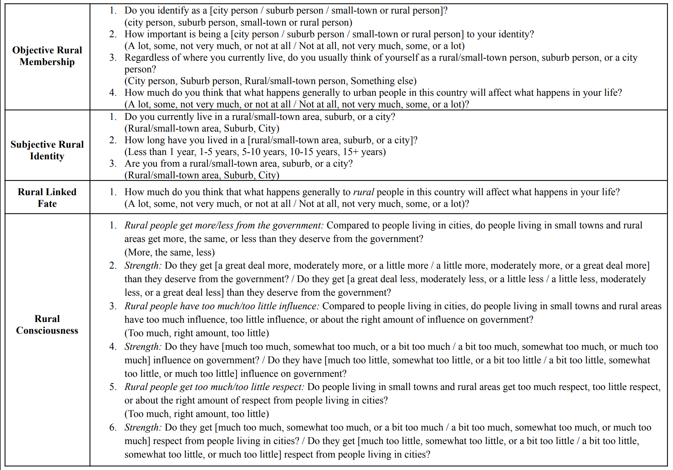
Table A1: Operationalization of independent variables from the first data collection
Appendix
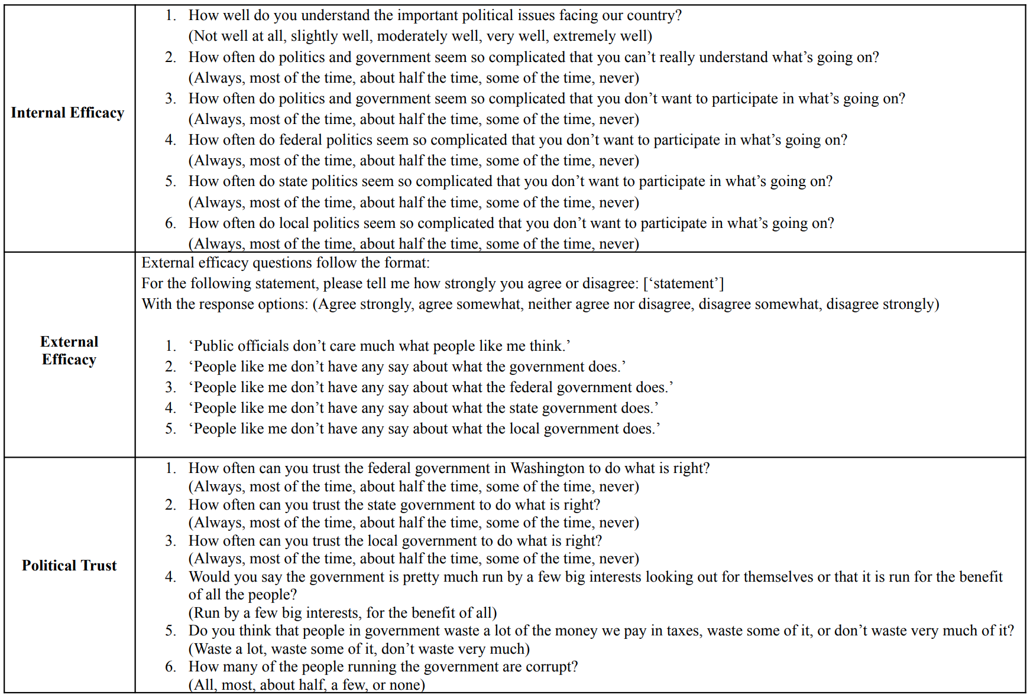
Table A2: Operationalizations of dependent variables from the first data collection
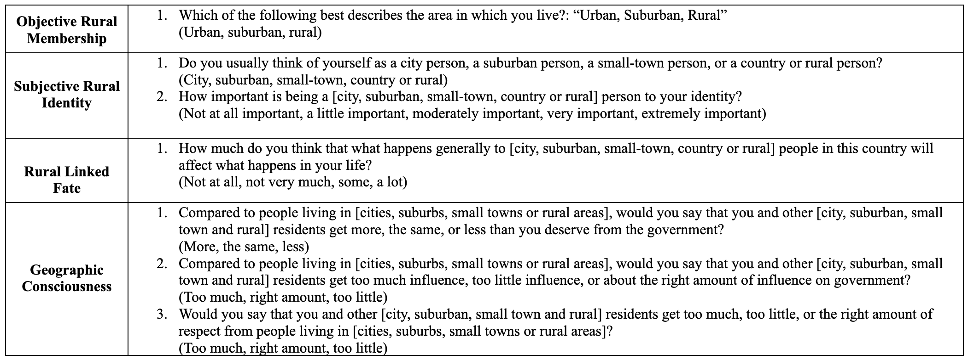
Table A3: Operationalization of independent variables from the second data collection

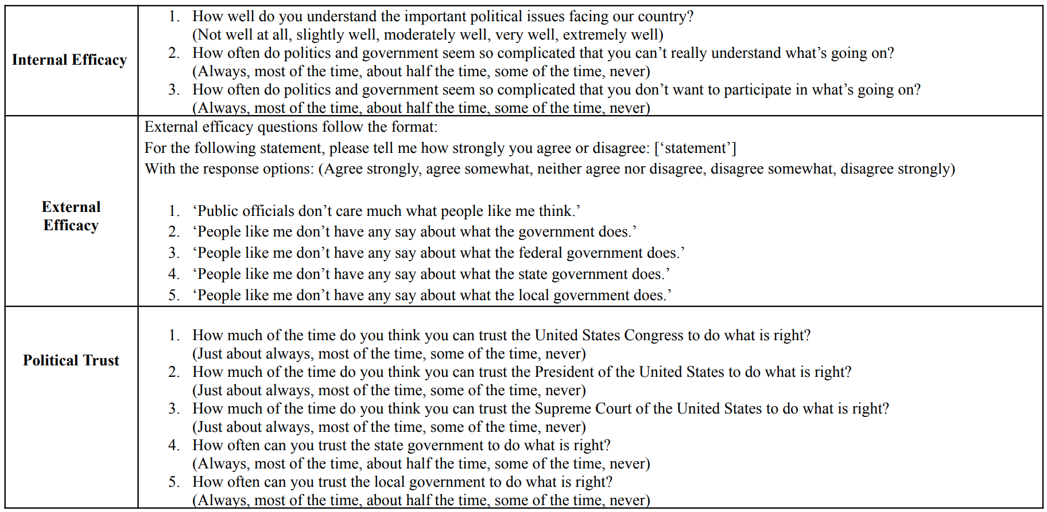
Table A4: Operationalizations of dependent variables from the second data collection
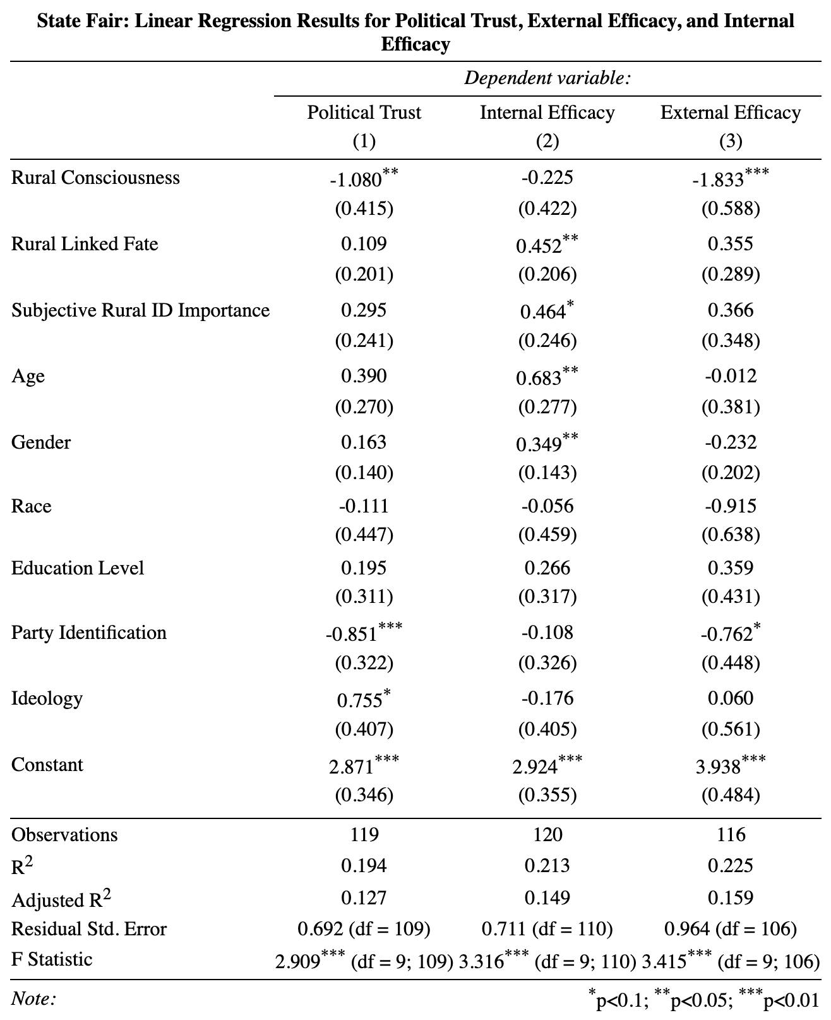
State Fair Collection Results
Table A5: OLS model estimates for ruralness on political trust, internal efficacy, and external efficacy – State fair collection. Coefficients reported with standard errors in parentheses. Party ID and ideology are coded so that higher scores reflect increasing Republican partisanship and conservative ideology, respectively. All variables lie on a 0-1 variable range.
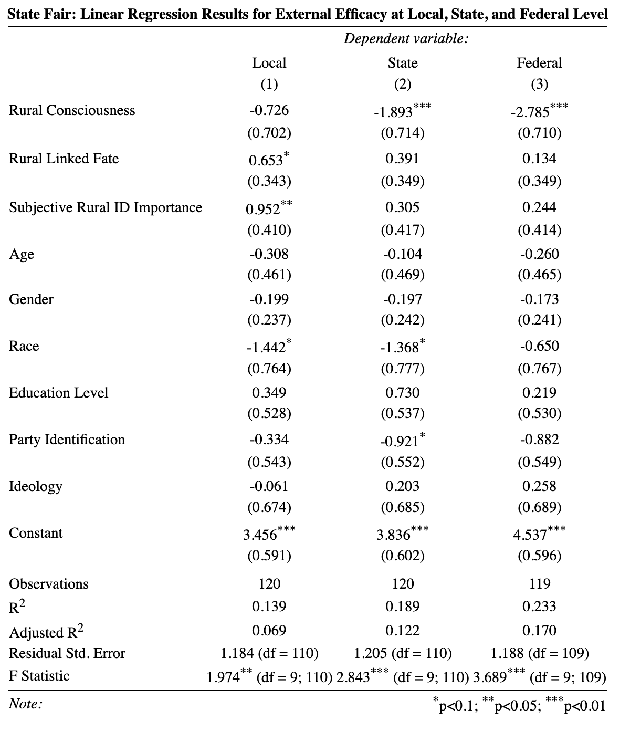
Table A6: OLS model estimates for ruralness on external efficacy at local, state, and federal government levels – State fair collection. Coefficients reported with standard errors in parentheses. Party ID and ideology are coded so that higher scores reflect increasing Republican partisanship and conservative ideology, respectively. All variables lie on a 0-1 variable range.

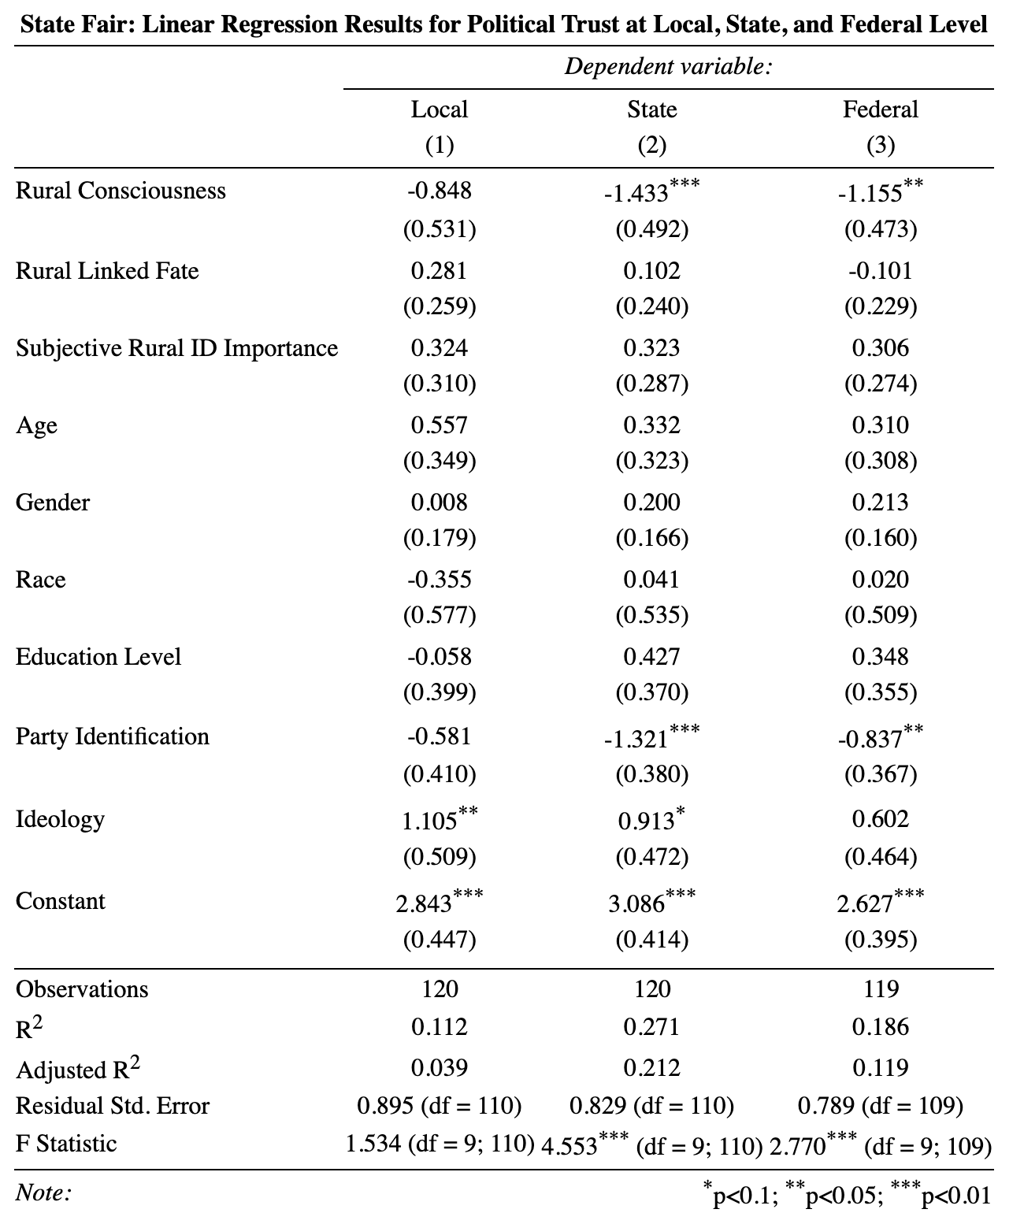
Table A7: OLS model estimates for ruralness on political trust at local, state, and federal government levels – State fair collection. Coefficients reported with standard errors in parentheses. Party ID and ideology are coded so that higher scores reflect increasing Republican partisanship and conservative ideology, respectively. All variables lie on a 0-1 variable range.

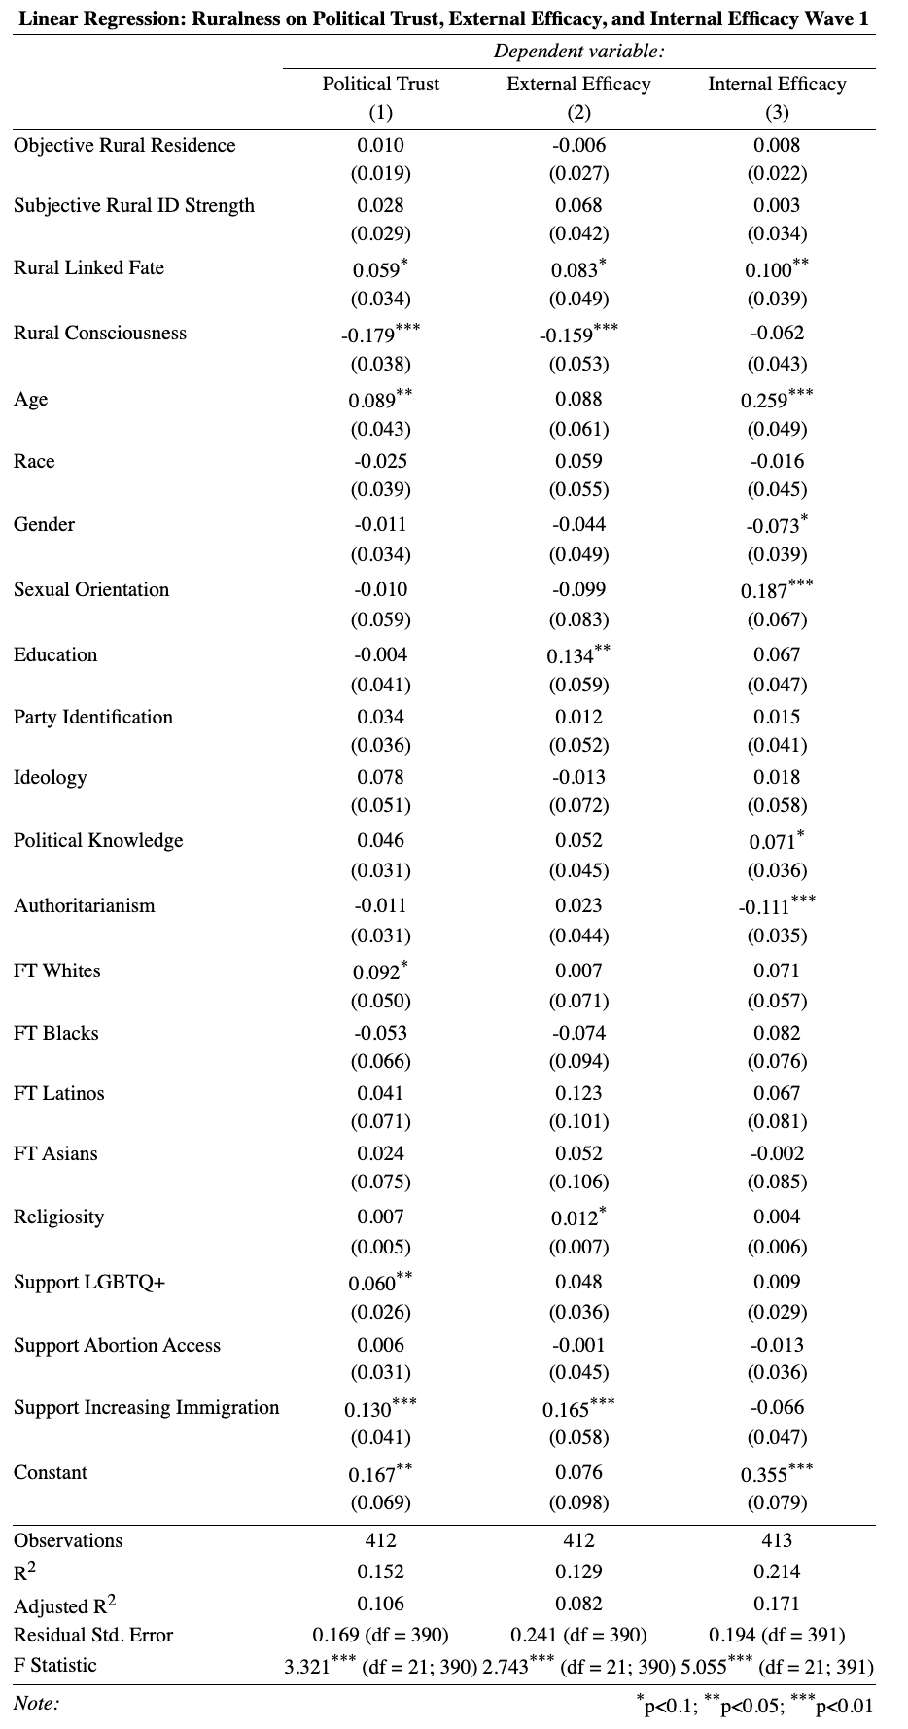
Bovitz/Forthright Collection Results
Table A8: OLS model estimates for ruralness on political trust, external efficacy, and internal efficacy – Wave 1 Bovitz/Forthright collection. Coefficients reported with standard errors in parentheses. Party ID and ideology are coded so that higher scores reflect increasing Republican partisanship and conservative ideology, respectively. All variables lie on a 0-1 variable range.

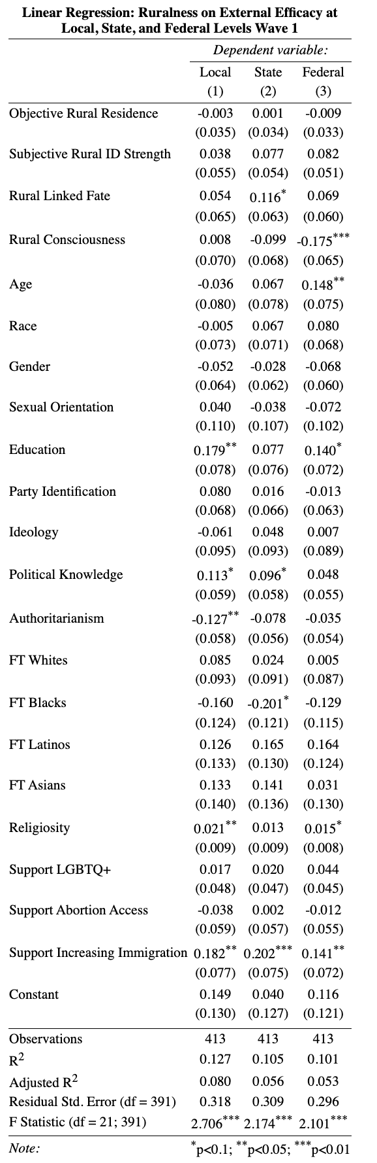
Table A9: OLS model estimates for ruralness on external efficacy at local, state, and federal government levels – Wave 1 Bovitz/Forthright collection. Coefficients reported with standard errors in parentheses. Party ID and ideology are coded so that higher scores reflect increasing Republican partisanship and conservative ideology, respectively. All variables lie on a 0-1 variable range.

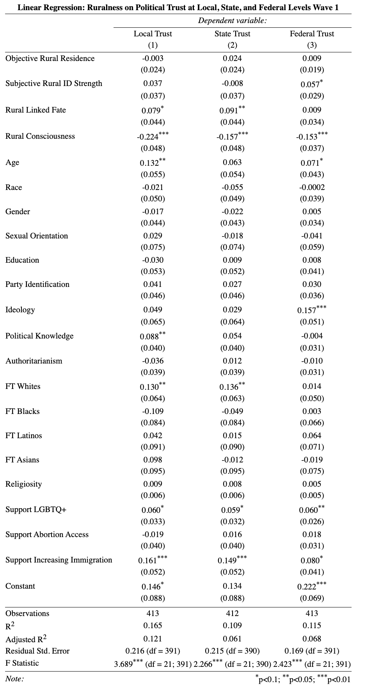
Table A10: OLS model estimates for ruralness on political trust at local, state, and federal government levels – Wave 1 Bovitz/Forthright collection. Coefficients reported with standard errors in parentheses. Party ID and ideology are coded so that higher scores reflect increasing Republican partisanship and conservative ideology, respectively. All variables lie on a 0-1 variable range.

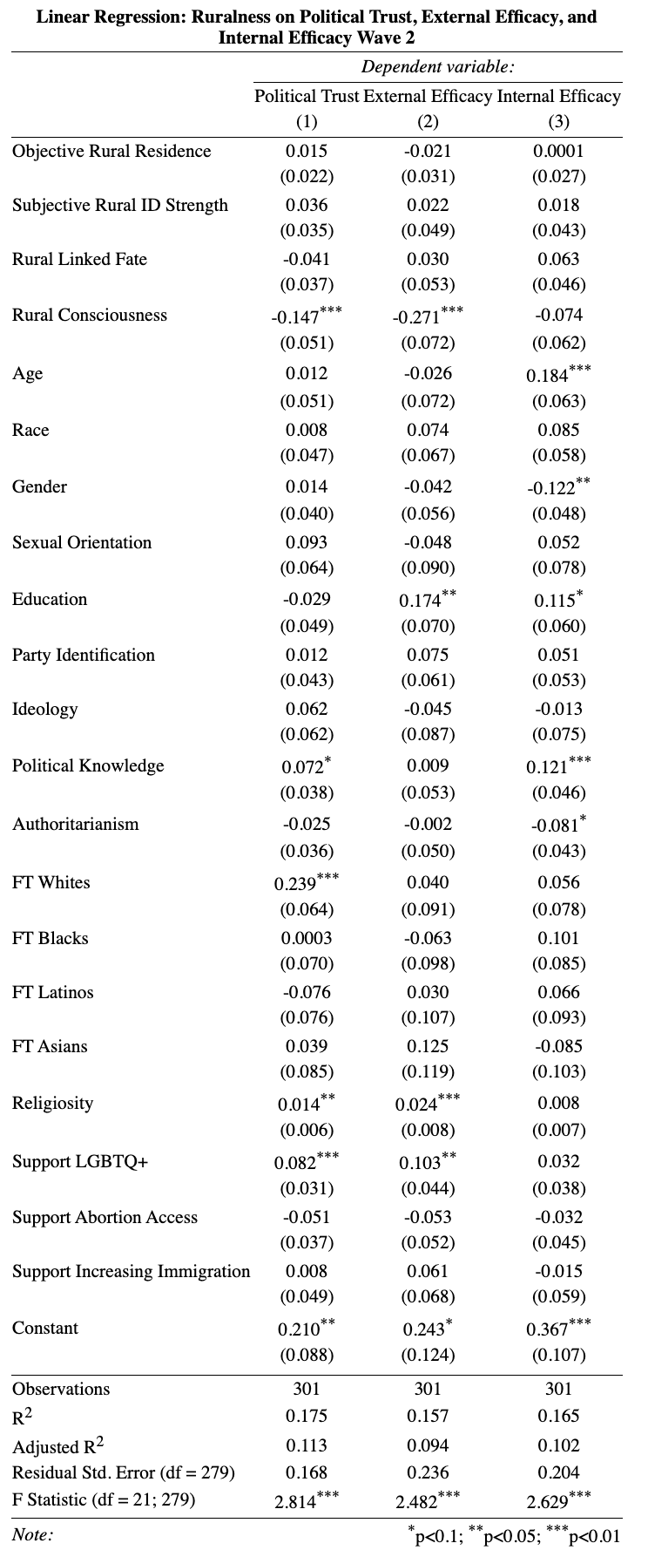
Table A11: OLS model estimates for ruralness on political trust, external efficacy, and internal efficacy – Wave 2 Bovitz/Forthright collection. Coefficients reported with standard errors in parentheses. Party ID and ideology are coded so that higher scores reflect increasing Republican partisanship and conservative ideology, respectively. All variables lie on a 0-1 variable range.

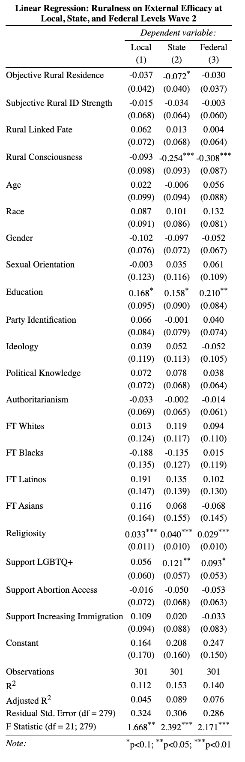
Table A12: OLS model estimates for ruralness on external efficacy at local, state, and federal government levels – Wave 2 Bovitz/Forthright collection. Coefficients reported with standard errors in parentheses. Party ID and ideology are coded so that higher scores reflect increasing Republican partisanship and conservative ideology, respectively. All variables lie on a 0-1 variable range.

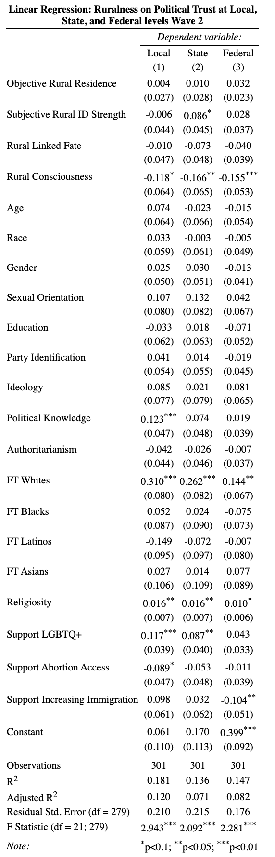
Table A13: OLS model estimates for ruralness on political trust at local, state, and federal government levels – Wave 2 Bovitz/Forthright collection. Coefficients reported with standard errors in parentheses. Party ID and ideology are coded so that higher scores reflect increasing Republican partisanship and conservative ideology, respectively. All variables lie on a 0-1 variable range.

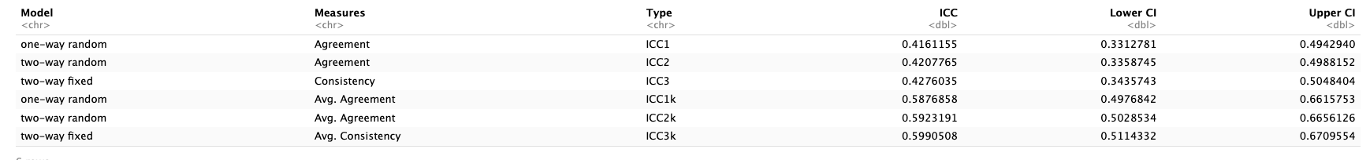
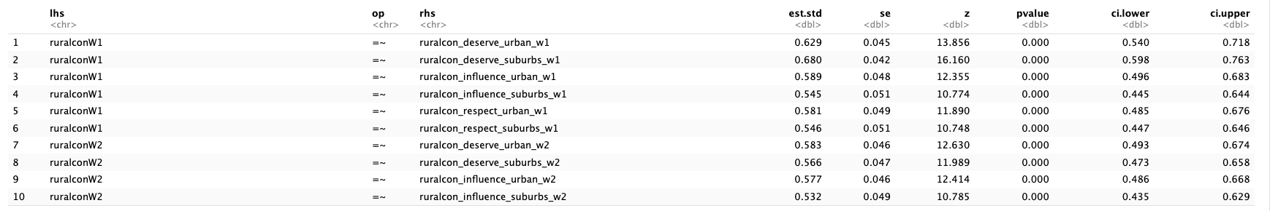
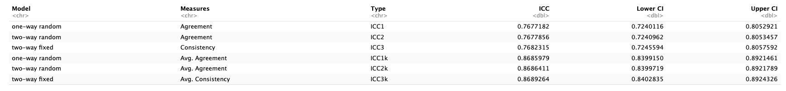
Figure A3: Time consistency of rural consciousness items across wave 1 and wave
Figure A4: Correlation between rural consciousness factors across wave 1 and wave 2
Figure A2: Time consistency of rural identity items across wave 1 and wave 2
Figure A1: Time consistency of rural linked fate items across wave 1 and wave 2
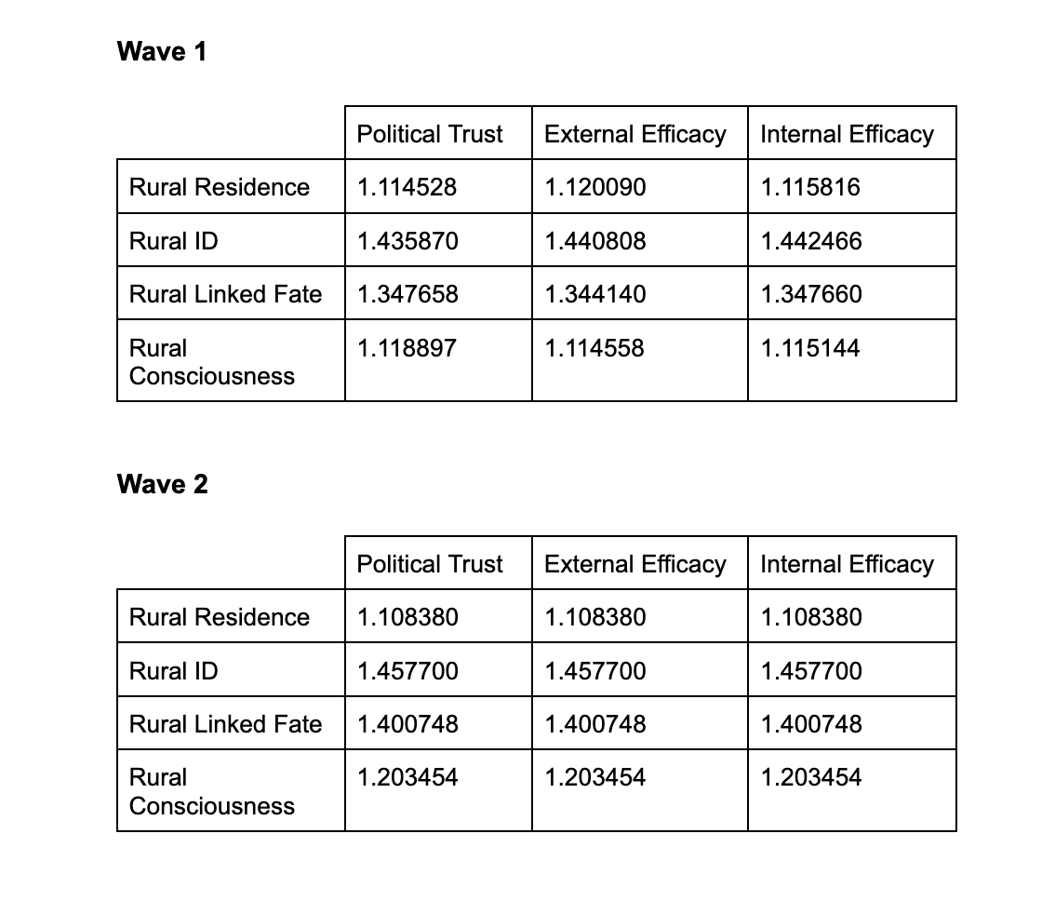
Figure A5: Variance Inflation Factor scores to test for multicollinearity. All VIF scores are less than 1.5, indicating multicollinearity is not an issue.
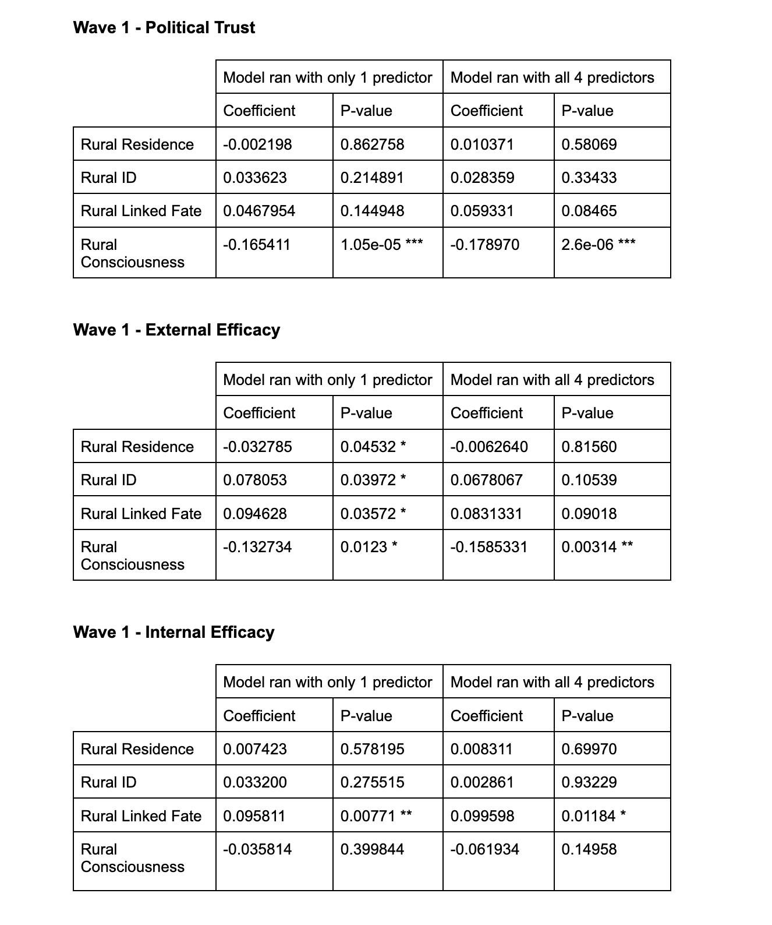
Figure A6: The coefficient estimates and p-values of linear regression models from wave 1 ran with only 1 rural predictor vs. all 4 rural predictors. In combination with the VIF scores, this shows there are no multicollinearity issues present.
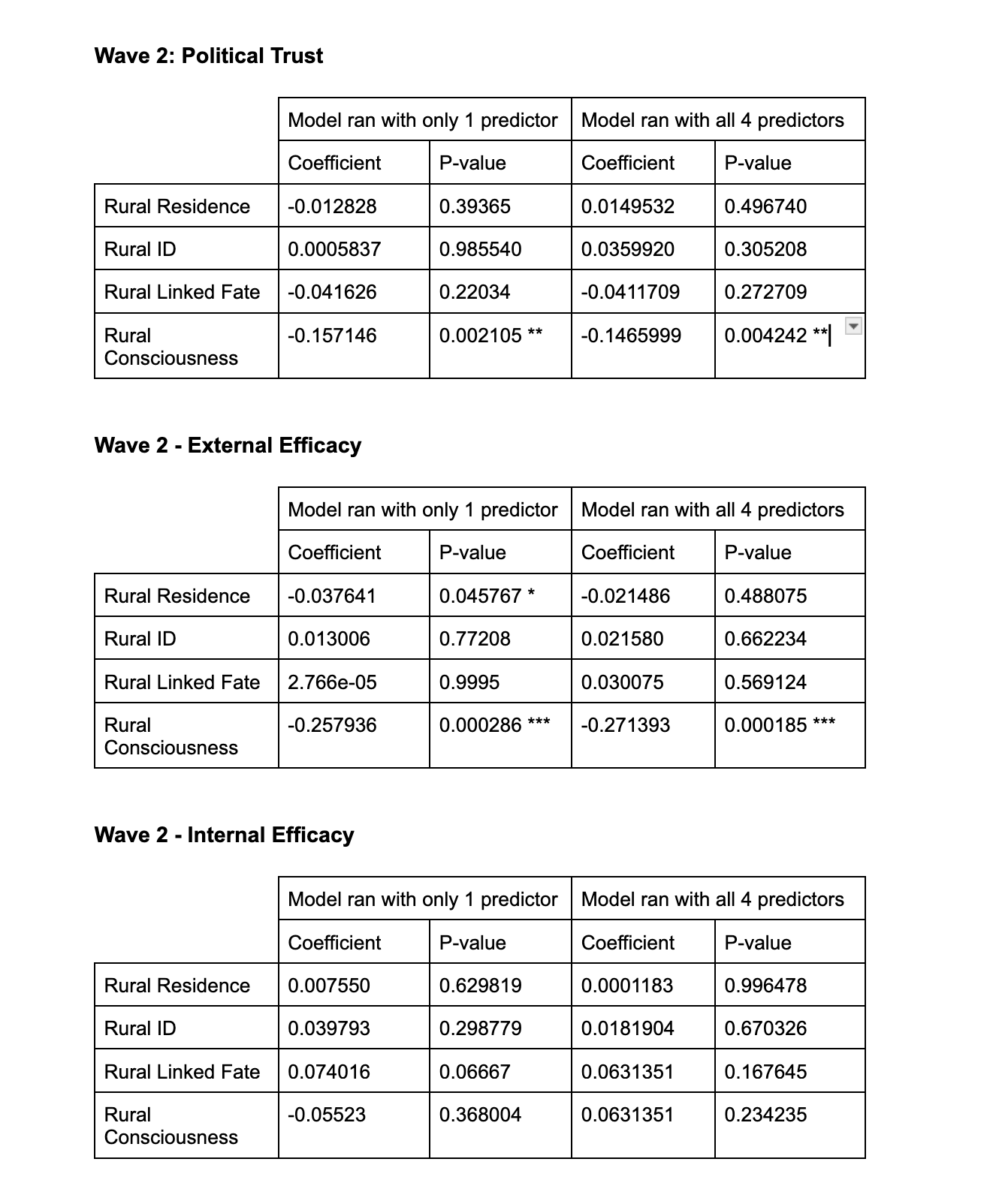
Figure A7: The coefficient estimates and p-values of linear regression models from wave 2 ran with only 1 rural predictor vs. All 4 rural predictors. In combination with the VIF scores, this shows there are no multicollinearity issues.

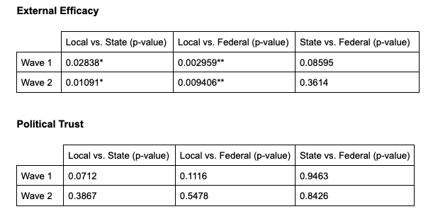
Figure A8: The p-value results from linear combination tests between each of the three levels of government from both wave 1 and wave 2. The difference between local vs. state and local vs. federal are significant for external efficacy.

