Supplementary information for
Reconciling biome-wide conservation of an apex carnivore with land-use economics: jaguars (Panthera onca) in the increasingly threatened Pantanal wetlands
Fernando R. Tortato^{1*}, Rafael Hoogesteijn¹, Allison L. Devlin¹, Howard B. Quigley¹, Fábio Bolzan², Thiago J. Izzo³, Katia M. P. M. B. Ferraz⁴, Carlos A. Peres⁵
1. Panthera, 8 West 40th Street, 18th Floor, New York, USA
2. Departamento de Ecologia, Instituto de Biologia, Universidade Federal do Mato Grosso do Sul, Campo Grande, MS, Brazil
3. Departamento de Ecologia e Botânica, Universidade Federal de Mato Grosso, Cuiabá, Mato Grosso, Brazil
4. University of São Paulo, Forest Science Department, Luiz de Queiroz College of Agriculture, Piracicaba, SP, Brazil
5. Centre for Ecology, Evolution and Conservation, School of Environmental Sciences, University of East Anglia, Norfolk, Norwich, UK
Corresponding Author: ftortato@panthera.org

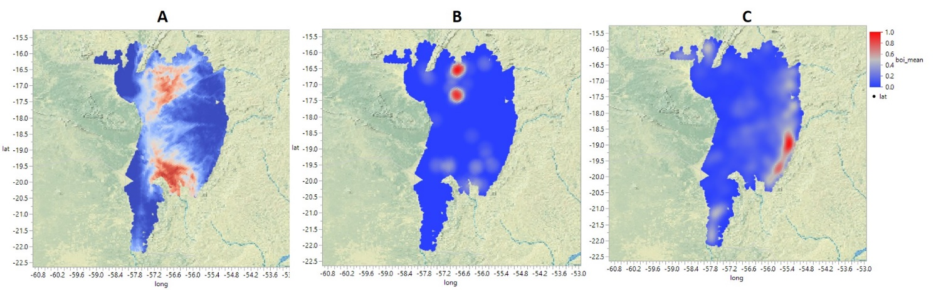
Supplementary figure 1. Maps of the Brazilian Pantanal where: A represents the habitat suitability model for jaguar (Panthera onca); B represents ecotourism lodge density model; and C represents livestock density model,

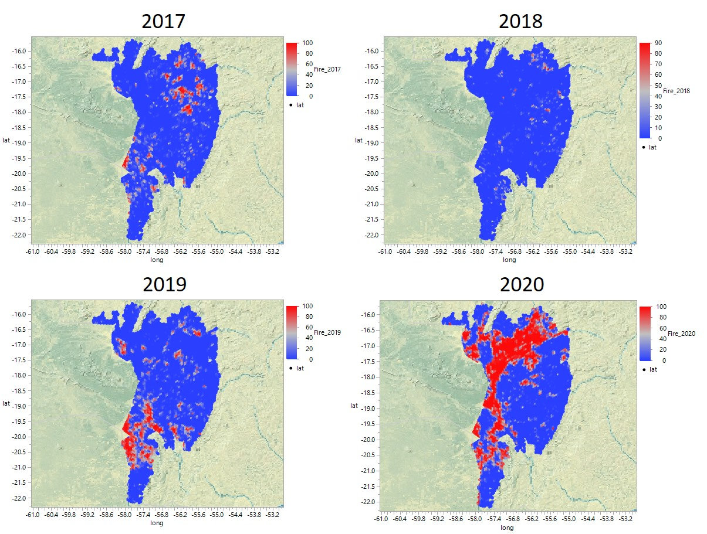
Supplementary figure 2. Spatial distribution of wildfires in the Pantanal for the years 2017, 2018, 2019 and 2020 with red colours indicating areas of fire incidence.

