SUPPORTING INFORMATION
Dual-Axis Life-History Framework Explains Metabolite Exchange and Functional Differentiation in Nodule Microbiomes

Zining Guo¹, Jianyang Li², Xiaoyu Ji¹, Zhengfei Yu¹, Wanpeng Wang^{2, *}, Xiangyu Guan^{1, *}

¹ School of Ocean Sciences, China University of Geosciences, Beijing, 100083, China
² Third Institute of Oceanography, Ministry of Natural Resources‌, Xiamen, 361000, China

* Corresponding authors:
E-mail address: guanxy@cugb.edu.cn (X.Y. Guan); wangwanpeng@tio.org.cn (W.P. Wang)

Supplementary Materials and Methods

Supplementary Method 1: Sediment and nodule sampling
Sediment and polymetallic nodule samples were collected during the DY135-E2 cruise (October 2023) from seven sites in the Clarion–Clipperton Fracture Zone (CCFZ) at water depths of 4,983–5,211 m. A total of 17 sediment stations were established across the survey area. Using a customized deep-sea sampler, 17 sediment samples and 3 nodule samples were obtained. Two replicate sediment subsamples (500 g each) were collected per site (Figure S1, Table S1). All samples were stored on dry ice and transferred to the laboratory. Nodule surfaces (3–5 mm) were scraped and ground using a sterile mortar and pestle, while sediment samples were centrifuged to remove excess water before DNA extraction.

Supplementary Method 2: DNA extraction and library preparation
Microbial DNA from 0.5 g sediment was extracted using the E.Z.N.A. Soil DNA Kit (Omega Bio-Tek, USA), and DNA from nodule powder was extracted using the PowerSoil Kit (Qiagen, Germany). All samples were extracted in duplicate. DNA integrity and purity were checked by gel electrophoresis and NanoDrop spectrophotometry. DNA was fragmented with a Covaris M220 ultrasonicator (~400 bp). Libraries were prepared using the NEXTFLEX® Rapid DNA-Seq Kit and sequenced on an Illumina HiSeq 2500 platform (2 × 150 bp).

Supplementary Method 3: Quality control and metagenomic assembly
Raw reads were processed using Trimmomatic (Bolger et al., 2014) with adapter removal and quality trimming parameters (ILLUMINACLIP:2:30:10; SLIDINGWINDOW:4:15; MINLEN:36). Clean reads were assembled using MEGAHIT (Li et al., 2015), which applies a de Bruijn graph–based iterative k-mer approach. Only contigs ≥1,000 bp were retained.

Supplementary Method 4: Genome binning, dereplication and quality evaluation
Genome binning was conducted using MetaBAT2 and MaxBin2 (Wu et al., 2016) integrated through MetaWRAP (Uritskiy et al., 2018). MAG completeness and contamination were assessed using CheckM (Parks et al., 2015), and genomes with completeness >70% and contamination <10% were retained. Dereplication was performed with dRep (Olm et al., 2017) at 99% ANI. Pairwise ANI values were computed using FastANI (Jain et al., 2018). Final taxonomic assignments followed the GTDB-Tk framework (Chaumeil et al., 2020).

Supplementary Method 5: Gene prediction and functional annotation
Protein-coding genes were predicted using Prodigal (Hyatt et al., 2010). tRNAs were annotated using tRNAscan-SE (Chan & Lowe, 2019).
Functional annotation included:
- Metal transporter proteins identified via BLASTP against TCDB (Saier et al., 2014)
- Iron-related genes identified using FeGenie (Garber et al., 2020)
- Other metal redox genes annotated by BLASTP against a curated reference and validated using the NCBI NR database
- Nitrogen-cycling genes annotated using NCycDB (Dang et al., 2019)
- Sulfur-cycling genes annotated using SCycDB
- All metabolism-related domain predictions validated using eggNOG-mapper v2.1.2 (Huerta-Cepas et al., 2019)
- CAZymes annotated using HMMER3 against dbCAN2 (Zhang et al., 2018)
- Small-carbon metabolism annotated using KEGG KO assignments derived from eggNOG-mapper (Huerta-Cepas et al., 2019)

Supplementary Method 6: Tracking of HGT in all MAGs
We used MetaCHIP (v.1.9.0) to detect all HGT events between MAGs in the bacterial community (Song et al., 2019). Each predicted gene was compared between different taxonomic groups using the best match method. Based on the defined phylogenetic tree, if the best match was found in a non-self-group, the gene was identified as an HGT candidate gene. Then, potential HGTs were refined using phylogenetic methods to determine the direction of gene flow. Sankey diagrams (Figure 1C) were used to visualize gene flow within the bacterial community at the genus level, to identify recent and non-recent gene horizontal transfer events and the transferred genes. Finally, these transferred genes were annotated as ARGs using the same method described above.

Supplementary Method 7: MAG abundance calculation
Clean reads were mapped to the MAGs using BWA (Li & Durbin, 2009). Alignments were sorted using SAMtools (Li et al., 2009), and duplicates were removed using the Picard Toolkit (Broad Institute). Low-quality alignments were filtered using CoverM v0.6.1. Relative abundance was calculated using the “genome” and “relative_abundance” modes.

Supplementary Method 8: Co-occurrence network construction
Pairwise Spearman correlations were calculated using MAG relative abundances. MAGs with zero abundance in more than half of the samples were removed using the majority-selection filter. The filtered matrix was used for Random Matrix Theory (RMT)–based network analysis on the iNAP platform (Deng et al., 2012). The resulting network includes robust co-occurrence relationships among abundant MAGs.

Supplementary Method 9: Metabolic complementarity and metabolite exchange
Metabolic complementarity between MAGs was inferred using the PhyloMint framework (Zhao et al., 2022). Genome-scale metabolic models were reconstructed using CarveMe (Machado et al., 2018) with the BiGG Models reference database (King et al., 2016).Metabolites were categorized according to Peng' s study: (i) fatty acyl-CoAs were separated from “lipids and lipid-like molecules” and grouped with other CoA derivatives into a new class termed “CoA derivatives”; (ii) compounds identified as amino acids, peptides, and analogues were separated from “organic acids and derivatives” into a distinct class; (iii) carbohydrates and carbohydrate conjugates were merged with inorganic compounds into a single category termed “inorganics,” which includes both metallic and non-metallic homogeneous compounds; (iv) organic nitrogen compounds, organic oxygen compounds, organic heterocyclic compounds, benzimidazoles, and organic sulfur compounds were merged into one category termed “organic compounds with specific atoms or structural motifs”; and (v) oxidized and reduced ferredoxins, heme, staphyloferrin B, and pyoverdine were grouped under “other metabolites” (Peng et al., 2024).

Supplementary Method 10: Life-history strategies of MAGs
We constructed a classification and regression framework based on the Y–A–S life-history strategy model using an XGBoost decision-tree algorithm. First, we screened genes involved in carbon metabolism, nitrogen cycling, and sulfur metabolism from all sediment- and nodule-derived MAGs to represent resource acquisition capacity (A). Genes related to metal resistance were selected as indicators of environmental stress tolerance (S), and tRNA gene counts were used as proxies for intrinsic growth capacity (Y)(Figure S7, Table S10). The relative abundance proportions of these gene categories were then calculated for each MAG. We defined the dominant life-history strategy as follows:
(1) If one capacity category exceeded 50%, or exceeded 40% while the other two categories were each below 30%, the MAG was assigned to the strategy dominated by that single capacity.
(2) If two capacity categories were both above 30% and the third was below 30%, the MAG was assigned to a mixed strategy dominated by those two capacities.
(3) If all three capacities were below 40%, the MAG was classified as AVERAGE, representing a balanced strategy without clear specialization toward resource acquisition, intrinsic growth, or stress tolerance.
Based on these criteria, seven life-history strategy groups were obtained:
• Y-type: microbes allocating most resources toward growth and biomass production;
• A-type: microbes prioritizing resource acquisition;
• S-type: microbes emphasizing adaptation to environmental stress;
• AS-type: microbes co-investing in resource acquisition and stress tolerance;
• AY-type: microbes co-investing in resource acquisition and growth;
• SY-type: microbes co-investing in growth and stress tolerance;
• AVER-type: microbes without a distinct allocation bias across the three capacities.
We subsequently performed regression analyses between these life-history categories and the classes of exchanged metabolites to quantify the influence of each life-history strategy on different metabolite categories.

Supplementary References
Bolger AM, Lohse M, Usadel B (2014). Trimmomatic: a flexible trimmer for Illumina sequence data. Bioinformatics 30: 2114–2120.
Chaumeil PA, Mussig AJ, Hugenholtz P, Parks DH (2020). GTDB-Tk: a toolkit to classify genomes with the Genome Taxonomy Database. Bioinformatics 36: 1925–1927.
Chan PP, Lowe TM (2019). tRNAscan-SE: searching for tRNA genes in genomic sequences. Methods Mol Biol 1962: 1–14.
Dang H, Chen R, Wang L, Shao S, Dai L, Ye Y et al. (2019). NCycDB: a curated integrative database for fast and accurate metagenomic profiling of nitrogen cycling genes. Bioinformatics 35: 1040–1048.
Deng Y, Jiang YH, Yang Y, He Z, Luo F, Zhou J (2012). Molecular ecological network analyses. BMC Bioinformatics 13: 113.
Garber AI, Nealson KH, Okamoto A, McAllister SM, Chan CS, Barco RA et al. (2020). FeGenie: a comprehensive tool for the identification of iron genes and gene neighborhoods in genome assemblies. mSystems 5: e00327-19.
Huerta-Cepas J, Szklarczyk D, Heller D, Hernández-Plaza A, Forslund SK, Cook H et al. (2019). eggNOG 5.0: a hierarchical, functionally and phylogenetically annotated orthology resource. Nucleic Acids Res 47: D309–D314.
Hyatt D, Chen GL, LoCascio PF, Land ML, Larimer FW, Hauser LJ (2010). Prodigal: prokaryotic gene recognition and translation initiation site identification. BMC Bioinformatics 11: 119.
Jain C, Rodriguez-R LM, Phillippy AM, Konstantinidis KT, Aluru S (2018). High-throughput ANI analysis using FastANI. Nat Commun 9: 5114.
King ZA, Lu J, Dräger A, Miller P, Federowicz S, Lerman JA et al. (2016). BiGG Models: a platform for integrating, standardizing and sharing genome-scale models. Nucleic Acids Res 44: D515–D522.
Li D, Liu CM, Luo R, Sadakane K, Lam TW (2015). MEGAHIT: an ultra-fast single-node solution for large and complex metagenomics assembly. Bioinformatics 31: 1674–1676.
Li H, Durbin R (2009). Fast and accurate short read alignment with Burrows–Wheeler transform. Bioinformatics 25: 1754–1760.
Li H, Handsaker B, Wysoker A, Fennell T, Ruan J, Homer N et al. (2009). The Sequence Alignment/Map format and SAMtools. Bioinformatics 25: 2078–2079.
Machado D, Andrejev S, Tramontano M, Patil KR (2018). Fast automated reconstruction of genome-scale metabolic models using CarveMe. Nat Commun 9: 5442.
Olm MR, Brown CT, Brooks B, Banfield JF (2017). dRep: a tool for fast and accurate genomic comparisons enabling improved genome recovery. ISME J 11: 2864–2868.
Parks DH, Imelfort M, Skennerton CT, Hugenholtz P, Tyson GW (2015). CheckM: assessing the quality of microbial genomes. Genome Res 25: 1043–1055.
Saier MH Jr, Reddy VS, Tamang DG, Västermark Å (2014). The Transporter Classification Database (TCDB): recent advances. Nucleic Acids Res 42: D251–D258.
Song, W., Wemheuer, B., Zhang, S., Steensen, K., & Thomas, T. (2019). MetaCHIP: community-level horizontal gene transfer identification through the combination of best-match and phylogenetic approaches. Microbiome, 7(1), 36.
Uritskiy GV, DiRuggiero J, Taylor J (2018). MetaWRAP: a flexible pipeline for genome-resolved metagenomic analysis. Microbiome 6: 158.
Wu YW, Simmons BA, Singer SW (2016). MaxBin 2.0: an automated binning algorithm. Bioinformatics 32: 605–607.
Zhao M, Zhang X, Li X, Sun X (2022). PhyloMint: phylogeny-informed metabolite complementarity for microbial interaction inference. ISME Commun 2: 64.

Supplementary Figures
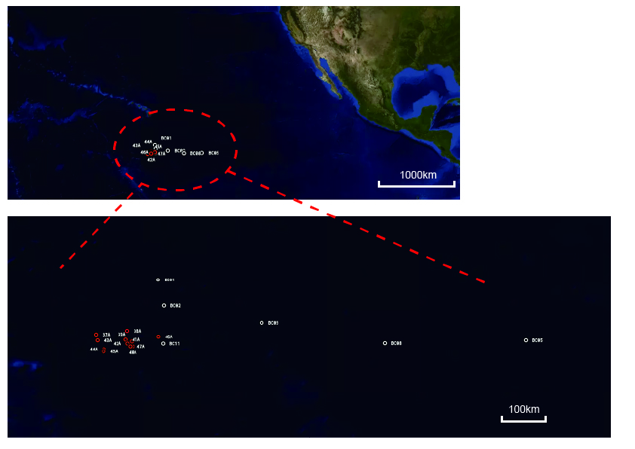
Figure S1. Location of sediment-inhabiting sampling sites in the study area. Specific sampling sites were given in the SUPPORTING INFORMATION Table S1.

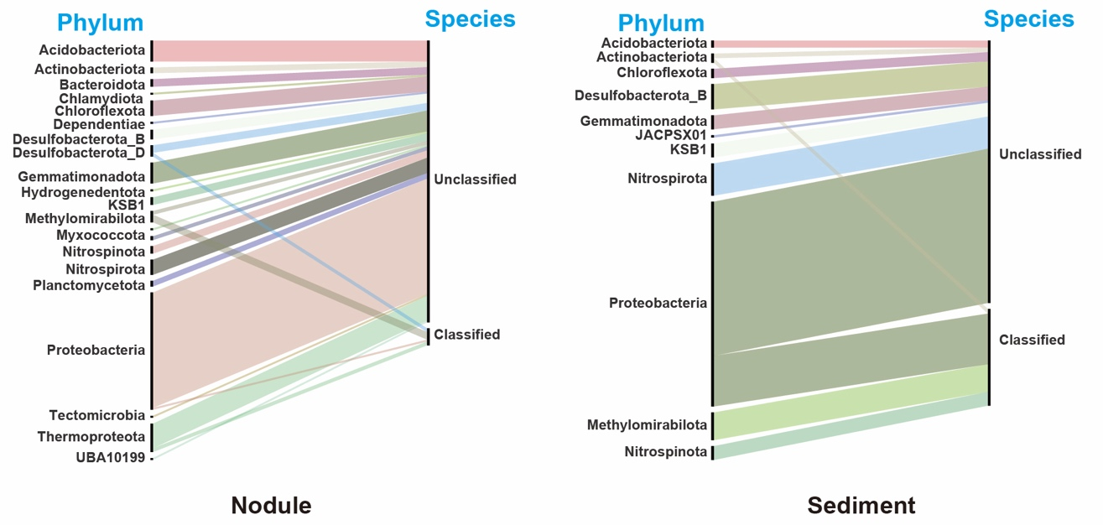
Figure S2. The hierarchical classification of MAG species annotated from sediments and nodule surfaces in the deep-sea nodule area. Those annotated at the species level are labeled as classified, while those that cannot be annotated to the species level are labeled as unclassified. Detailed information was provided in Table S2 and S3.

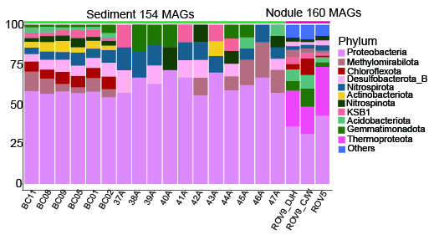
Figure S3. Stacked bar chart of MAG species annotation from sediments and nodule surfaces in the deep-sea nodule area. The top 15 phyla in relative abundance are selected, and all remaining phyla are grouped as ‘Others’.

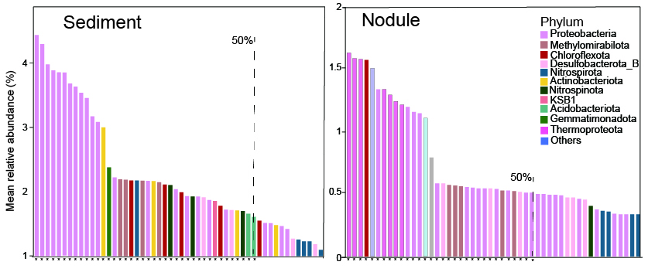
Figure S4. Abundance ranking of dominant MAG from sediments and nodule surfaces in the deep-sea nodule area. The sum of the relative abundance of dominant MAGs accounted for at least 50% of the total abundance; these MAGs are marked with asterisks on the x-axis.

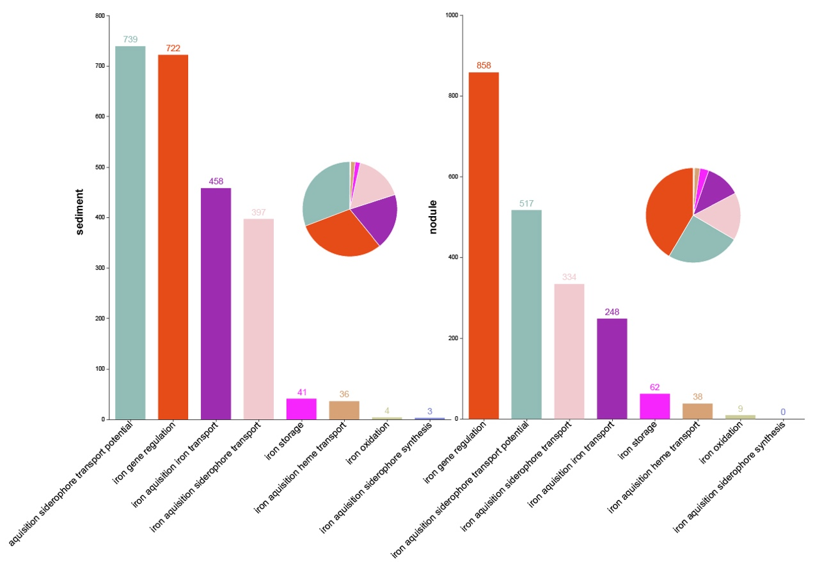
Figure S5. MAG iron carrier uptake, absorption, and transport capabilities from sediments and nodule surfaces in the deep-sea nodule area. The pie chart summarizes the percentage of genes encoding enzymes related to Iron gene regulation, Iron acquisition siderophore transport potential, Iron acquisition siderophore transport, and Iron acquisition iron transport in the two samples. The numbers represent the total number of genes for each enzyme category in the genome.

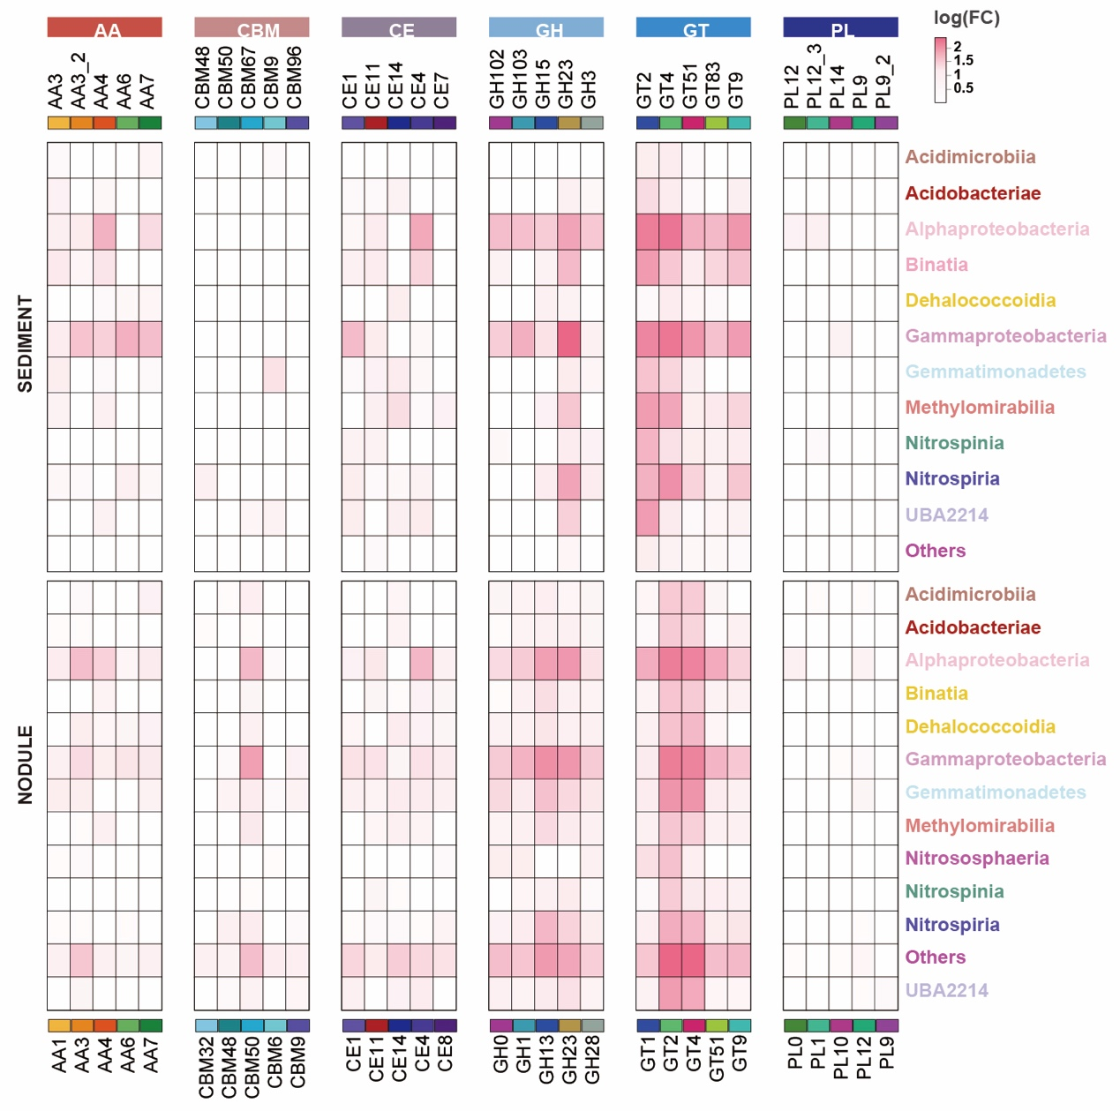
Figure S6. Carbohydrate-active enzymes (CAZymes) detected in MAGs, and the number of MAGs containing genes encoding CAZymes. The heatmap summarizes the number of genomes within each phylum that contain genes encoding GTs (glycosyltransferases), GHs (glycoside hydrolases), and CEs (carbohydrate esterases).

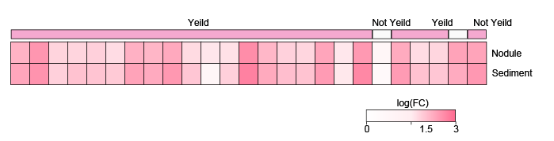
Figure S7. tRNAs detected in MAGs from sediments and nodule surfaces in the deep-sea nodule area. They are classified into ‘Yield’ (used for synthesizing substances required for their own growth and reproduction) and ‘Not Yield’ (not used for their own growth). The tRNAs used for self-growth are subsequently regarded as the growth life-history strategy (Y). Detailed information was provided in Table S10.

