Supplementary material to:
Sea-surface temperature extremes during the last interglacial
Torin Cannings¹, Erica de Leau², Stephanie Stainbank¹, László Kocsis³, Dick Kroon^{2🎗}, Silvia Spezzaferri^{4🎗}, Elias Samankassou¹
¹Department of Earth Sciences, University of Geneva, Rue des Maraîchers 13, 1205 Geneva, Switzerland
² School of GeoSciences, Grant Institute, University of Edinburgh, James Hutton Road, Edinburgh EH9 3FE, UK
³Institute of Earth Surface Dynamics (IDYST), University of Lausanne, Quartier UNIL-Mouline, Bâtiment Géopolis, 1015 Lausanne, Switzerland
⁴Department of Geosciences, University of Fribourg, Chemin du Musée 6, 1700 Fribourg, Switzerland

Correspondence to: torin.cannings@unige.ch
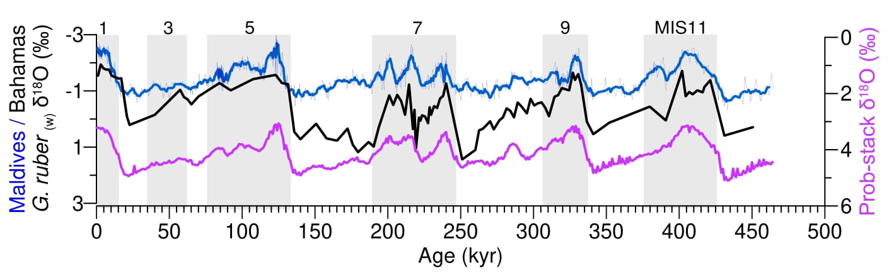
Supplementary Figure 1 – Long-term ‘pooled’ G. ruber oxygen isotope records for both site U1467 (Maldives) and 1006 (Bahamas) shown relative to the Prob-stack reference curve¹.
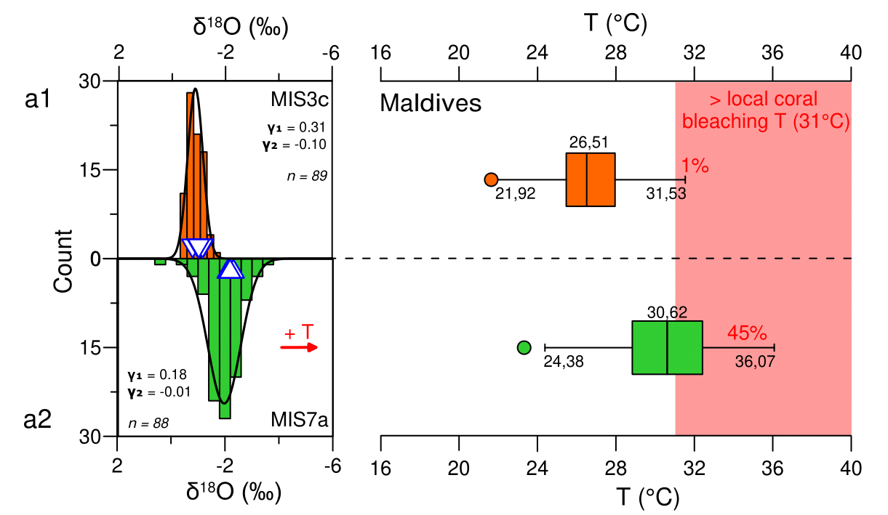
Supplementary Figure 2 – Spread in δ¹⁸O_{c} values from individual foraminiferal analyses (IFA) and the associated seawater temperature estimates. Panels show histograms of δ¹⁸O_{c} (counts represent individual measurements) with temperature box and whisker plots for G. ruber from two intervals: MIS3c (a1) and MIS7a (a2) from the Maldives. Pooled δ¹⁸O_{c} values (triangles) are shown for each sample. Y₁ = Skewness, Y₂ = Kurtosis and n = total number of measurements. All δ¹⁸O_{c} values are reported relative to VDPB. Box and whisker plots include labelled upper and lower bounds and mean values. The percentage of IFA-derived temperatures exceeding the modern coral-bleaching threshold is highlighted in bold red.

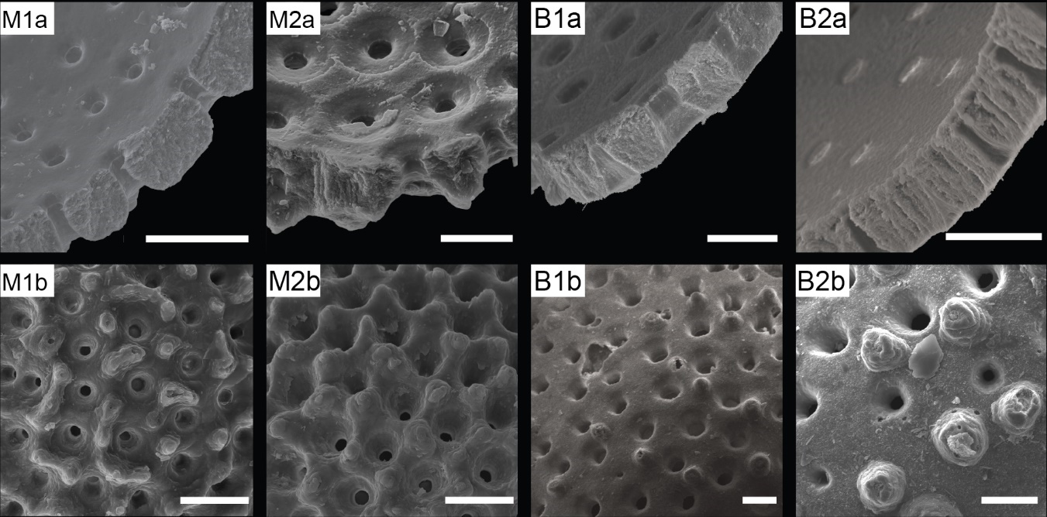
Supplementary Figure 3 – Scanning electron microscope (SEM) images showing preservation quality in representative G. ruber specimens from IODP Site U1467 in the Maldives and ODP Site 1006 off the Bahamas. Maldives samples include A, B-Mudline (M1) C-1H-1, 99–100 cm (M2). Bahamas samples are from A-1H-1, 55–57 cm and A-1H-3, 15–17 cm. For each specimen, panel ‘a’ shows a cross-section with the inner surface and panel ‘b’ shows the external test surface. Images from Site U1467 are from Stainbank, et al. ², who provide a detailed assessment of preservation and diagenesis at that site. Scale bars for all images = 10 μm.
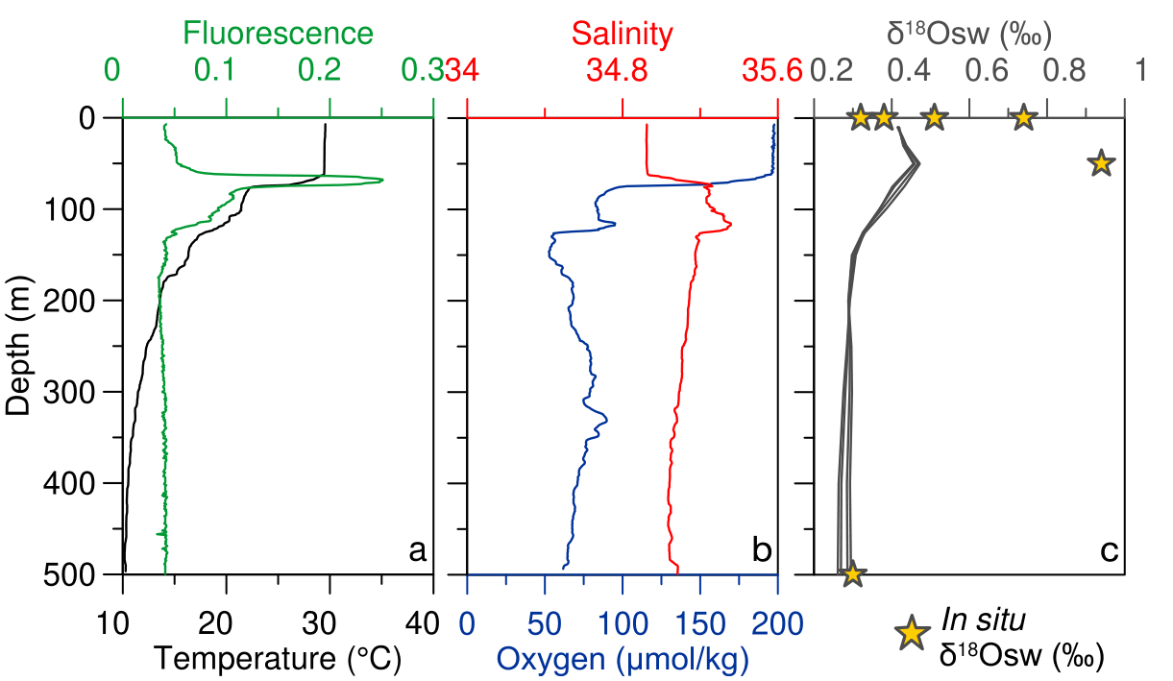
Supplementary Figure 4 – Physical oceanographic data showing profiles of temperature (black), fluorescence (green), salinity (red), Oxygen (blue) and δ¹⁸O_{sw} (grey) relative to depth for the modern Maldives ³. In situ δ¹⁸O_{sw} values⁴⁻⁸ are shown by yellow stars.

The methodological workflow used in this research utilises Mg/Ca-based temperature estimates in order to calculate an estimated value for the δ¹⁸O seawater (δ¹⁸O_{sw}). This method ensures that the temperature estimates from individual foraminifera analysis (IFA) use a δ¹⁸O_{sw} value which is relevant to the conditions when each foraminifera produced its carbonate test. This is important as δ¹⁸O_{sw} can vary with numerous factors such as local hydrography and depth, which are not accounted for by climate or latitude-based δ¹⁸O_{sw} estimates, as shown in Supplementary Figure 4, which demonstrates δ¹⁸O_{sw} variation with depth in the modern Maldives. The δ¹⁸O_{sw calculated} in this study are consistently more positive than climate and latitude-based estimates (Supplementary Table 2). The estimates shown in Supplementary Table 2 were estimated from the benthic δ¹⁸O stack of Lisiecki and Raymo ⁹ using the multi-proxy sea level model from Rohling, et al. ¹⁰. A latitude adjustment for the δ¹⁸O_{sw} estimation was made using ¹¹ Eq. S9.
We attribute this difference to the fact that such estimates do not account for depth-based variation in δ¹⁸O_{sw.} Data from the modern Maldives demonstrates that δ¹⁸O_{sw} values become more positive for much of the depth habitat of G. ruber (c. 0 – 50 m) than at the surface or bottom water, resulting in a discrepancy between calculated values and estimates of surface or bottom water δ¹⁸O_{sw.} The corresponding temperature profile (Supplementary Figure 4) highlights that despite this change in δ¹⁸O_{sw} with depth, temperature is consistent from the surface, throughout the depth habitat of the planktic foraminifera species analysed (G. ruber).

Supplementary Table 1 – Traditional pooled whole shell geochemical data from all intervals discussed from both sites.
Location | Interval | Sample | δ¹⁸O (‰) | Mg/Ca (mmol/mol)
Maldives (IODP 359 U1467) | MIS3c | U1467C, 1H2, 7–8 cm | -0.97 | 6.28
Maldives (IODP 359 U1467) | MIS3c | U1467C, 1H2, 7–8 cm | -1.13
Maldives (IODP 359 U1467) | MIS3c | U1467C, 1H2, 10–11 cm | -0.76
Maldives (IODP 359 U1467) | MIS3c | U1467C, 1H2, 10–11 cm | -0.97
Maldives (IODP 359 U1467) | MIS3c | U1467C, 1H2, 13–14 cm | -1.15 | 5.40
Maldives (IODP 359 U1467) | MIS3c | U1467C, 1H2, 13–14 cm | -0.99
Maldives (IODP 359 U1467) | MIS5e | U1467B, 2H1, 115–116 cm | -2.48 | 7.35
Maldives (IODP 359 U1467) | MIS5e | U1467B, 2H1, 115–116 cm | -2.20
Maldives (IODP 359 U1467) | MIS5e | U1467B, 2H1, 118–119 cm | -2.02
Maldives (IODP 359 U1467) | MIS5e | U1467B, 2H1, 118–119 cm | -2.62
Maldives (IODP 359 U1467) | MIS5e | U1467B, 2H1, 121–122 cm | -2.51 | 6.16
Maldives (IODP 359 U1467) | MIS7a | U1467B, 2H3, 63–64 cm | -2.31 | 7.86
Maldives (IODP 359 U1467) | MIS7a | U1467B, 2H3, 63–64 cm | -2.11
Maldives (IODP 359 U1467) | MIS7a | U1467B, 2H3, 66–67 cm | -2.15
Maldives (IODP 359 U1467) | MIS7a | U1467B, 2H3, 69–70 cm | -2.18 | 8.98
Bahamas (ODP 166 1006) | MIS1 | 1006A, 1H1, 35–37 cm | -1.85 | 5.09
Bahamas (ODP 166 1006) | MIS1 | 1006A, 1H1, 35–37 cm | -1.81
Bahamas (ODP 166 1006) | MIS1 | 1006A, 1H1, 55–57 cm | -1.47 | 5.01
Bahamas (ODP 166 1006) | MIS1 | 1006A, 1H1, 55–57 cm | -1.79
Bahamas (ODP 166 1006) | MIS1 | 1006A, 1H1, 75–77 cm | -1.74
Bahamas (ODP 166 1006) | MIS1 | 1006A, 1H1, 75–77 cm | -1.70
Bahamas (ODP 166 1006) | MIS5e | 1006A, 1H2, 135–137 cm | -1.45
Bahamas (ODP 166 1006) | MIS5e | 1006A, 1H2, 135–137 cm | -1.58
Bahamas (ODP 166 1006) | MIS5e | 1006A, 1H3, 15–17 cm | -1.83 | 5.66
Bahamas (ODP 166 1006) | MIS5e | 1006A, 1H3, 15–17 cm | -2.15
Bahamas (ODP 166 1006) | MIS5e | 1006A, 1H3, 35–37 cm | -1.66 | 5.90
Bahamas (ODP 166 1006) | MIS5e | 1006A, 1H3, 35–37 cm | -1.40

Supplementary Table 2 - Mean δ¹⁸O_{sw} estimates for each time interval calculated using the mean G. ruber (w) Mg/Ca derived temperatures together with the traditional ‘pooled’ δ¹⁸O data together with climate and latitude-based estimates (see supplementary text).
Location | Interval | δ¹⁸O_{sw} calculated | δ¹⁸O_{sw} climate & latitude-based estimate (see text)
Maldives (IODP 359 U1467) | MIS3c | 2.09 | 1.03
Maldives (IODP 359 U1467) | MIS5e | 0.99 | 0.47
Maldives (IODP 359 U1467) | MIS7a | 1.58 | 0.56
Bahamas (ODP 166 1006) | MIS1 | 0.98 | 0.43
Bahamas (ODP 166 1006) | MIS5e | 1.64 | 0.41

Supplementary Table 3 - Statistical overview of all δ¹⁸O_{c} Individual Foraminifera Analyses (IFA) datasets for each site and interval. SE = standard error, SD = standard deviation
Location | Interval | # | Mean | SE of the mean | SD | p Value Shapiro | Skewness
Maldives (IODP 359 U1467) | MIS3c | 98 | -0.75 | 0.04 | 0.39 | 0.35 | 0.31
Maldives (IODP 359 U1467) | MIS5e | 123 | -2.31 | 0.09 | 0.99 | 0.00* | 0.59
Maldives (IODP 359 U1467) | MIS7a | 88 | -2.00 | 0.05 | 0.50 | 0.81 | 0.18
Bahamas (ODP 166 1006) | MIS1 | 82 | -1.69 | 0.04 | 0.37 | 0.48 | 0.09
Bahamas (ODP 166 1006) | MIS5e | 114 | -1.91 | 0.04 | 0.47 | 0.26 | 0.34

Supplementary Table 4 - Temperature estimates for the Individual Foraminifera Analyses (IFA) (excluding identified outliers) and pooled analysis using the combined δ¹⁸O & Mg/Ca method.
Location | Interval |  | Temperature (°C)
Maldives (IODP 359 U1467) | MIS3c | IFA Maximum | 31.53
Maldives (IODP 359 U1467) | MIS3c | IFA Minimum | 21.64
Maldives (IODP 359 U1467) | MIS3c | Pooled Mean (± SD) | 27.48 ± 0.77
Maldives (IODP 359 U1467) | MIS5e | IFA Maximum | 39.74
Maldives (IODP 359 U1467) | MIS5e | IFA Minimum | 17.43
Maldives (IODP 359 U1467) | MIS5e | Pooled Mean (± SD) | 28.90 ± 0.87
Maldives (IODP 359 U1467) | MIS7a | IFA Maximum | 36.07
Maldives (IODP 359 U1467) | MIS7a | IFA Minimum | 23.32
Maldives (IODP 359 U1467) | MIS7a | Pooled Mean (± SD) | 31.07 ± 0.51
Bahamas (ODP 166 1006) | MIS1 | IFA Maximum | 29.84
Bahamas (ODP 166 1006) | MIS1 | IFA Minimum | 21.52
Bahamas (ODP 166 1006) | MIS1 | Pooled Mean (± SD) | 26.46 ± 0.08
Bahamas (ODP 166 1006) | MIS5e | IFA Maximum | 35.88
Bahamas (ODP 166 1006) | MIS5e | IFA Minimum | 23.53
Bahamas (ODP 166 1006) | MIS5e | Pooled Mean (± SD) | 27.78 ± 0.2

References
1 Ahn, S., Khider, D., Lisiecki, L. E. & Lawrence, C. E. A probabilistic Pliocene–Pleistocene stack of benthic δ18O using a profile hidden Markov model. Dynamics and Statistics of the Climate System 2 (2017). https://doi.org/10.1093/climsys/dzx002
2 Stainbank, S. et al. Assessing the impact of diagenesis on foraminiferal geochemistry from a low latitude, shallow-water drift deposit. Earth and Planetary Science Letters 545 (2020). https://doi.org/10.1016/j.epsl.2020.116390
3 Krahmann, G. & Krüger, K. Physical oceanography during SONNE cruise SO235. (2018). https://doi.org/10.1594/PANGAEA.887805
4 Srivastava, R., Ramesh, R., Prakash, S., Anilkumar, N. & Sudhakar, M. Oxygen isotope and salinity variations in the Indian sector of the Southern Ocean. Geophysical Research Letters 34 (2007). https://doi.org/10.1029/2007gl031790
5 Singh, A., Jani, R. A. & Ramesh, R. Spatiotemporal variations of the δ O-salinity relation in the northern Indian Ocean. Deep-Sea Research Part I-Oceanographic Research Papers 57, 1422-1431 (2010). https://doi.org/10.1016/j.dsr.2010.08.002
6 Duplessy, J. C., Be, A. W. H. & Blanc, P. L. Oxygen and Carbon Isotopic Composition and Biogeographic Distribution of Planktonic-Foraminifera in the Indian-Ocean. Palaeogeogr Palaeocl 33, 9-46 (1981). https://doi.org/10.1016/0031-0182(81)90031-6
7 Dahl, K. A. & Oppo, D. W. Sea surface temperature pattern reconstructions in the Arabian Sea. Paleoceanography 21 (2006). https://doi.org/10.1029/2005pa001162
8 Blättler, C. L., Higgins, J. A. & Swart, P. K. Advected glacial seawater preserved in the subsurface of the Maldives carbonate edifice. Geochimica et Cosmochimica Acta 257, 80-95 (2019). https://doi.org/10.1016/j.gca.2019.04.030
9 Lisiecki, L. E. & Raymo, M. E. A Pliocene‐Pleistocene stack of 57 globally distributed benthic δ18O records. Paleoceanography 20 (2005). https://doi.org/10.1029/2004PA001071
10 Rohling, E. J. et al. Sea level and deep-sea temperature reconstructions suggest quasi-stable states and critical transitions over the past 40 million years. Science Advances 7 (2021). https://doi.org/10.1126/sciadv.abf5326
11 Gaskell, D. E. et al. The latitudinal temperature gradient and its climate dependence as inferred from foraminiferal δ18O over the past 95 million years. Proceedings of the National Academy of Sciences 119, e2111332119 (2022). https://doi.org/10.1073/pnas.2111332119

