Supplementary Information: A Regime Shift in Seasonal Total Antarctic Sea Ice Extent in the 20th Century

Ryan L. Fogt¹, Amanda M. Sleinkofer¹, Marilyn N. Raphael², Mark S. Handcock³

¹Department of Geography and Scalia Laboratory for Atmospheric Analysis, Ohio University, Athens, OH
²Department of Geography, University of California – Los Angeles, Los Angeles, CA
³Department of Statistics, University of California – Los Angeles, Los Angeles, CA

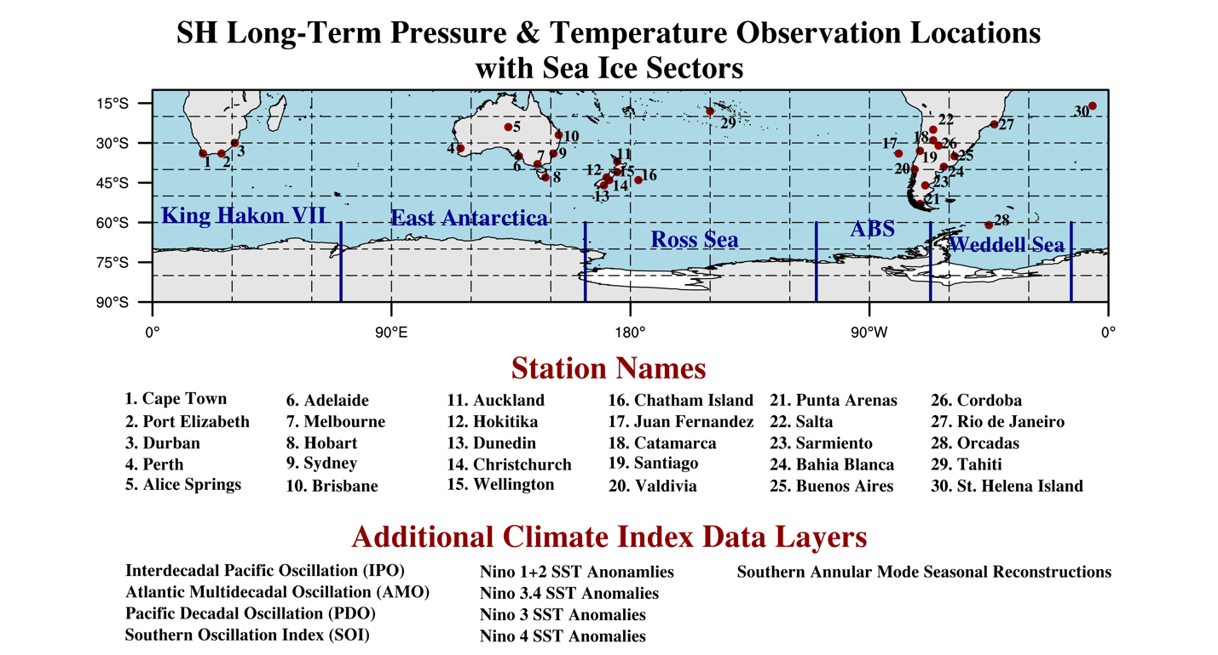
Figure S1. Map of predictor stations and sea ice sectors defined in Raphael and Hobbs (2014)¹.

References
1. Raphael, M. N. & Hobbs, W. The influence of the large-scale atmospheric circulation on Antarctic sea ice during ice advance and retreat seasons. Geophys. Res. Lett. 41, 5037–5045 (2014).

