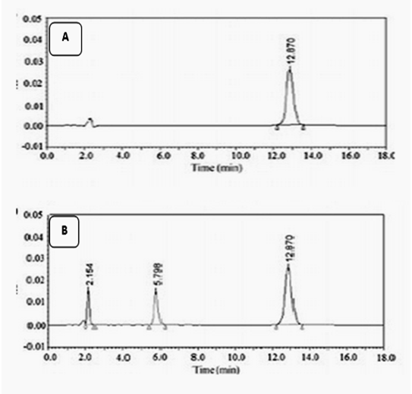
S1: HPLC chromatograms of A, AFM1 standard (3.6 ng mL⁻¹); B, sample of Karish cheese

