Different synthetic chemical dispersants elicit distinct bacterial community responses to crude oil

Ciara Keating^{1#}, Laura Duran Suja^{2#}, Stephen Summers^{1,3}, Ian M. Head⁴, Umer. Z. Ijaz^{5*}, Tony Gutierrez¹*

¹Department of Engineering, Durham University, Durham, DH1 3LE, UK
²Institute of Mechanical, Process and Energy Engineering, School of Engineering and Physical Sciences, Heriot-Watt University, Edinburgh EH14 4AS, UK
³The Singapore Centre for Environmental Life Sciences Engineering, Nanyang Technological University, Singapore 637551, Singapore
⁴School of Natural and Environmental Sciences, Newcastle University, Newcastle Upon Tyne, UK
⁵School of Engineering, University of Glasgow, Glasgow, G12 8LT, UK

#Joint first authors, authors contributed equally
*Joint corresponding authors:
Tony Gutierrez Tony.Gutierrez@hw.ac.uk ; Umer Ijaz Umer.Ijaz.@glasgow.ac.uk

Running Title: Chemical dispersant affects bacterial response

Keywords: dispersant; oil spill; biodegradation; marine oil snow (MOS); marine dispersant snow (MDS); Faroe-Shetland Channel; microbial community

Supplementary Information

- Supplementary Methods
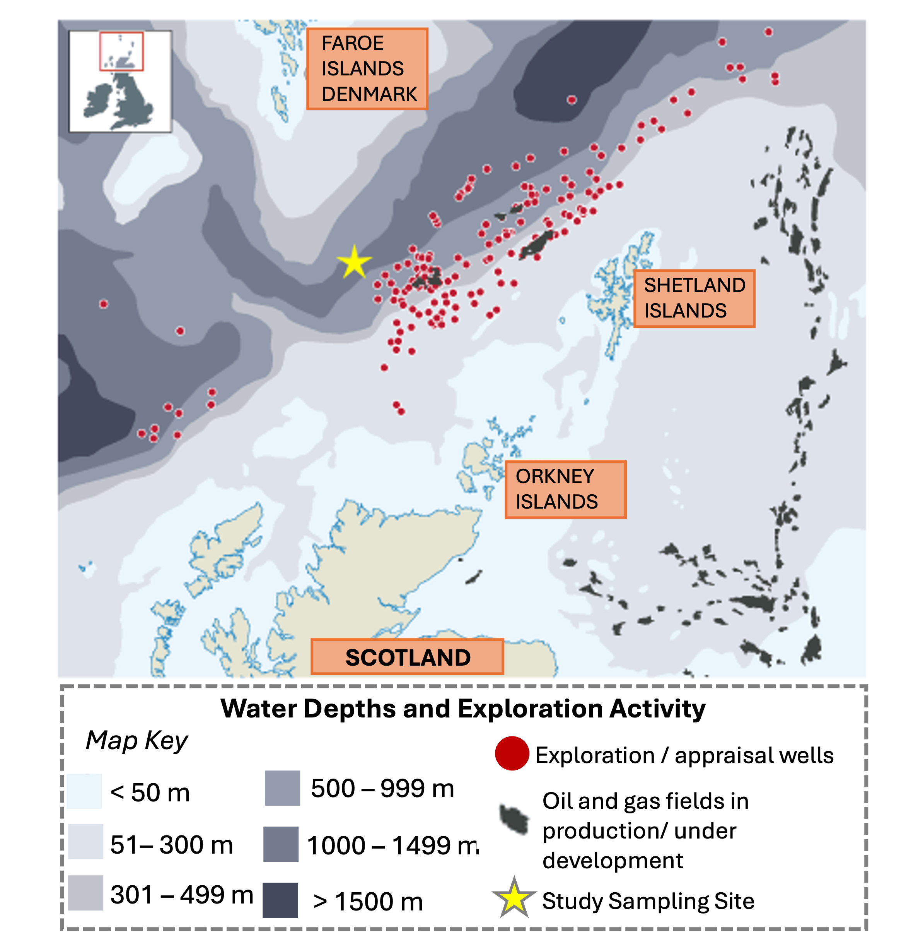
Supplementary Figure S1. Map of the Faroe-Shetland Channel (FSC) that runs between the Faroe and Shetland Isles to the north of Scotland, and showing the oil and gas fields that are in production or under development, as well as the exploration and appraisal wells in this region and to the east in the North Sea. The yellow star marks the sampling site. Figure is an adaptation from Thompson et al. (2020) [1].

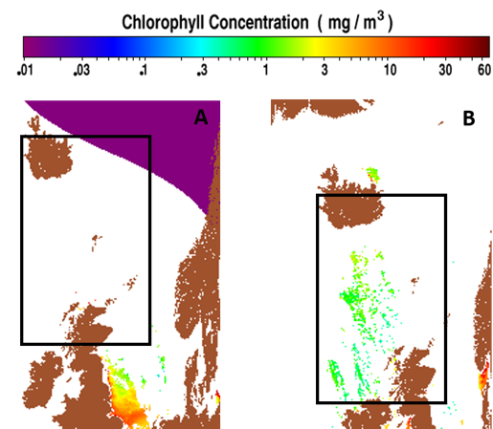

Supplementary Figure S2. Location of the sampling area chl a concentrations (in mg/m³) in surface waters of the FSC at the respective sampling times A: December 2015; B: October 2017. These were available online from the MODIS Aqua data of NASA (sea surface on 8-day averages) as produced with the Giovanni online data system – developed and maintained by the NASA GES DISC.

Supplementary Table S1. Treatments, their designated names and components. Sw, seawater; N, nutrients; O, crude oil; D, Superdispersant 25; Dsew, Slickgone-EW; Dsns, Slickgone-NS.

Treatment No. | Treatment name | Treatment components
Treatments used in the December (winter) 2015 study
1 | Sw | Seawater only
2 | Sw+N | Seawater and nutrients
3 | Sw+O | Seawater and oil
4 | Sw+D | Seawater and Superdisperant 25
5 | Sw+O+D | Seawater, oil and Superdisperant 25
6 | Sw+O+D+N | Seawater, oil, Superdisperant 25 and nutrients
Treatments used in the October (fall) 2017 study
1 | Sw | Seawater only
2 | Sw+N | Seawater and nutrients
3 | Sw+O | Seawater and oil
4 | Sw+O+N | Seawater, oil and nutrients
5 | Sw+Dsew | Seawater and Slickgone-EW
6 | Sw+Dsns | Seawater and Slickgone-NS
7 | Sw+Dsew+N | Seawater, Slickgone-EW and nutrients
8 | Sw+Dsns+N | Seawater, Slickgone-NS and nutrients
9 | Sw+O+Dsew | Seawater, oil and Slickgone-EW
10 | Sw+O+Dsns | Seawater, oil and Slickgone-NS
11 | Sw+O+Dsew+N | Seawater, oil, Slickgone-EW and nutrients
12 | Sw+O+Dsns+N | Seawater, oil, Slickgone-NS and nutrients

Note: Sw+O+N was not included in the 2015 study.

Supplementary Table S2. Identity of aromatic hydrocarbons which were identified by GC-MS.
Hydrocarbon name | Abbreviation
2-methylnaphthalene | 2-MN
1-methylnaphthalene | 1-MN
triaromatic steroid-20 | TAS-20
triaromatic steroid-21 | TAS-21
triaromatic steroid-26-S | TAS-26-S
triaromatic steroid-26-R | TAS-26-R
triaromatic steroid-27-S | TAS-27-S
triaromatic steroid-27-R | TAS-27-R
triaromatic steroid-28-R | TAS-28-R
triaromatic steroid-29 | TAS-29
Phenanthrene | Phe
1,3,7-trimethylnaphthalene | 1,3,7-TMN
1,3,6-trimethylnaphthalene | 1,3,6-TMN
(1,3,5+1,2,6)-tri-methylnaphthalene | 1,3,5+1,2,6-TMN
2,3,6--trimethylnaphthalene | 2,3,6-TMN
1,2,7-trimethylnaphthalene | 1,2,7-TMN
1,2,4-trimethylnaphthalene | 1,2,4-TMN
1,2,5-trimethylnaphthalene | 1,2,5-TMN
Naphthalene | Nap
2-ethylnaphthalene | 2-EN
1-ethylnaphthalene | 1-EN
(2,6+2,7)-dimethylnaphthalene | 2,6+2,7-DMN
(1,3+1,7)-dimethylnaphthalene | 1,3+1,7-DMN
1,6-dimethylnaphthalene | 1,6-DMN
(1,4+2,3)-dimethylnaphthalene | 1,4+2,3-DMN
1,5-dimethylnaphthalene | 1,5-DMN
1,2-dimethylnaphthalene | 1,2-DMN

Supplementary Figure S3. Top 20 phyla with the highest coverage difference between primer sets. The mean coverage (%) per pair is indicated on the x-axis and the individual phyla are shown on the y-axis.

Supplementary Table S3. Table showing the summaries of the classification methods (Naïve Bayes Classifier or Bayesian Lowest Common Ancestor) and denoising algorithms (Dada2 or Deblur) per hypervariable region (V3-V4 or V4). To join the 2015 and 2017 studies and create a phylogenetic tree for downstream analysis we needed full 16S rRNA sequences, therefore ASVs which were not classified needed to be removed. Procrustes and Mantel tests were employed to assess what beta-diversity was lost. An R² value of >0.8 indicates strong correlations which are in an acceptable range along with the corresponding p-values. Bayesian Lowest Common Ancestor classification and Deblur provided the best strategy for collation.

Classification and Denoising Method | Region | Procrustes test R² value | Procrustes  p-value | Mantel test R² value | Mantel p-value
Naïve Bayes Classifier + Dada2 | V3-V4 | 0.1798 | 0.308 | 0.2557079 | 0.0001
Naïve Bayes Classifier + Dada2 | V4 | 0.5227 | 0.001 | 0.385567 | 0.0001
Naïve Bayes Classifier + Deblur | V3-V4 | 0.2237 | 0.414 | 0.09837368 | 0.0495
Naïve Bayes Classifier + Deblur | V4 | 0.6354 | 0.001 | 0.4799481 | 0.0001
Bayesian Lowest Common Ancestor + Dada2 | V3-V4 | 0.5276 | 0.001 | 0.8772589 | 0.0001
Bayesian Lowest Common Ancestor + Dada2 | V4 | 0.8741 | 0.001 | 0.9948328 | 0.0001
Bayesian Lowest Common Ancestor + Deblur | V3-V4 | 0.7097 | 0.001 | 0.998239 | 0.0001
Bayesian Lowest Common Ancestor + Deblur | V4 | 0.9144 | 0.001 | 0.994251 | 0.0001

- Supplementary Results

Supplementary Figure S4 (A) MDS formation in treatments amended with Superdispersant 25 in the absence of crude oil compared to (B) MDS that formed in treatments with Slickgone NS or (C) with Slickgone EW. (D) MOS aggregates that formed in the SW+O+N treatment with the dispersant Slickgone EW, or (E) with Slickgone NS. (F, G) Epifluorescence micrographs of MDS that formed in seawater treatments amended with Superdispersant 25 after staining with acridine orange. (H) Marine snow that formed in the SW+N treatments as observed under the epifluorescence microscope after staining with acridine orange showed very few associated prokaryotic cells (bright green dots) compared to (I) MOS formed in the SW+Oil+N treatments amended with Superdispersant 25 showing abundant associated prokaryotic cells. In panels F and G, large pale-green shapes are discs or "blobs" of dispersant. In panels F–I, small green dots are prokaryotic cells associated with either MDS or MOS. Bar, 10μm.

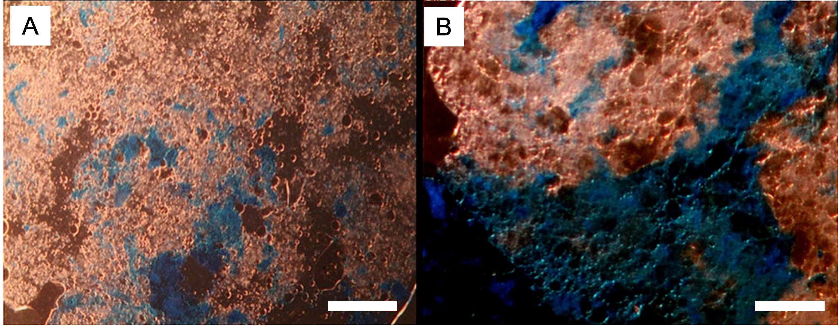
Supplementary Figure S5. MOS which formed in the SW+O+N treatments amended with the dispersant Superdispersant 25 after staining with (A) Coomassie brilliant blue G, or with (B) Alcian Blue shows the MOS particles composed of polysaccharide and protein. Bar, 50 µm.

Supplementary Figure S6. Microbial beta diversity from samples across both sampling regimes and experiments. A) Principal Coordinates Analysis based on Unifrac dissimilarity with colour-coded circles representing the different treatment groups over time. B) The same ordination is constrained, showing the subset of ASVs which best correlated with the observed dissimilarity between samples as the full abundance table.

Supplementary Figure S7. Microbial diversity measures from the mesocosm experiments. Alpha-diversity measures (Pielou’s evenness and Fisher’s Alpha) from the 2015 (A) and 2017 (C) studies. The x-axis shows the treatment names and the y-axis shows the observed values. Beta-diversity of the microbial communities from the 2015 (B) and 2017 (D) studies using Bray-Curtis dissimilarity. Statistical analysis: in A) and C) pair-wise statistical analysis was carried out; * values indicates a significant difference with * = p < 0.05, ** = p < 0.01, and *** = p < 0.001. In B) and D) PERMANOVA (permutational multivariate ANOVA) was carried out using ‘Time’ [the sampling time-period] and ‘Treatment’ [the group condition].

Supplementary Figure S8. The core microbiome of genera found in 85% of samples from the treatments in the 2015 study (at > 0.01% relative abundance): A) seawater (Sw), B) seawater and crude oil (Sw+O), C) seawater and Superdispersant 25 (Sw+D), and D) seawater and oil and Superdispersant 25 (Sw+O+D).

Supplementary Figure S9. sPLS-DA heatmap of the discriminant amplicon sequence variants (ASVs) >1% relative abundance in the 2015 study. Rows and columns are ordered using hierarchical (average linkage) clustering to identify blocks of ASVs of interest. The heatmap depicts TSS + CLR (Total Sum Scaling followed by Centralised Log Ratio) normalised abundances: high abundance (orange/yellow) and low abundance (dark purple). Time-point (T0, T1, T2, T4 and T6) and Treatment (Sw, Sw+D, Sw+O, and Sw+O+D) are indicated in coloured groupings. sPLS-DA was fine-tuned using max.dist and 6 tuning components.

Supplementary Figure S10. The core microbiome of genera found in 85% of individuals in the treatments of the 2017 study (at > 0.01% relative abundance): A) seawater (Sw), B) seawater and the dispersant Slickgone EW (Sw+Dsew), C) seawater and crude oil (Sw+O), and D) oil with Slickgone NS (Sw+O+Dsns). Note; Sw+Dsns (seawater and Slickgone NS) and Sw+O+Dsew (oil with Slickgone EW) are not presented as the core microbiome consisted solely of Alcanivorax under the criteria used.

Supplementary Figure S11. sPLS-DA heatmap of the discriminant amplicon sequence variants (ASVs) >1% relative abundance in the 2017 study. Rows and columns are ordered using hierarchical (average linkage) clustering to identify blocks of ASVs of interest. The heatmap depicts TSS + CLR (Total Sum Scaling followed by Centralised Log Ratio) normalised abundances: high abundance (orange/yellow) and low abundance (dark purple). Time-point (T2, T4 and T6) and Treatment (Sw, Sw+Dsew, Sw+Dsns, Sw+O, Sw+O+Dsew, and Sw+O+Dsns) are indicated in coloured groupings. sPLS-DA was fine-tuned using centroids.dist and 2 tuning components.

