Section 4.10 - System Implementation and User Interface
This section presents the practical implementation of the duress-enabled banking system through user interface screenshots demonstrating core functionality from account registration through normal and duress operational modes, showcasing how the system maintains security while ensuring intuitive navigation.
Fig. 3
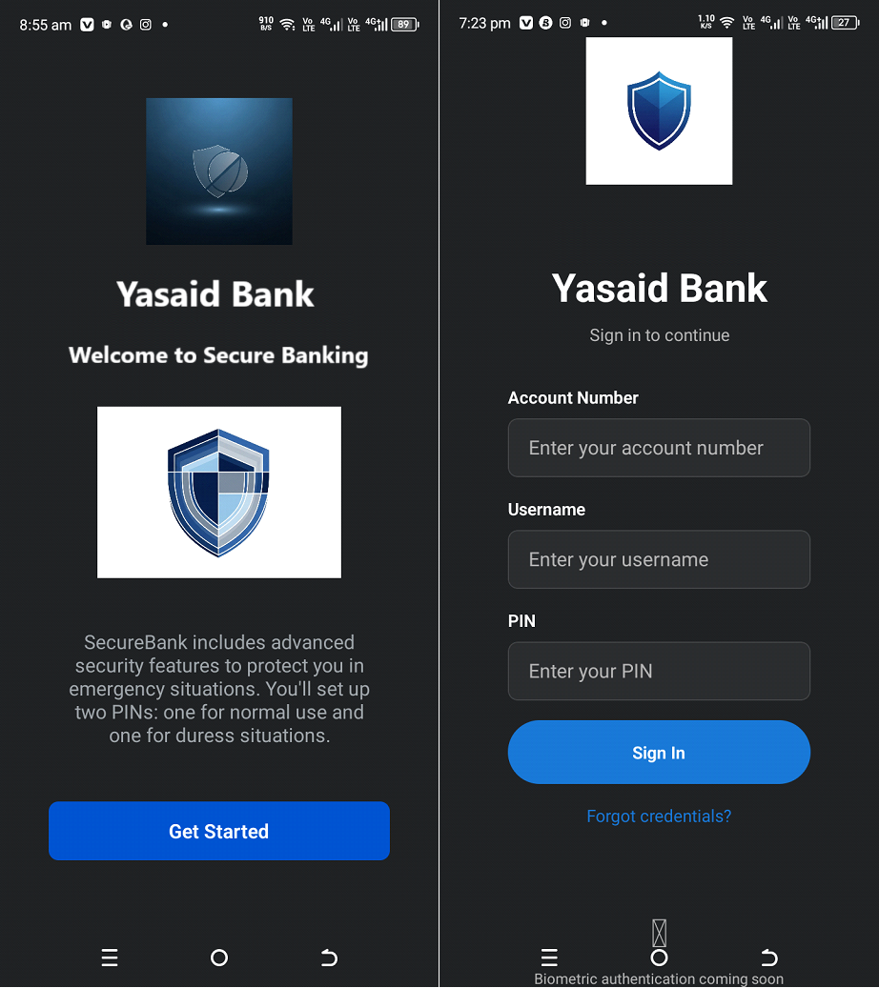
Account Creation and Registration Interface
As shown in Figure 3, it is the phase for the initial account registration screen displaying user information input fields, including full name, username, and pin creation with security requirements.
Fig. 4
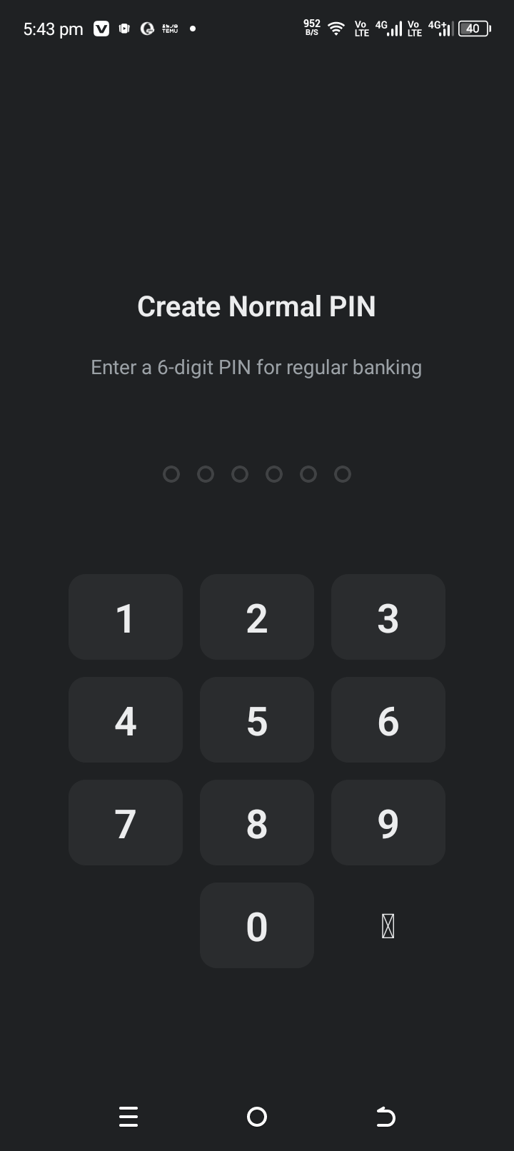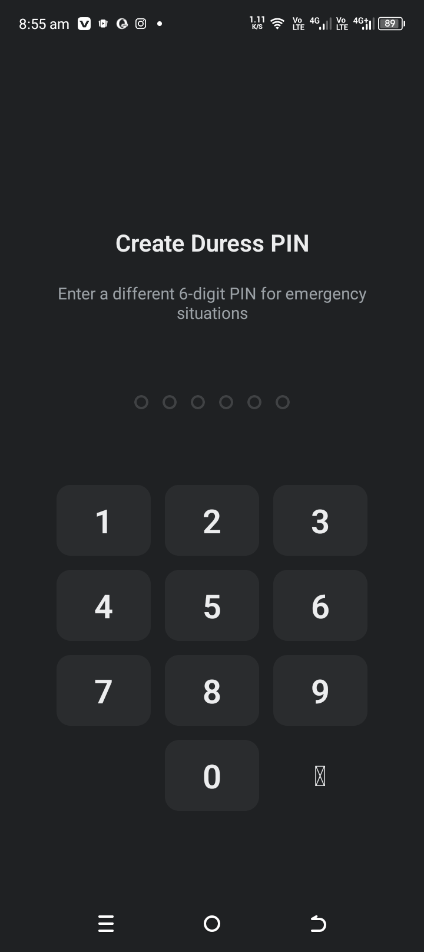
Normal and Duress PIN Configuration Screen
Figure 4 shows the Normal and Duress PIN setup interface allowing users to create a secondary authentication credential distinct from their primary PIN for emergency situations. a covert security mechanism that serves as the cornerstone of the system's protective functionality. The screen guides users to create a PIN that differs from their normal authentication credential, ensuring clear differentiation between regular and emergency access modes. The system implements validation logic to prevent users from accidentally setting identical PINs for both normal and duress modes, which would compromise the security architecture.
Fig. 5
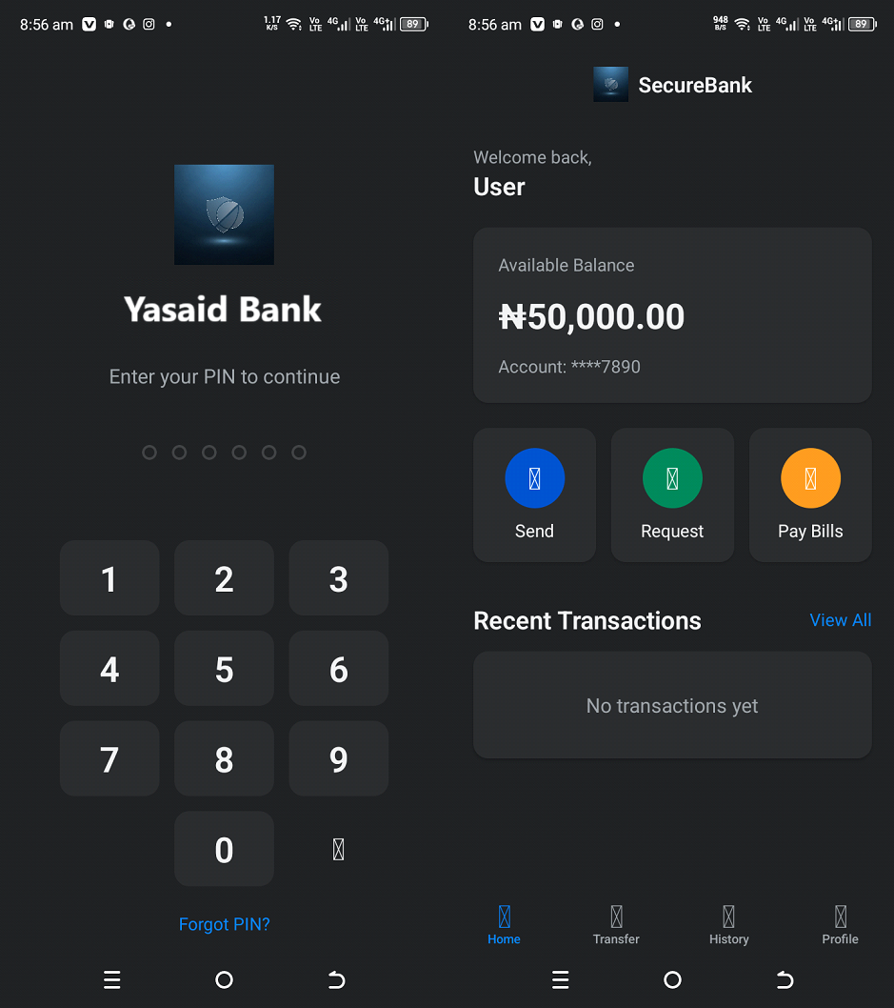Primary Dashboard and Account Overview for Normal PIN
Figure 5 as seen above shows the main dashboard interface displaying full account balance, upon entering the normal PIN recent transaction history, and navigation menu for accessing core banking functions. The primary dashboard serves as the control center for users operating in normal authentication mode. It presents comprehensive account information, including current balance, recent transactions, and quick-access buttons for common banking operations such as transfers, bill payments, and account settings.
Fig. 6
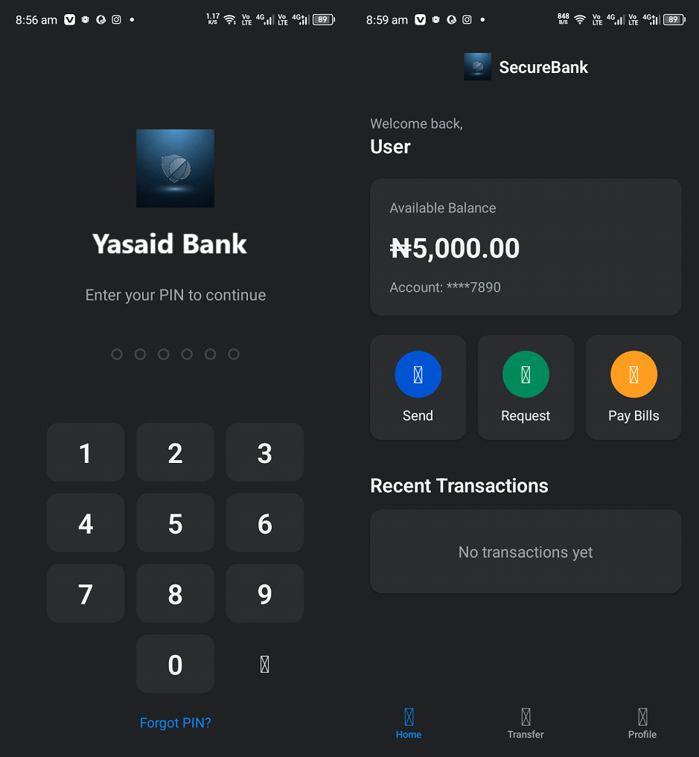Duress Mode Dashboard (Restricted View)
Figure 6 shows the Duress mode dashboard showing limited account information (10% of the actual balance) and restricted transaction capabilities to protect user assets during coercion. This interface demonstrates the system's protective mechanism when activated through duress credentials. The dashboard intentionally displays only a fraction of the actual account balance, creating the appearance of limited funds that reduces the coercer's incentive to demand larger transfers. Navigation options are deliberately restricted, with cash withdrawal and point-of-sale payment functions disabled, leaving only controlled interbank transfers available.
Fig. 7
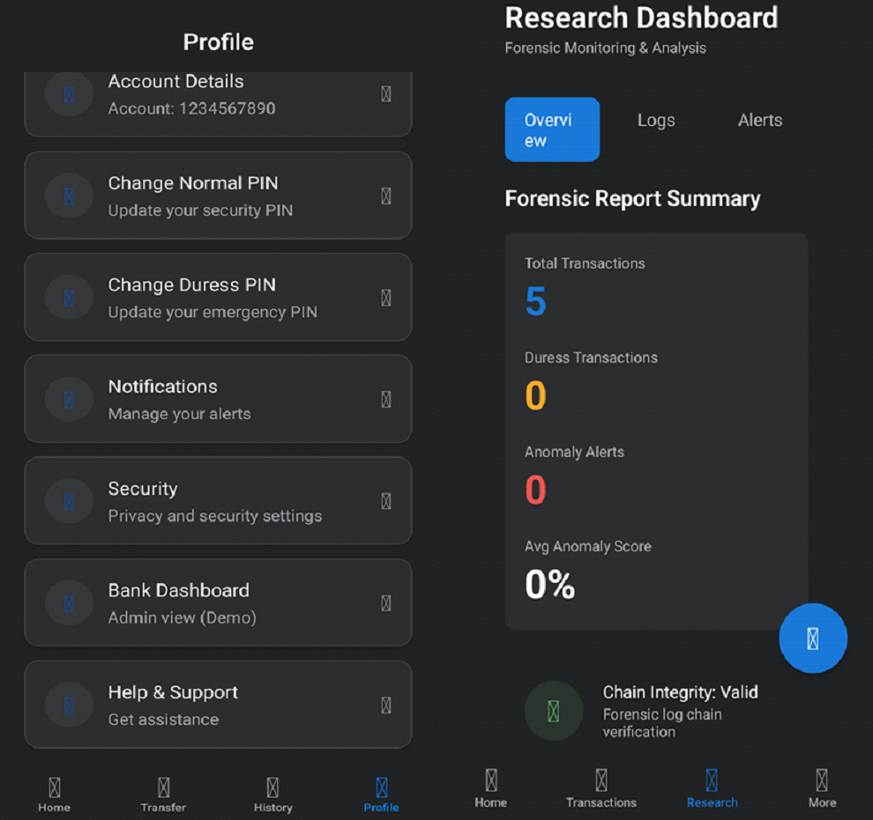
Profile and Forensic Dashboard Overview
Figure 7 displays the user Profile settings alongside the Forensic Research Dashboard, summarizing recent account activity, including total transactions, duress activity, anomaly alerts, and log-chain integrity status.
Fig. 8
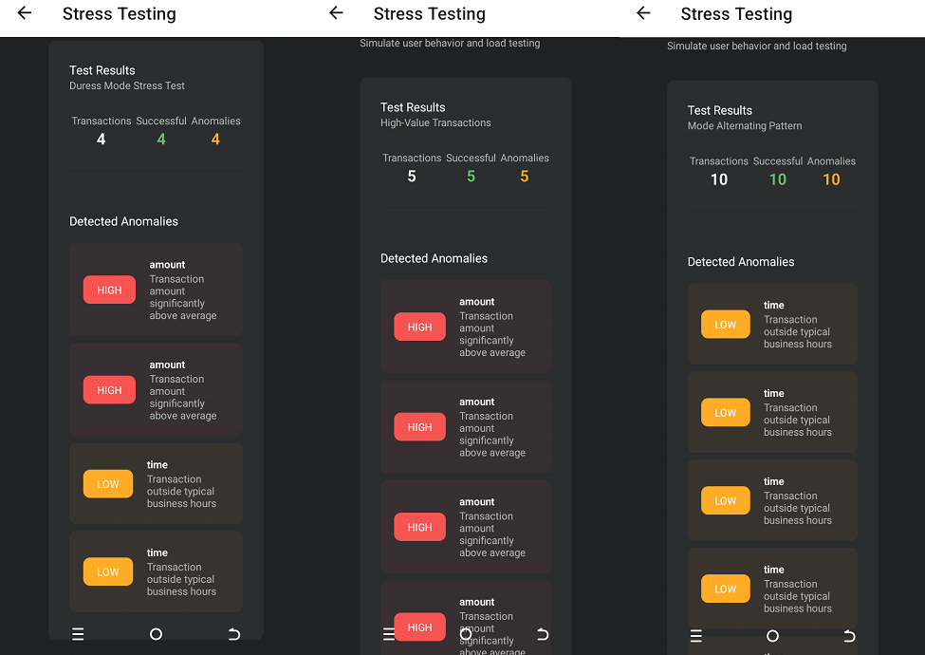
Stress Testing Results
Figure 8 presents the outcomes of three stress-testing scenarios used to evaluate anomaly-detection performance under different transactional conditions: Duress Mode, High-Value Transactions, and Alternating Pattern. Across the tests, the system consistently flagged irregularities such as unusually high transaction amounts and activities occurring outside normal business hours. The Duress Mode test recorded 4 transactions with 4 anomalies, primarily elevated amounts and off-hour actions. The High-Value Transaction test produced 5 anomalies, all linked to significantly above-average amounts. The Alternating Pattern scenario generated 10 anomalies, dominated by time-related deviations. Together, these results demonstrate the system’s ability to detect financial behavior anomalies across diverse stress conditions.

