Supplementary Material

Population-Based Characterization of PTEN Hamartoma Tumor Syndrome
Gideon Idumah, Chloe Bautista, Lin Li, Lamis Yehia, Ying Ni

Supplementary Table 1: Comparison of Demographic and Cancer-Related Characteristics by Pathogenic Significance
Variable | Carriers of P/LP PTEN Variant  N = 55¹ | Carriers of PTEN Variant of Uncertain Significance  N = 342² | p-value³
Sex |  |  | >0.9
Female | 31 (59.6%) | 205 (60.5%)
Male | 21 (40.4%) | 134 (39.5%)
Race |  |  | <0.001
American Indian or Alaska Native | 0 (0%) | 9 (2.6%)
Asian | * | 8 (2.3%)
Black or African American | * | 84 (24.6%)
Middle Eastern or North African | 0 (0%) | 2 (0.6%)
More than one population | * | 11 (3.2%)
Native Hawaiian or Other Pacific Islander | 0 (0%) | 0 (0%)
Other/Unspecified | * | 61 (17.8%)
White | 36 (65%) | 167 (48.8%)
Cancer Diagnosis |  |  | <0.001
No | 24 (52.2%) | 189 (80.1%)
Yes | 22 (47.8%) | 47 (19.9%)
Age at First Cancer Diagnosis | 48 (8 – 67) | 61 (23 – 85) | <0.001
¹Counts of 20 or fewer are suppressed as '*' in compliance with AOU guidelines
²n (%); Median (Min – Max)
³p-values calculated using Kruskal-Wallis test for age and Chi-Squared test for others.

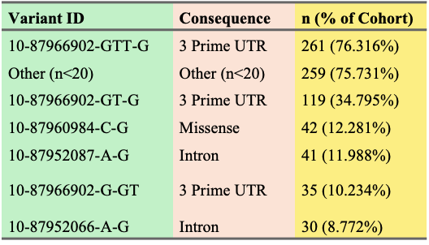
List of PTEN Variants of Unspecified Significance

Supplementary Figure 1: Characterization of Participants with PTEN Variants of Uncertain Significance (VUS)
- Age at First Cancer Diagnosis by Variant Group

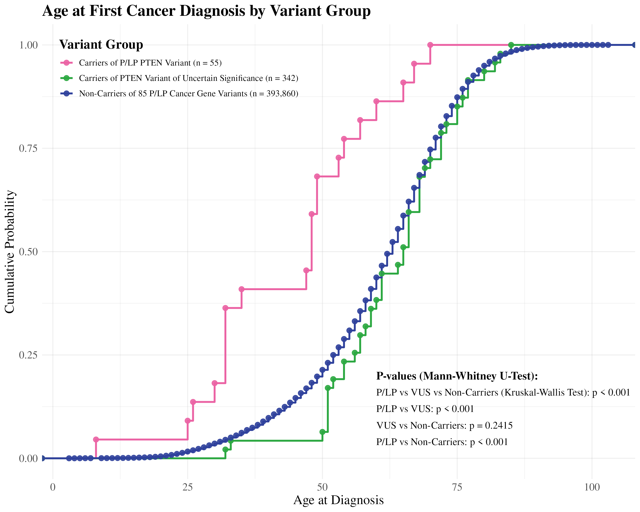

B. Phenotypic Data of Carriers of PTEN VUS

