Edlinger et al., Agricultural management and pesticide use reduce the phosphorus uptake capability of beneficial plant symbionts

Supplementary material
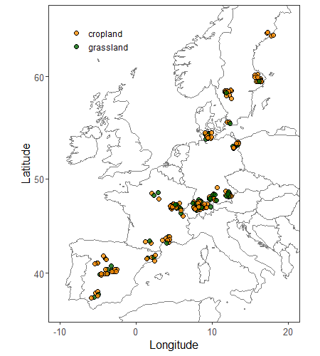
Figure S1: Sampling locations of the grassland (green) and cropland soils (orange) along the trans-European gradient.

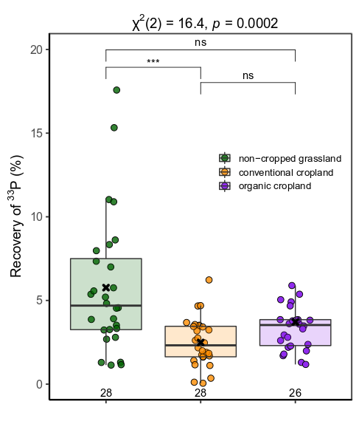
Fig. S2: Differences in ³³P recovery in grassland (green), conventionally (orange) and organically managed (purple) cropland covering field sites in Switzerland and Southern Germany (area Landshut and Augsburg) (n=82). Asterisks indicate significant differences (*** p<0.001), ”ns” no significant difference between the groups.

Table S1: Range (minimum to maximum values) of fungicide application events, number of different active ingredients used and the total amount of active ingredients applied during the year before sampling. Correlation matrix showing Spearman's correlation coefficient for the 33P recovery and the fungicide variables. Significant correlations are indicated as *** p<0.001, * p<0.05.
 | range (min.-max.) | ³³P recovery | No. of application events | No. of active compounds
No. of application events | 0 - 3 | -0.29***
No. of active compounds | 0 - 11 | -0.20* | 0.75***
Amount of active compounds (kg ha⁻¹) | 0 - 3.48 | -0.12 | 0.68*** | 0.92***

Appendix A:
Assessment of crop diversity and crop cover, following Garland et al. (2021)⁸:
Crop diversity was estimated using a Simpson diversity index (D₂) following equation (1):
$$D_{2}= \frac{1}{\sum_{i=1}^{S}{{p_{i }}^{2}}}$$ | Eq. (1)

Where S is the number of species cultivated in each site across the last ten years since the field sampling and p_{i} is the proportional abundance across the time for the crop species i. Proportional abundance across the time was estimated by using the equation (2):
$$p_{i}=\frac{\sum_{j=1}^{P}{{cover}_{ij }M_{ij}}}{M_{t}}$$ | Eq. (2)

Where cover_{ij} represents the annual proportional abundance of the crop species i in the year j, M_{ij} the number of months in the year j with the species i presents in the field and M_{t} the number of total months in the last ten years since the sampling (i.e., 120 months). The annual proportional abundance of each crop species was one when the species was cultivated alone (we assumed that it covered 100% of the field) or less than one when the species was cultivated as a mixed crop, being this value equivalent to the seed mass ratio present in the commercial mix used by the farmer.
The proportion of crop cover was defined as the number of months with plant cover divided by the total number of months in the crop rotation period. This estimate reflects the amount of time the soil was with a living plant cover, irrespective of plant type.

Appendix B
To assess AMF root colonization, P. lanceolata roots were washed with deionized water after harvest, cut and stored in falcon tubes with 70% EtOH solution. To estimate the percentage of root colonization by AMF we followed the procedure of Vierheilig et al. (1998)¹. In brief, roots were cleared in 10% KOH in a water bath at 80 C° for 30 min and stained with a 5% ink-vinegar solution for 40 min. Roots were prepared on a microscopy slide and colonization was measured with a light microscope at a magnification of x 200 using a modified line-intersection method for a hundred intersections per sample (McGonigle et al., 1990)².
For quantification of AMF in the hyphal compartment using qPCR, DNA was extracted from 400mg of the frozen (-80 °C) soil samples of the hyphal compartment using the Nucleo Spin® soil kit (Macherey-Nagel, Germany) ³. DNA was quantified using a Quant-iT™ PicoGreen™ dsDNA Assay Kit (Invitrogen, Thermo Fisher Scientific, USA) on a Varian Cary Eclipse fuorescence spectrometer (Varian Cary Eclipse, Agilent Technologies, USA). For later qPCR analysis, DNA samples were diluted to a final concentration of 5 ng/µl. The reaction volumes were 20 µl and contained onefold HOT FIREPol EvaGreen qPCR Mix Plus (Solis Biodyne, Tartu, Estonia), 0.3% bovine serine albumin, 250 nM of each primer, and 1 µl of DNA sample. The AMF community was quantified based on the 18S rRNA gene fragment, amplified with the primers AMG1F (Hewins et al. 2015)⁴ and AM1 (Helgason et al. 1998)⁵. Negative controls were included in each run and qPCR assays were run in duplicate on a CFX96 Touch™ Real-Time PCR Detection System and C1000 Touch™ Thermal Cycler (BioRad Laboratories, USA). The program consisted of 15 minutes at 95°C for denaturation, then at 62°C for 15 second for annealing, 30 seconds at 72°C for elongation, 10 minutes at 72°C and at the end heated up from 65°C to 95°C in 0.5°C steps for the melting curve analysis. The analysis was run through for 45 cycles. The raw data were exported from Bio-Rad CFX Manager 3.1 and imported into LinRegPCR version 2016.0 ⁶ to investigate the cycle number to threshold and efficiency using the default baseline threshold from LinRegPCR.

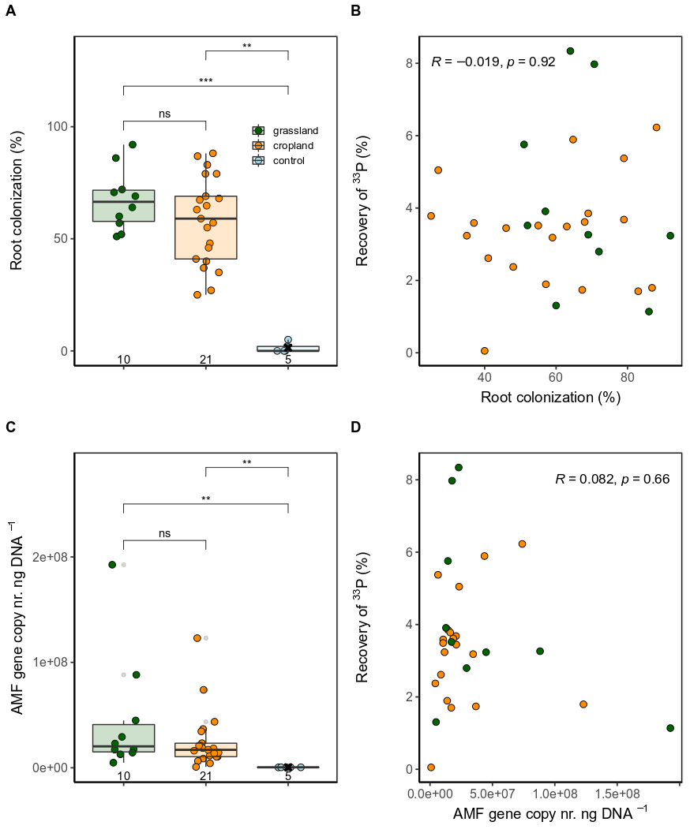Figure S3: Differences in AMF root colonization (A) and AMF abundance in the hyphal compartment (C) in grassland, cropland, and control soils using a subset (n=36). Correlations between ³³P recovery and root colonization (B), as well as AMF abundance (D) in field soils of the respective subset. Numbers at the bottom of the left panels correspond to the number of observations per group. Asterisks indicate significant differences (*** p<0.001, ** p<0.01), ”ns” no significant difference between the groups. R = Spearman’s rank correlation coefficient.

Supplementary tables S2 and S3 see Excel file

Figure S4: Relationship between the soil microbial biomass C (A) and soil available P (B) with the ³³P recovery in grassland (green) and cropland soils (orange). Asterisks indicate a significant relationship at p<0.001 (***). The grey polygon marks a confidence level of 0.95.

Figure S5: Relationships of the shoot biomass with soil mineral N (sqrt Nmin) (A), and the total P uptake with available soil P (sqrt P Olsen) (B) in the grassland (green) and cropland soils (orange). Asterisks indicate a significant relationship at p<0.001 (***). The grey polygon marks a confidence level of 0.95.

Table S4: Spearman's rank coefficients of correlations between the measured plant output parameters (hyphal P transfer, shoot biomass, total P uptake and N:P ratio) in the grassland and cropland soils. Asterisks indicate signficant differences at p<0.001 (***), p<0.01 (**) and p<0.01 (*).
 |  |  | ³³P recovery
 |  |  | across all sites |  | grassland |  | cropland
Shoot biomass |  | -0.13 |  | -0.09 |  | -0.14
Total P uptake |  | -0.04 |  | -0.34** |  | 0.13
plant N:P |  | 0.05 |  | 0.46*** |  | -0.19*

Figure S6: The relationship between hyphal P transfer activity (measured as ³³P recovery in the shoots) and the shoot N:P ratio (scale log-transformed) in grassland (A) and cropland soils (B). The polygons frame the upper and lower confidence level (0.95). Asterisks indicate the significanes of the relationships at p<0.001 (***) and p<0.05 (*).

Table S5: Output parameters resulting from the model averaging approach used to explain hyphal P transfer in grassland soils (A.). Additionally, the parameters of the best model (highest AICc), including the model fit (adjusted R²) are shown (B.) Significant p-values (p<0.05) are highlighted in bold.
A. | Averaged, coefficients (unconditional) | Coefficient estimate | Std. Error | Adjusted Std. Error | z-value | p-value | Relative importance
(Intercept) |  | 1.279 | 0.064 | 0.066 | 19.494 | 0.000
Aridity |  | -0.219 | 0.087 | 0.089 | 2.460 | 0.014 | 0.204
pH |  | 0.373 | 0.078 | 0.080 | 4.642 | 0.000 | 0.346
Olsen P |  | -0.274 | 0.067 | 0.068 | 4.019 | 0.000 | 0.254
SOC |  | 0.149 | 0.071 | 0.072 | 2.065 | 0.039 | 0.138
Silt |  | -0.019 | 0.047 | 0.048 | 0.389 | 0.697 | 0.057
B. | Best model (R²adj. = 0.47) | Coefficient estimate | Std. Error | t-value |  | p-value
(Intercept) |  | 1.279 | 0.064 | 19.942 |  | 0.000
Aridity |  | -0.214 | 0.086 | -2.486 |  | 0.016
pH |  | 0.370 | 0.078 | 4.733 |  | 0.000
Olsen P |  | -0.276 | 0.066 | -4.175 |  | 0.000
SOC |  | 0.146 | 0.070 | 2.084 |  | 0.042

Table S6: A. Averaged, unconditional coefficients of the best models within an AICc range < 2 (i.e., 15 models), used to explain hyphal P transfer in cropland soils (Fig. 3 B). Additionally, the parameters of the best model (highest AICc), including the model fit (adjusted R²) are shown (B.) Significant p-values (p<0.05) are highlighted in bold.
A. | Averaged coefficients (unconditional) | Coefficient estimate | Std. Error | Adjusted Std. Error | z-value | p-value | Relative importance
(Intercept) |  | 2.745 | 0.155 | 0.156 | 17.57 | 0.000
pH |  | 0.514 | 0.180 | 0.181 | 2.842 | 0.004 | 0.108
Soil bacteria Shannon |  | -0.327 | 0.252 | 0.254 | 1.287 | 0.198 | 0.085
Soil cercozoa Shannon |  | 0.339 | 0.191 | 0.192 | 1.760 | 0.078 | 0.074
Crop Shannon |  | 0.399 | 0.194 | 0.195 | 2.043 | 0.041 | 0.084
Tillage intensity |  | 0.286 | 0.168 | 0.169 | 1.690 | 0.091 | 0.063
Fungicide applications |  | -0.701 | 0.176 | 0.177 | 3.963 | 0.000 | 0.147
Silt |  | 0.013 | 0.064 | 0.064 | 0.199 | 0.842 | 0.039
Annual temperature |  | -0.013 | 0.074 | 0.074 | 0.169 | 0.866 | 0.045
Nmin |  | -0.080 | 0.177 | 0.178 | 0.447 | 0.655 | 0.069
Fertilizer Nmin added |  | -0.009 | 0.061 | 0.061 | 0.146 | 0.884 | 0.036
Nmin:Pmin |  | 0.073 | 0.172 | 0.172 | 0.426 | 0.670 | 0.066
Soil archaea Shannon |  | -0.007 | 0.047 | 0.048 | 0.137 | 0.891 | 0.028
Soil C:N |  | -0.006 | 0.045 | 0.045 | 0.128 | 0.898 | 0.025
Soil N:P |  | -0.030 | 0.104 | 0.104 | 0.286 | 0.775 | 0.047
Olsen P |  | -0.005 | 0.041 | 0.041 | 0.113 | 0.910 | 0.022
SOC |  | -0.004 | 0.041 | 0.041 | 0.109 | 0.913 | 0.021
Organic fertilization |  | 0.005 | 0.043 | 0.044 | 0.107 | 0.915 | 0.022
Clay |  | -0.004 | 0.039 | 0.039 | 0.100 | 0.921 | 0.019
B. | Best model (R²adj. = 0.18) | Coefficient estimate | Std. Error | t-value |  | p-value
(Intercept) |  | 2.745 | 0.155 | 17.75 |  | 0.000
pH |  | 0.518 | 0.169 | 3.074 |  | 0.003
Soil bacteria Shannon |  | -0.406 | 0.212 | -1.918 |  | 0.057
Soil cercocoa Shannon |  | 0.367 | 0.178 | 2.065 |  | 0.041
Crop Shannon |  | 0.424 | 0.189 | 2.247 |  | 0.026
Tillage intensity |  | 0.299 | 0.156 | 1.908 |  | 0.058
Fungicide applications |  | -0.702 | 0.170 | -4.122 |  | 0.000

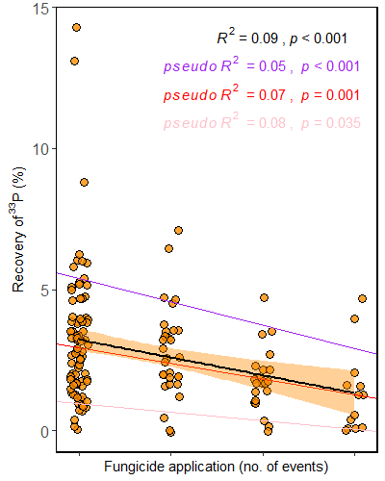
Figure S7: The relationship between hyphal P transfer activity (measured as ³³P recovery in the shoots) and the number of fungicide application events in cropland soils. The linear regression model is shown in black and the orange polygon frames the upper and lower confidence level (0.95). Purple, red, and pink lines and letters correspond to the 0.1, 0.5, and 0.9 quantile regression models, respectively.

References
1. Vierheilig, H., Coughlan, A. P., Wyss, U. & Piché, Y. Ink and Vinegar, a Simple Staining Technique for Arbuscular-Mycorrhizal Fungi. Appl. Environ. Microbiol. 64, 5004–5007 (1998).
2. McGonigle, T. P., Miller, M. H., Evans, D. G., Fairchild, G. L. & Swan, J. A. A new method which gives an objective measure of colonization of roots by vesicular—arbuscular mycorrhizal fungi. New Phytol. 115, 495–501 (1990).
3. Lazarevic, V., Gaïa, N., Girard, M., François, P. & Schrenzel, J. Comparison of DNA Extraction Methods in Analysis of Salivary Bacterial Communities. PLoS One 8, (2013).
4. Hewins, C. R., Carrino-Kyker, S. R. & Burke, D. J. Seasonal variation in mycorrhizal fungi colonizing roots of Allium tricoccum (wild leek) in a mature mixed hardwood forest. Mycorrhiza 25, 469–483 (2015).
5. Helgason, T., Daniell, T. J., Husband, R., Fitter, A. H. & Young, J. P. W. Ploughing up the wood-wide web? Nature 394, 431–431 (1998).
6. Ruijter, J. M. et al. Amplification efficiency: linking baseline and bias in the analysis of quantitative PCR data. Nucleic Acids Res. 37, e45–e45 (2009).
7. Garland, G. et al. Crop cover is more important than rotational diversity for soil multifunctionality and cereal yields in European cropping systems. Nat. Food 2, 28–37 (2021).
8. Garland, G. et al. Crop cover is more important than rotational diversity for soil multifunctionality and cereal yields in European cropping systems. Nat. Food 2, 28–37 (2021).

