Table 1: Baseline Table
VARIABLE | VALUE
Sex (male) | 26
Sex (female) | 23
Mean Age at Diagnosis | 85
Mean Gestational Age (weeks) | 33.25
Mean Birth Weight (kg) | 2.00
Race (White) | 40
Race (Black) | 3
Race (Asian) | 6
Origin (Hispanic, Latino or Spanish) | 31

Table 2: Primary Diagnosis
DIAGNOSIS | NUMBERS OF PATIENTS | PERCENTAGE (%)
Intestinal Volvulus | 16 | 32.7
Necrotizing Enterocolitis | 11 | 22.4
Intestinal Atresia | 7 | 14.3
Hirschsprung’s Disease | 3 | 6.1
Gastroschisis | 3 | 6.1
Congenital Enteropathy | 2 | 4.1
Meconium Ileus | 1 | 2.0

Table 3: Comorbidities

Table 4: Descriptive Statistics For Length And Diameter Change
Technique | Length change (mean, cm) | Length change (std) | Diameter change (mean, cm) | Diameter change (std)
LILT | 16.33 | 2.31 | 4.17 | 0.76
STEP | 8.38 | 4.44 | 3.44 | 1.27
SILT | 16.2 | 6.46 | 2.8 | 0.45

Table 5: Increase in Bowel Length by Surgical Technique
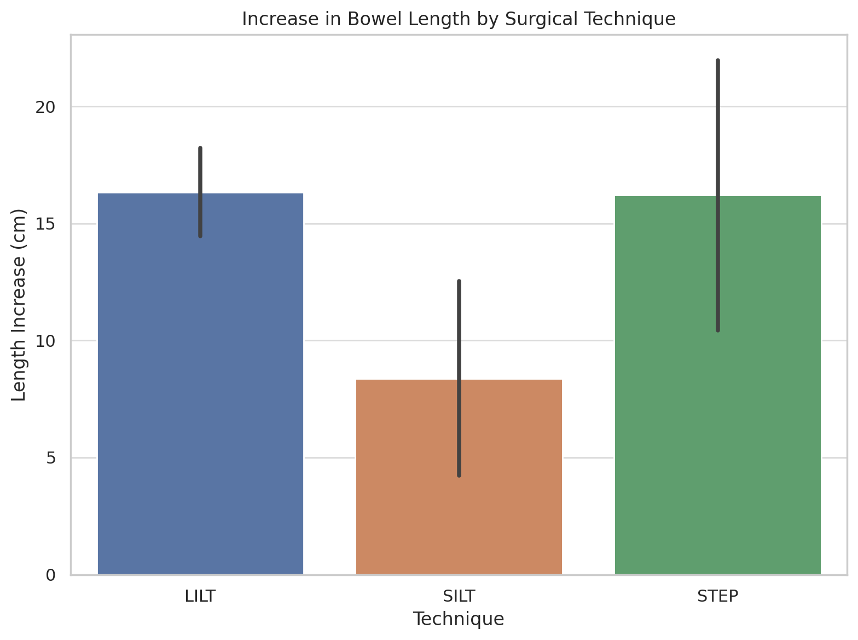
Table 6: Percentage Increase in Bowel Length by Surgical Technique
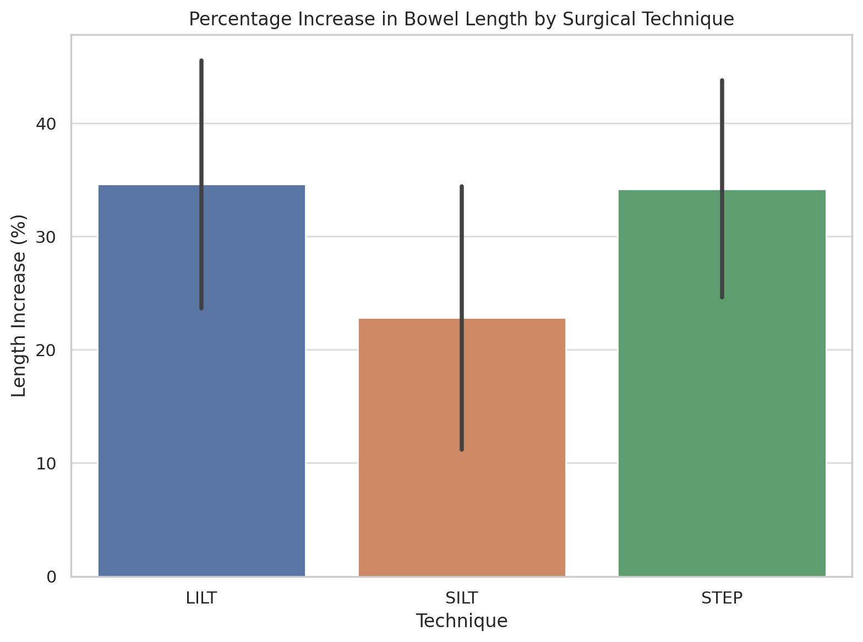

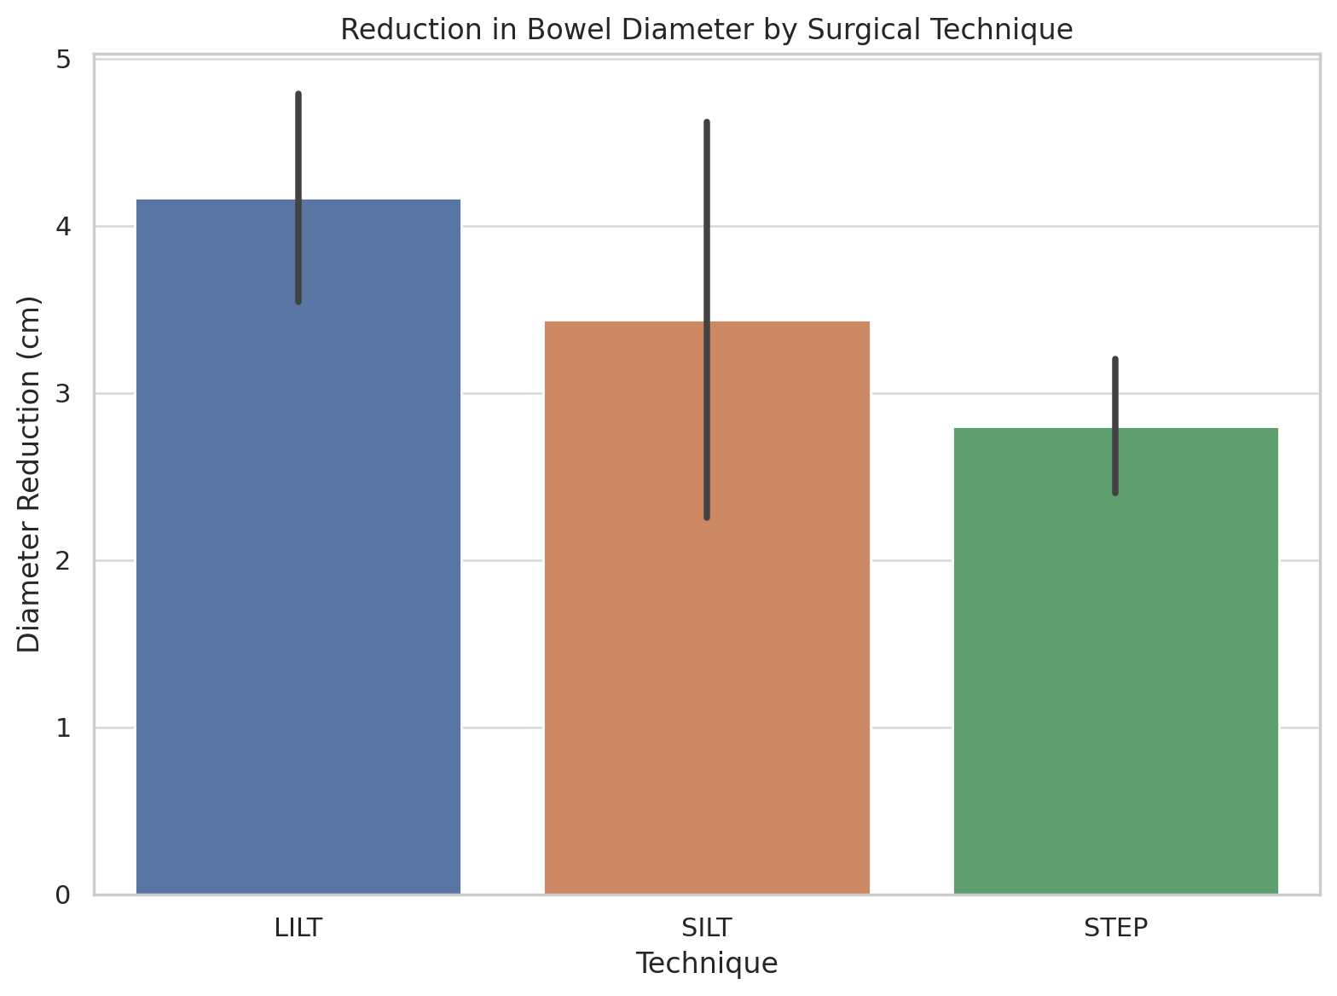

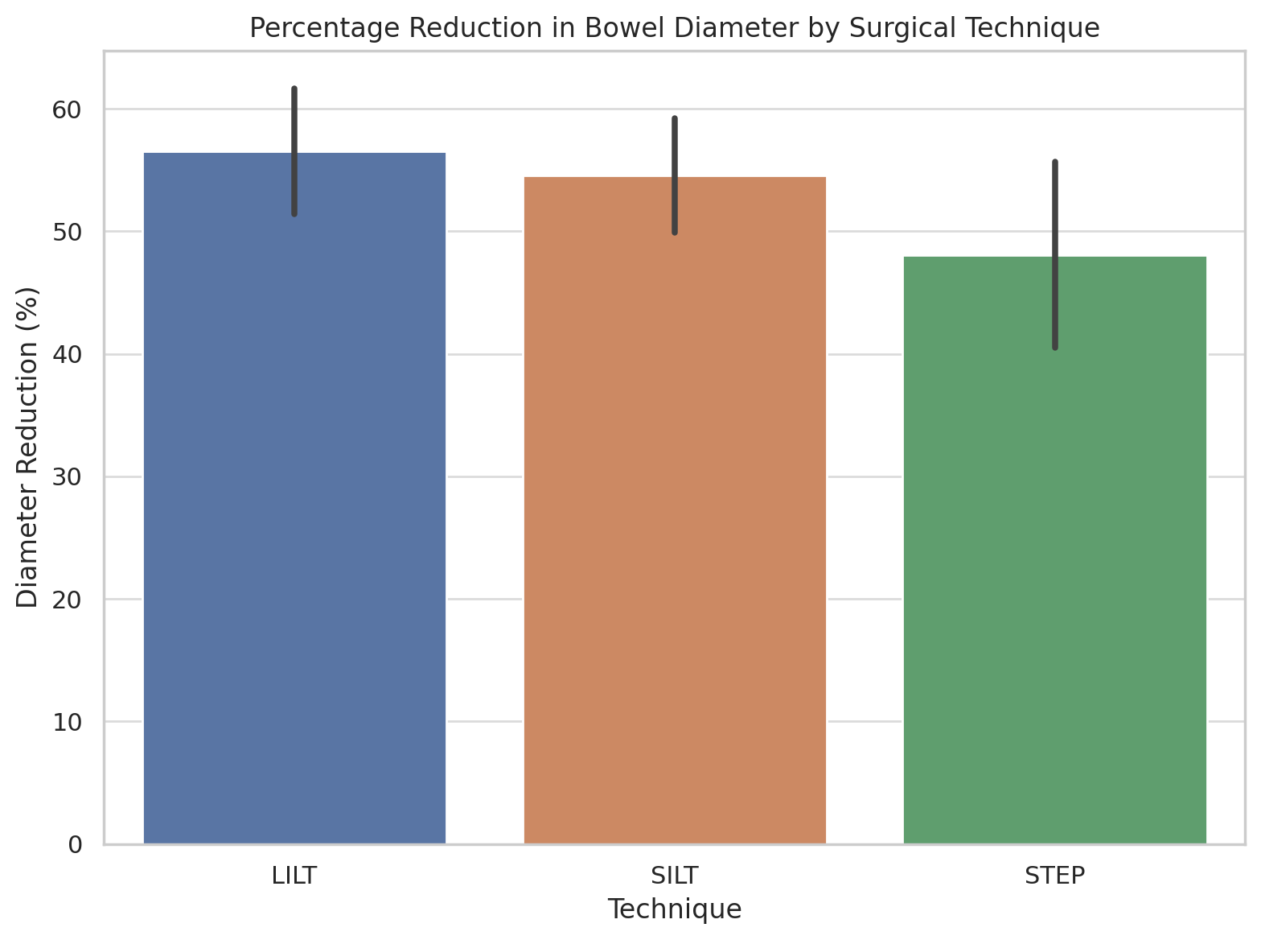

Table 7: Descriptive Statistic for Parenteral Volume Reduction
Technique | Timepoint | Mean Parenteral Volume (ml/Kg/die) | Mean Parenteral Volume  (% Reduction) | Std
LILT | 6 Months | 46.93 | 10.41 | 9.47
LILT | 12 Months | 40.47 | 26.84 | 24.61
LILT | 24 Months | 34.67 | 44.82 | 47.84
LILT | 48 Months | 33.67 | 46.79 | 46.39
STEP | 6 Months | 74.72 | 27.14 | 29.94
STEP | 12 Months | 76.32 | 45.58 | 33.34
STEP | 24 Months | 70.5 | 58.84 | 32.69
STEP | 48 Months | 48.66 | 72.25 | 29.97
SILT | 6 Months | 52.72 | 33.01 | 40.54
SILT | 12 Months | 41.83 | 34.43 | 37.52
SILT | 24 Months | 32.31 | 39.24 | 37.17
SILT | 48 Months | 23.4 | 52.01 | 32.07

Table 8: Percentage Reduction in Parenteral Volume by Surgical Technique Over Time
