Supplement
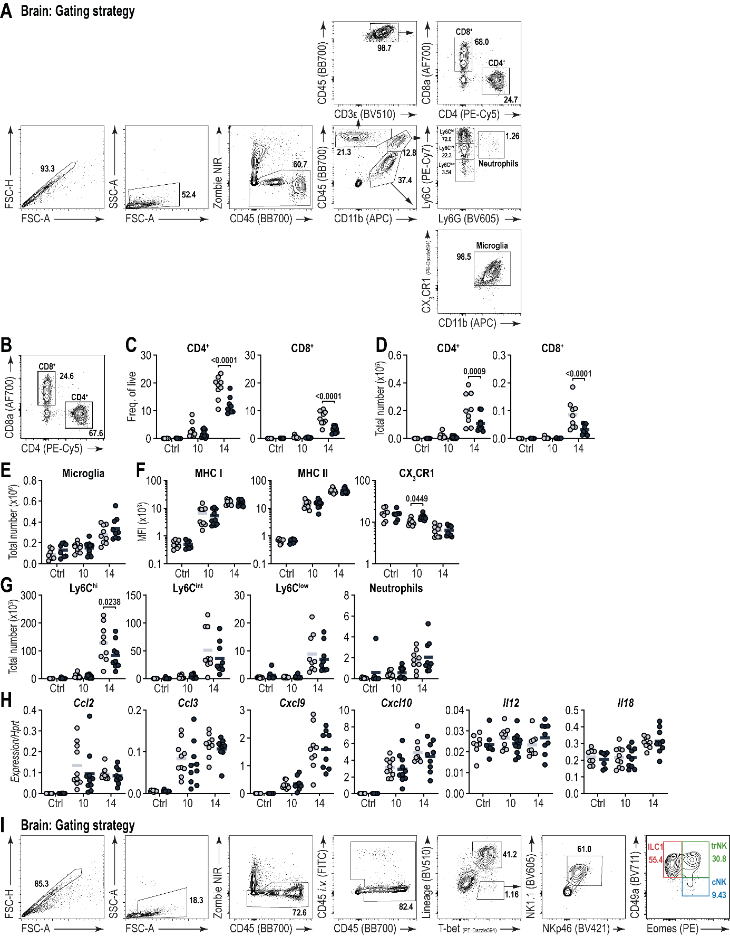
Figure S1. Related to Figure 1.
Wild-type C57Bl/6 mice with T. gondii or mock-infected (Control) and orally treated with FTY720 or diluent (see also Fig. 1A). Representative gating strategy of flow cytometry data from the brain shows (A) pre-gating (singlets/cells/viable), followed by gating on CD45⁺CD11b⁻CD3ε⁺ cells to identify CD4⁺ and CD8⁺ T cells, or CD45⁺CD11b⁺ cells to identify Ly6G⁻Ly6C^{hi}, Ly6G⁻Ly6C^{int}, Ly6G⁻Ly6C^{low} monocytes, and Ly6G⁺ neutrophils, or CD45^{low}CD11b⁺ cells to identify CX₃CR1⁺ microglia. Representative gating strategy of flow cytometry data from the brain shows (I) pre-gating (singlets/cells/viable), followed by gating on CD45⁺Lineage(CD3ε, CD5, CD8, CD19, Ly6G)⁻NKp46⁺NK1.1⁺ cells to identify Eomes⁺CD49a⁻ conventional NK (cNK) cells, Eomes⁺CD49a⁺ tissue-resident NK (trNK) cells, and Eomes⁻CD49a⁺ ILC1s. Individual values and mean are plotted.
Table S1: Categorical evaluation of the disease symptoms to calculate the disease score. The disease score is the sum of the maximum points from all four categories.
Symptom |  | Score
Body weight
 | <5% Reduction | 3
 | 5-10% Reduction | 5
 | 11-14% Reduction | 10
 | 11-19% Reduction | 15
 | >20% Reduction | 20
General state of health
 | Fur defects (reduced or excessive grooming) | 3
 | Unkept or dull fur, neglected orifices, bleared eyes, increased muscle tone | 5
 | Dirty fur, clotted or secreting orifices, abnormal posture, cloudy eyes, high muscle tone | 10
 | Cramps, paralysis (trunk muscles, extremities), "cat hump", breathing noises, animal feels cold | 20
Spontaneous behavior
 | Minor deviations from normal behavior | 1
 | Unusual behavior, including abnormally limited motor activity or hyperkinetics | 5
 | Self-isolation, lethargy; pronounced hyperkinetics or behavioural stereotypes; coordination disorders; pain reaction when touched | 10
 | Pain reaction with defensive reactions when touched, repeated pain sounds during grasping/touching; self-amputation (autoaggression, autotomy) | 20
Clinical observations
 | Minor deviations from the normal situation | 1
 | Changes in breathing (shallow breathing) | 10
 | Severe changes in breathing (gasping, etc.) | 20
Table S2: TaqMan probes used for gene expression analysis.
Gene | Assay ID
Hprt | Mm01545399_m1
Ifng | Mm00801778_m1
Il12a | Mm00434169_m1
Il15 | Mm00434210_m1
Il18 | Mm00434226_m1
Il7 | Mm01295805_m1
Irf8 | Mm00492567_m1
Tgfb1 | Mm01178820_m1
Tnf | Mm00443258_m1
Table S3: Oligonucleotide primers used for qPCR.
Gene | Oligonucleotide Sequences
Gene | Fw | Rc
Asl | 5’-TCTTCGTTAGCTGGCAACTCACCT-3’ | 5’-ATGACCCAGCAGCTAAGCAGATCA-3’
T. gondii B1 | 5’-GCATTGCCCGTCCAAACT-3’ | 5’-AGACTGTACGGAATGGAGACGAA-3’

1. Kovacs M, Dominguez-Belloso A, Ali-Moussa S, Deczkowska A. Immune control of brain physiology. Nat Rev Immunol. 2025.
2. Smyth LCD, Kipnis J. Redefining CNS immune privilege. Nat Rev Immunol. 2025.
3. Becher B, Derfuss T, Liblau R. Targeting cytokine networks in neuroinflammatory diseases. Nat Rev Drug Discov. 2024;23(11):862-79.
4. Heneka MT, van der Flier WM, Jessen F, Hoozemanns J, Thal DR, Boche D, et al. Neuroinflammation in Alzheimer disease. Nat Rev Immunol. 2024.
5. Weiner HL. Immune mechanisms and shared immune targets in neurodegenerative diseases. Nat Rev Neurol. 2025;21(2):67-85.
6. Wang X, Li J, Rebuffet L, Cheng M, Bao B, Chen Y, et al. Innate lymphoid cells originate from fetal liver-derived tissue-resident progenitors. Sci Immunol. 2025;10(109):eadu7962.
7. Fumagalli V, Venzin V, Di Lucia P, Moalli F, Ficht X, Ambrosi G, et al. Group 1 ILCs regulate T cell-mediated liver immunopathology by controlling local IL-2 availability. Sci Immunol. 2022;7(68):eabi6112.
8. Sparano C, Solis-Sayago D, Zangger NS, Rindlisbacher L, Van Hove H, Vermeer M, et al. Autocrine TGF-beta1 drives tissue-specific differentiation and function of resident NK cells. J Exp Med. 2025;222(3).
9. Romero-Suarez S, Del Rio Serrato A, Bueno RJ, Brunotte-Strecker D, Stehle C, Figueiredo CA, et al. The Central Nervous System Contains ILC1s That Differ From NK Cells in the Response to Inflammation. Front Immunol. 2019;10:2337.
10. Matta SK, Rinkenberger N, Dunay IR, Sibley LD. Toxoplasma gondii infection and its implications within the central nervous system. Nat Rev Microbiol. 2021.
11. Gazzinelli R, Xu Y, Hieny S, Cheever A, Sher A. Simultaneous depletion of CD4+ and CD8+ T lymphocytes is required to reactivate chronic infection with Toxoplasma gondii. J Immunol. 1992;149(1):175-80.
12. Landrith TA, Harris TH, Wilson EH. Characteristics and critical function of CD8+ T cells in the Toxoplasma-infected brain. Semin Immunopathol. 2015;37(3):261-70.
13. Nishiyama S, Pradipta A, Ma JS, Sasai M, Yamamoto M. T cell-derived interferon-gamma is required for host defense to Toxoplasma gondii. Parasitol Int. 2020;75:102049.
14. Sa Q, Ochiai E, Tiwari A, Perkins S, Mullins J, Gehman M, et al. Cutting Edge: IFN-gamma Produced by Brain-Resident Cells Is Crucial To Control Cerebral Infection with Toxoplasma gondii. J Immunol. 2015;195(3):796-800.
15. Figueiredo CA, Steffen J, Morton L, Arumugam S, Liesenfeld O, Deli MA, et al. Immune response and pathogen invasion at the choroid plexus in the onset of cerebral toxoplasmosis. J Neuroinflammation. 2022;19(1):17.
16. Suzuki Y, Lutshumba J, Chen KC, Abdelaziz MH, Sa Q, Ochiai E. IFN-gamma production by brain-resident cells activates cerebral mRNA expression of a wide spectrum of molecules critical for both innate and T cell-mediated protective immunity to control reactivation of chronic infection with Toxoplasma gondii. Front Cell Infect Microbiol. 2023;13:1110508.
17. Torcellan T, Friedrich C, Doucet-Ladeveze R, Ossner T, Sole VV, Riedmann S, et al. Circulating NK cells establish tissue residency upon acute infection of skin and mediate accelerated effector responses to secondary infection. Immunity. 2023.
18. Schuster IS, Wikstrom ME, Brizard G, Coudert JD, Estcourt MJ, Manzur M, et al. TRAIL+ NK cells control CD4+ T cell responses during chronic viral infection to limit autoimmunity. Immunity. 2014;41(4):646-56.
19. Klose CSN, Flach M, Mohle L, Rogell L, Hoyler T, Ebert K, et al. Differentiation of type 1 ILCs from a common progenitor to all helper-like innate lymphoid cell lineages. Cell. 2014;157(2):340-56.
20. Steffen J, Ehrentraut S, Bank U, Biswas A, Figueiredo CA, Holsken O, et al. Type 1 innate lymphoid cells regulate the onset of Toxoplasma gondii-induced neuroinflammation. Cell Rep. 2022;38(13):110564.
21. Baeyens AAL, Schwab SR. Finding a Way Out: S1P Signaling and Immune Cell Migration. Annu Rev Immunol. 2020;38:759-84.
22. French T, Steffen J, Glas A, Osbelt L, Strowig T, Schott BH, et al. Persisting Microbiota and Neuronal Imbalance Following T. gondii Infection Reliant on the Infection Route. Frontiers in Immunology. 2022;13.
23. Bank U, Deiser K, Plaza-Sirvent C, Osbelt L, Witte A, Knop L, et al. c-FLIP is crucial for IL-7/IL-15-dependent NKp46(+) ILC development and protection from intestinal inflammation in mice. Nat Commun. 2020;11(1):1056.
24. Rebejac J, Eme-Scolan E, Arnaud Paroutaud L, Kharbouche S, Teleman M, Spinelli L, et al. Meningeal macrophages protect against viral neuroinfection. Immunity. 2022;55(11):2103-17 e10.
25. Van Gassen S, Callebaut B, Van Helden MJ, Lambrecht BN, Demeester P, Dhaene T, et al. FlowSOM: Using self-organizing maps for visualization and interpretation of cytometry data. Cytometry A. 2015;87(7):636-45.
26. Becht E, McInnes L, Healy J, Dutertre CA, Kwok IWH, Ng LG, et al. Dimensionality reduction for visualizing single-cell data using UMAP. Nat Biotechnol. 2018.
27. Allen M, Poggiali D, Whitaker K, Marshall TR, van Langen J, Kievit RA. Raincloud plots: a multi-platform tool for robust data visualization. Wellcome Open Res. 2019;4:63.
28. Team RC. R: A Language and Environment for Statistical Computing. R Foundation for Statistical Computing, Vienna, Austria. 2024:https://www.R-project.org/.
29. Livak KJ, Schmittgen TD. Analysis of relative gene expression data using real-time quantitative PCR and the 2(-Delta Delta C(T)) Method. Methods. 2001;25(4):402-8.
30. Figueiredo CA, Dusedau HP, Steffen J, Gupta N, Dunay MP, Toth GK, et al. Immunomodulatory Effects of the Neuropeptide Pituitary Adenylate Cyclase-Activating Polypeptide in Acute Toxoplasmosis. Front Cell Infect Microbiol. 2019;9:154.
31. Merlini A, Haberl M, Strauss J, Hildebrand L, Genc N, Franz J, et al. Distinct roles of the meningeal layers in CNS autoimmunity. Nat Neurosci. 2022;25(7):887-99.
32. Schwartz M, Baruch K. The resolution of neuroinflammation in neurodegeneration: leukocyte recruitment via the choroid plexus. EMBO J. 2014;33(1):7-22.
33. Cowan MN, Sethi I, Harris TH. Microglia in CNS infections: insights from Toxoplasma gondii and other pathogens. Trends Parasitol. 2022;38(3):217-29.
34. Kvestak D, Juranic Lisnic V, Lisnic B, Tomac J, Golemac M, Brizic I, et al. NK/ILC1 cells mediate neuroinflammation and brain pathology following congenital CMV infection. J Exp Med. 2021;218(5).
35. Dunay IR, Fuchs A, Sibley LD. Inflammatory monocytes but not neutrophils are necessary to control infection with Toxoplasma gondii in mice. Infect Immun. 2010;78(4):1564-70.
36. Biswas A, Bruder D, Wolf SA, Jeron A, Mack M, Heimesaat MM, et al. Ly6C(high) monocytes control cerebral toxoplasmosis. J Immunol. 2015;194(7):3223-35.
37. Biswas A, French T, Dusedau HP, Mueller N, Riek-Burchardt M, Dudeck A, et al. Behavior of Neutrophil Granulocytes during Toxoplasma gondii Infection in the Central Nervous System. Front Cell Infect Microbiol. 2017;7:259.
38. Gasteiger G, Fan X, Dikiy S, Lee SY, Rudensky AY. Tissue residency of innate lymphoid cells in lymphoid and nonlymphoid organs. Science. 2015;350(6263):981-5.
39. Huang Y, Mao K, Chen X, Sun MA, Kawabe T, Li W, et al. S1P-dependent interorgan trafficking of group 2 innate lymphoid cells supports host defense. Science. 2018;359(6371):114-9.
40. Dutton EE, Gajdasik DW, Willis C, Fiancette R, Bishop EL, Camelo A, et al. Peripheral lymph nodes contain migratory and resident innate lymphoid cell populations. Sci Immunol. 2019;4(35).
41. Ito T, Ishida Y, Zhang Y, Guichard V, Zhang W, Han R, et al. ILC2s navigate tissue redistribution during infection using stage-specific S1P receptors. bioRxiv. 2024.
42. Castro-Rojas C, Deason K, Hussain RZ, Hayardeny L, Cravens PC, Yarovinsky F, et al. Testing effects of glatiramer acetate and fingolimod in an infectious model of CNS immune surveillance. J Neuroimmunol. 2014;276(1-2):232-5.
43. Orchanian SB, Still K, Harris TH, Lodoen MB. Deficiency in astrocyte CCL2 production reduces neuroimmune control of Toxoplasma gondii infection. PLoS Pathog. 2024;20(1):e1011710.
44. Babcock IW, Sibley LA, Labuzan SA, Cowan MN, Sethi I, Alemu S, et al. Caspase-1 in Cx3cr1-expressing cells drives an IL-18-dependent T cell response that promotes parasite control during acute Toxoplasma gondii infection. PLoS Pathog. 2024;20(10):e1012006.
45. Kovacs MA, Cowan MN, Babcock IW, Sibley LA, Still K, Batista SJ, et al. Meningeal lymphatic drainage promotes T cell responses against Toxoplasma gondii but is dispensable for parasite control in the brain. Elife. 2022;11.
46. Abt MC, Lewis BB, Caballero S, Xiong H, Carter RA, Susac B, et al. Innate Immune Defenses Mediated by Two ILC Subsets Are Critical for Protection against Acute Clostridium difficile Infection. Cell Host Microbe. 2015;18(1):27-37.
47. Weizman OE, Adams NM, Schuster IS, Krishna C, Pritykin Y, Lau C, et al. ILC1 Confer Early Host Protection at Initial Sites of Viral Infection. Cell. 2017;171(4):795-808 e12.
48. Shannon JP, Vrba SM, Reynoso GV, Wynne-Jones E, Kamenyeva O, Malo CS, et al. Group 1 innate lymphoid-cell-derived interferon-gamma maintains anti-viral vigilance in the mucosal epithelium. Immunity. 2021.
49. Coombs RS, Overacre-Delgoffe AE, Bhattacharjee A, Hand TW, Boyle JP. Mouse innate resistance to Neospora caninum infection is driven by early production of IFNgamma by NK cells in response to parasite ligands. mSphere. 2024;9(11):e0025524.
50. Gattinoni L, Finkelstein SE, Klebanoff CA, Antony PA, Palmer DC, Spiess PJ, et al. Removal of homeostatic cytokine sinks by lymphodepletion enhances the efficacy of adoptively transferred tumor-specific CD8+ T cells. J Exp Med. 2005;202(7):907-12.
51. Martin CE, Spasova DS, Frimpong-Boateng K, Kim HO, Lee M, Kim KS, et al. Interleukin-7 Availability Is Maintained by a Hematopoietic Cytokine Sink Comprising Innate Lymphoid Cells and T Cells. Immunity. 2017;47(1):171-82 e4.
52. Schuster IS, Sng XYX, Lau CM, Powell DR, Weizman OE, Fleming P, et al. Infection induces tissue-resident memory NK cells that safeguard tissue health. Immunity. 2023;56(3):531-46 e6.
53. Roberts LB, Kelly AM, Hepworth MR. There's no place like home: How local tissue microenvironments shape the function of innate lymphoid cells. Mucosal Immunol. 2025.
54. Cortez VS, Cervantes-Barragan L, Robinette ML, Bando JK, Wang Y, Geiger TL, et al. Transforming Growth Factor-beta Signaling Guides the Differentiation of Innate Lymphoid Cells in Salivary Glands. Immunity. 2016;44(5):1127-39.
55. Lopes N, Galluso J, Escaliere B, Carpentier S, Kerdiles YM, Vivier E. Tissue-specific transcriptional profiles and heterogeneity of natural killer cells and group 1 innate lymphoid cells. Cell Rep Med. 2022;3(11):100812.
56. Asahi T, Abe S, Cui G, Shimba A, Nabekura T, Miyachi H, et al. Liver type 1 innate lymphoid cells lacking IL-7 receptor are a native killer cell subset fostered by parenchymal niches. Elife. 2023;12.
57. Porte R, Belloy M, Audibert A, Bassot E, Aida A, Alis M, et al. Protective function and differentiation cues of brain-resident CD8+ T cells during surveillance of latent Toxoplasma gondii infection. Proc Natl Acad Sci U S A. 2024;121(24):e2403054121.
58. Pournajaf S, Dargahi L, Javan M, Pourgholami MH. Molecular Pharmacology and Novel Potential Therapeutic Applications of Fingolimod. Front Pharmacol. 2022;13:807639.

