Table 2. Image and symbol cases from the TBU maps and the choices made in the annotation process. The same situations and choices were used for manual cleaning of the shapefile maps after prediction of presence and absence categories.
Cases | Description | Choice
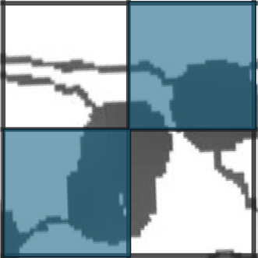 | Black dots or bird’s eye dots overlapping more than one grid cell. the upper example shows four grid cells, where three black dots overlap all, but only count in the grid cells, which overlap the centre of the black dot (blue shade). | Each dot was counted only once, within a single 10 × 10 km grid cell. When a dot overlapped or was predicted to overlap multiple grid cells, we manually assigned it to the grid cell containing the largest proportion of the dot’s area. In cases where the overlap was visually ambiguous, we used the QGIS measurement tool to determine the shortest distance from the circle’s perimeter to the grid cell borders, assigning the dot to the cell with the greatest area coverage based on these measurements.
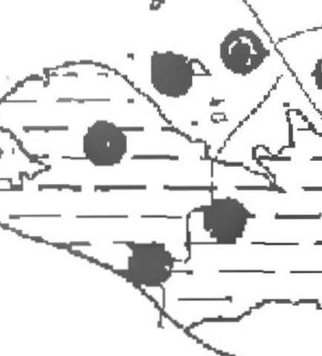 | Black dots or bird’s eye dots overlapping with dashed horizontal black lines. | If a dot occurred within a grid cell that also contained dashed lines, it was categorized as present rather than ‘here and there, since dots represent herbarium or field records, while dashed hatching are based on expert estimates.
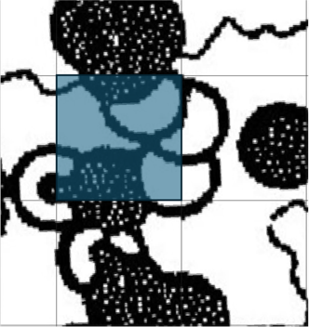 | Dots, full hatching or dashed hatching in the same grid cell as open circles. In this example, black dots overlap with open dots in the same grid cell shaded blue. | Dots and full hatching were prioritized in classification. Therefore, when a grid cell contained both black dots and open dots (symbol for vanished occurrences), the cell was categorized as presence.
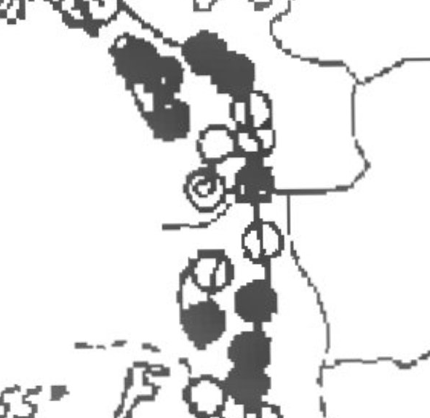 | Divergent use of symbols. In this example, open circles that otherwise represent disappearance of a species represent Spartina × townsendii agg. in a map otherwise made to show Spartina alterniflora × maritima | In some maps, open and black dots were used to denote subspecies rather than their standardized meanings. In these cases, we did not distinguish between subspecies, but merged them at species level, reassigning their symbols to the presence category (‘1’; Table 1).
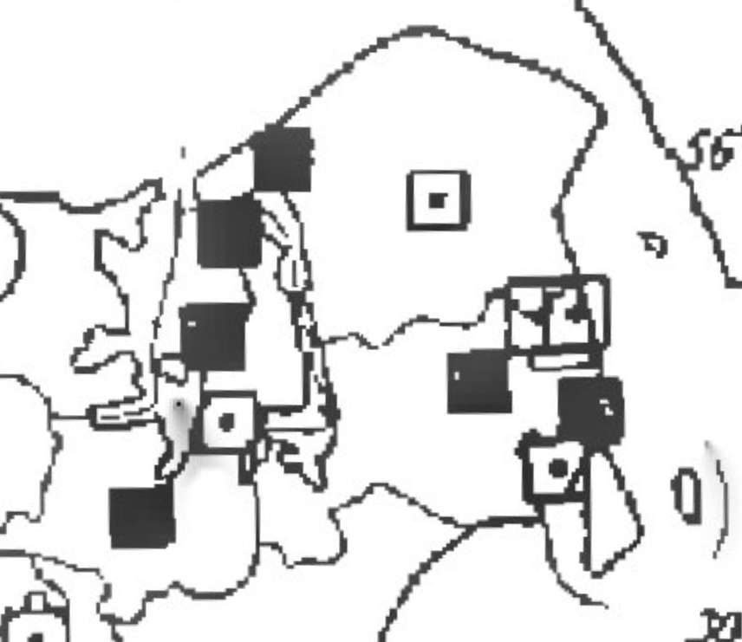 | Non-standard symbols. This example shows squares used to represent Galium pumilum ssp. vulgatum, while the standard dots have been used to represent Galium pumilum ssp. slesvicense. | A few maps included additional symbols for presence (category ‘1’; Table 1), such as squares, crosses, or triangles, often used to depict multiple subspecies on the same map. These were rarely recognized by the image recognition algorithm due to insufficient training data, and were manually corrected by consulting the original map legends in the TBU publications.
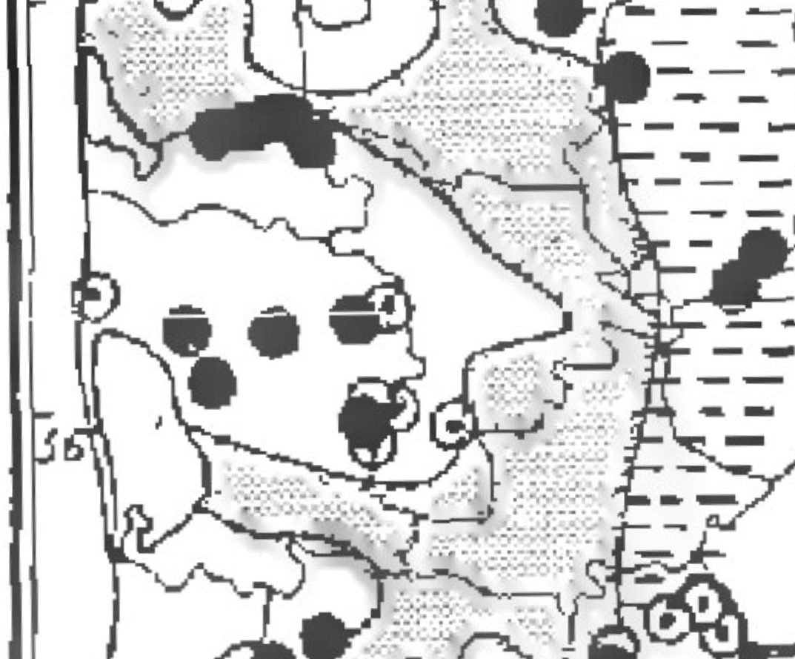 | Uncertain symbols (e.g question marks, shades on the map). In this example, the grey shade represents heath vegetation in Western Jutland, which was used to interpret regional absence of Galium pumilum subsp. septentrionale. | When symbol interpretation was uncertain or equivocal, we referred to the regional occupancy descriptions provided in the TBU publications to guide classification decisions.

