- Simple water tank experiment to explore the conditions of stable cavitation and inertial cavitation

1.1. Practice

As shown in Appendix Figure 1, distilled water was poured into a clean basin (a). The 5 ml of 0.9% sodium chloride solution and SonoVue contrast agent powder were thoroughly mixed and injected into the basin and gently mixed. The U5–15L ultrasound probe was placed flat on the water surface, and the operating interface of the ultrasound machine was set to “Vflash” mode. Parameters such as acoustic power, frequency, pulse length, and pulse repetition frequency were adjusted, and the changes in the mechanical index (MI) and the timing of contrast agent microbubble bursting on the ultrasound screen were observed.

1.2. Results

No significant contrast agent bursting was observed in the MI range of 0.2–0.4 (b, d, f), which corresponds to the stable cavitation range. Microbubbles initiated rupture at an approximate MI of 0.4. Significant contrast agent bursting occurred at MI 0.7 (c, e, g), indicating the initiation of inertial cavitation.

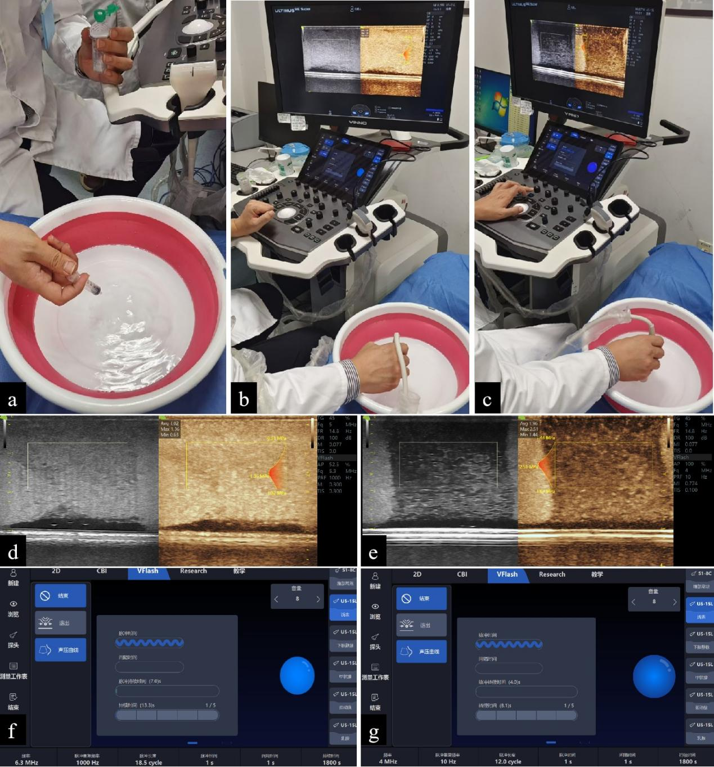

Appendix Figure 1. Simple water tank.
(a–c) represents the operation of USMC. (d–e) represents the cavitation images displayed on the ultrasound screen with two different kinds of MI (d: low MI, e: high MI). The left half of (d) and (e) are grayscale images, and the right half are contrast-enhanced ultrasound images. (f) and (g) represent the parameters during two kinds of cavitation corresponding to (d) and (e), respectively.

- Preliminary experiments using ultrasound-stimulated microbubble cavitation (USMC) with a low MI (0.3) to improve vascular permeability

After initially exploring the MI range (0.2 – 0.4) required for stable cavitation in a simplified water bath experiment, we set the MI to 0.3. This is because we retrieved a recently published study (PMID: 37757603) comparing the effects of different MI during USMC in mice with colon cancer. The authors found that the contrast agent perfusion volume in colon cancer lesions was highest when MI was 0.3. We designed animal experiments as follows to further verify that an MI of 0.3 can indeed play a role in improving vascular permeability through stable cavitation.

2.1. Modeling and grouping

HCC models were established in six-week-old male mice using the Hepa 1–6 mouse cell line. The modeling method involved laparotomy and intrahepatic injection of a cancer cell suspension. Tumor formation was confirmed using high-frequency ultrasound 10–14 days after modeling. Eight-week-old mice were divided into four groups: Group 1, liver cancer mice treated with USMC; Group 2, liver cancer mice not treated with USMC; Group 3, healthy control mice treated with USMC; and Group 4, healthy control mice not treated with USMC. The MI was set to 0.3, which was considered a parameter for stable cavitation.

2.2. Vascular permeability assessment

Sodium isothiocyanate-labeled 500kD dextran sulfate (FD500) was stored in the dark at 4°C. FD500 was injected twice via the tail vein (5 mg/ml, 250 µL) at approximately 3 min of USMC treatment in Groups 1 and 3. FD500 was directly injected via the tail vein into mice in Groups 2 and 4 at the same dose. All practices were protected from light.

The mice were sacrificed half an hour later, and fresh liver tissue was collected, fixed, destained, and frozen into sections. The sections were observed under a fluorescence microscope and stained with hematoxylin and eosin (HE) (Appendix Figure 2).

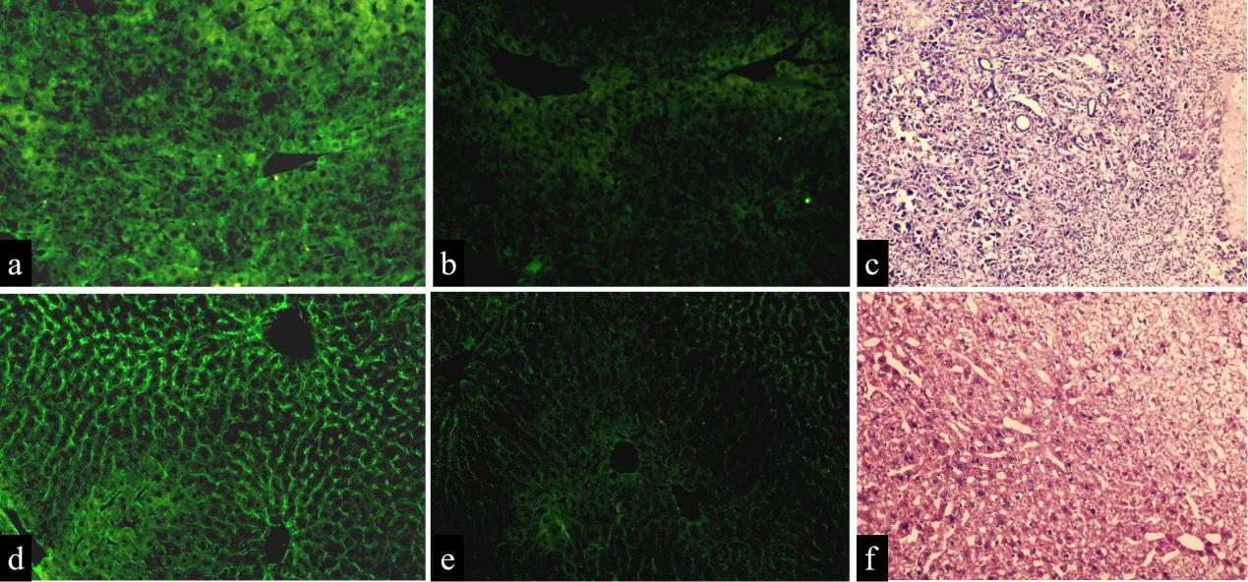

Appendix Figure 2. USMC Therapy Enhances Microvascular Permeability in Mouse Liver
Following USMC therapy, strong fluorescence staining of FD500 was observed in the tumor region of tumor-bearing mice (a) and in the liver region of normal mice (d). In contrast, weak fluorescence staining of FD500 was detected in tumor-bearing mice (b) and normal mice (e) without USMC therapy, indicating that USMC therapy enhances microvascular permeability and exerts effects on both tumor vasculature and normal vessels. (a–c) Tumor-bearing mice; (d–f) normal control mice. (c) and (f) show hematoxylin and eosin (HE)-stained cancer and normal liver tissues, respectively. In (c), HE staining revealed marked cellular atypia in the HCC lesion, including cellular proliferation, an increased nuclear-to-cytoplasmic ratio, and nuclear pleomorphism. The plate-like architecture was disrupted, with a disorganized cell arrangement. In (f), normal hepatocytes exhibited uniform size and were radially arranged in regular plate-like structures emanating from the central vein. Magnification: 40×.

- Operation steps and parameters of USMC

The mice were then euthanized, and their abdomens were shaved. The mice were anesthetized by intraperitoneal injection of 20 mg/ml 1.25% sterile tribromoethanol solution at a dose of 0.2 ml/10 g body weight. Notably, a homemade acoustic pad containing a coupling agent was placed on the abdomen of the mice to keep the US probe 1 cm away from the skin surface. The aim of this practice is to ensure that US energy is effectively focused on the tumor. Afterwards, a 100 μl dose of sulfur hexafluoride injection (SonoVue, Bracco, Milan) was injected into the tail vein via insulin needles.

For USMC treatment, click “Vflash” mode and set the treatment parameters as follows:

Appendix Table 1 Parameters of USMC in this study
 | First three sessions of USMC | Last two sessions of USMC
Types of cavitation | stable cavitation | inertial cavitation
Mechanical Index | 0.3 | 0.8
Frequency (MHz) | 6.3 | 4
Pulse repetition frequency (Hz) | 1000 | 10
Pulse length (cycles) | 18.5 | 12
Pulse duration (second) | 1 | 1
Interval duration (second) | 1 | 1
Total treatment duration (seconds) | 1800 | 1800

- Definitions and significance of URM parameters

4.1. Mean Density

Microvessel density: This represents the number of microbubbles that move through a certain spatial location of a blood vessel within a collection time (usually 10 s). The greater the number of microbubbles that move through a spatial location, the greater the density value at that point.

Mean density= Sum of microvascular density in the Vascular Density Region / Number of Pixels in the Vascular Density Region.

Significance: A higher number of microbubbles passing through a given location corresponds to a higher density value at that point.

4.2. Density Ratio (%)

Density ratio (%)= Regions with microvessels determined based on microvessel density / Total area

Significance: This parameter reflects the abundance of blood supply within the region of interest and may be considered for differential diagnosis of disease and assessment of disease progression.

4.3. Vascular Complexity

The “box-counting algorithm” was employed for data analysis: the microvascular density map was partitioned using progressively smaller boxes, and the number of boxes containing blood vessels was counted. This metric represents the rate of change in detail within the target area relative to changes in scale, thereby reflecting the geometric complexity of microvasculature. A steeper slope and higher value indicate greater microvascular complexity.

Significance: This method quantifies the morphological, edge, and textural information of vascular regions in tissues, thereby aiding in the pathological diagnosis of vascular areas (e.g., distinguishing between benign and malignant tumors).

4.4. Mean Velocity（mm/s）

Mean velocity= Sum of Blood Flow Velocities in the Region of Interest / Number of Pixels in the Region of Interest.

4.5. Perfusion Index

The perfusion index was calculated as the Average Vascular Flow Velocity within the ROI multiplied by the Microvascular Density Ratio within the ROI.

Significance: While velocity reflects blood flow speed and density indicates red blood cell quantity, their product more accurately represents the perfusion status. A higher perfusion index indicates regions with abundant and rapid blood flow.

- Definitions and significance of UVI parameters

Three types of viscoelastic indices, including elastic values (shown as Young’s modulus, measured in kPa), viscosity values (shown as viscosity coefficient, measured in Pa·s), and dispersion values (shown as dispersion coefficient, measured in m/s/kHz), were measured. The elasticity value is a direct quantitative index of tissue elasticity. The viscosity and dispersion values were quantitatively measured using the following formula (also called the Voigt model):

For viscosity coefficient (η), V= $\sqrt{\frac{2（E^{2}+({2πf)}^{2}η^{2}）}{ρ（E+\sqrt{E^{2}+{(2πf)}^{2}η^{2}}）}}$

For dispersion coefficient (slope), V=slope×f+a

(f= specific frequency; ρ= tissue density; E=Young’s modulus; η=viscosity coefficient; slope =dispersion coefficient; V=shear wave velocity; and a=intercept (constant term)).

The reason for using both the viscosity and dispersion coefficients to evaluate the viscosity is as follows.

First, the dispersion coefficient is a viscosity parameter with a relatively long history of application; currently, the majority of published studies on UVI use the dispersion coefficient to evaluate viscosity. If we do not measure the dispersion coefficient, our research will lack comparability with previous studies because of the inconsistency in the parameters used for viscosity. However, the dispersion coefficient is believed to be an indirect and simplified measurement of viscosity (PMID: 37373934). As the shear wave speed varied with frequency, a fitting dispersion curve could be algorithmically reconstructed using the frequency values and varying shear wave velocities. Then, the slope of this curve, named the shear wave “dispersion slope” or “dispersion coefficient,” could be obtained as a viscosity-related parameter (PMID: 35916675). The viscosity coefficient, the Voigt model-based shear viscosity, considers the influence of more parameters on viscosity, making it theoretically more accurate. In agreement, a recent study found that the viscosity coefficient demonstrates higher diagnostic accuracy than the dispersion coefficient (AUC of viscosity coefficient model is 0.88 while that of dispersion model is 0.83) (PMID: 38582684). Second, in current ultrasonic systems, the viscosity and dispersion coefficients can be directly measured on the machine, which is very convenient.

Based on this, we incorporated both the viscosity and dispersion coefficients to assess the viscosity more accurately.

