Untargeted serum metabolomic investigate the effects of calcium propionate in alleviating negative energy balance of Holstein dairy cows in early lactation
Fan Zhang ^{1,2}, Yue Wang ¹, Yuming Guo ^{2,∗} and Benhai Xiong ^{1,}*
¹ State Key Laboratory of Animal Nutrition, Institute of Animal Science, Chinese Academy of Agricultural Sciences, Beijing 100193, China
² State Key Laboratory of Animal Nutrition, College of Animal Science and Technology, China Agricultural University, Beijing 100193, China
* Corresponding author: Yuming Guo, Email: guoyum@cau.edu.cn; Benhai Xiong, Email: xiongbenhai@caas.cn

a
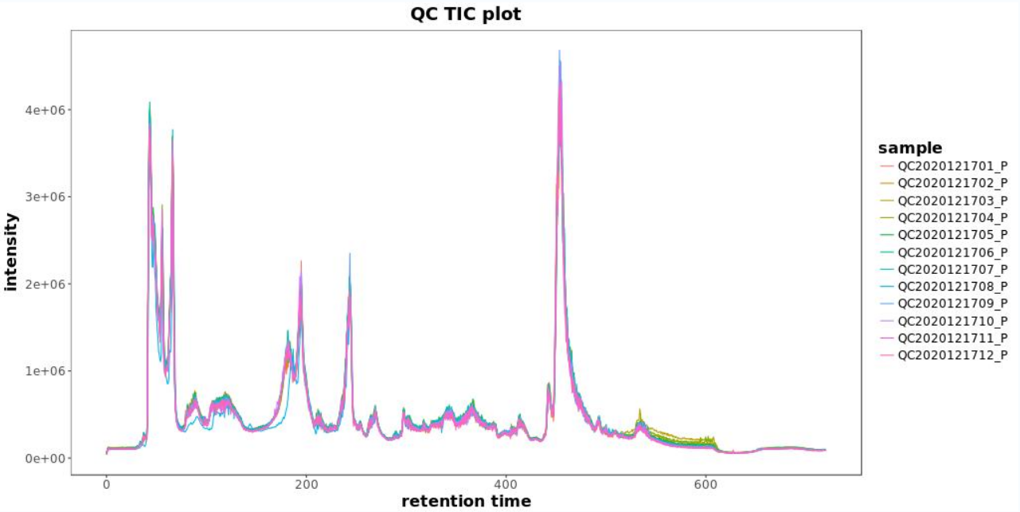

b
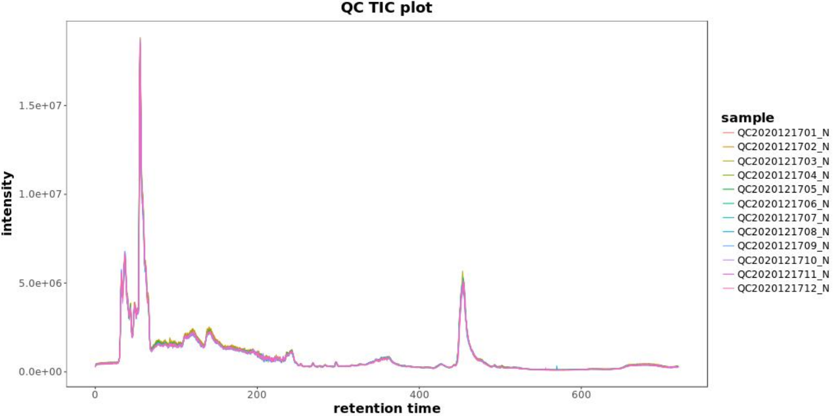
Fig. S1. The ion chromatograms of quality control (QC) samples in the positive mode (a), and the ion chromatograms of quality control (QC) samples in the negative mode (b).

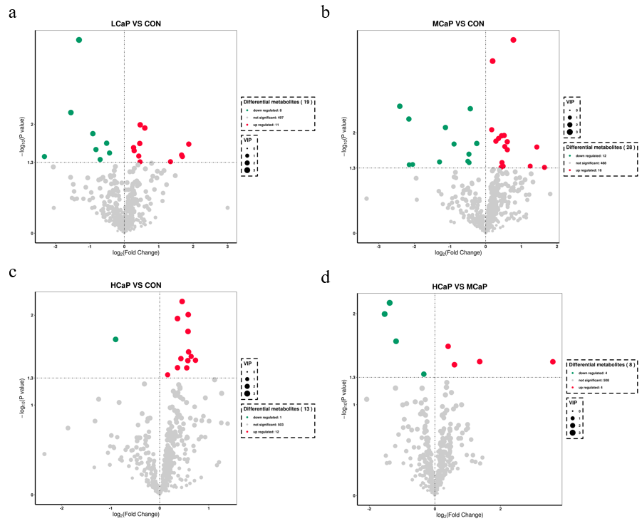
Fig. S2 Volcano plot of CON vs LCaP (a), CON vs MCaP (B), CON vs HCaP (C), and HCaP vs MCaP (d) from the serum metabolite profiles of experimental cows. The x-axis is the 1og₂ (FC) value, and the y-axis represents −log₁₀ (P value). The dot size represents the variable importance in the projection (VIP) value. CON = control group, basal diet; LCaP = low calcium propionate, basal diet plus 200 g/d calcium propionate; MCaP = medium calcium propionate, basal diet plus 350 g/d calcium propionate; HCaP = high calcium propionate, basal diet plus 500 g/d calcium propionate.

