SUPPORTING INFORMATION:

1H-Phenanthro[9,10-d]imidazole functionalized iron(ii,iii)oxide nanoparticle for magnetically recoverable nanocatalyst for monoalkylation of cyclam

Uğur TAŞDEMİR, Aslıhan YILMAZ OBALI*

Department of Chemistry, Science Faculty, Selcuk University, Türkiye
*Corresponding Author, aslihanyilmaz@selcuk.edu.tr

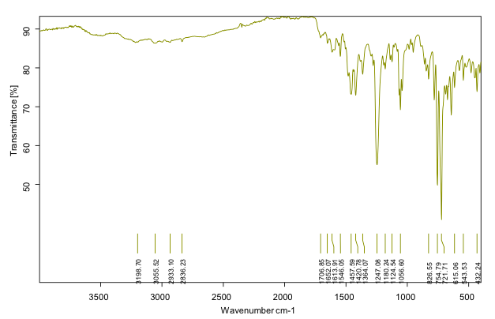
Fig. S1. The FT-IR spectrum of 1.

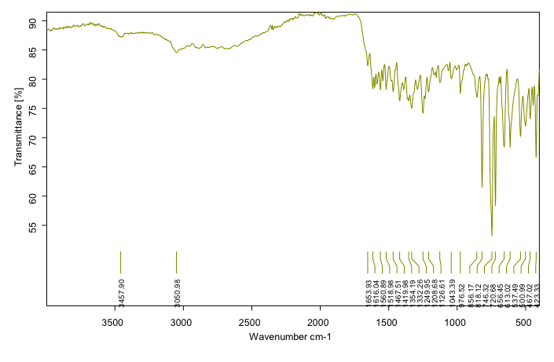
Fig. S2. The FT-IR spectrum of 2.

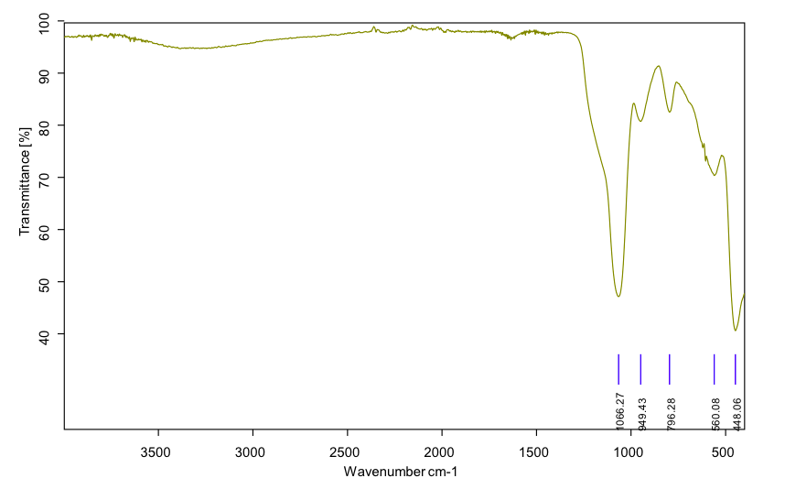
Fig. S3. The FT-IR spectrum of Fe₃O₂@SiO₂@CPTMS.

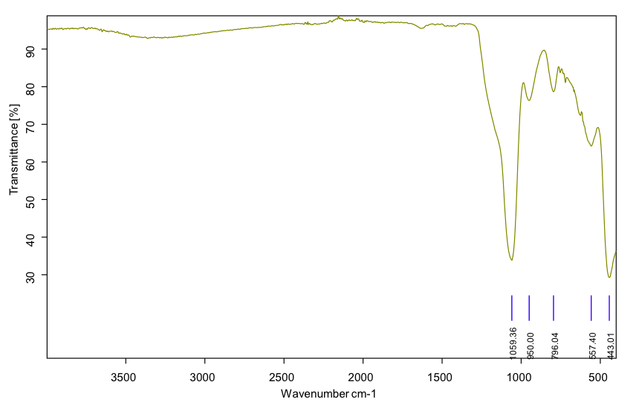
Fig. S4. The FT-IR spectrum of MNP1.
Fig. S5. The FT-IR spectrum of MNP2.

Fig.S6. ¹H-NMR spectrum of 1.

Fig.S7. ¹H-NMR spectrum of 2.

Fig.S8. ¹³C-NMR spectrum of 1.

Fig.S9. ¹³C-NMR spectrum of 2.

