Achieving ultrahigh power factor in n-type Ag₂Se thin films by carrier engineering
Zhuang-hao ZHENG¹, Jun-yu NIU¹, Tian-bao CHEN^{1, 2}, Yue-Xing CHEN^{1,} *, Fu LI¹, Jing-ting LUO¹, Guang-xing LIANG¹, Shuo CHEN¹, Hong-li MA², Xiang-hua ZHANG², Ping FAN¹
¹Shenzhen Key Laboratory of Advanced Thin Films and Applications, Key Laboratory of Optoelectronic Devices and Systems of Ministry of Education and Guangdong Province, College of Physics and Optoelectronic Engineering, Shenzhen University, Shenzhen 518060, P. R. China.
² Univ Rennes, CNRS, ISCR (Institut des Sciences Chimiques de Rennes) UMR6226, Rennes F-35000, France.
* Corresponding Author, Email: chenyx@szu.edu.cn

Supporting information
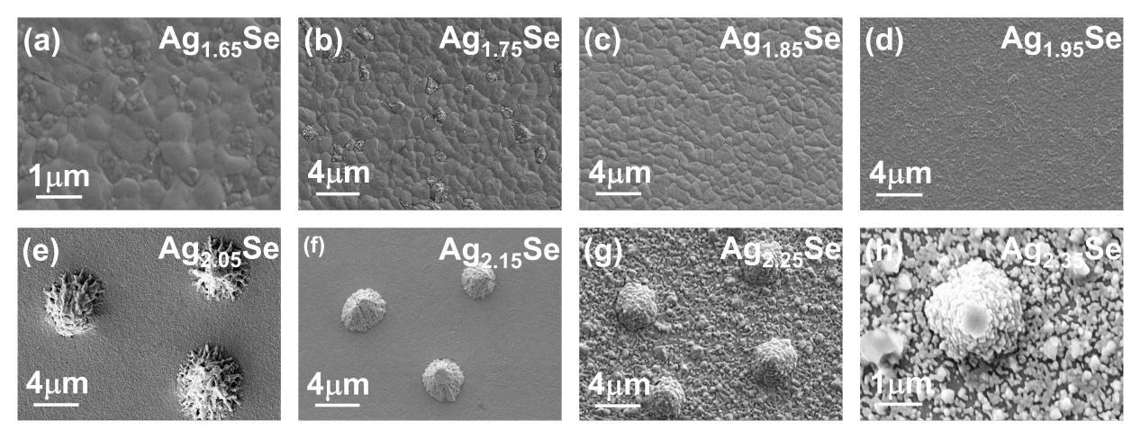
Fig. S1. Surface morphology of the Ag₂Se based thin films with different Ag to Se atomic ratio

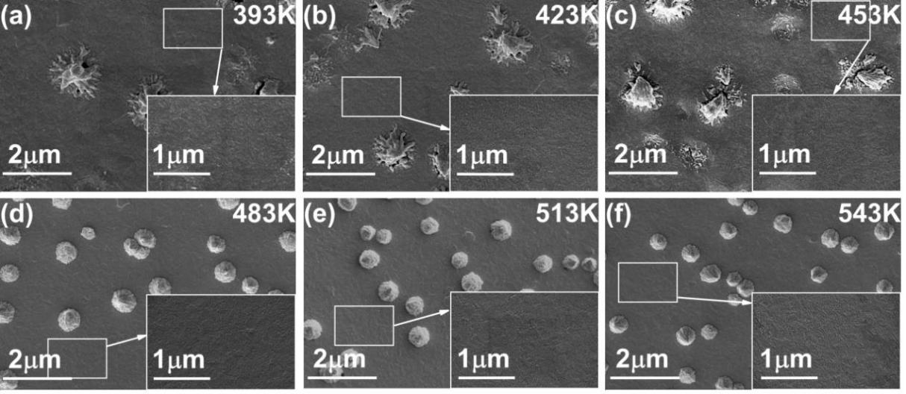
Fig. S2. SEM shows morphology of Ag_{2.05}Se with different annealing temperature (a-f: 393K,423K,453K,483K,513K,543K) contains the chemical deviation due to heat treatment at high temperature.

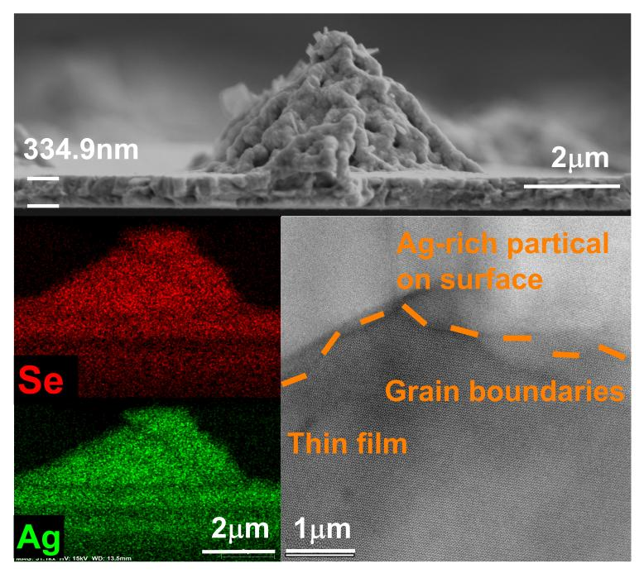
Fig. S3. Section morphology and element distribution of Ag_{2.05}Se after annealed at 493 K.

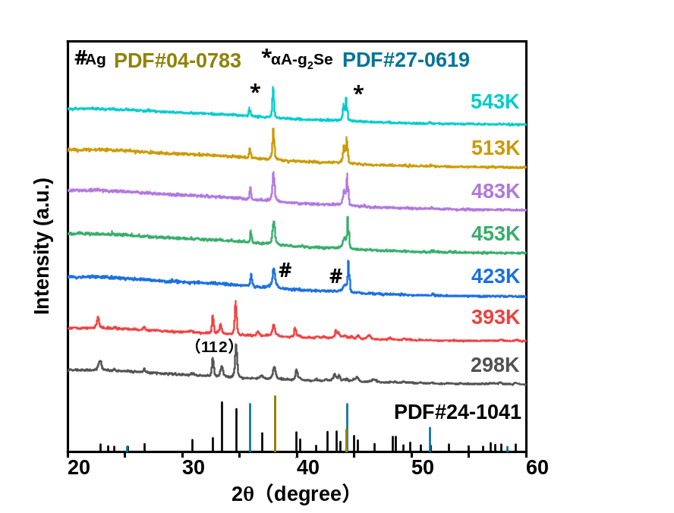
Fig. S5. The temperature dependence of X-ray peaks corresponding to Ag₂Se thin film

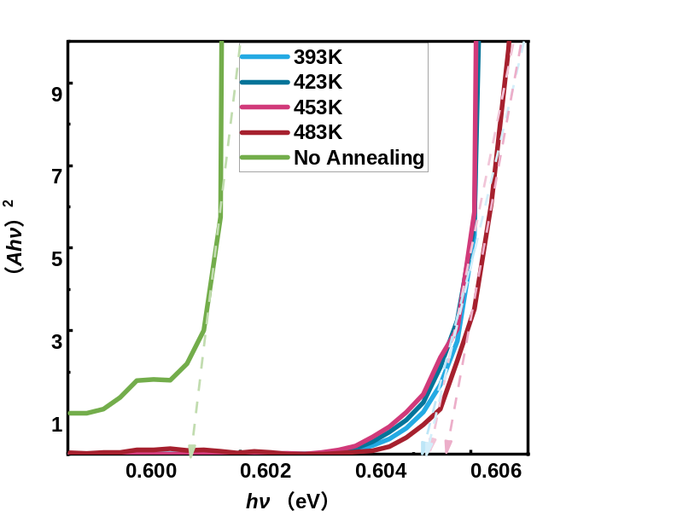
Fig. S5. plot of ln[(R_{max}-R_{min})/(R-R_{min})] versus energy used to obtain direct band gap. This shows the heat treatment reduces Ag vacancies.

Table S1. Compositions of the Ag_{2.05}Se thin films with different annealing temperature.
Annealing temperature (K) | 303 | 393 | 423 | 453 | 483 | 513 | 543
Ag（at%) | 67.2 | 67.3 | 67.6 | 67.6 | 68.1 | 68.8 | 69.1
Se（at%) | 32.8 | 32.7 | 32.4 | 32.4 | 31.9 | 31.2 | 30.9

