- Simple water tank experiment to explore the conditions of stable cavitation and inertial cavitation
1.1. Practice
As shown in Appendix Figure 1, distilled water was poured into a clean basin (a). 5 ml of 0.9% sodium chloride solution and SonoVue contrast agent powder were thoroughly mixed and injected into the basin, gently mixing. The U5–15L ultrasound probe was placed flat on the water surface, and the ultrasound machine’s operating interface was set to “Vflash” mode. Parameters such as acoustic power, frequency, pulse length, and pulse repetition frequency were adjusted, and the changes in the mechanical index (MI) and the timing of the contrast agent microbubble bursting on the ultrasound screen were observed.
1.2. Results
No significant contrast agent bursting was observed in the MI range of 0.2–0.4 (b, d, f), corresponding to the stable cavitation range. Microbubbles initiate rupture at an approximate MI of 0.4. Significant contrast agent bursting occurred at MI 0.7 (c, e, g), indicating the initiation of inertial cavitation.
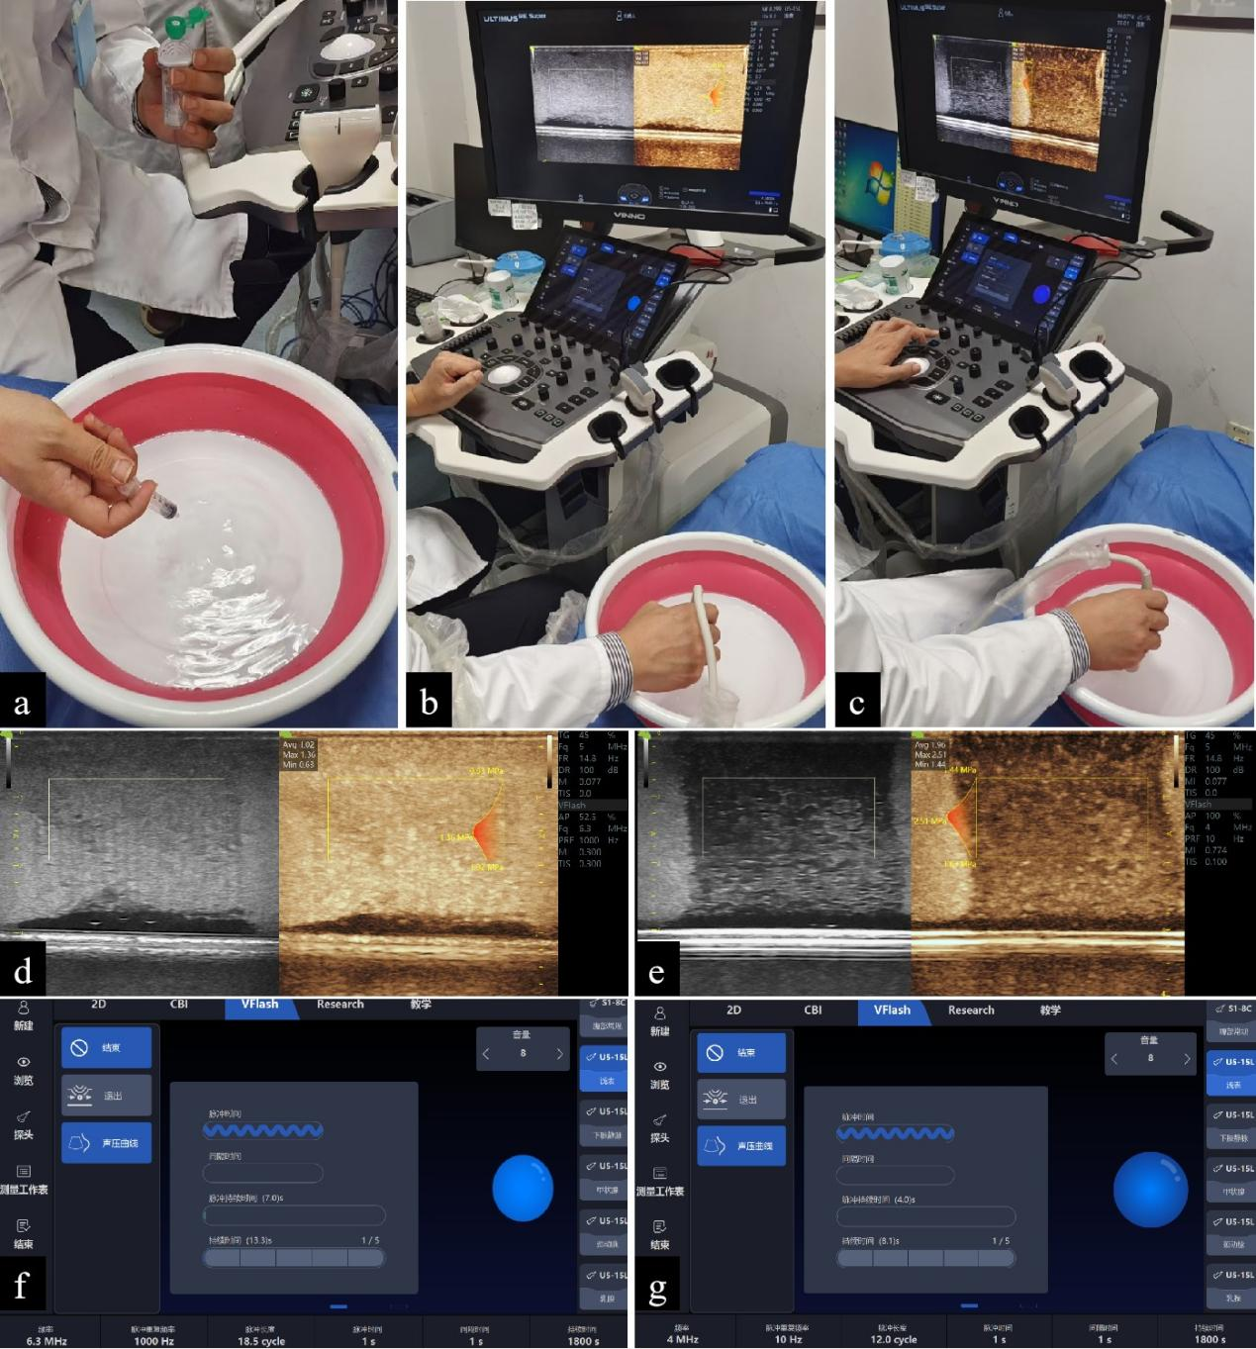
Appendix Figure 1. Simple water tank.
(a–c) represents the operation of USMC. (d–e) represents the cavitation images displayed on the ultrasound screen with two different kinds of MI (d: low MI, e: high MI). The left half of (d) and (e) are grayscale images, and the right half are contrast-enhanced ultrasound images. (f) and (g) represent the parameters during two kinds of cavitation corresponding to (d) and (e), respectively.
- Preliminary experiments using ultrasound-stimulated microbubbles cavitation (USMC) with a low MI (0.3) to improve vascular permeability
After initially exploring the MI range (0.2–0.4) required for stable cavitation in a simplified water bath experiment, we tried to set MI at 0.3. This is because we retrieved a recently published study (PMID: 37757603) comparing the effects of different MI during USMC in mice with colon cancer. The authors found that the contrast agent perfusion volume in colon cancer lesion was highest when MI was 0.3. We designed animal experiments as follows to further verify that an MI of 0.3 can indeed play a role in improving vascular permeability through stable cavitation.
2.1. Modeling and grouping
HCC models were established on six-week-old male mice, using Hepa 1–6 mouse cell line. The modeling method involved laparotomy and intrahepatic injection of a suspension of cancer cells. Tumor formation was confirmed by high-frequency ultrasound 10–14 days after modeling. Then, eight-week-old mice were divided into four groups: Group 1: liver cancer mice treated with USMC; Group 2: liver cancer mice not treated with USMC; Group 3: healthy control mice treated with USMC; and Group 4: healthy control mice not treated with USMC. The MI was set as 0.3, which was considered to be a parameter to make stable cavitation.
2.2. Vascular permeability assessment
Take Sodium isothiocyanate-labeled 500kD dextran sulfate (FD500) which has been stored in the dark at 4°C. For mice in Group 1 and 3, FD500 were injected twice via the tail vein (5 mg/ml, 250 µl) at approximately 3 minutes of USMC treatment. For mice in Group 2 and 4, FD500 were directly injected via the tail vein with the same dose. All the practice were taken protected from light.
Mice were sacrificed half an hour later, and fresh liver tissue was collected, fixed, destained, and frozen into sections. The sections were observed under a fluorescence microscope and stained with hematoxylin and eosin (HE) (Appendix Figure 2).
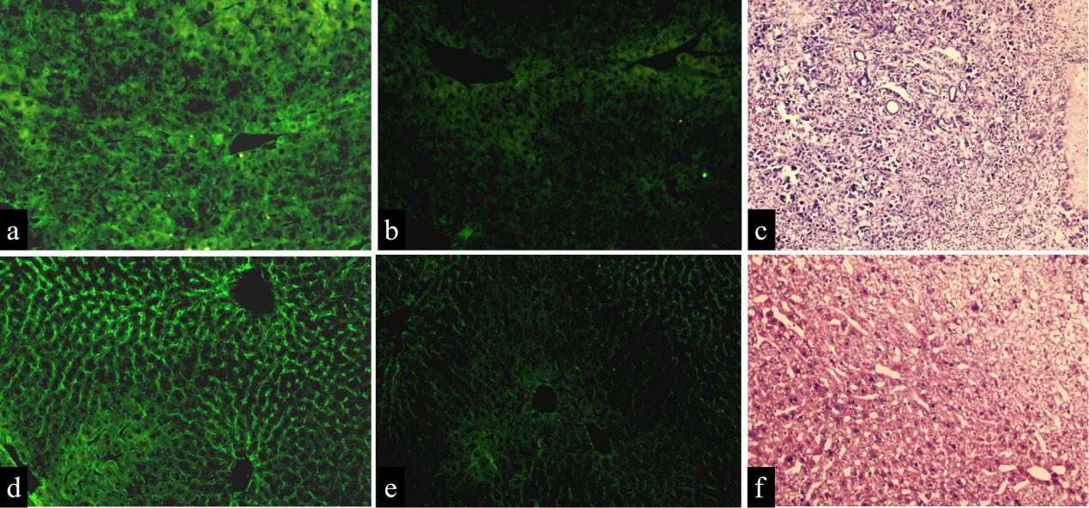
Appendix Figure 2. USMC Therapy Enhances Microvascular Permeability in Mouse Liver
Following the application of USMC therapy, strong fluorescence staining of FD500 was observed in the tumor region of tumor‑bearing mice (a) and in the liver region of normal mice (d). In contrast, weak fluorescence staining of FD500 was detected in tumor‑bearing mice (b) and normal mice (e) without USMC therapy, indicating that USMC therapy enhances microvascular permeability and exerts effects on both tumor vasculature and normal vessels. (a–c) tumor‑bearing mice; (d–f) normal control mice. (c) and (f) show hematoxylin and eosin (HE)‑stained cancer tissue and normal liver tissue, respectively. In (c), HE staining revealed marked cellular atypia in HCC lesion, including cellular proliferation, an increased nuclear‑to‑cytoplasmic ratio, and nuclear pleomorphism. The plate‑like architecture was disrupted, with disorganized cell arrangement. In (f), normal hepatocytes exhibited uniform size and were radially arranged in regular plate‑like structures emanating from the central vein. Magnification: 40×.
- Operation steps and parameters of USMC
The mice’ abdomen were shaved. The mice were anesthetized by intraperitoneal injection of 20 mg/ml 1.25% sterile tribromoethanol solution at a dose of 0.2 ml/10g body weight. Notably, place a homemade acoustic pad containing coupling agent on the abdomen of mice, in order to keep the US probe 1 cm away from the skin surface. The aim of this practice is to ensure US energy be effectively focusing on the tumor. Afterwards, a 100 μl dose of Sulfur hexafluoride injection (SonoVue®, Bracco, Milan) was injected into an tail vein via insulin needles.
For USMC treatment, click “Vflash” mode and set the treatment parameters to the followings.
Appendix Table 1 Parameters of USMC in this study
 | First three sessions of USMC | Last two sessions of USMC
Types of cavitation | stable cavitation | inertial cavitation
Mechanical Index | 0.3 | 0.8
Frequency (MHz) | 6.3 | 4
Pulse repetition frequency (Hz) | 1000 | 10
Pulse length (cycles) | 18.5 | 12
Pulse duration (second) | 1 | 1
Interval duration (second) | 1 | 1
Total treatment duration (seconds) | 1800 | 1800
- Definitions and significance of URM parameters
4.1. Mean Density
Microvessel density: This represents the number of microbubbles that move through a certain spatial location of a blood vessel within a collection time (usually 10 seconds). The more microbubbles that move through that spatial location, the greater the density value at that point.
Mean density= Sum of microvascular density in the Vascular Density Region / Number of Pixels in the Vascular Density Region.
Significance: A higher number of microbubbles passing through a given location corresponds to a greater density value at that point.
4.2. Density Ratio (%)
Density ratio (%)= Regions with microvessels determined based on microvessel density / Total area
Significance: This parameter reflects the abundance of blood supply within the region of interest and may be considered for disease differential diagnosis and assessment of disease progression.
4.3. Vascular Complexity
The “box-counting algorithm” is employed for data analysis: the microvascular density map is partitioned using progressively smaller boxes, and the number of boxes containing blood vessels is counted. This metric represents the rate of change in detail within the target area relative to changes in scale, thereby reflecting the geometric complexity of the microvasculature. A steeper slope and a higher value indicate greater microvascular complexity.
Significance: This method quantifies morphological, edge, and textural information of vascular regions in tissues, thereby aiding in the pathological diagnosis of vascular areas (e.g., distinguishing between benign and malignant tumors).
4.4. Mean Velocity（mm/s）
Mean velocity= Sum of Blood Flow Velocities in the Region of Interest / Number of Pixels in the Region of Interest.
4.5. Perfusion Index
Perfusion index = Average Vascular Flow Velocity within the ROI × Microvascular Density Ratio within the ROI.
Significance: While velocity reflects the speed of blood flow and density indicates the quantity of red blood cells, their product more accurately represents the perfusion status. A higher perfusion index indicates regions with both abundant and rapid blood flow.
- Definitions and significance of UVI parameters
Three types of viscoelastic index, including elastic values (shown as Young’s modulus, the unit of measure is kPa), the viscosity values (shown as viscosity coefficient, the unit of measure is Pa·s) and dispersion values (shown as dispersion coefficient, the unit of measure is m/s/kHz), were measured. Elasticity value is the direct quantitative indexes of tissue elasticity. The viscosity and dispersion value are quantitatively measured by the following formula (also called Voigt model), respectively.
For viscosity coefficient (η), V=$\sqrt{\frac{2（E^{2}+({2πf)}^{2}η^{2}）}{ρ（E+\sqrt{E^{2}+{(2πf)}^{2}η^{2}}）}}$
For dispersion coefficient (slope), V=slope×f+a
(f= specific frequency; ρ= tissue density; E=Young’s modulus; η=viscosity coefficient; Slope=dispersion coefficient; V=shear wave velocity; a=intercept (constant term)).
The reason why we use both viscosity coefficient and dispersion coefficient to evaluate viscosity are as follows.
Firstly, the dispersion coefficient is a viscosity parameter with a relatively long history of application; currently, the majority of published studies on UVI use the dispersion coefficient to evaluate viscosity. If we do not measure the dispersion coefficient, our research will lack comparability with previous studies due to the inconsistency in the parameters used for viscosity. However, dispersion coefficient is believed to be an indirect and simplified measurement for viscosity (PMID: 37373934). As shear wave speed varied with frequencies, a fitting dispersion curve can be algorithmically reconstructed using the value of frequencies and varying shear wave velocities, then the slope of this curve, named the shear wave “dispersion slope” or “dispersion coefficient”, could be obtained as a viscosity-related parameter (PMID: 35916675). Viscosity coefficient, the Voigt model-based shear viscosity, takes into account the influence of more parameters on viscosity, making it theoretically more accurate. In agreement, recent study have found that the viscosity coefficient demonstrates higher diagnostic accuracy than dispersion coefficient (AUC of viscosity coefficient model is 0.88 while that of dispersion model 0.83) (PMID: 38582684). Secondly, in current ultrasonic systems, viscosity and dispersion coefficients can be directly measured on the machine, which is very convenient.
Based on this, we incorporate both viscosity and dispersion coefficients to more accurately assess viscosity.

