Supplementary Information

Pilot-Scale Continuous Synthesis of Pt Single-Atom Catalysts via Electron-Beam Processing in Ice Matrices

Soyeon Si^{1,}†, Dami Yun^{2,3,†}, Youn-Mook Lim², Hyun-Bin Kim², Seung-Hwan Oh², Byungnam Kim², Huisu Kim², Jeong Hoon Park², Inchan Kwon³, Sehyun Lee^{1,*}, Jin-Mun Yun^{2,*}

¹Department of Materials Science and Engineering, Sungshin Women’s University (SSWU), Seoul 01133, Republic of Korea.
²Advanced Radiation Technology Institute, Korea Atomic Energy Research Institute (KAERI), Jeongeup, Jeollabuk-do 56212, Republic of Korea.
³School of Materials Science and Engineering, Gwangju Institute of Science and Technology (GIST), Gwangju 61005, Republic of Korea.

* Corresponding author: sehyun@sungshin.ac.kr, yjm90@kaeri.re.kr

Supplementary Table 1. Comparison of TOF values of RI-SAC with those of previously reported Pt-based catalysts

Catalyst | Electrolyte | Voltage (V vs. RHE) | TOF (s⁻¹) | Source
RI-SAC | 1.0 M KOH | 100 mV | 7.63 | This work
Pt/C | 1.0 M KOH | 100 mV | 2.42 | This work
Pt/C(1.87) | 1.0 M KOH | 100 mV | 4.82 | This work
Pt@CoS | 1.0 M KOH | 100 mV | 0.131 | [1]
Pt-Ru/Acet | 1.0 M KOH | 100 mV | 0.7 | [2]
Pt₁/(Co,Ni)(OH)₂/C | 1.0 M KOH | 100 mV | 5.950 | [3]
Pt/C60-2/KB | 1.0 M KOH | 100 mV | 5.55 | [4]
PtRu@CNT | 1.0 M KOH | 100 mV | 3.06 | [5]
Pt-CoFe | 1.0 M KOH | 100 mV | 2.32 | [6]
Pt_{SA}@MoS₂ | 1.0 M KOH | 100 mV | 0.806 | [7]
PtCu/NC | 1.0 M KOH | 100 mV | 1.44 | [8]
Ni-NiO-Pt | 1.0 M KOH | 100 mV | 5.69 | [9]

* Source numbers correspond to the Supplementary references section
Supplementary Table 2. Comparison of mass activities of RI-SAC with those of previously reported Pt-based catalysts

Catalyst | Electrolyte | Overpotential  (V vs. RHE) | Mass activity  (A mg⁻¹) | Source
RI-SAC | 1.0 M KOH | 0.85 | 7.002 | This work
Pt/C | 1.0 M KOH | 0.85 | 0.8489 | This work
Pt/C(1.87) | 1.0 M KOH | 0.85 | 2.996 | This work
PtP₂@PNC | 0.1 M KOH | 0.85 | $≈$0.35 | [10]
Pt/Nb-SnO₂ | 0.1 M HClO₄ | 0.90 | 0.55 | [11]
Pt24 | 0.1 M KOH | 0.90 | 0.2254 | [12]
PtCu/C-10 | 0.1 M HClO₄ | 0.90 | 1.19 | [13]
d-int−Pt-Co/C | 0.1 M HClO₄ | 0.90 | 1.69 | [14]
PtCu aerogels/C | 0.1 M HClO₄ | 0.90 | 0.3964 | [15]
PtCo/C-600 | 0.1 M HClO₄ | 0.90 | 0.68 | [16]
Pt@Mn-SAs/N-C | 1.0 M KOH | 0.85 | 0.62 | [17]
PtCuNC-700 | 0.1 M HClO₄ | 0.90 | 0.45 | [18]
NPP-70 | 0.1 M KOH | 0.85 | 1.0092 | [19]
Pt₁Ni₁@Pt/C | 0.1 M KOH | 0.90 | 1.424 ± 0.019 | [20]
NiPP | 0.1 M KOH | 0.85 | 5.0503 | [21]
Ge-L₁₀-PtZn@N-C | 0.1 M KOH | 0.90 | 3.04 | [22]
PdPt–CoNi | 0.1 M KOH | 0.85 | 3.250 | [23]
Pt@Co | 0.1 M KOH | 0.85 | 0.817 | [24]

* Source numbers correspond to the Supplementary references section

Supplementary Table 3. Comparison of TOF values of RI-SAC with those of previously reported Pt-based catalysts

Metal | Support | Scale | Loading | Methods | Application | Note | Source
Pd | ZnO | ~1 kg | 0.25 wt% | Ball-milling, calcination | Selective dehydrogenation reaction of phenylacetylene | batch | [25]
Pd | Fe₂O₃ | ~1 kg | 0.2 wt% | Ball-milling, calcination | Suzuki–Miyaura cross-coupling reaction | batch | [26]
Pd | Fe₂O₃ | 1 kg/day | 0.23 wt% | Precursor-atomization strategy | Suzuki–Miyaura cross-coupling reaction | continuous | [27]
Cu | CN | 3.565 kg | 9.97 wt% | Metal coordination Route | CO₂RR | batch | [28]
Ni | C | 1.6 kg | 2.5 wt% | Ligand-mediated method | CO₂RR | - | [29]
Co | ZIF-8 | ~ 24 g | 3.3 wt% | Solid-phase synthesis | ORR | batch | [30]

* Source numbers correspond to the Supplementary references
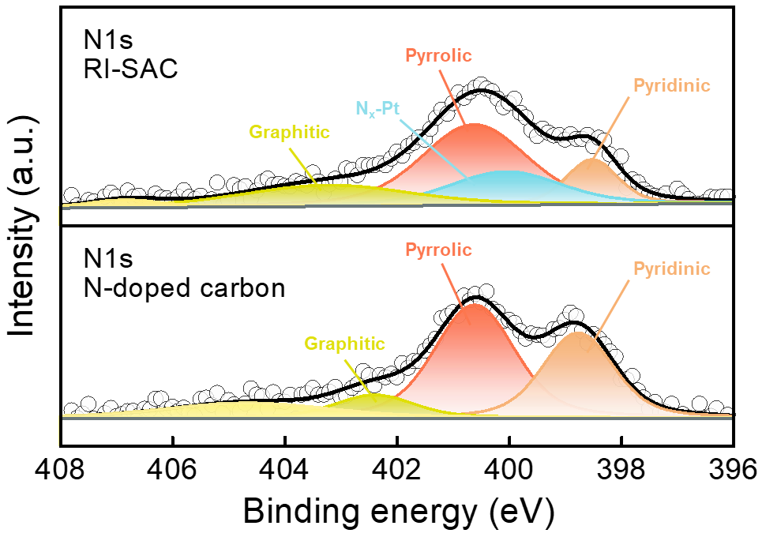

Supplementary Figure 1. N 1s XPS spectra with peak fitting results for RI-SAC and N-doped carbon.

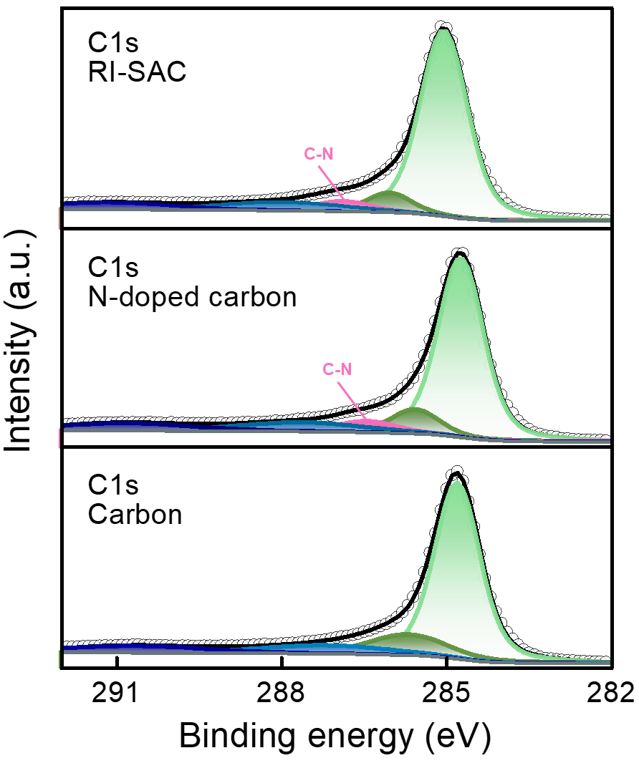

Supplementary Figure 2. C 1s XPS spectra with peak fitting results for RI-SAC, N-doped carbon, and carbon. The C–N peak, which was not observed in pristine carbon, appeared in both N-doped carbon and RI-SAC, indicating the successful incorporation of nitrogen into the carbon framework.

Supplementary Figure 3. Pt loadings of RI-SAC and Pt/C.
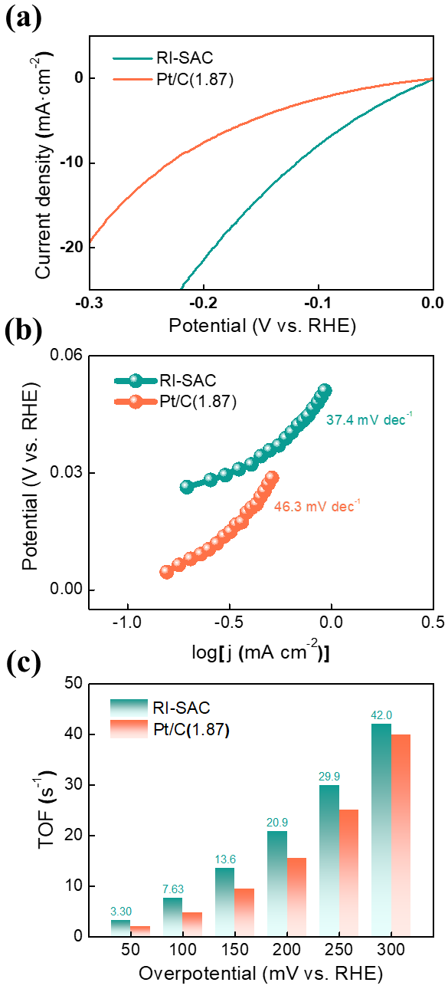

Supplementary Figure 4. Comparison of (a) LSV curves, (b) Tafel plots, and (c) TOF values of RI-SAC and Pt/C catalysts with matched Pt loadings (Pt/C(1.87)). Compared with Pt/C(1.87), RI-SAC exhibited superior performance in terms of the overpotential, Tafel slope, and TOF.

Supplementary Figure 5. CP durability test of Pt/C(1.87) conducted for 10 h at 10 mA cm⁻². At an equivalent Pt loading, the Pt/C catalyst exhibited a relatively pronounced decline in performance during the CP test compared with RI-SAC.

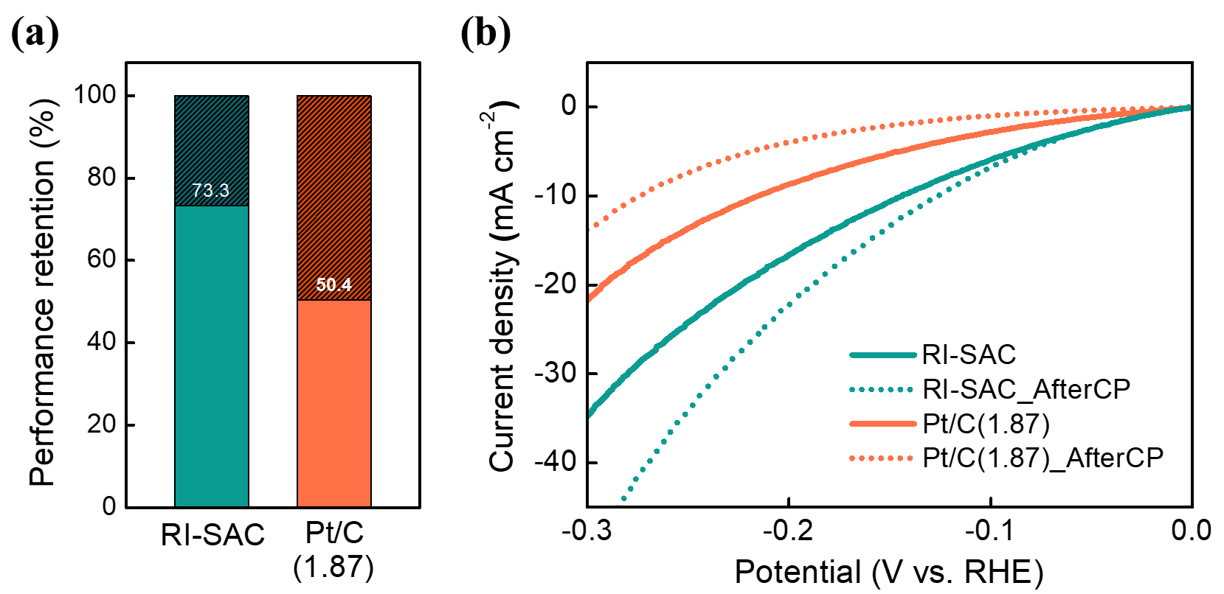

Supplementary Figure 6. (a) Performance retention of Pt/C(1.87) after the CP durability test and (b) LSV curves recorded after CP. After CP operation, Pt/C(1.87) exhibited a pronounced loss of activity, retaining only 50.4% of its initial performance, which was lower than that of RI-SAC (73.3%). This degradation was also evident in the LSV curve recorded after CP.

Supplementary Figure 7. LSV curves of the RI-SAC measured at various rotational speeds from 400 to 2,000 rpm.

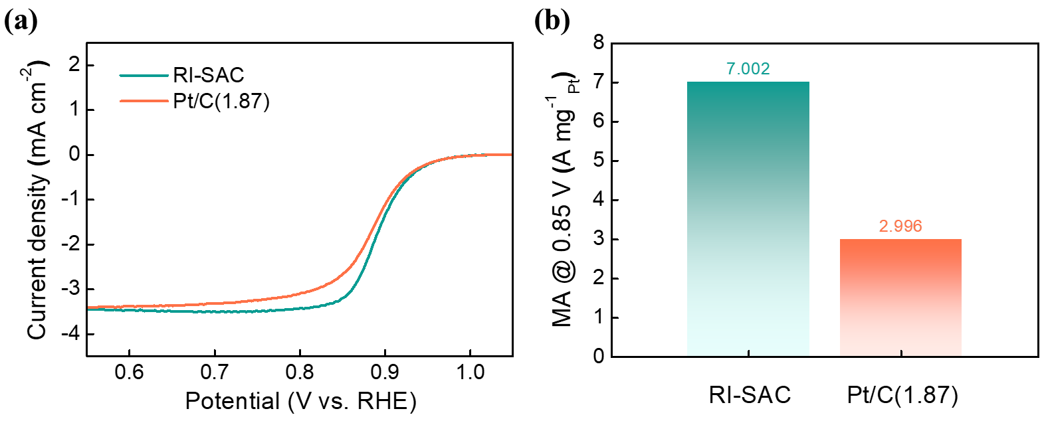

Supplementary Figure 8. Comparison of (a) LSV curves and (b) mass activity of RI-SAC and Pt/C catalysts with matched Pt loadings. RI-SAC, with the same Pt loading as Pt/C, shows a higher half-wave potential and about 2.3 times higher mass activity at 0.85 V_{RHE}.

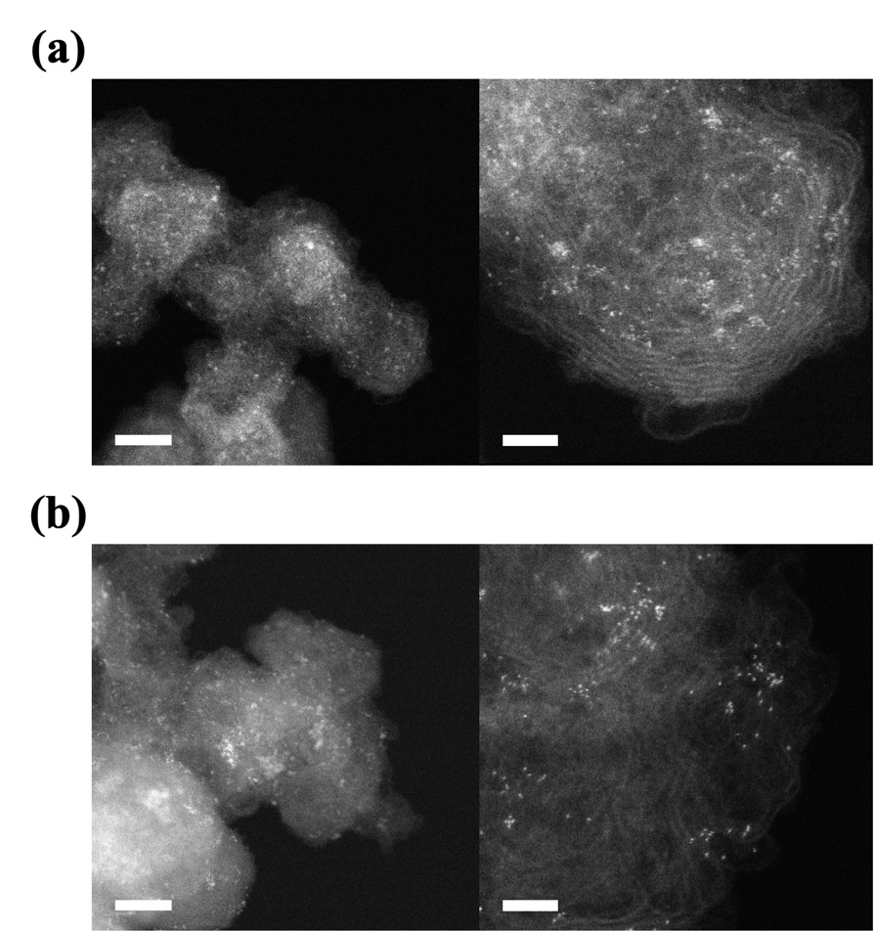

Supplementary Figure 9. TEM images of atomic-level dispersed catalyst synthesis by the same method (left, scale bar = 10 nm, and right, scale bar = 2 nm): (a) Pd and (b) Ir.

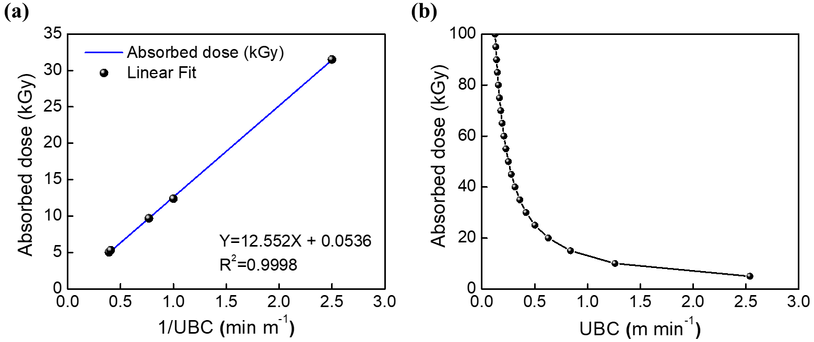

Supplementary Figure 10. Absorbed dose as a function of the UBC: (a) linear plot as a function with $1/UBC$ and (b) nonlinear decay with the UBC.
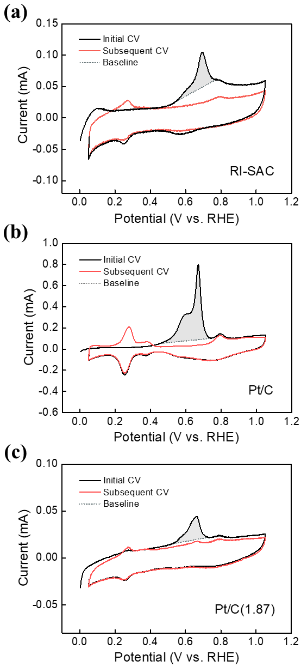

Supplementary Figure 11. Integrated region of CO-stripping, corresponding to the CO oxidation and desorption area used for TOF calculation.
Supplementary references
- Mosallanezhad, A. et al. Interfacial synergies between single-atomic Pt and CoS for enhancing hydrogen evolution reaction catalysis. Appl. Catal. B 315, 121534 (2022). https://doi.org/10.1016/j.apcatb.2022.121534.
- Chen, Y. et al. Plasma-assisted highly dispersed Pt single atoms on Ru nanoclusters electrocatalyst for pH-universal hydrogen evolution. Chem. Eng. J. 448, 137611 (2022). https://doi.org/10.1016/j.cej.2022.137611.
- Pei, A. et al. Effective electronic tuning of Pt single atoms via heterogeneous atomic coordination of (Co,Ni)(OH)₂ for efficient hydrogen evolution. Energy Environ. Sci. 16, 1035–1048 (2023). https://doi.org/10.1039/D2EE02785B.
- Zhang, R. et al. Single-atomic platinum on fullerene C₆₀ surfaces for accelerated alkaline hydrogen evolution. Nat. Commun. 14, 2460 (2023). https://doi.org/10.1038/s41467-023-38126-z.
- Jiang, Y. et al. Ultrahigh Pt-mass-activity catalyst for alkaline hydrogen evolution synthesized by microwave method in air. Ceram. Int. 50, 34789–34795 (2024). https://doi.org/10.1016/j.ceramint.2024.06.286.
- Xu, H. et al. Ultralow Pt loading on CoFe layered double hydroxides achieves superior alkaline hydrogen evolution through interfacial synergistic catalysis. Catal. Sci. Technol. 15, 6231–6239 (2025). https://doi.org/10.1039/D5CY00915D.
- Li, Z. et al. In situ doping Pt single atoms into 3D flower-like 1T-MoS₂ via Pt-S bond for efficient hydrogen evolution reaction. J. Colloid Interface Sci. 689, 137282 (2025). https://doi.org/10.1016/j.jcis.2025.137282.
- Wu, P. et al. Dynamic modulation of Pt 5d valence electrons by single-atom Cu for boosted alkaline hydrogen evolution catalysis. J. Energy Chem. 110, 372–381 (2025). https://doi.org/10.1016/j.jechem.2025.06.066.
- Zheng, X. et al. Ohmic contact heterostructures immobilized Pt single atoms for boosting alkaline hydrogen evolution reaction. Small 21, 2411696 (2025). https://doi.org/10.1002/smll.202411696.
- Pu, Z. et al. Anion-modulated platinum for high-performance multifunctional electrocatalysis toward HER, HOR, and ORR. Iscience 23, 101793 (2020). https://doi.org/10.1016/j.isci.2020.101793.
- Shi, G. et al. Temperature dependence of oxygen reduction activity at Pt/Nb-doped SnO₂ catalysts with varied Pt loading. ACS Catal. 11, 5222–5230 (2021). https://doi.org/10.1021/acscatal.0c05157.
- Fracchia, M. et al. Molecular cluster route for the facile synthesis of a stable and active Pt nanoparticle catalyst. New J. Chem. 45, 11292–11303 (2021). https://doi.org/10.1039/D1NJ00937K.
- Xiao, Z., Wu, H., Zhong, H., Abdelhafiz, A. & Zeng, J. De-alloyed PtCu/C catalysts with enhanced electrocatalytic performance for the oxygen reduction reaction. Nanoscale 13, 13896–13904 (2021). https://doi.org/10.1039/D1NR02820K.
- Đukić, T. et al. Understanding the crucial significance of the temperature and potential window on the stability of carbon supported Pt-alloy nanoparticles as oxygen reduction reaction electrocatalysts. ACS Catal. 12, 101–115 (2021). https://doi.org/10.1021/acscatal.1c04205.
- Chen, Z., Liao, Y. & Chen, S. Facile synthesis of platinum-copper aerogels for the oxygen reduction reaction. Energy Mater. 2, 200033 (2022). https://doi.org/10.20517/energymater.2022.36.
- Zhong, H. et al. Tuning oxygen reduction reaction activity via structure orientation and surface arrangement: a study on ordered PtCo/C catalysts. Int. J. Hydrog. Energy 47, 40952–40960 (2022). https://doi.org/10.1016/j.ijhydene.2022.09.177.
- Gong, L. et al. Marriage of ultralow platinum and single-atom MnN₄ moiety for augmented ORR and HER catalysis. ACS Catal. 13, 4012–4020 (2023). https://doi.org/10.1021/acscatal.2c06340.
- Wu, B. et al. Arranging electronic localization of PtCu nanoalloys to stimulate improved oxygen electroreduction for high-performance fuel cells. CCS Chem. 5, 2545–2556 (2023). https://doi.org/10.31635/ccschem.022.202202552.
- Bhalothia, D. et al. Pt-Mediated interface engineering boosts the oxygen reduction reaction performance of Ni Hydroxide-Supported Pd nanoparticles. ACS Appl. Mater. Interfaces 15, 16177–16188 (2023). https://doi.org/10.1021/acsami.2c21814.
- Cui, J. et al. Carbon-anchoring synthesis of Pt1Ni1@Pt/C core-shell catalysts for stable oxygen reduction reaction. Nat. Commun. 15, 9458 (2024). https://doi.org/10.1038/s41467-024-53808-y.
- Bhalothia, D. et al. Potential synergy between Pt₂Ni₄ Atomic-Clusters, oxygen vacancies and adjacent Pd nanoparticles outperforms commercial Pt nanocatalyst in alkaline fuel cells. Chem. Eng. J. 483, 149421 (2024). https://doi.org/10.1016/j.cej.2024.149421.
- Lu, S. et al. Simultaneously geometrical and electronic modulation of L₁₀-PtZn by Trace Ge boosts high-performance oxygen reduction reaction. Small 20, 2305296 (2024). https://doi.org/10.1002/smll.202305296.
- Bhalothia, D., Bagaria, A., Beniwal, A. & Chen, T. Y. Strong electronic coupling between CoNi mixed oxide support and PdPt nanoalloys enables highly active and durable oxygen reduction reaction. Sci. Rep. 15, 23403 (2025). https://doi.org/10.1038/s41598-025-07795-9.
- Beniwal, A., Gurjar, H., Shekhawat, K., Bagaria, A. & Bhalothia, D. Screening the oxygen reduction reaction performance of carbon-supported Pt-M (M= Ni, Cu, Co) Binary Electrocatalysts via Tuning Metal–Support Interaction. Oxygen 5, 10 (2025). https://doi.org/10.3390/oxygen5030010.
- He, X. et al. Mechanochemical kilogram-scale synthesis of noble metal single-atom catalysts. Cell Rep. Phys. Sci. 1, 100004 (2020). https://doi.org/10.1016/j.xcrp.2019.100004.
- Zhang, H. et al. Highly efficient fabrication of kilogram-scale palladium single-atom catalysts for the Suzuki–Miyaura cross-coupling reaction. ACS Appl. Mater. Interfaces 14, 53755–53760 (2022). https://doi.org/10.1021/acsami.2c14743.
- He, X. et al. Building up libraries and production line for single atom catalysts with precursor-atomization strategy. Nat. Commun. 13, 5721 (2022). https://doi.org/10.1038/s41467-022-33442-2.
- Duan, Y. et al. Large-scale synthesis of high-loading single metallic atom catalysts by a metal coordination route. Adv. Mater. 36, 2404900 (2024). https://doi.org/10.1002/adma.202404900.
- Yang, H. et al. A universal ligand mediated method for large scale synthesis of transition metal single atom catalysts. Nat. Commun. 10, 4585 (2019). https://doi.org/10.1038/s41467-019-12510-0.
- Huo, J. et al. Solid-phase production of Co–N–C electrocatalysts at a kilogram scale via the Kirkendall effect for proton exchange membrane fuel cells. EES Catal. (2026). https://doi.org/10.1039/d5ey00264h.

† These authors contributed equally to this work.

