Table 1. Key indicators and definitions for critical mass and hidden mass
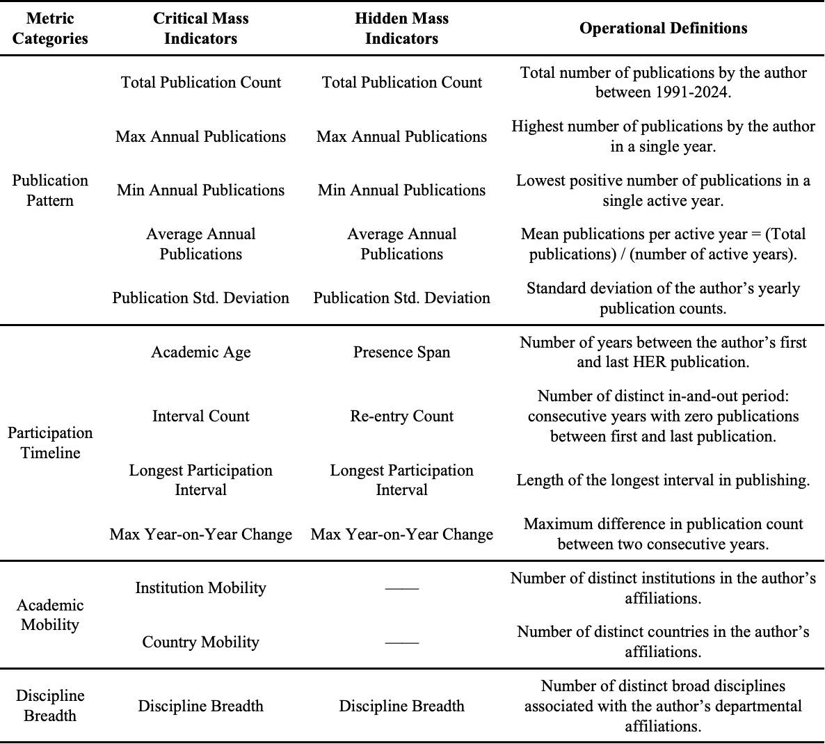

Table 2 Descriptive analysis of critical mass
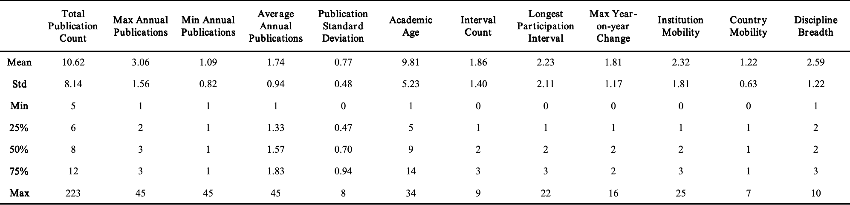

Table 3 Representative participation profiles of critical mass
