Supplementary Materials

Table S1. Sensitivity Analysis: Linear Associations Adjusting for Substance Use (Full Sample)
Predictors | (1) Main Model (Table 2) | (2) Sensitivity Model
PASTBI Index | -0.014* | -0.01
 | -0.006 | -0.006
Obesity Status (Ref: Normal)
Overweight/Obese | 0.221 | 0.084
 | -0.205 | -0.196
Interaction Term
Obesity × PASTBI | 0.014 | 0.013
 | -0.017 | -0.017
Key Covariates
Female Sex | 1.217*** | 1.133***
 | -0.136 | -0.133
Baseline Depression (Age 14) | 0.379*** | 0.444***
 | -0.019 | -0.019
Diet Quality Index | 0.205** | 0.181**
 | -0.073 | -0.07
Substance Use Controls
Smoker (Ref: Never) | -- | -0.43
 |  | -0.23
Drinker (Ref: Never) | -- | 0.145
 |  | -0.134
Constant | 1.700*** | 0.662*
 | -0.324 | -0.336
Observations | 8,753 | 8,624
R-squared | 0.194 | 0.219
Notes: Unstandardized coefficients (Standard Errors in parentheses). All models control for family income and household size (OECD equivalence scale). The sensitivity model (Column 2) additionally controls for cigarette smoking status (Ever/Never) and alcohol consumption status (Ever/Never). * p < 0.05, ** p < 0.01, *** p < 0.001.

Table S2. Sensitivity Analysis: Non-linear Relationship between PASTBI and Psychological Distress in Adolescents with Obesity (Winsorized Data)
Predictors | Coefficient (β) | Robust SE | t-value | P-value | 95% CI
Primary Predictors
PASTBI Index (Winsorized)ª | 0.035 | 0.027 | 1.26 | 0.208 | [-0.019, 0.088]
PASTBI Squared (Quadratic) | -0.0014 | 0.0009 | -1.52 | 0.129 | [-0.003, 0.000]
Covariates
Sex (Female) | 1.453*** | 0.201 | 7.24 | <0.001 | [1.059, 1.847]
Baseline Depression (Age 14) | 0.370*** | 0.019 | 19.04 | <0.001 | [0.331, 0.408]
Diet Quality Index (Z-score) | 0.053 | 0.099 | 0.53 | 0.594 | [-0.142, 0.247]
Model Statistics
Constant | 1.421*** | 0.307 | 4.63 | <0.001 | [0.819, 2.023]
Observations (N) | 2,299
R-squared | 0.181
Calculated Inflection Point^{b} | 12.76 | 4.55 |  | 0.005 | [3.83, 21.68]
Notes: Models were adjusted for sex, baseline depression, and diet quality index. Analysis was restricted to the overweight/obese subsample (N=2,299).ªWinsorization:To mitigate the influence of extreme outliers observed in the raw ratio data (Max > 200), the PASTBI variable was Winsorized at the 99th percentile (values > 45.91 were replaced with 45.91).^{b}Threshold Recalibration:The inflection point (threshold for benefit) shifted from 25.0 in the original model to 12.8 in this sensitivity analysis. While the statistical significance of the quadratic term attenuated (p=0.129) due to reduced variance, the direction of the coefficient remained consistent ($β_{original}$= -0.0013 vs. $β_{winsorized}$ = -0.0014), and the derived threshold of 12.8 represents a more clinically plausible target for behavioral intervention.p < 0.05, ** p < 0.01, *** p < 0.001.

Table S3. Sensitivity Analysis: Robustness to Substance Use Confounding (Original Data)
Predictors | Coefficient (β) | Standard Error (SE) | P-value
Linear Term (PASTBI) | 0.04 | 0.024 | 0.096
Quadratic Term (PASTBI2) | -0.0011 | 0.0004 | 0.003
Covariates
Female Sex | 1.187 | 0.288 | <0.001
Baseline Depression | 0.452 | 0.042 | <0.001
Diet Quality Index | 0.139 | 0.147 | 0.344
Smoker (Yes) | -0.812 | 0.479 | 0.09
Drinker (Yes) | 0.291 | 0.277 | 0.295
Constant | 0.778 | 0.682 | 0.254
Observations (Subpop) | 2,255
R-squared | 0.239
Notes: Analysis restricted to the overweight/obese subpopulation. The highly significant negative quadratic term (p = 0.003) indicates that the non-linear threshold effect remains robust even after adjusting for smoking and alcohol consumption behaviors.This analysis uses the original non-Winsorized PASTBI index to assess stability against confounding from smoking and drinking.

Table S4 Moderating Effect of Self-Rated Health (Obese Group Only)
Predictors | Coefficient (β) | P-value
PASTBI Index | 0.018 | 0.739
Self-Rated Health | -0.151 | 0.589
Interaction: Health × PASTBI | -0.008 | 0.658
Note: Consistent with previous findings, physical health status does not moderate the effect of PASTBI in obese adolescents.

Table S5. Coding Scheme for Sedentary Behaviors
Original Survey Response Category (MCS Questionnaire) | Implied Daily Duration (Range) | Imputed Value (Hours/Day)
1. Not at all | 0 mins | 0.00
2. Less than half an hour | 0 - 29 mins | 0.25
3. Half an hour to less than 1 hour | 30 - 59 mins | 0.75
4. 1 hour to less than 2 hours | 1 - 1.99 hours | 1.50
5. 2 hours to less than 3 hours | 2 - 2.99 hours | 2.50
6. 3 hours to less than 5 hours | 3 - 4.99 hours | 4.00
7. 5 hours to less than 7 hours | 5 - 6.99 hours | 6.00
8. 7 hours or more | 7+ hours | 8.00
Note: For active transport, continuous minutes were reported directly and capped at reasonable limits (e.g., 2 hours).

Table S6. Composition of Sedentary Time Measures for PASTBI Calculation
Classification of sedentary activities into "Passive" and "Active" domains for mechanism analysis.
Activity Domain | Data Source | Included in Total SB (PASTBI Denominator) | Included in Passive SB | Included in Active SB
1. Television Viewing | Self-report | ✓ | ✓ | -
2. Computer Games | Self-report | ✓ | ✓ | -
3. Social Networking | Self-report | ✓ | ✓ | -
4. General Internet Use | Self-report | ✓ | ✓ | -
5. Passive Transport | Self-report | ✓ | ✓ | -
6. Homework / Study | Self-report | ✓ | - | ✓
7. Reading for Pleasure | Self-report | ✓ | - | ✓
Numerator (PA) | Accelerometer | Total MVPA | Total MVPA | Total MVPA
Note: SB = Sedentary Behavior; MVPA = Moderate-to-Vigorous Physical Activity. Total SB is used for the primary PASTBI index. Passive and Active SB are used for secondary mechanism analysis (Table 5 in main text).

Figure S1. STROBE Flowchart of Study Participants

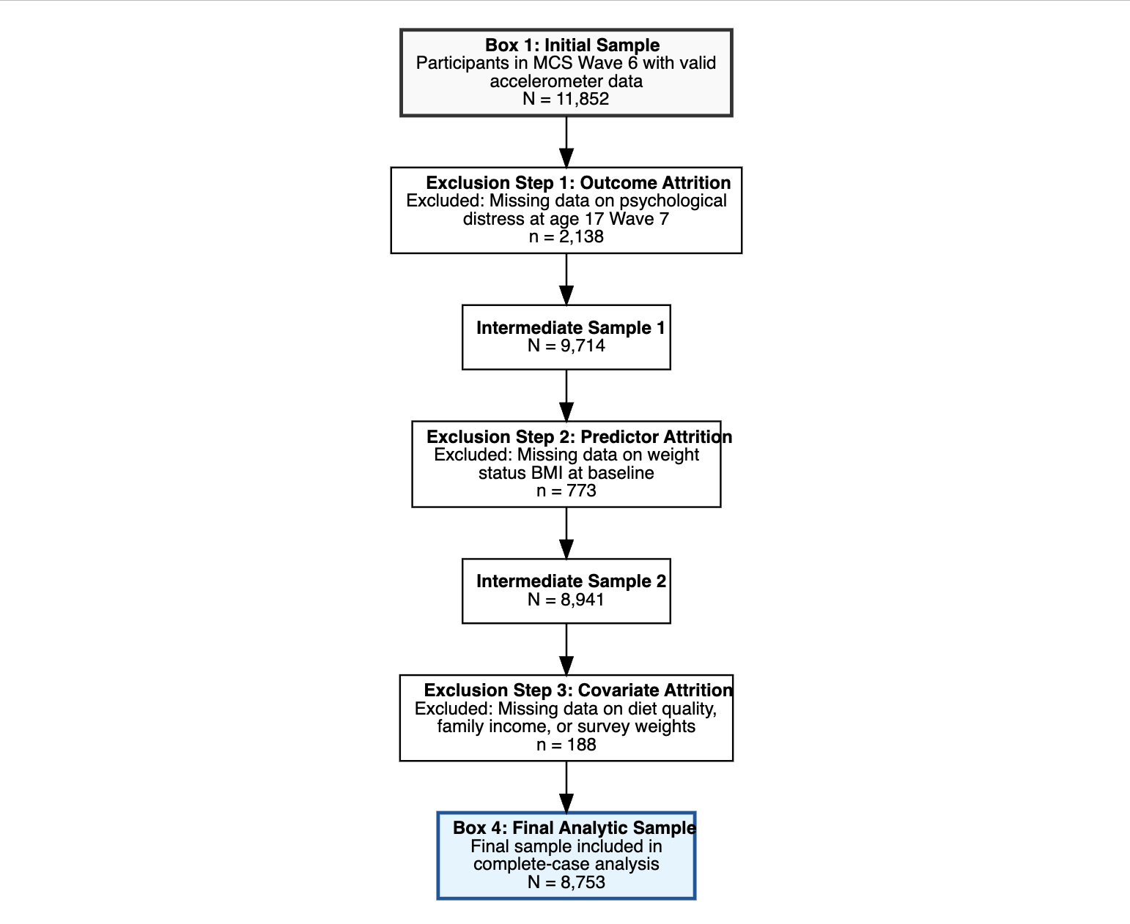

Text S1. Construction Methodology of the Standardized Diet Quality Index
To control for the confounding effects of dietary habits, we constructed a composite Standardized Diet Quality Index derived from five key dietary behaviors reported in the MCS Wave 6 survey. The index construction followed a three-step process:
- Directional Alignment:
Variables were recoded so that higher values consistently indicate healthier behaviors:
  - Fruit Consumption: Reverse coded (Original 1=Frequent $\rightarrow$ New High Score)
  - Vegetable Consumption: Reverse coded (Original 1=Frequent $\rightarrow$ New High Score)
  - Breakfast Frequency: Retained (Higher days = Healthier)
  - Fast Food Frequency: Retained (Higher category = Less frequent = Healthier)
  - Sugary Drink Consumption: Retained (Higher category = Less frequent = Healthier)
- Standardization (Z-scoring):
Due to differing measurement scales (e.g., "days per week" vs. "frequency categories"), each of the five aligned variables was standardized to a Z-score with a mean of 0 and standard deviation of 1.
- Composite Calculation:
The final index was calculated as the mean of the five Z-scores, and then re-standardized to facilitate interpretation.
$$DietQualityIndex=Z\left(\frac{Z_{fruit}+Z_{veg}+Z_{breakfast}+Z_{fastfood}+Z_{soda}}{5}\right)$$
A higher score indicates a healthier overall diet quality relative to the sample population.

