Supplementary Materials

Contents:
- Supplementary Figures S1
- Supplementary Figures S2
- Supplementary Figures S3
- Supplementary Figure S4

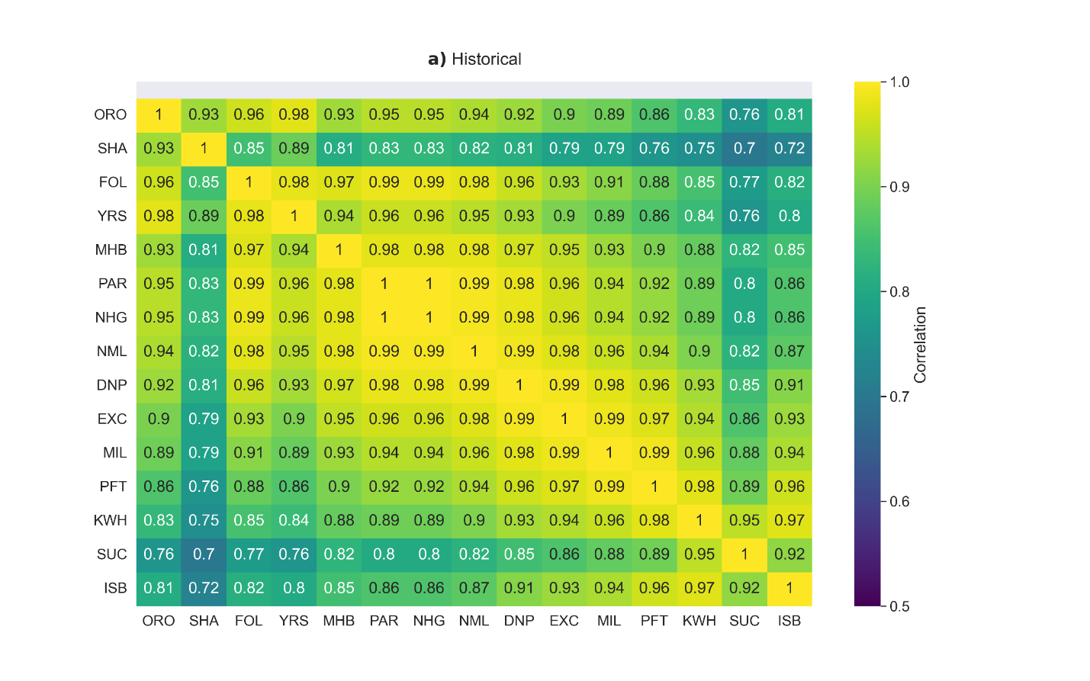
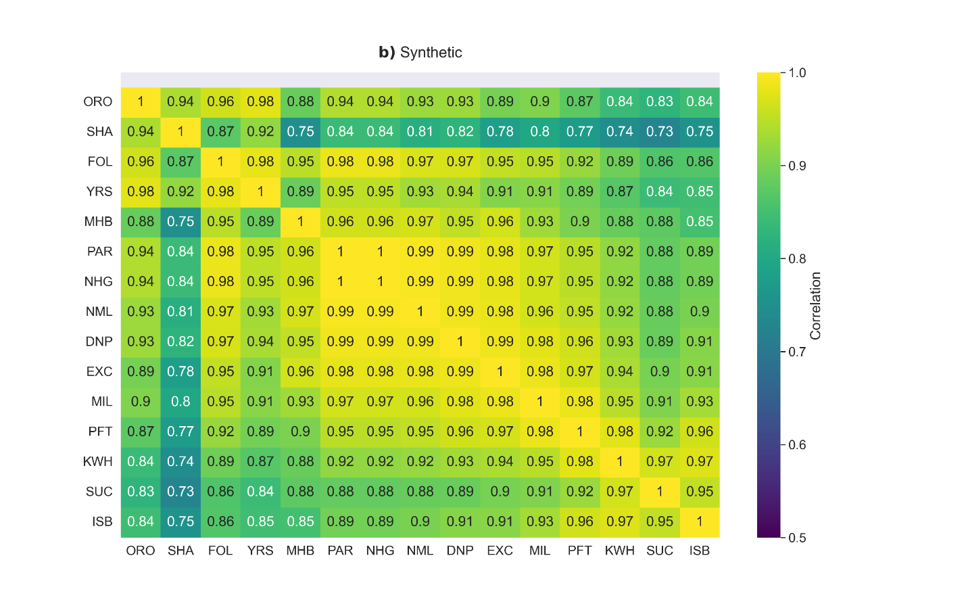
Supplementary Figure S1. (a) historical and (b) synthetic annual correlations across system inflow locations.

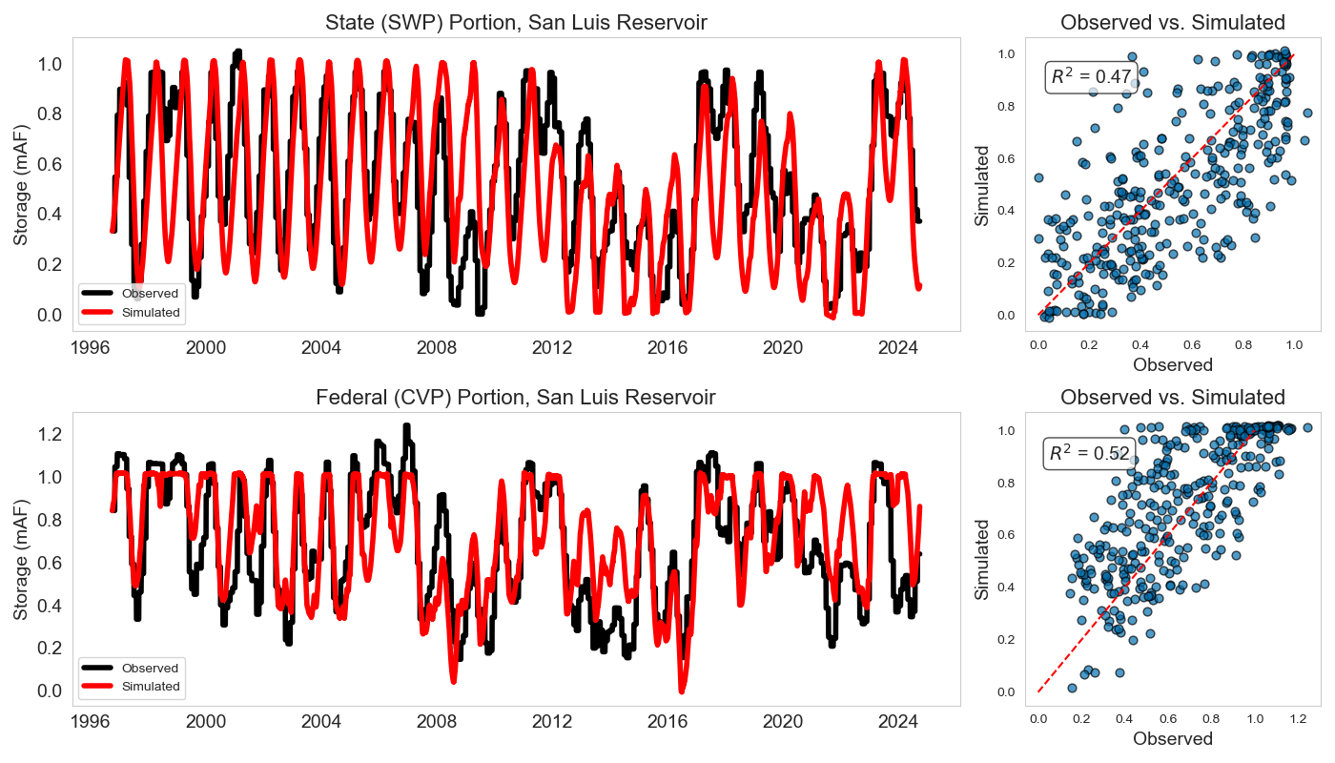
Supplementary Figure S2. Comparison of the observed and simulated storage for the state (SWP) and federal (CVP) portions of the San Luis Reservoir from October 1996 to September 2024: daily time series (left), and monthly storage levels with R² (right).

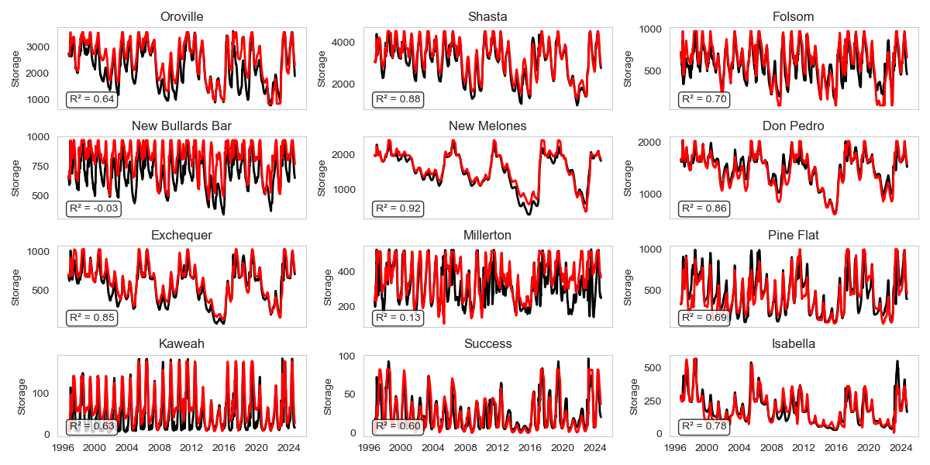
Supplementary Figure S3. Comparison of observed and simulated daily time series for the 12 major surface water reservoirs modeled in CALFEWS (excluding San Luis Reservoir) from October 1996 to September 2024.

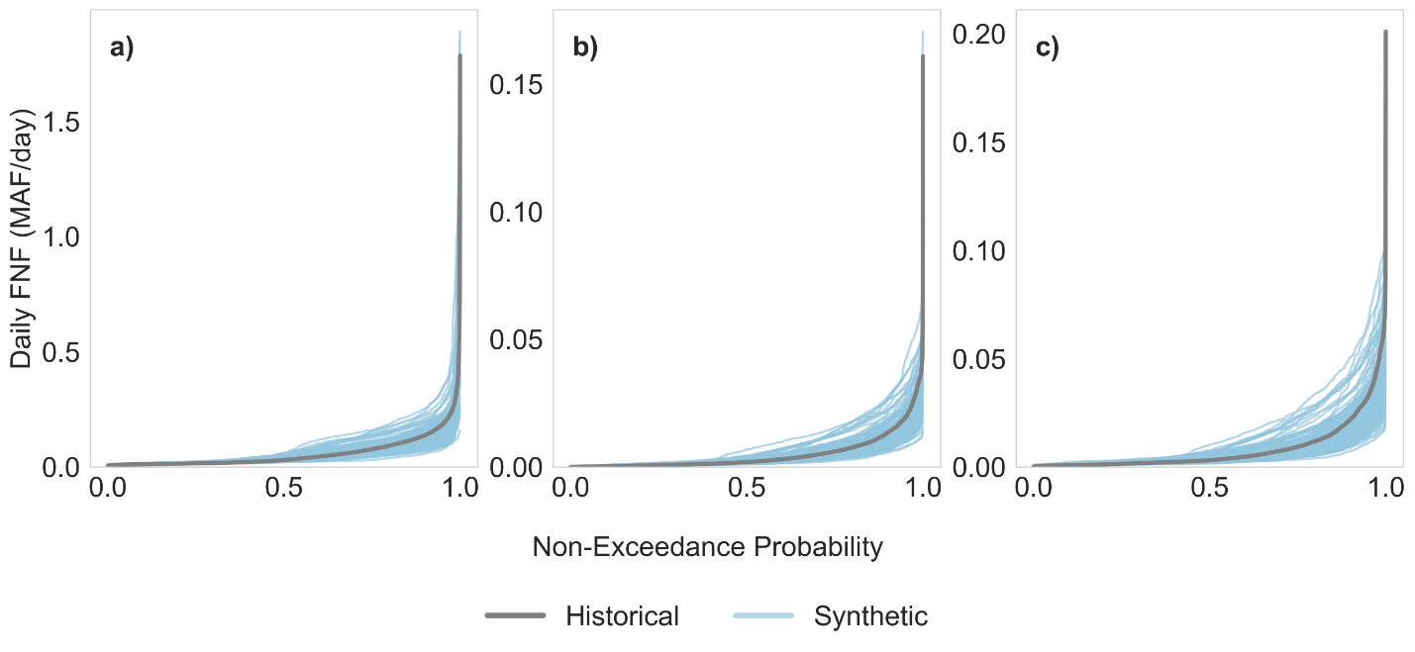
Supplementary Figure S4. Daily FNF Distribution for Historical and Synthetic Datasets. Each subfigure displays the non-exceedance curves for daily FNF, with distributions presented for the following regions: (a) the cumulative surface water reservoirs north of Millerton Lake, comprising Shasta, Oroville, New Bullards Bar, Folsom, New Melones, Don Pedro, and McClure; (b) Millerton Lake; and (c) the cumulative surface water reservoirs south of Millerton Lake, including Pine Flat, Kaweah, Success, and Isabella. The label "Historical" corresponds to the 119-year historical FNF, while "Synthetic" refers to the 100 one-year synthetic flow scenarios.

